Early detection of feline chronic kidney disease via 3-hydroxykynurenine and machine learning
Ellen Vanden Broecke^{1,2}, Laurens Van Mulders^{1,2}, Ellen De Paepe¹, Dominique Paepe², Sylvie Daminet², Lynn Vanhaecke^{1,3,*}

¹Ghent University, Faculty of Veterinary Medicine, Department of Translational Physiology, Infectiology and Public Health, Laboratory of Integrative Metabolomics (LIMET), Salisburylaan 133, B-9820 Merelbeke, Belgium.
²Ghent University, Faculty of Veterinary Medicine, Small Animal Department, Salisburylaan 133, B-9820 Merelbeke, Belgium.
³Queen’s University Belfast, School of Biological Sciences, Institute for Global Food Security, Chlorine Gardens 19, BT9-5DL Belfast, Northern Ireland, United Kingdom

Supplementary tables
Table S1. Total (N) and significant number (Sign, FDR corrected P-value < 0.05) of differential metabolites and metabolite ratios at T₋₆ and T₀.
Table S2. Significant (FDR corrected P-value < 0.05) upregulated (Fold change (FC) ≥ 2.0) metabolites and metabolite ratios in healthy cats compared with CKD2 at T₋₆ and T₀.
Table S3. Significant (FDR corrected P-value < 0.05) downregulated (Fold change (FC) ≤ 0.50) metabolites and metabolite ratios in healthy cats compared with CKD2 at T₋₆ and T₀.
Table S4. Sensitivity and specificity of individual metabolites and metabolite ratios for the classification of healthy and CKD2 in the longitudinal population. The top 15 metabolites are presented, sorted according to the highest AUC-value at T₋₆.
Table S5. Top 15 metabolites and metabolite ratios from the LIMMA TopTable for both matrices separately and combined, sorted according to their FDR corrected P-value.
Table S6. Predictive performance of models based on LIMMA with subsequent GLM for both matrices separately and combined. AUC and accuracy were evaluated twelve at T₋₁₂, T₋₆ and T₀.
Table S7. Sensitivity and specificity of the multivariate and ML-based models with the highest performance for serum, urine and both matrices combined.
Table S8. Deuterium-labelled analytical internal standards (ISTD) with compound specific information about the identity as well as chromatographic and mass spectrometric parameters.
Table S9. Overview of all metabolites included in the analytical standards mixture, sorted according to their class. For each metabolite, the matrix is mentioned in which the metabolite was detected.
Supplementary Figures
Fig. S1. Box plot representation of 3-hydroxykynurenine in healthy cats remaining healthy (blue shades) and developing CKD2 (red shades) in serum and urine. Significant differences (FDR adjusted P-value < 0.05) in the CKD2 group could be observed at T₀ for serum and from T₋₆ onwards in urine.
Fig. S2. Confusion matrices of CKD2 predictions at T₋₆ using S/U 3-hydroxykynurenine, serum metabolite panels resulting from LASSO regression and LIMMA with subsequent GLM, and ML-based serum models using RF and SVM.
Fig. S3. Variable importance of the selected urinary metabolites resulting from LASSO regression and LIMMA with subsequent GLM, and the top 15 metabolites from the RF and SVM models. The relative importance of each metabolite is quantified by assigning a weight between 0 and 100. Metabolites exhibiting higher values are deemed to exert greater influence within the model. Dark blue represents increased metabolites, while light blue indicates a decrease in the CKD2 population.
Fig. S4. Variable importance of the selected serum and urinary metabolites resulting from LASSO regression and LIMMA with subsequent GLM, and the top 15 metabolites from the RF and SVM models. The relative importance of each metabolite is quantified by assigning a weight between 0 and 100. Metabolites exhibiting higher values are deemed to exert greater influence within the model. Dark blue represents increased metabolites, while light blue indicates a decrease in the CKD2 population.
Additional
- Predictive function for CKD2 resulting from LASSO regression using urinary metabolites
- Predictive function for CKD2 resulting from LASSO regression using serum (S) and urinary (U) metabolites
- Predictive function for CKD2 resulting from LIMMA with GLM modelling using urinary metabolites
- Predictive function for CKD2 resulting from LIMMA with GLM modelling using serum (S) and urinary (U) metabolites
- Serum extraction protocol
- Urine extraction protocol
- Questionnaire for owner regarding the general health status
Table S1. Total (N) and significant number (Sign, FDR corrected P-value < 0.05) of differential metabolites and metabolite ratios at T₋₆ and T₀.
Matrix | Metabolites |  |  | Metabolites ratios
Matrix | N | Sign T₀ | Sign T₋₆ | N | Sign T₀ | Sign T₋₆
S | 80 | 37 | 3 | 45 | 24 | 2
U | 64 | 45 | 21 | 36 | 21 | 5
S/U | 61 | 47 | 28 | 33 | 22 | 4
U/S | 61 | 45 | 26 | 33 | 21 | 3
Total | 266 | 174 | 78 | 147 | 88 | 14

Table S2. Significant (FDR corrected P-value < 0.05) upregulated (Fold change (FC) ≥ 2.0) metabolites and metabolite ratios in healthy cats compared with CKD2 at T₋₆ and T₀.
Matrix | Metabolite | FC | P-value
T₀
S/U | Guanine | 7.75 | 6.71E-04
U/S | Fumaric acid | 7.66 | 2.65E-08
U | Fumaric acid | 4.93 | 5.19E-09
U/S | Tyrosine/3-hydroxyphenylacetic acid | 4.85 | 4.85E-06
S/U | Indole-3-acetic acid | 4.69 | 3.44E-06
S/U | Xanthurenic acid | 4.64 | 4.16E-08
U/S | Tyrosine/p-cresol | 4.33 | 4.44E-14
U | Tyrosine/3-hydroxyphenylacetic acid | 4.32 | 3.17E-05
U/S | Kynurenine/xanthurenic acid | 4.21 | 2.30E-12
U/S | Betaine/N,N-dimethylglycine | 3.91 | 1.88E-08
U | Guanidinosuccinate | 3.79 | 1.54E-16
U | Isocitrate | 3.67 | 1.35E-10
S/U | N,N-Dimethylglycine | 3.59 | 1.52E-09
U/S | Methionine/N,N-dimethylglycine | 3.51 | 1.41E-07
U/S | Oxoglutaric acid | 3.47 | 1.14E-07
U | Oxoglutaric acid | 3.45 | 4.78E-08
S/U | Choline | 3.44 | 2.15E-02
S/U | Deoxycarnitine | 3.23 | 1.22E-06
U | Methionine/N,N-dimethylglycine | 3.08 | 4.29E-05
U | Methionine sulfoxide | 3.07 | 1.63E-05
U/S | Asparagine | 3.05 | 2.26E-05
U | Citric acid | 2.98 | 1.87E-09
S/U | Serotonin | 2.90 | 5.59E-08
U | Asparagine | 2.85 | 8.78E-06
S/U | Adenine | 2.80 | 8.88E-05
U/S | 3-Hydroxykynurenine/xanthurenic acid | 2.80 | 9.85E-03
S/U | Tryptophan | 2.67 | 1.17E-05
U/S | Methionine sulfoxide | 2.59 | 6.33E-07
S/U | Tryptophan/kynurenine | 2.58 | 5.14E-08
U/S | Tryptophan/xanthurenic acid | 2.43 | 1.05E-02
S/U | p-Cresol | 2.34 | 2.53E-09
S/U | N-Acetylleucine | 2.33 | 3.07E-04
S/U | Carnitine | 2.33 | 2.04E-04
S | Indoxyl sulfate | 2.33 | 5.35E-10
U | 2-Hydroxyethanesulfonate | 2.32 | 2.54E-16
S | Xanthurenic acid | 2.32 | 4.20E-07
S | 1-Methylhistidine | 2.31 | 2.37E-10
U/S | Isocitrate | 2.30 | 6.65E-07
U | Kynurenine/xanthurenic acid | 2.28 | 2.94E-06
U | Glucaric acid | 2.26 | 5.66E-13
U | Lactic acid | 2.25 | 2.66E-10
U/S | Kynurenine/3-hydroxykynurenine | 2.25 | 2.30E-12
U/S | Lactic acid | 2.23 | 5.22E-08
S/U | 3-Hydroxykynurenine | 2.21 | 5.80E-14
S | Aconitic acid | 2.20 | 3.30E-15
S/U | 3-Hydroxyphenylacetic acid | 2.10 | 7.41E-04
U | Betaine/N,N-dimethylglycine | 2.06 | 3.13E-04
S/U | Phenylacetylglutamine | 2.05 | 3.83E-05
S | 2-Hydroxyethanesulfonate | 2.04 | 3.30E-15
U | Citramalic acid | 2.03 | 4.03E-09
U | Kynurenine/3-hydroxykynurenine | 2.03 | 8.70E-12
U | 1-Methylhistidine | 2.03 | 1.26E-06
T₋₆
S/U | Trimethylamine-N-oxide | 37.91 | 2.23E-03
U/S | Choline/trimethylamine-N-oxide | 18.69 | 1.42E-02
U/S | Betaine/trimethylamine-N-oxide | 13.56 | 2.63E-02
S/U | Tyrosine | 3.27 | 2.53E-03
S/U | Leucine | 3.25 | 3.78E-03
S/U | Xanthosine | 3.19 | 1.48E-02
S/U | Adenine | 2.88 | 1.84E-02
S/U | Xanthurenic acid | 2.81 | 1.29E-02
S/U | Creatine | 2.66 | 1.48E-02
S/U | p-Cresol | 2.23 | 3.31E-02
S/U | Tryptophan | 2.23 | 4.17E-02
S/U | Isovalerylcarnitine | 2.22 | 1.48E-02
S/U | p-Cresol sulfate | 2.19 | 1.42E-02
S/U | Phenylalanine | 2.17 | 9.50E-03
U | Guanidinosuccinate | 2.15 | 3.56E-02
S/U | Methionine/choline | 2.13 | 1.48E-02
S/U | Serotonin | 2.09 | 1.29E-02
S/U | Isoleucine | 2.05 | 1.62E-03
S/U | Phenylacetylglutamine | 2.01 | 1.48E-02
Table S3. Significant (FDR corrected P-value < 0.05) downregulated (Fold change (FC) ≤ 0.50) metabolites and metabolite ratios in healthy cats compared with CKD2 at T₋₆ and T₀.
Matrix | Metabolite | FC | P-value
T₀
S/U | Adenosine | 0.04 | 3.10E-02
U | Creatine/guanidinosuccinate | 0.04 | 1.64E-13
U | Creatinine/guanidinosuccinate | 0.04 | 1.64E-13
U | Guanidinosuccinate/guanidinoacetate | 0.04 | 4.09E-15
S/U | Uridine | 0.23 | 2.38E-06
U/S | Deoxycarnitine | 0.27 | 4.38E-06
U | Tryptophan/indoxyl sulfate | 0.28 | 4.62E-07
S | Guanidinoacetate/creatinine | 0.30 | 3.43E-08
S | Tryptophan/indoxyl sulfate | 0.32 | 4.14E-10
U | Tryptophan/kynurenine | 0.33 | 5.72E-12
S/U | Kynurenine/3-hydroxykynurenine | 0.33 | 3.84E-12
S/U | Tyrosine/p-cresol | 0.33 | 4.44E-14
S/U | Kynurenine/xanthurenic acid | 0.34 | 8.83E-11
S/U | Tyrosine/3-hydroxyphenylacetic acid | 0.35 | 3.67E-07
U | Deoxycarnitine/carnitine | 0.36 | 5.57E-05
S/U | Fumaric acid | 0.36 | 2.65E-08
U/S | Adenine | 0.37 | 8.40E-05
S/U | Betaine/N,N-dimethylglycine | 0.37 | 3.71E-09
S/U | Phenylalanine/phenylacetylglutamine | 0.38 | 4.62E-03
U | Indole-3-acetic acid | 0.40 | 4.24E-06
U | Cholic acid | 0.40 | 5.37E-06
U/S | Indole-3-acetic acid | 0.41 | 3.89E-06
U/S | Tryptophan/kynurenine | 0.41 | 5.93E-08
S/U | Isocitrate | 0.41 | 6.32E-07
U/S | Serotonin | 0.42 | 6.39E-08
S/U | Methionine sulfoxide | 0.43 | 2.02E-06
S/U | Kynurenine/kynurenic acid | 0.43 | 1.17E-05
S | Guanidinoacetate/creatine | 0.44 | 1.14E-05
U | Tryptophan/kynurenic acid | 0.44 | 4.14E-11
S | Phenylalanine/phenylacetylglutamine | 0.44 | 9.47E-04
U/S | 3-Hydroxyphenylacetic acid | 0.44 | 1.03E-04
U | Deoxycarnitine | 0.45 | 2.88E-04
U | Serotonin | 0.46 | 4.32E-09
U | Adenine | 0.47 | 4.59E-06
U/S | Deoxycarnitine/carnitine | 0.47 | 7.33E-03
U/S | N,N-Dimethylglycine | 0.47 | 2.35E-10
S/U | Uric acid | 0.48 | 3.71E-08
S/U | Guanidinoacetate/creatinine | 0.48 | 1.65E-04
S | Betaine/trimethylamine-N-oxide | 0.48 | 1.23E-05
S | Guanidoacetate | 0.49 | 2.59E-04
U/S | p-Cresol | 0.50 | 2.53E-09
S | 2-Deoxyuridine | 0.50 | 4.14E-10
U | 3-Hydroxyphenylacetic acid | 0.50 | 3.00E-04
T₋₆
U | Cholic acid | 0.21 | 5.99E-03
U | Creatine/guanidinosuccinate | 0.35 | 8.27E-03
U | Creatinine/guanidinosuccinate | 0.35 | 8.27E-03
U/S | Adenine | 0.39 | 1.01E-02
U/S | Carnitine | 0.44 | 1.38E-02
S/U | Choline/trimethylamine-N-oxide | 0.44 | 1.48E-02
U | Serotonin | 0.44 | 5.99E-03
U | Carnitine | 0.45 | 2.51E-02
U/S | Serotonin | 0.49 | 1.01E-02
U | Guanidinosuccinate/guanidinoacetate | 0.50 | 2.64E-02

Table S4. Sensitivity and specificity of individual metabolites and metabolite ratios for the classification of healthy and CKD2 in the longitudinal population. The top 15 metabolites are presented, sorted according to the highest AUC-value at T₋₆.
Matrix | Metabolite | T₀ |  | T₋₆ |  | T₋₁₂
Matrix | Metabolite | Sensitivity | Specificity | Sensitivity | Specificity | Sensitivity | Specificity
S/U | 3-Hydroxykynurenine | 1.000 | 0.840 | 0.750 | 0.846 | 0.600 | 0.808
U/S | 3-Hydroxykynurenine | 1.000 | 0.760 | 0.750 | 0.808 | 0.600 | 0.731
S/U | Isoleucine | 0.857 | 0.680 | 0.850 | 0.731 | 0.600 | 0.500
S/U | Creatinine | 0.905 | 0.680 | 0.800 | 0.654 | 0.733 | 0.692
U/S | Creatinine | 0.952 | 0.560 | 0.800 | 0.615 | 0.733 | 0.577
S/U | Kynurenic acid | 1.000 | 0.360 | 0.900 | 0.462 | 0.867 | 0.423
U/S | Kynurenic acid | 1.000 | 0.280 | 0.900 | 0.346 | 0.933 | 0.346
U | 3-Hydroxykynurenine | 1.000 | 0.600 | 0.800 | 0.577 | 0.867 | 0.538
S | Tryptophan/  5-hydroxyindole-3-acetic acid | 1.000 | 0.320 | 0.950 | 0.308 | 0.933 | 0.308
U | Serotonin | 0.952 | 0.440 | 0.900 | 0.346 | 0.800 | 0.192
U | Adenosine | 0.952 | 0.840 | 0.650 | 0.808 | 0.467 | 0.846
U | Creatine/guanidinosuccinate | 0.905 | 0.280 | 0.850 | 0.346 | 0.667 | 0.462
U | Creatinine/guanidinosuccinate | 0.905 | 0.280 | 0.850 | 0.346 | 0.667 | 0.462
S | SDMA | 0.571 | 0.920 | 0.350 | 0.923 | 0.400 | 0.885
S | Trimethylamine-N-oxide | 0.952 | 0.280 | 0.950 | 0.385 | 0.800 | 0.269

Table S5. Top 15 metabolites and metabolite ratios from the LIMMA TopTable for both matrices separately and combined, sorted according to their FDR corrected P-value.
Serum
Metabolite |  | logFC | P-Value
Creatinine |  | 0.888 | 1.22E-27
2-Hydroxyethanesulfonate |  | 1.124 | 4.86E-27
SDMA |  | 1.084 | 1.36E-17
Aconitic acid |  | 0.803 | 1.90E-17
Kynurenic acid |  | 0.871 | 5.37E-14
Isocitrate |  | 0.806 | 2.67E-12
Citric acid |  | 0.802 | 3.10E-12
1-Methylhistidine |  | 0.954 | 5.51E-11
Allantoin |  | 0.564 | 1.86E-09
5-Hydroxyindoleacetic acid |  | 0.648 | 2.90E-09
3-Hydroxykynurenine |  | 0.507 | 2.01E-08
ADMA |  | 0.503 | 5.29E-07
Carnosine |  | 0.578 | 8.78E-07
Indoxyl sulphate |  | 0.843 | 2.52E-06
Urine
Metabolite |  | logFC | Adj. P-Value
2-Hydroxyethanesulfonate |  | 1.285 | 1.17E-21
Tyrosine |  | 1.147 | 5.49E-21
Oxoglutaric acid |  | 1.359 | 9.20E-17
Lactic acid |  | 1.289 | 1.46E-16
Glucaric acid |  | 1.099 | 3.79E-15
N-Acetylneuraminate |  | 1.108 | 3.79E-15
Citramalic acid |  | 1.087 | 4.80E-15
Guanidinosuccinate |  | 1.538 | 1.97E-14
Gluconic acid |  | 0.914 | 2.03E-11
Citric acid |  | 1.218 | 3.81E-11
Isocitrate |  | 1.247 | 6.02E-11
1-Methylhistidine |  | 0.898 | 3.34E-10
Fumaric acid |  | 1.435 | 4.42E-09
Kynurenine |  | 0.812 | 1.96E-07
Arginine |  | 0.677 | 3.41E-07
Serum and urine combined
Matrix | Metabolite | logFC | Adj. P-Value
S | Creatinine | 0.880 | 5.79E-26
S | 2-Hydroxyethanesulfonate | 1.118 | 1.37E-25
U | 2-Hydroxyethanesulfonate | 1.285 | 2.69E-22
U | Tyrosine | 1.147 | 1.25E-21
S | Aconitic acid | 1.080 | 4.48E-17
S | SDMA | 0.802 | 6.95E-17
U | Oxoglutaric acid | 1.359 | 6.95E-17
U | Lactic acid | 1.289 | 1.15E-16
U | Acetylneuraminate | 1.108 | 2.74E-15
U | Glucaric acid | 1.099 | 2.82E-15
U | Citramalic acid | 1.087 | 3.76E-15
U | Guanidinosuccinate | 1.538 | 3.42E-14
S | Kynurenic acid | 0.853 | 2.18E-13
S | Isocitrate | 0.801 | 5.43E-12
S | Citric acid | 0.796 | 6.82E-12

Table S6. Predictive performance of models based on LIMMA with subsequent GLM for both matrices separately and combined. AUC and accuracy were evaluated twelve at T₋₁₂, T₋₆ and T₀.
N | Time-point | S |  |  |  | U |  |  |  | Combined
N | Time-point | AUC | CI | ACC | CI | AUC | CI | ACC | CI | AUC | CI | ACC | CI
2 | T₀ | 0.934 | 0.862-1 | 0.894 | 0.769-0.965 | 0.362 | 0.196-0.527 | 0.426 | 0.283-0.578 | 0.933 | 0.861-1 | 0.891 | 0.764-0.964
2 | T₋₆ | 0.755 | 0.617-0.894 | 0.708 | 0.559-0.830 | 0.387 | 0.216-0.557 | 0.435 | 0.289-0.589 | 0.746 | 0.606-0.890 | 0.696 | 0.542-0.823
2 | T₋₁₂ | 0.679 | 0.513-0.846 | 0.659 | 0.494-0.799 | 0.363 | 0.188-0.538 | 0.381 | 0.236-0.544 | 0.679 | 0.513-0.846 | 0.659 | 0.494-0.799
3 | T₀ | 0.934 | 0.860-1 | 0.894 | 0.769-0.965 | 0.416 | 0.248-0.584 | 0.447 | 0.302-0.599 | 0.891 | 0.802-0.981 | 0.783 | 0.636-0.891
3 | T₋₆ | 0.760 | 0.621-0.900 | 0.729 | 0.582-0.847 | 0.408 | 0.231-.584 | 0.435 | 0.289-0.589 | 0.704 | 0.551-0.857 | 0.674 | 0.520-0.805
3 | T₋₁₂ | 0.705 | 0.544-0.866 | 0.659 | 0.494-0.799 | 0.348 | 0.173-0.523 | 0.381 | 0.236-0.544 | 0.579 | 0.401-0.758 | 0.512 | 0.351-0.671
4 | T₀ | 0.951 | 0.890-1.000 | 0.894 | 0.769-0.695 | 0.418 | 0.250-0.586 | 0.447 | 0.302-0.599 | 0.739 | 0.593-0.885 | 0.696 | 0.542-0.823
 | T₋₆ | 0.806 | 0.681-0.931 | 0.750 | 0.604-0.864 | 0.410 | 0.233-0.587 | 0.435 | 0.289-0.589 | 0.581 | 0.409-0.752 | 0.500 | 0.349-0.651
 | T₋₁₂ | 0.741 | 0.590-0.892 | 0.707 | 0.545-0.839 | 0.351 | 0.175-0.526 | 0.405 | 0.256-0.567 | 0.524 | 0.332-0.717 | 0.439 | 0.285-0.603
5 | T₀ | 0.954 | 0.899-1.000 | 0.894 | 0.769-0.965 | 0.520 | 0.350-0.690 | 0.511 | 0.361-0.659 | 0.766 | 0.639-0.893 | 0.761 | 0.612-0.874
 | T₋₆ | 0.809 | 0.686-0.933 | 0.750 | 0.604-0.864 | 0.431 | 0.254-0.607 | 0.435 | 0.289-0.589 | 0.630 | 0.477-0.783 | 0.587 | 0.432-0.730
 | T₋₁₂ | 0.733 | 0.581-0.886 | 0.683 | 0.519-0.819 | 0.415 | 0.233-0.597 | 0.405 | 0.256-0.567 | 0.559 | 0.390-0.728 | 0.561 | 0.397-0.715
6 | T₀ | 0.952 | 0.895-1.000 | 0.894 | 0.769-0.965 | 0.424 | 0.255-0.592 | 0.383 | 0.245-0.536 | 0.752 | 0.627-0.878 | 0.739 | 0.589-0.857
 | T₋₆ | 0.809 | 0.685-0.934 | 0.771 | 0.627-0.880 | 0.381 | 0.212-0.563 | 0.370 | 0.232-0.525 | 0.680 | 0.535-0.825 | 0.630 | 0.475-0.768
 | T₋₁₂ | 0.731 | 0.577-0.885 | 0.707 | 0.545-0.839 | 0.388 | 0.212-0.563 | 0.381 | 0.236-0.544 | 0.538 | 0.365-0,712 | 0.463 | 0.307-0.626
7 | T₀ | 0.954 | 0.898-1.000 | 0.894 | 0.769-0.965 | 0.424 | 0.255-0.592 | 0.383 | 0.245-0.536 | 0.770 | 0.642-0.899 | 0.717 | 0.565-0.840
 | T₋₆ | 0.806 | 0.681-0.931 | 0.771 | 0.627-0.880 | 0.379 | 0.210-0.548 | 0.370 | 0.232-0.525 | 0.656 | 0.502-0.810 | 0.587 | 0.532-0.730
 | T₋₁₂ | 0.733 | 0.580-0.887 | 0.707 | 0.545-0.839 | 0.388 | 0.212-0.563 | 0.381 | 0.236-0.544 | 0.533 | 0.367-0.700 | 0.488 | 0.329-0.649
8 | T₀ | 0.974 | 0.940-1.000 | 0.872 | 0.743-0.952 | 0.504 | 0.333-0.674 | 0.489 | 0.341-0.639 | 0.790 | 0.663-0.916 | 0.696 | 0.542-0.823
 | T₋₆ | 0.823 | 0.702-0.944 | 0.771 | 0.627-0.880 | 0.425 | 0.253-0.597 | 0.370 | 0.232-0.525 | 0.671 | 0.516-0.826 | 0.674 | 0.520-0.805
 | T₋₁₂ | 0.746 | 0.596-0.896 | 0.659 | 0.494-0.799 | 0.395 | 0.219-0.571 | 0.429 | 0.277-0.590 | 0.708 | 0.557-0.858 | 0.585 | 0.421-0.737
9 | T₀ | 0.956 | 0.904-1.000 | 0.851 | 0.717-0.938 | 0.602 | 0.436-0.767 | 0.553 | 0.401-0.698 | 0.905 | 0.819-0.991 | 0.848 | 0.711-0.937
 | T₋₆ | 0.799 | 0.669-0.929 | 0.771 | 0.627-0.880 | 0.481 | 0.306-0.656 | 0.435 | 0.289-0.589 | 0.706 | 0.560-0.852 | 0.674 | 0.520-0.805
 | T₋₁₂ | 0.738 | 0.584-0.893 | 0.707 | 0.545-0.839 | 0.435 | 0.256-0.614 | 0.429 | 0.277-0.590 | 0.682 | 0.517-0.847 | 0.659 | 0.494-0.799
10 | T₀ | 0.956 | 0.904-1.000 | 0.851 | 0.717-0.938 | 0.651 | 0.489-0.812 | 0.617 | 0.464-0.755 | 0.918 | 0.839-0.997 | 0.870 | 0/737-0.951
 | T₋₆ | 0.799 | 0.668-0.930 | 0.771 | 0.627-0.880 | 0.513 | 0.340-0.687 | 0.478 | 0.329-0.631 | 0.733 | 0.588-0.878 | 0.696 | 0.542-0.823
 | T₋₁₂ | 0.738 | 0.584-0.893 | 0.707 | 0.545-0.839 | 0.437 | 0.257-0.617 | 0.429 | 0.277-0.590 | 0.705 | 0.539-0.871 | 0.659 | 0.494-0.799
N = number of metabolites included in the biomarker panel

Table S7. Sensitivity and specificity of the multivariate and ML-based models with the highest performance for serum, urine and both matrices combined.
 |  | Without clinical parameters |  |  | With clinical parameters
 |  | T₀ | T₋₆ | T₋₁₂ | T₀ | T₋₆ | T₋₁₂
LASSO
Serum | Sensitivity | 0.857 | 0.773 | 0.667 | 1.000 | 0.714 | 0.714
Serum | Specificity | 0.923 | 0.731 | 0.654 | 0.952 | 0.773 | 0.727
Urine | Sensitivity | 0.591 | 0.450 | 0.467 | 0.875 | 0.667 | 0.400
Urine | Specificity | 0.360 | 0.308 | 0.407 | 0.850 | 0.773 | 0.652
Combined | Sensitivity | 0.810 | 0.650 | 0.733 | 0.875 | 0.714 | 0.429
Combined | Specificity | 0.760 | 0.615 | 0.538 | 0.950 | 0.810 | 0.727
LIMMA
Serum | Sensitivity | 0.810 | 0.818 | 0.733 | 1.000 | 0.714 | 0.571
Serum | Specificity | 0.923 | 0.731 | 0.615 | 0.952 | 0.818 | 0.773
Urine | Sensitivity | 0.682 | 0.550 | 0.600 | 0.438 | 0.333 | 0.500
Urine | Specificity | 0.560 | 0.462 | 0.333 | 0.750 | 0.545 | 0.565
Combined | Sensitivity | 0.905 | 0.800 | 0.800 | 0.875 | 0.857 | 0.857
Combined | Specificity | 0.840 | 0.577 | 0.577 | 0.950 | 0.762 | 0.727
RF
Serum | Sensitivity | 0.952 | 0.864 | 0.733 | 0.889 | 0.857 | 0.714
Serum | Specificity | 0.885 | 0.692 | 0.577 | 0.952 | 0.773 | 0.773
Urine | Sensitivity | 0.773 | 0.600 | 0.667 | 0.750 | 0.583 | 0.500
Urine | Specificity | 0.560 | 0.385 | 0.296 | 0.700 | 0.455 | 0.522
Combined | Sensitivity | 0.905 | 0.850 | 0.733 | 0.875 | 0.714 | 0.429
Combined | Specificity | 0.800 | 0.692 | 0.500 | 0.900 | 0.714 | 0.682
SVM linear
Serum | Sensitivity | 0.857 | 0.864 | 0.867 | 1.000 | 0.857 | 0.857
Serum | Specificity | 0.962 | 0.692 | 0.577 | 0.952 | 0.864 | 0.727
Urine | Sensitivity | 0.909 | 0.600 | 0.533 | 0.813 | 0.583 | 0.400
Urine | Specificity | 0.640 | 0.423 | 0.259 | 0.600 | 0.500 | 0.522
Combined | Sensitivity | 0.905 | 0.850 | 0.667 | 0.750 | 0.714 | 0.571
Combined | Specificity | 0.880 | 0.538 | 0.423 | 0.850 | 0.762 | 0.773
SVM radial
Serum | Sensitivity | 0.905 | 0.864 | 0.800 | 1.000 | 0.857 | 0.857
Serum | Specificity | 0.923 | 0.692 | 0.654 | 0.952 | 0.818 | 0.682
Urine | Sensitivity | 0.864 | 0.650 | 0.733 | 0.813 | 0.667 | 0.600
Urine | Specificity | 0.520 | 0.423 | 0.370 | 0.550 | 0.455 | 0.609
Combined | Sensitivity | 0.952 | 0.900 | 0.867 | 0.875 | 0.857 | 0.714
Combined | Specificity | 0.840 | 0.500 | 0.423 | 0.850 | 0.762 | 0.773

Table S8. Deuterium-labelled analytical internal standards (ISTD) with compound specific information about the identity as well as chromatographic and mass spectrometric parameters.
ISTD | Superclass | Class | Subclass | Ion adduct | m/z-value (Da) | Rt (min)
L-Alanine-d3 | Organic acids and derivatives | Carboxylic acids and derivatives | Amino acids, peptides, and analogues | [M-H]⁺ | 93.074 | 0.9
Dopamine.HCl-d4 | Benzenoids | Phenols | Benzenediols | [M-H]⁺ | 158.111 | 1.5
Indole-3-acetic acid-d5 | Organoheterocyclic metabolites | Indoles and derivatives | Indolyl carboxylic acids and derivatives | [M-H]⁺ | 181.102 | 8.9
L-Tyrosine-d2 | Organic acids and derivatives | Carboxylic acids and derivatives | Amino acids, peptides, and analogues | [M-H]⁺ | 184.094 | 1.8
Deoxycholic acid-d4 | Lipids and lipid-like molecules | Steroids and steroid derivatives | Bile acids, alcohols and derivatives | [M-H]⁻ | 395.310 | 10.9
m/z-value = mass-to-charge ratio; Rt = retention time

Table S9. Overview of all metabolites included in the analytical standards mixture, sorted according to their class. For each metabolite, the matrix is mentioned in which the metabolite was detected.
 | Metabolites | m/z-value (Da) | Rt (min) | Main ion | Chemical formula | Matrix
 | Amines
 | Choline | 104.106 | 0.9 | [M+H]⁺ | C₅H₁₄NO.Cl | U, S
 | Benzene and substituted derivatives
 | Hippuric acid | 180.066 | 6.5 | [M+H]⁺ | C₉H₉NO₃ | U, S
 | Carboxylic acids and derivatives
 | 1-Methylhistidine | 170.092 | 0.8 | [M+H]⁺ | C₇H₁₁N₃O₂ | U, S
 | 2-Aminoisobutyric acid | 104.071 | 1.0 | [M+H]⁺ | C₄H₉NO₂ | S
 | 3-Hydroxyphenylacetic acid | 151.040 | 6.9 | [M-H]⁻ | C₈H₈O₃ | U, S
 | Aconitic acid | 197.006 | 1.7 | [M+H]⁺ | C₆H₆O₆ | S
 | Arginine | 175.119 | 0.8 | [M+H]⁺ | C₆H₁₄N₄O₂ | U, S
 | Asparagine | 131.046 | 0.8 | [M-H]⁻ | C₄H₈N₂O₃ | U, S
 | Betaine | 118.086 | 0.9 | [M+H]⁺ | C₅H₁₁NO₂ | U, S
 | Carnitine | 162.113 | 0.9 | [M+H]⁺ | C₇H₁₅NO₃ | U, S
 | Carnosine | 227.114 | 0.8 | [M+H]⁺ | C₉H₁₄N₄O₃ | U, S
 | Citric acid | 191.020 | 1.5 | [M-H]⁻ | C₆H₈O₇ | U, S
 | Citrulline | 176.103 | 0.9 | [M+H]⁺ | C₆H₁₃N₃O₃ | S
 | Creatine | 132.076 | 1.0 | [M+H]⁺ | C₄H₉N₃O₂ | U, S
 | Creatinine | 114.066 | 0.9 | [M-H]⁻ | C₄H₇N₃O | U, S
 | Deoxycarnitine | 146.117 | 1.0 | [M+H]⁺ | C₇H₁₅NO₂ | U, S
 | Fumaric acid | 115.004 | 1.8 | [M-H]⁻ | C₄H₄O₄ | U, S
 | Gluconic acid | 195.051 | 0.9 | [M-H]⁻ | C₆H₁₂O₇ | U, S
 | Glutamic acid | 146.046 | 0.9 | [M-H]⁻ | C₅H₉NO₄ | S
 | Glutamine | 147.076 | 0.9 | [M+H]⁺ | C₅H₁₀N₂O₃ | S
 | Guanidinosuccinate | 176.067 | 0.9 | [M+H]⁺ | C₅H₉N₃O₄ | U
 | Guanidoacetate | 118.061 | 0.9 | [M+H]⁺ | C₃H₇N₃O₂ | U, S
 | Histidine | 156.077 | 0.8 | [M+H]⁺ | C₆H₉N₃O₂ | U, S
 | Hydroxyproline | 132.066 | 0.9 | [M+H]⁺ | C₅H₉NO₃ | S
 | Isocitrate | 191.020 | 1.5 | [M-H]⁻ | C₆H₈O₇ | U, S
 | Isoleucine | 132.102 | 2.0 | [M+H]⁺ | C₆H₁₃NO₂ | U, S
 | Leucine | 132.102 | 2.2 | [M+H]⁺ | C₆H₁₃NO₂ | U, S
 | Lysine | 147.113 | 0.8 | [M+H]⁺ | C₆H₁₄N₂O₂ | U, S
 | Methionine | 150.058 | 1.4 | [M+H]⁺ | C₅H₁₁NO₂S | U, S
 | Methionine sulfoxide | 164.039 | 0.9 | [M-H]⁻ | C₅H₁₁NO₃S | U, S
 | N,N-Dimethylarginine | 203.150 | 1.0 | [M+H]⁺ | C₈H₁₈N₄O₂ | U, S
 | N,N-Dimethylglycine | 104.071 | 0.9 | [M+H]⁺ | C₄H₉NO₂ | U, S
 | N-Acetylleucine | 174.113 | 7.5 | [M+H]⁺ | C₈H₁₅NO₃ | U, S
 | Ornithine | 133.097 | 0.8 | [M+H]⁺ | C₅H₁₂N₂O₂ | U, S
 | Phenylacetylglutamine | 265.118 | 6.6 | [M+H]⁺ | C₁₃H₁₆N₂O₄ | U, S
 | Phenylalanine | 166.086 | 4.1 | [M+H]⁺ | C₉H₁₁NO₂ | U, S
 | Picolinic acid | 124.039 | 1.4 | [M+H]⁺ | C₆H₅NO₂ | S
 | Proline | 116.071 | 1.0 | [M+H]⁺ | C₅H₉NO₂ | U, S
 | Pyroglutamic acid | 130.050 | 1.6 | [M+H]⁺ | C₅H₇NO₃ | S
 | Succinic acid | 199.034 | 2.0 | [M+H]⁺ | C₄H₆O₄ | S
 | Tryptophan | 205.097 | 5.4 | [M+H]⁺ | C₁₁H₁₂N₂O₂ | U, S
 | Tyrosine | 182.081 | 2.0 | [M+H]⁺ | C₉H₁₁NO₃ | U, S
 | Xanthurenic acid | 206.045 | 5.4 | [M+H]⁺ | C₁₀H₇NO₄ | U, S
 | Fatty Acyls
 | Citramalic acid | 147.030 | 2.0 | [M-H]⁻ | C₅H₈O₅ | U, S
 | Isovalerylcarnitine | 246.170 | 6.4 | [M+H]⁺ | C₁₂H₂₃NO₄ | U, S
 | Pimelic acid | 159.066 | 6.4 | [M-H]⁻ | C₇H₁₂O₄ | U, S
 | Glycerophospholipids
 | Lysophosphatidylcholine 18:1 | 522.355 | 11.6 | [M+H]⁺ | C₂₆H₅₂NO₇P | S
 | Hydroxy acids and derivatives
 | Lactic acid | 89.024 | 1.4 | [M-H]⁻ | C₃H₆O₃ | U, S
 | Imidazopyrimidines
 | Adenine | 136.062 | 1.4 | [M+H]⁺ | C₅H₅N₅ | U, S
 | Allantoin | 159.051 | 1.0 | [M+H]⁺ | C₄H₆N₄O₃ | S
 | Guanine | 152.056 | 1.4 | [M+H]⁺ | C₅H₅N₅O | U, S
 | Hypoxanthine | 137.046 | 1.5 | [M+H]⁺ | C₅H₄N₄O | U, S
 | Uric acid | 167.021 | 1.4 | [M-H]⁻ | C₅H₄N₄O₃ | U, S
 | Xanthine | 151.026 | 1.7 | [M-H]⁻ | C₅H₄N₄O₂ | S
 | Indoles and derivatives
 | 1-Acetyl-indole-3-carboxaldehyde | 146.059 | 9.0 | [M+H]⁺ | C₁₁H₉NO₂ | S
 | 5-Hydroxyindole-3-acetic acid | 192.066 | 6.2 | [M+H]⁺ | C₁₀H₉NO₃ | U, S
 | Indole-3-acetic acid | 176.071 | 8.8 | [M+H]+ | C₁₀H₉NO₂ | U, S
 | Indole-3-proprionic acid | 190.086 | 9.1 | [M+H]⁺ | C₁₁H₁₁NO₂ | S
 | Indoxyl sulfate | 212.002 | 6.2 | [M-H]⁻ | C₈H₇NO₄S | U, S
 | Serotonin | 177.102 | 3.6 | [M+H]⁺ | C₁₀H₁₂N₂O | U, S
 | Keto acids and derivatives
 | Oxoglutaric acid | 145.014 | 1.4 | [M-H]⁻ | C₅H₆O₅ | U, S
 | Organosulfonic acids and derivatives
 | 2-Hydroxyethanesulfonate | 124.992 | 0.9 | [M-H]⁻ | C₂H₆O₄S | U, S
 | Taurine | 124.007 | 0.9 | [M-H]⁻ | C₂H₇NO₃S | S
 | Organonitrogen metabolites
 | Putrescine | 89.107 | 0.7 | [M+H]⁺ | C₄H₁₂N₂ | U, S
 | Spermidine | 146.165 | 0.7 | [M+H]⁺ | C₇H₁₉N₃ | S
 | Trimethylamine N-oxide | 76.076 | 0.9 | [M+H]⁺ | C₃H₉NO | U, S
 | Organooxygen metabolites
 | 3-Hydroxykynurenine | 225.087 | 1.9 | [M+H]⁺ | C₁₀H₁₂N₂O₄ | U, S
 | Glucaric acid | 209.030 | 0.9 | [M-H]⁻ | C₆H₁₀O₈ | U
 | Kynurenine | 209.092 | 3.9 | [M+H]⁺ | C₁₀H₁₂N₂O₃ | U, S
 | Myo-inositol | 179.056 | 0.9 | [M-H]⁻ | C₆H₁₂O₆ | U, S
N-Acetylneuraminate |  | 310.113 | 1.0 | [M+H]⁺ | C₁₁H₁₉NO₉ | U, S
 | p-Cresol sulfate | 187.007 | 7.5 | [M-H]⁻ | C₇H₈O₄S | U, S
 | Pantothenic acid | 220.118 | 4.6 | [M+H]⁺ | C₉H₁₇NO₅ | U
 | Phenols
 | p-Cresol | 107.050 | 7.5 | [M-H]⁻ | C₇H₈O | U, S
 | Pyrimidine nucleotides
 | 2-Deoxyuridine | 227.067 | 2.5 | [M-H]⁻ | C₉H₁₂N₂O₅ | S
 | Adenosine | 268.104 | 2.5 | [M+H]⁺ | C₁₀H₁₃N₅O₄ | U, S
 | Cytidine | 244.093 | 1.4 | [M+H]⁺ | C₉H₁₃N₃O₅ | U, S
 | Uridine | 245.077 | 1.8 | [M+H]⁺ | C₉H₁₂N₂O₆ | U, S
 | Xanthosine | 285.083 | 3.9 | [M+H]⁺ | C₁₀H₁₂N₄O₆ | U, S
 | Quinolines and derivatives
 | Kynurenic acid | 190.045 | 5.8 | [M+H]⁺ | C₁₀H₇NO₃ | U, S
 | Steroids and steroid derivatives
 | Cholic acid | 407.280 | 9.9 | [M-H]⁻ | C₂₄H₄₀O₅ | U, S
 | Deoxycholic acid | 391.285 | 10.9 | [M-H]⁻ | C₂₄H₄₀O₄ | S
m/z-value = mass-to-charge ratio; Rt = retention time
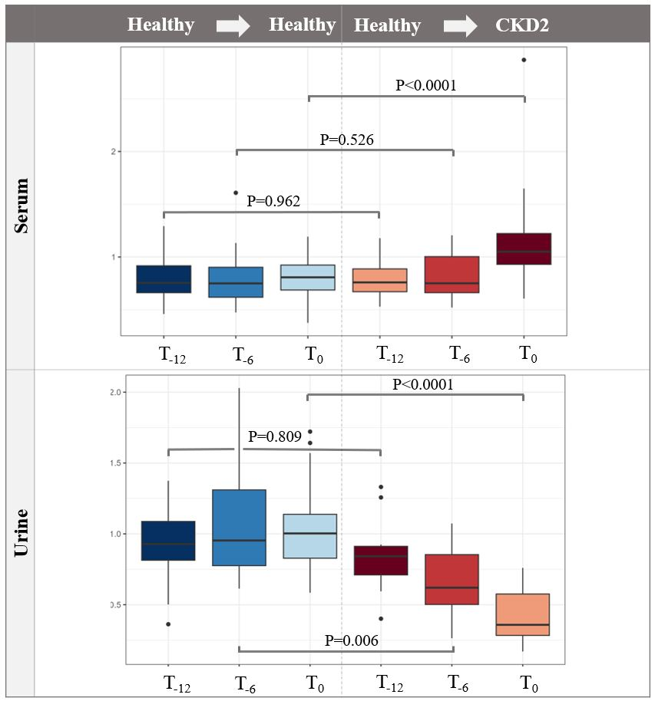
Fig. S1. Box plot representation of 3-hydroxykynurenine in healthy cats remaining healthy (blue shades) and developing CKD2 (red shades) in serum and urine. Significant differences (FDR (false discovery rate) corrected P-value < 0.05) in the CKD2 group could be observed at T₀ for serum and from T₋₆ onwards in urine.

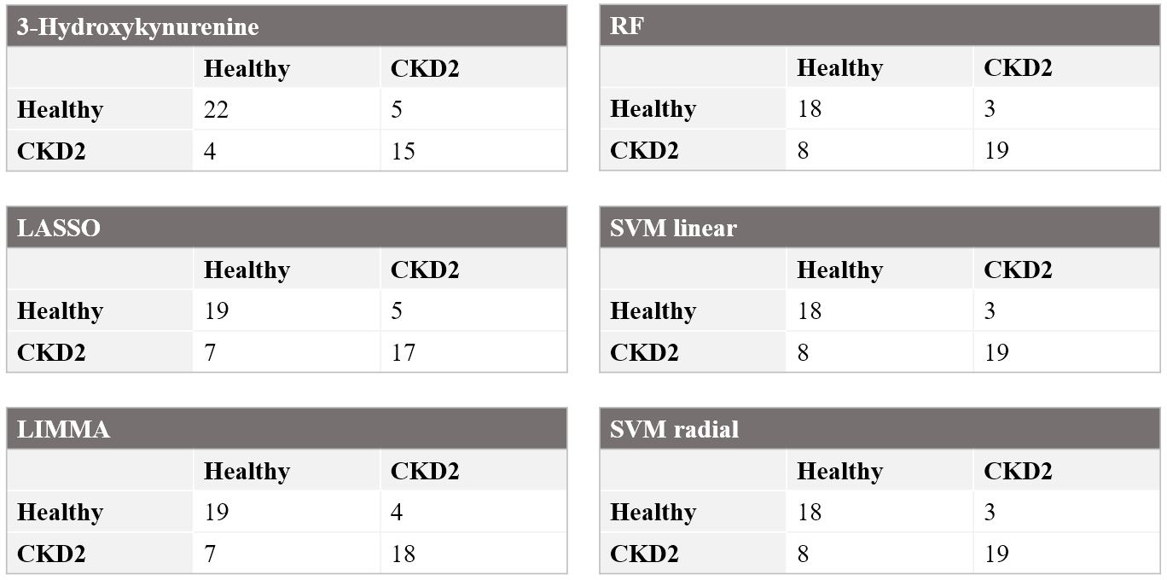
Fig. S2. Confusion matrices of CKD2 predictions at T₋₆ using S/U 3-hydroxykynurenine, serum metabolite panels resulting from LASSO regression and LIMMA with subsequent GLM, and ML-based serum models using RF and SVM.
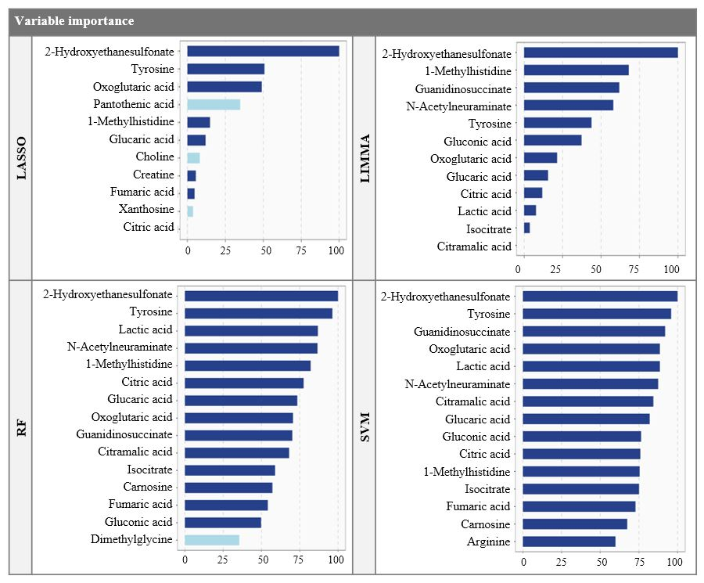
Fig. S3. Variable importance of the selected urinary metabolites resulting from LASSO regression and LIMMA with subsequent GLM, and the top 15 metabolites from the RF and SVM models. The relative importance of each metabolite is quantified by assigning a weight between 0 and 100. Metabolites exhibiting higher values are deemed to exert greater influence within the model. Dark blue represents increased metabolites, while light blue indicates a decrease in the CKD2 population.
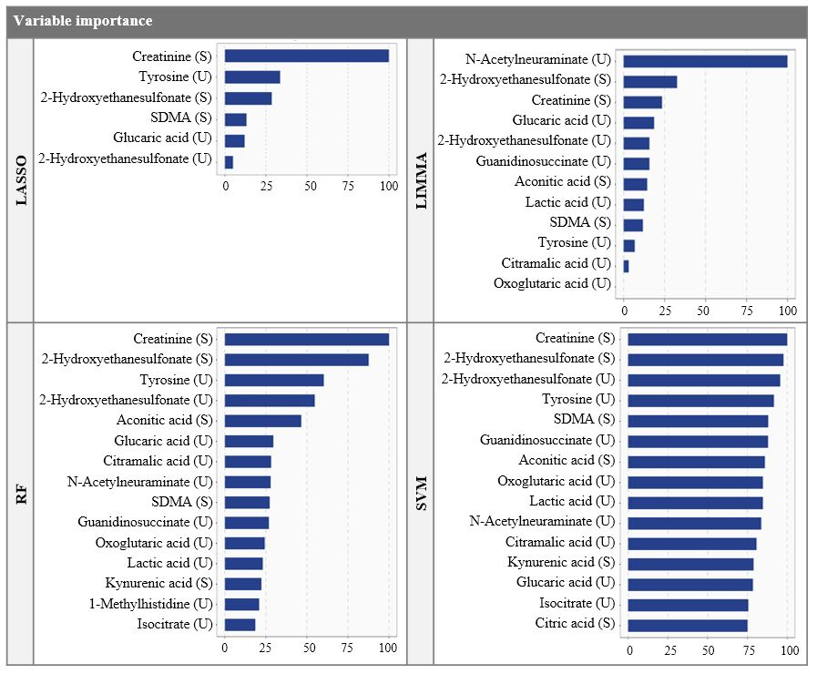
Fig. S4. Variable importance of the selected serum and urinary metabolites resulting from LASSO regression and LIMMA with subsequent GLM, and the top 15 metabolites from the RF and SVM models. The relative importance of each metabolite is quantified by assigning a weight between 0 and 100. Metabolites exhibiting higher values are deemed to exert greater influence within the model. Dark blue represents increased metabolites, while light blue indicates a decrease in the CKD2 population.

Predictive function for CKD2 resulting from LASSO regression using urinary metabolites
$P\left(CKD2\right)=\frac{1}{1+\exp\left(-z\right)}$
with z = 0.275 + 1.364 × 2-hydroxyethanesulfonate + 0.692 × tyrosine + 0.669 × oxoglucaric acid – 0.475 × pantothenic acid + 0.203 × 1-methylhistidine + 0.164 × glucaric acid – 0.111 × choline + 0.076 × creatine + 0.065 fumaric acid – 0.051 × xanthosine + 0.001 × citric acid

Predictive function for CKD2 resulting from LASSO regression using serum (S) and urinary (U) metabolites
$P\left(CKD2\right)=\frac{1}{1+\exp\left(-z\right)}$
with z = 1.755 + 0.591 × creatinine (S) + 0.591 × tyrosine (U) + 0.501 × 2-hydroxyethanesulfonate (S) + 0.231 SDMA (S) + 0.211 × glucaric acid (U) 0.087 × 2-hydroxyethanesulfonate (U)

Predictive function for CKD2 resulting from LIMMA with GLM modelling using urinary metabolites
$P\left(CKD2\right)=\frac{1}{1+\exp\left(-z\right)}$
with z = 0.847 + 5.534 × 2-hydroxyethanesulfonate 4.666 × citric acid -3.241 × isocitrate -2.667 × acetylneuraminate + 2.091 × guanidinosuccinate + 1.974 × tyrosine + 1.550 × 1-methylhistidine + 1.382 × gluconic acid + 0.975 × oxoglutaric acid -0.573 × lactic acid + 0.471 × glucaric acid – 0.357 × citramalic acid

Predictive function for CKD2 resulting from LIMMA with GLM modelling serum (S) and urinary (U) metabolites
$P\left(CKD2\right)=\frac{1}{1+\exp\left(-z\right)}$
with z = 4.496 + 61.622 × creatinine (S) + 33.524 ×2-hydroxyethanesulfonate (S) + 26.703 × acetylneuraminate (U) + 18.863 × SDMA (S) – 15.989 × 2-hydroxyethanesulfonate (U) + 13.677 × aconitic acid (S) + 13.573 × glucaric acid (U) + 10.713 lactic acid (U) + 8.305 × guanidinosuccinate (U) + 7.268 × tyrosine (U) – 2.951 × citramalic acid (U) – 1.229 oxoglutaric acid (U)

Serum extraction protocol
To extract the serum metabolome, 100 µL was pipetted into a 1.5-mL Eppendorf tube. Next, 400 µL of a 1:1:1 mixture of ACN, MeOH and acetone was added, together with 20 µL of the ISTD mixture (L-tyrosine-d2, indole-3-acetic acid-d5, dopamine.HCl-d4, deoxycholic acid-d4, L-alanine-d3; final concentration in the vial was 1 ng/µL). The sample was then vigorously vortexed for 2 min, followed by storage for 30 min at 4 °C to facilitate protein precipitation. Following this, centrifugation was initiated (10 min; 15 000 x g at 4 °C) and 250 µL of the resulting supernatant was transferred into a 10 mL plastic Eppendorf tube without cap and evaporated under a nitrogen (N₂) stream at 35 °C until a droplet of ca. 20 µL remained. Reconstitution was performed by adding 80 µL of a 98:2 UPW and MeOH solution and the extract was vortexed for 30 sec. A second centrifugation step was then performed (10 min; 15 000 x g; at 4 °C) and the supernatant was transferred into a HPLC-vial with insert for analysis.

Urine extraction protocol
Extraction was performed by transferring 300 µL of urine into a 1.5-mL Eppendorf tube. Similar to serum, 30 µL of the ISTD mixture was added, after which, a centrifugation step (8 min; 1000 x g at 4 °C) was performed and 100 µL of the supernatant was pipetted and diluted (1:10) with UPW. Finally, the extract was transferred into a HPLC-vial with insert.

Questionnaire for owner regarding the general health status
1. How is your cat's general health?
2. Is your cat generally an active or rather a passive animal? Has this changed from the past? Specify this by some of your cat's everyday activities.
3. Is your cat an indoor cat/outdoor cat/both indoors and outdoors?
4. Has there recently been a stressful event for your cat (moving house, the arrival of a baby or new pet, a collision with another animal in the house, …)? If yes, please specify.
5. Are there other animals in the house? If yes, which ones and how many?
6. How does the eating go? No more or less than usual? If abnormalities, specify (quantity, how long, evolution, …)
7. How does the drinking go? No more or less than usual? If abnormalities, specify (quantity, how long, evolution, …)
8. Can you keep a close eye on urination and defecation? Yes or No?
9. How does the urination go? Is there straining or "meowing" when urinating? Does he/she urinate more often than before? Does he/she sometimes pee next to the litter box? Is blood sometimes seen in the urine?
10. How does the defecation go? Is there straining while defecating? Does he/she defecate less or more often than before?
11. Has your cat had any medical problem in the last 6 months? If yes, describe, when, frequency, what was given for treatment and how long?
12. Has your cat vomited during the last 6 months? If yes, describe, when, frequency, what was given for treatment and how long?
13. Did your cat have diarrhoea during the last 6 months? If yes, describe, when, frequency, what was given for treatment and how long?
14. Does your cat have complaints of coughing, sneezing or nasal discharge? If yes, describe, when, frequency, what was given for treatment and how long?
15. Do you have the impression that your cat is tired more quickly and/or sleeps more than before?
16. Does your cat sometimes have rapid and/or difficult breathing? At rest and/or during exercise?
17. Which diet does your cat receive?
- Commercial diet: brand + type + kibbles/canned food/chunks in sauce?
- Homemade diet: ingredients?
- Quantity?
- Frequency?
- Recent changes?
- Extra’s?
18. Is your cat's weight stable? If not, specify (evolution, duration, measures taken)
19. Has your cat recently (past 2 months) had to take any medication? If yes, product, when and how long?
20. Is vaccination up to date and is this done on a regular basis? When was your cat last vaccinated/titer determined? Which vaccines are given and what is the frequency?
21. Is your cat dewormed on a regular basis? If yes, when was the last time, what frequency and which product was used?
22. Do you use treatment for fleas and ticks? If yes, when was this last given, what frequency and which product?
23. Do you brush your cat's teeth? If yes, how often?
24. Has your cat ever been abroad? If yes, where and when?
25. Important medical history? (illness, operations, trauma/wounds, medication)
26. Last visit to the vet? Frequency?
27. Has your cat already had a blood pressure measurement in the past? If yes, do you know the result?
28. Has your cat had a urinalysis in the past? If yes, do you know the result?
29. Has your cat had a blood analysis in the past? If yes, do you know the result?
30. Who is your regular vet? Were the above examinations carried out on him/her? Can he/she be contacted by us for the results?

