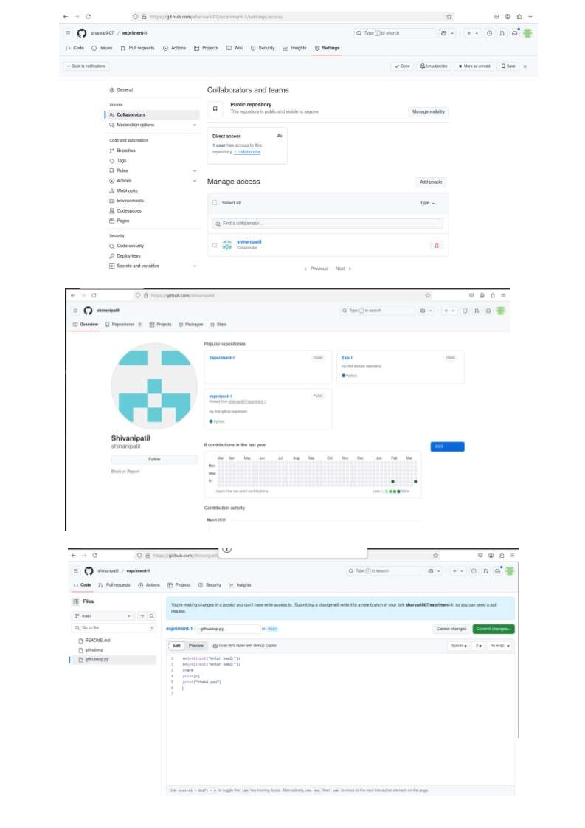 Name: Shruti Santaji shevale

Roll no: 222 Batch:B3

