Experiment No.3

Name= Shruti santaji shevale

Roll No= 222

Batch= B3

GitFlow Workflow

1.Clone Repository

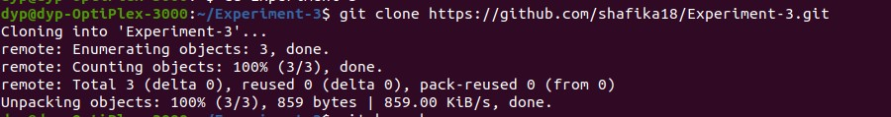

1. git Branch

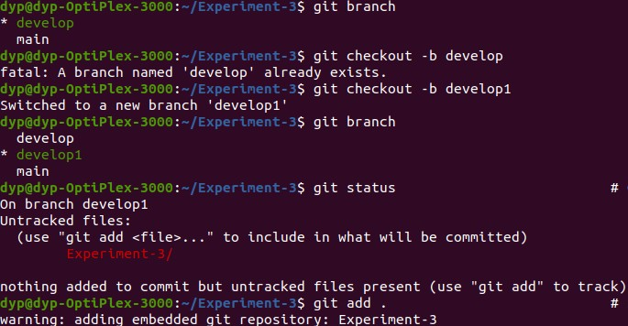

1. Git checkout -b develop
2. git branch

5.create new project and push into github

1. git status
2. git add

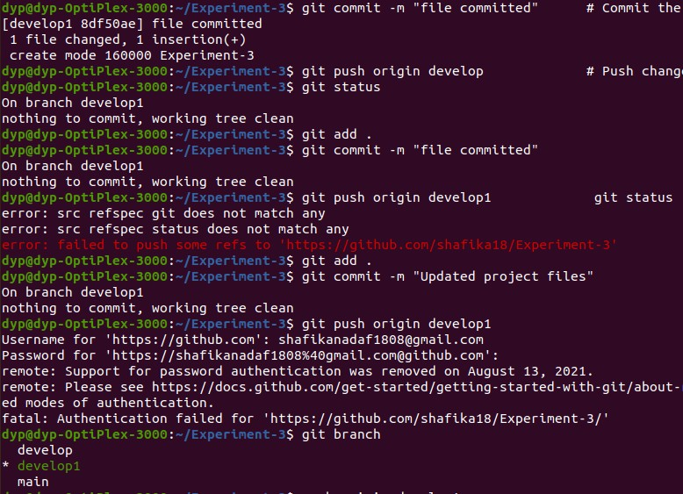

8.git commit -m “file commmited” 9.git push origin develop

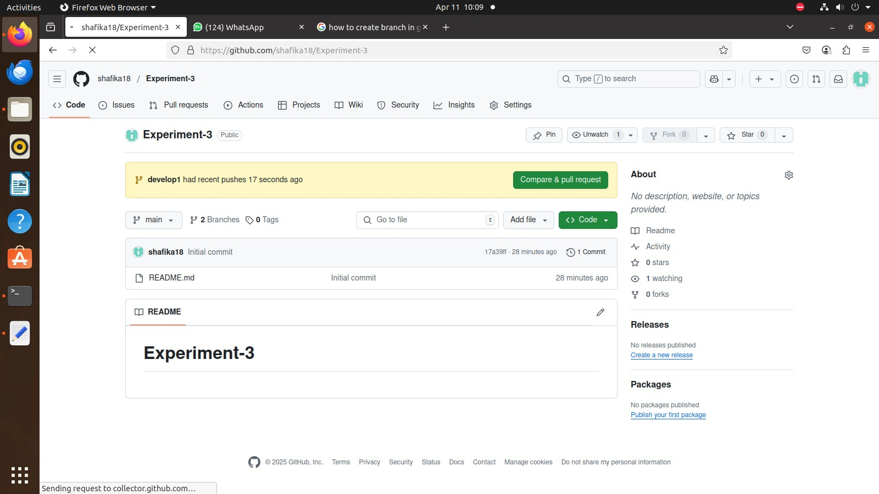

Make changes in project

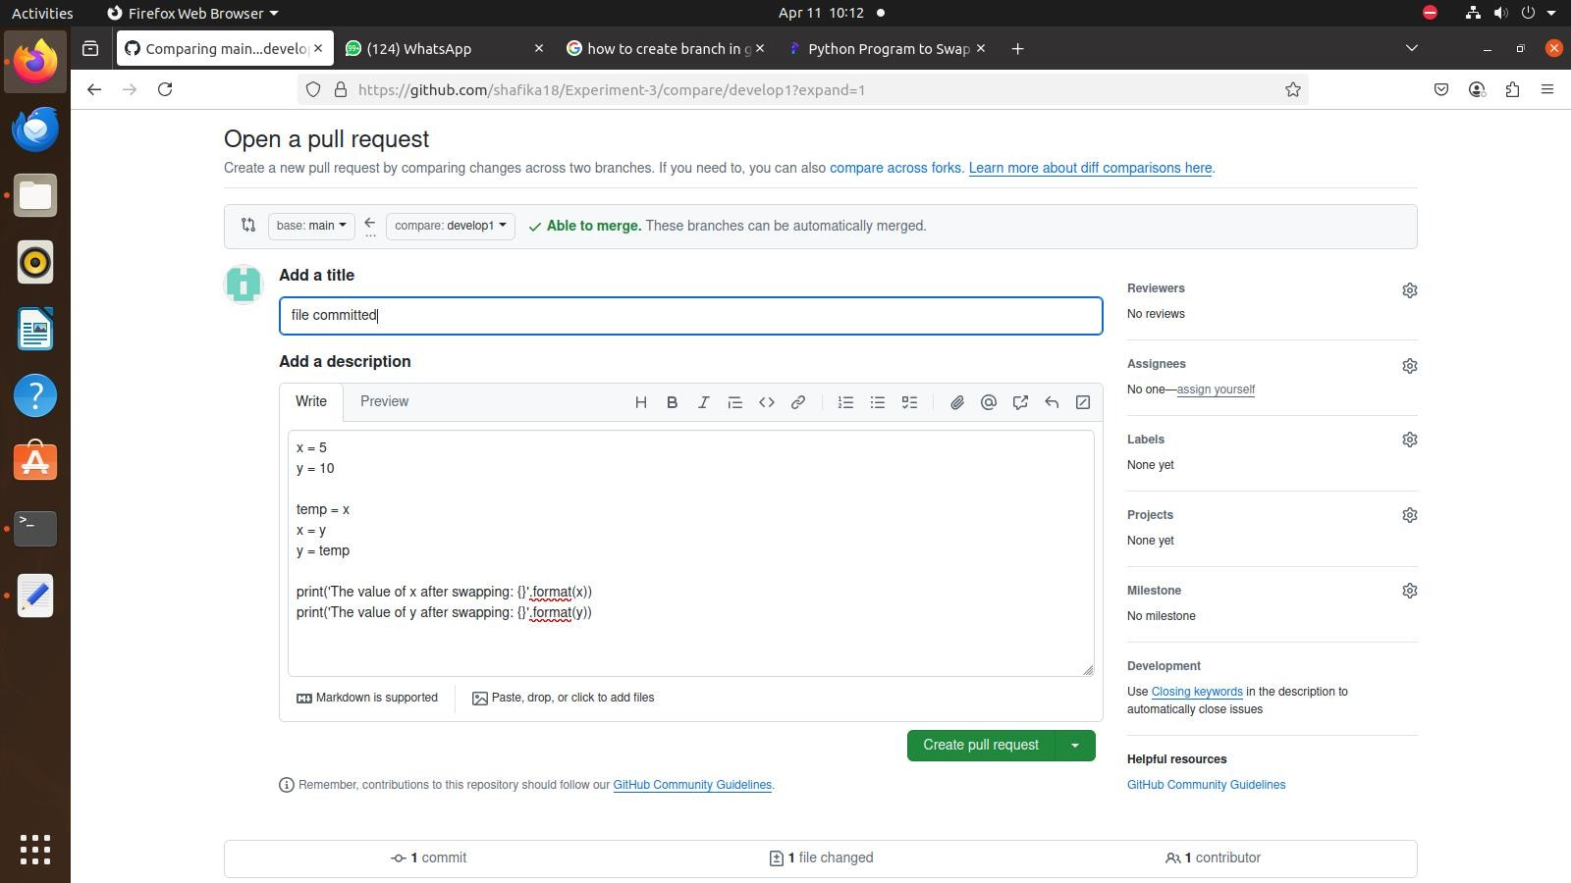

Pull request send to main to develop

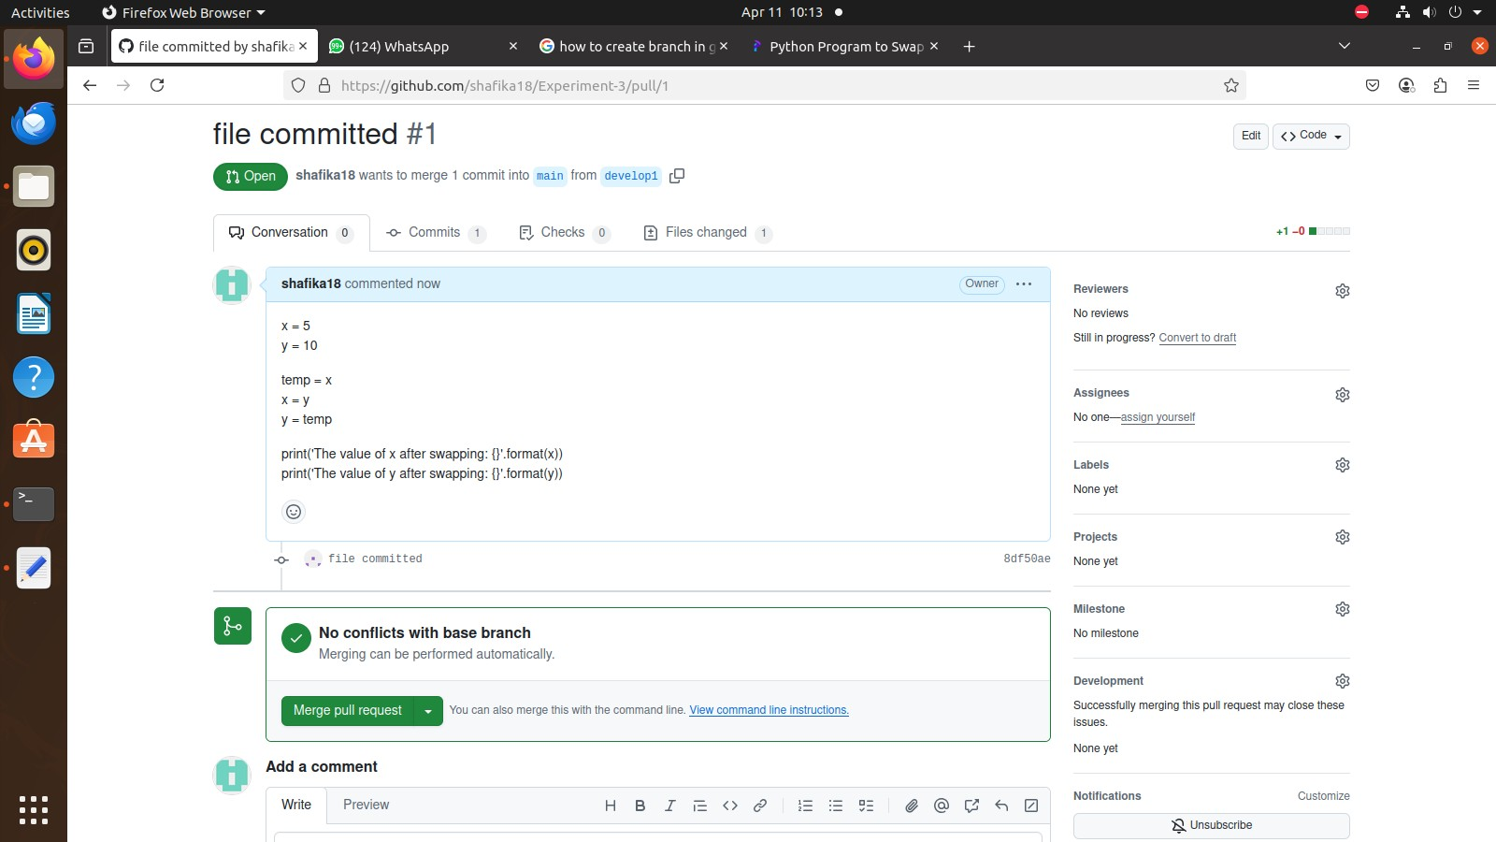

1. git branch checkout -b feature,

Git push origin feature

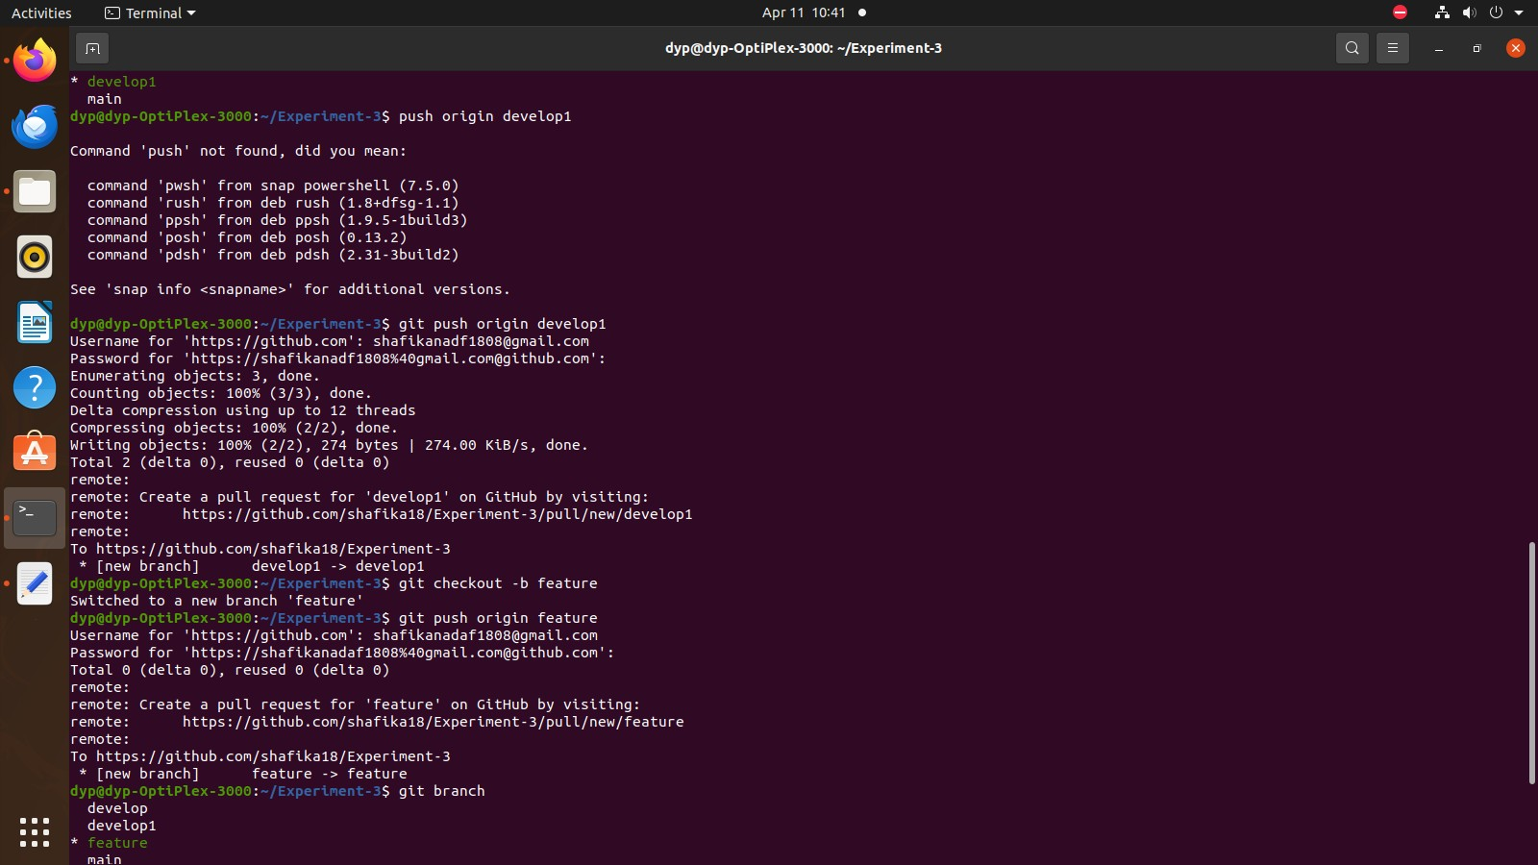

1. search in branch menu

Release v1.0- create new branch

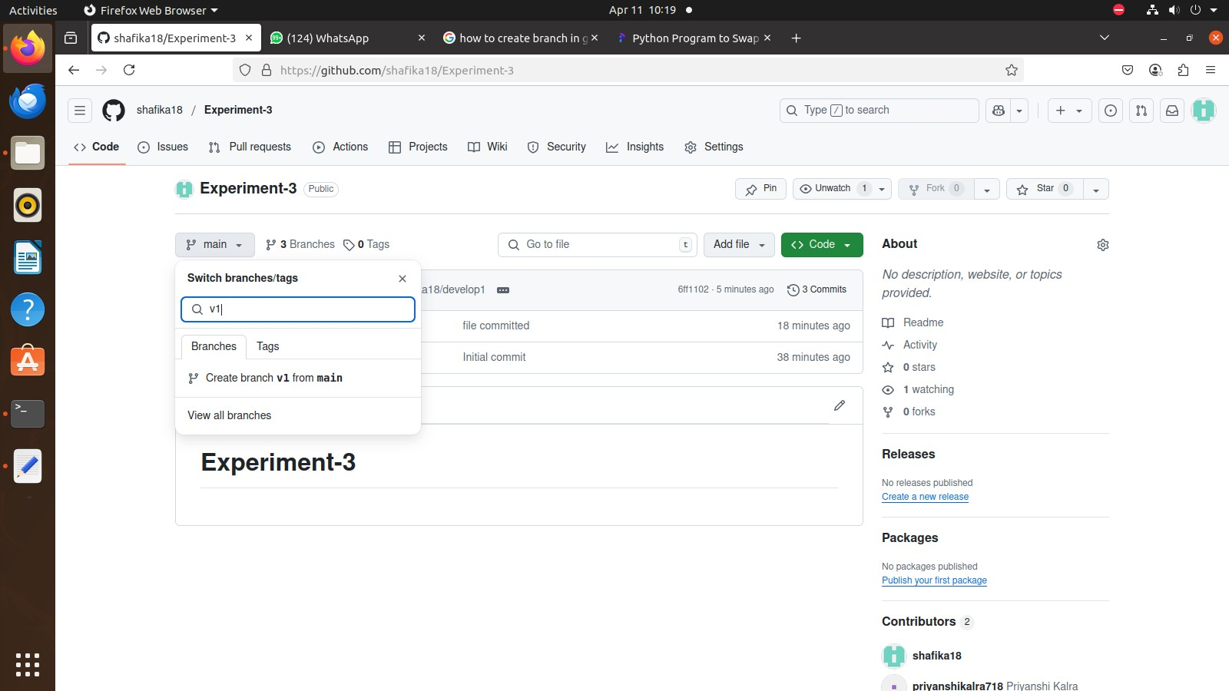

Send pull request feature to release v1.0

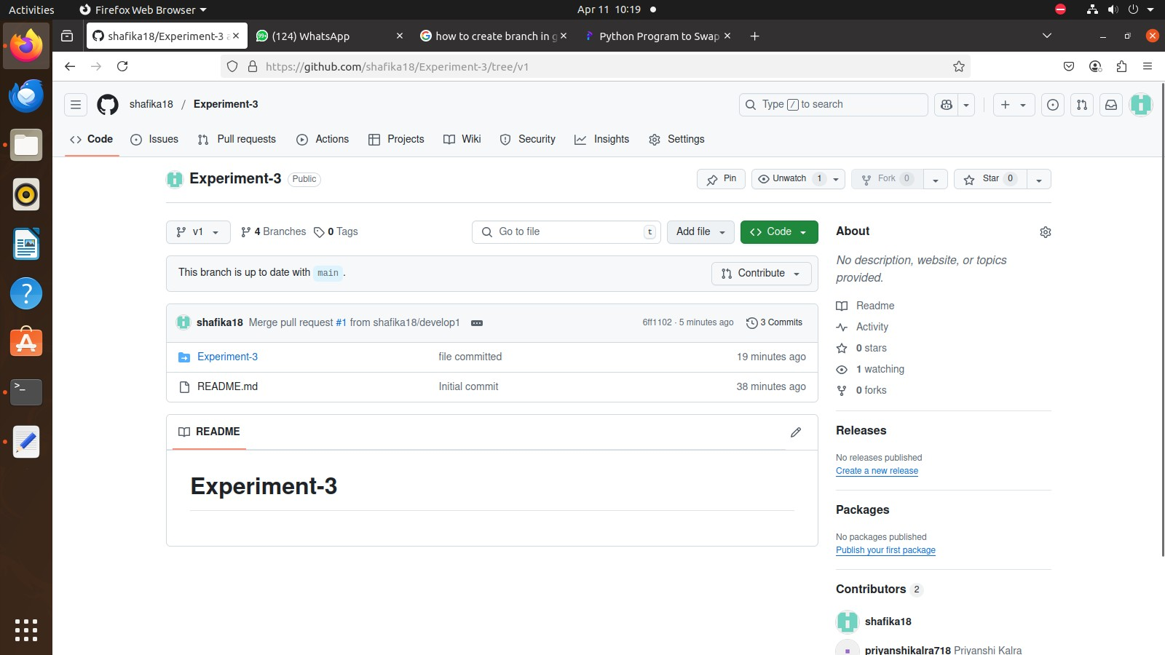

Send pull request main to release v1.0

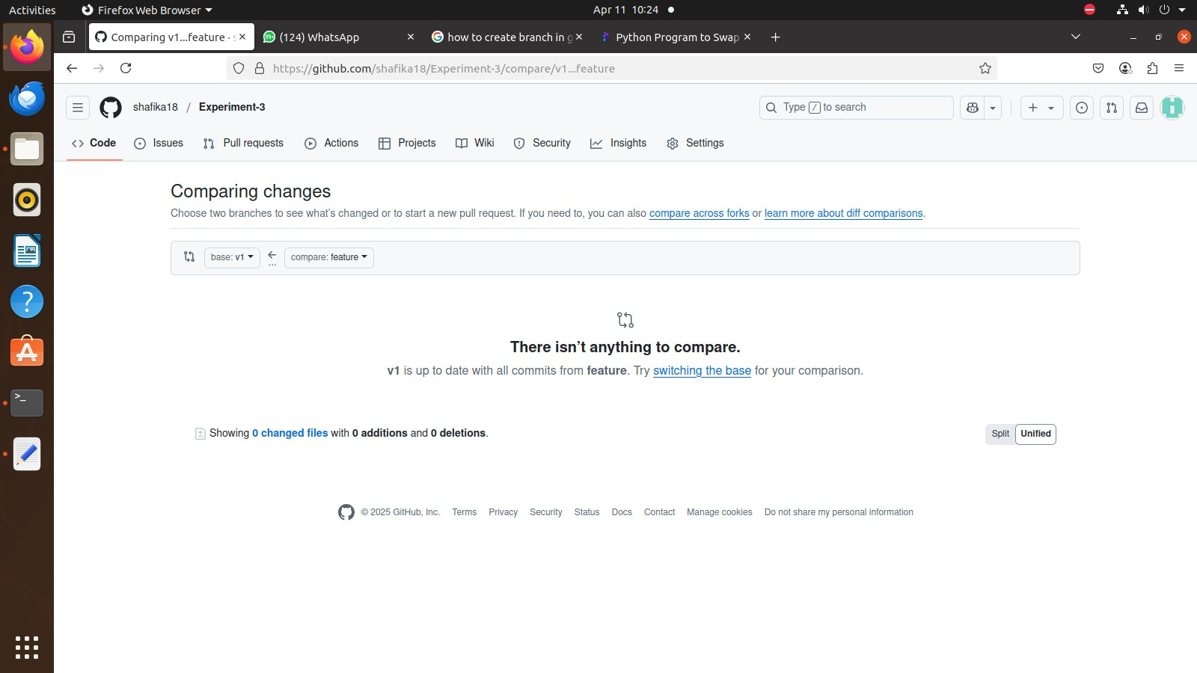

1. git branch
2. git checkout -b hotfix/bug-4
3. git push origin hotfix/bug-4

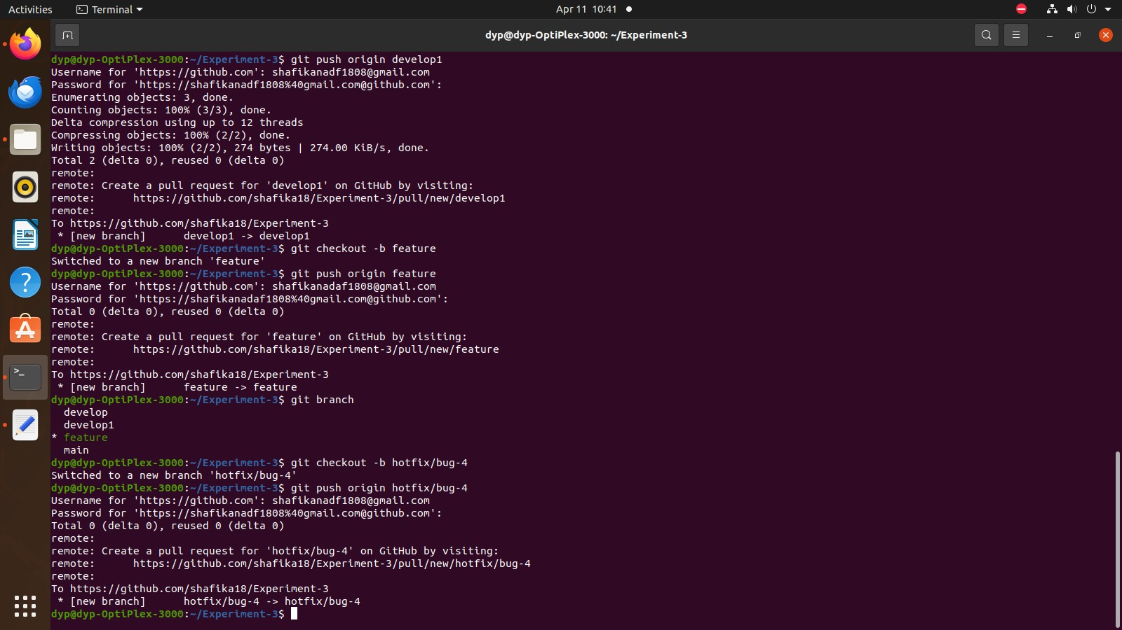

1. git branch

Send pull request main to hotfix/bug-4

Send pull request develop to hotfix/bug-4

Send pull request feature to hotfix/bug-4

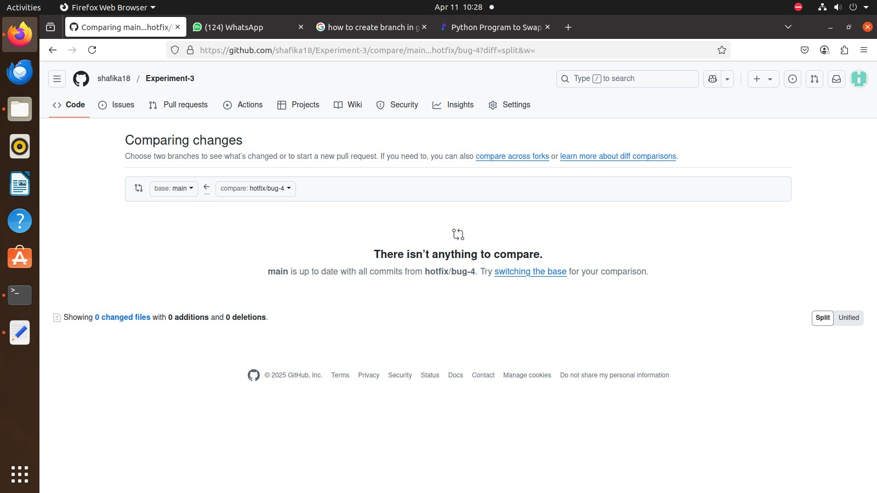

16.choose option right side bottom of github account – create new release

-v1 to main

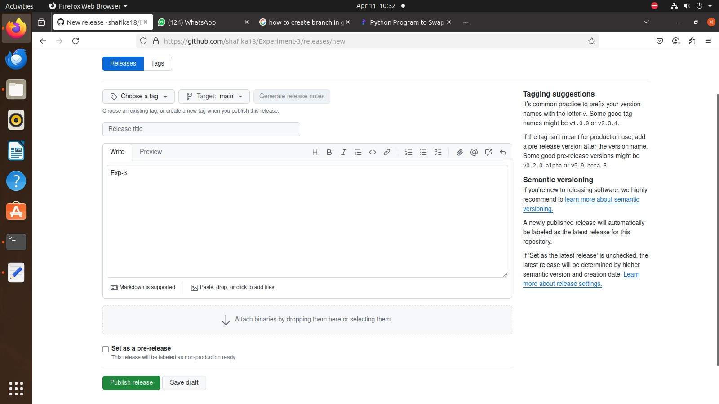

Click publish release

