Warning: Directory already exists.

optrank_l = 1

optrank_h = 1

Warning: Directory already exists.

optrank_l = 1

optrank_h = 1

Warning: Directory already exists.

optrank_l = 1

optrank_h = 1

Warning: Directory already exists.

optrank_l = 1

optrank_h = 1

Warning: Directory already exists.

optrank_l = 1

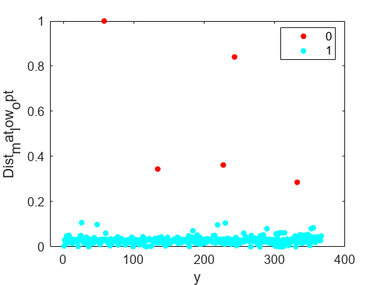

optrank_h = 1

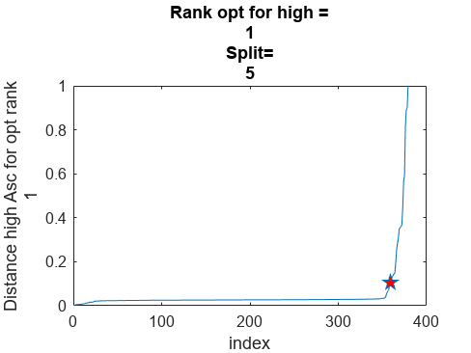

Warning: Directory already exists.

optrank_l = 1

optrank_h = 1

Warning: Directory already exists.

optrank_l = 1

optrank_h = 1

Warning: Directory already exists.

optrank_l = 1

optrank_h = 1

Warning: Directory already exists.

optrank_l = 1

optrank_h = 1

Warning: Directory already exists.

optrank_l = 1

optrank_h = 1

