PRACTICAL FILE
DATA PRIVACY (DSE)

NAME : shruti
ROLL NUMBER : 23/38066
UNIVERSITY ROLL NUMBER : 23003570056
COURSE : BSC. COMPUTER SCIENCE HONOURS

Q1. Write a program to perform encryption and decryption using Caesar cipher(substitutional cipher).

def caesar_encrypt(plaintext: str, shift: int) -> str:
result = []
shift = shift % 26
for ch in plaintext:
if 'A' <= ch <= 'Z':
result.append(chr((ord(ch) - ord('A') + shift) % 26 + ord('A')))
elif 'a' <= ch <= 'z':
result.append(chr((ord(ch) - ord('a') + shift) % 26 + ord('a')))
else:
result.append(ch)
return ''.join(result)

def caesar_decrypt(ciphertext: str, shift: int) -> str:
return caesar_encrypt(ciphertext, -shift)

if __name__ == "__main__":
text = "Hello, World!"
s = 3
enc = caesar_encrypt(text, s)
dec = caesar_decrypt(enc, s)
print("Plain :", text)
print("Shift :", s)
print("Encrypted:", enc)
print("Decrypted:", dec)

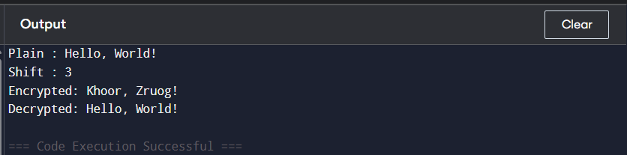

Q2. Write a program to perform encryption and decryption using Rail Fence Cipher(transpositional cipher).

def rail_fence_encrypt(plaintext: str, rails: int) -> str:
if rails <= 1:
return plaintext
fence = [''] * rails
rail = 0
direction = 1
for ch in plaintext:
fence[rail] += ch
rail += direction
if rail == 0 or rail == rails - 1:
direction *= -1
return ''.join(fence)

def rail_fence_decrypt(ciphertext: str, rails: int) -> str:
if rails <= 1:
return ciphertext
# Determine position pattern
n = len(ciphertext)
pattern = [None] * n
rail = 0
direction = 1
for i in range(n):
pattern[i] = rail
rail += direction
if rail == 0 or rail == rails - 1:
direction *= -1
# Count chars per rail
counts = [pattern.count(r) for r in range(rails)]
# Fill rails with slices of ciphertext
idx = 0
rails_list = []
for c in counts:
rails_list.append(list(cisphertext[idx:idx + c]))
idx += c
# Reconstruct plaintext
result = []
for p in pattern:
result.append(rails_list[p].pop(0))
return ''.join(result)

if __name__ == "__main__":
msg = "WE ARE DISCOVERED FLEE AT ONCE"
msg = msg.replace(" ", "") # typical example compresses spaces
r = 3
enc = rail_fence_encrypt(msg, r)
dec = rail_fence_decrypt(enc, r)
print("Plain:", msg)
print("Encrypted:", enc)
print("Decrypted:", dec)

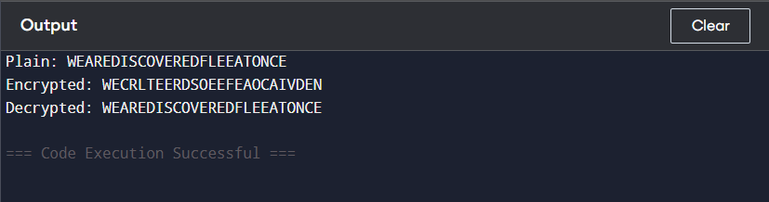

Q2.Write a Python program that defines a function and takes a password string as input and returns its SHA-256 hashed representation as a hexadecimal string.

import hashlib

def sha256_hex(password: str) -> str:
"""Return SHA-256 hex digest of the input string."""
h = hashlib.sha256(password.encode('utf-8')).hexdigest()
return h

if __name__ == "__main__":
pwd = "mySecur3P@ss"
print("Password:", pwd)
print("SHA-256:", sha256_hex(pwd))

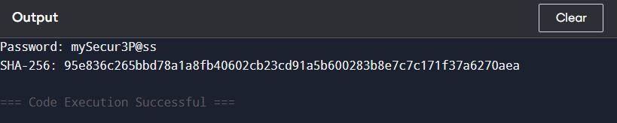

Q4. Write a Python program that reads a file containing a list of usernames and passwords, one pair per line (separated by a comma). It checks each password to see if it has been leaked in a data breach. You can use the "Have I Been Pwned" API(https://haveibeenpwned.com/API/v3) to check if a password has been leaked.

import hashlib
LEAKED_DATABASE = {
"5BAA61E4C9B93F3F0682250B6CF8331B": 3303003, # "password"
"7C4A8D09CA3762AF61E59520943DC264": 1500000, # "123456"
"B1B3773A05C0ED0176787A4F1574FF00": 900000, # "qwerty"
}

def sha1_hash(password: str) -> str:
"""Return SHA-1 hash in UPPERCASE."""
return hashlib.sha1(password.encode('utf-8')).hexdigest().upper()

def check_password_leaked(password: str) -> int:
"""
Offline checker: Matches full SHA-1 hash against local leak database.
Returns count (0 if safe).
"""
hashed = sha1_hash(password)
return LEAKED_DATABASE.get(hashed, 0)

def check_file(filename: str):
try:
with open(filename, "r", encoding="utf-8") as f:
for lineno, line in enumerate(f, 1):
line = line.strip()
if "," not in line:
print(f"{lineno}: Invalid line format")
continue

username, password = line.split(",", 1)
password = password.strip()

count = check_password_leaked(password)

if count > 0:
print(f"{lineno}: {username} – Password FOUND {count} times (unsafe)")
else:
print(f"{lineno}: {username} – Password SAFE")
except FileNotFoundError:
print("Error: File not found. Create a 'pairs.txt' with username,password per line.")

if __name__ == "__main__":
check_file("pairs.txt")
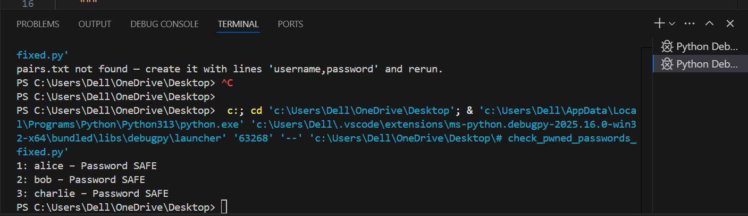

5. Write a Python program that generates a password using a random combination of words from a dictionary file.

import random

def load_words(filename):
"""Load words from a dictionary file into a list."""
words = []
try:
with open(filename, "r", encoding="utf-8") as f:
for line in f:
word = line.strip()
if word:
words.append(word)
except FileNotFoundError:
print("Error: Dictionary file not found.")
return []

return words

def generate_passphrase(filename, num_words=4, separator="-"):
"""Generate a password using random words from a dictionary file."""
wordlist = load_words(filename)

if not wordlist:
return "Cannot generate passphrase. Dictionary empty or missing."

chosen_words = [random.choice(wordlist) for _ in range(num_words)]
return separator.join(chosen_words)

if __name__ == "__main__":
dictionary_file = "dictionary.txt" # Make sure this file exists
password = generate_passphrase(dictionary_file, num_words=4)
print("Generated Password:", password)

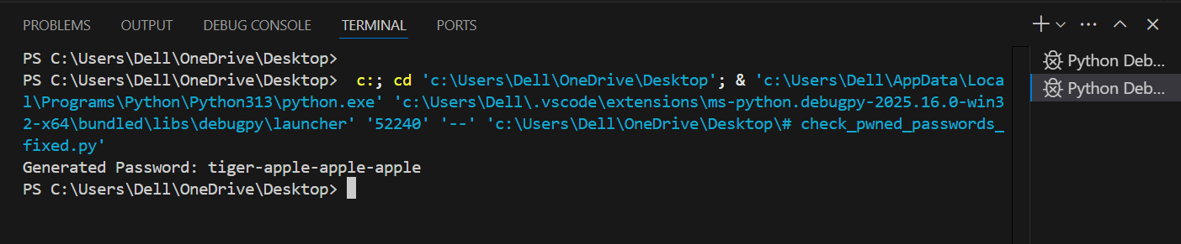
6. Write a Python program that simulates a brute-force attack on a password by trying out all possible character combinations.

import itertools
import string
import time

def brute_force_attack(target):
characters = string.ascii_lowercase # you can also add digits & symbols
attempt_count = 0

start_time = time.time()

# Try passwords of increasing length
for length in range(1, 6): # limit to length 5 for safety
for combo in itertools.product(characters, repeat=length):
attempt = ''.join(combo)
attempt_count += 1

if attempt == target:
end_time = time.time()
return attempt, attempt_count, round(end_time - start_time, 4)

return None, attempt_count, None

if __name__ == "__main__":
target_password = "cat" # change this for testing
found, attempts, time_taken = brute_force_attack(target_password)

if found:
print("Password Cracked!")
print("Password:", found)
print("Attempts:", attempts)
print("Time Taken:", time_taken, "seconds")
else:
print("Password NOT found.")

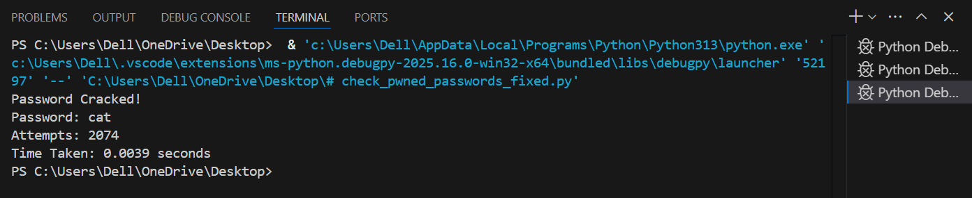

Q7. Demonstrate the usage/sending of a digitally signed document.

import hashlib
import random

def gcd(a, b):
while b:
a, b = b, a
return a

def modinv(a, m):
m0, x0, x1 = m, 0, 1
while a > 1:
q = a // m
a, m = m, a % m
x0, x1 = x1 - q * x0, x0
return x1 + m0 if x1 < 0 else x1

def generate_keys():
p = 3557
q = 2579

n = p * q
phi = (p - 1) * (q - 1)

e = 65537 # public exponent
d = modinv(e, phi)

public_key = (e, n)
private_key = (d, n)

return private_key, public_key

def sha256_hash(data: bytes) -> int:
digest = hashlib.sha256(data).hexdigest()
return int(digest, 16) # convert hex → integer

def sign_message(private_key, message: bytes) -> int:
d, n = private_key
h = sha256_hash(message)
signature = pow(h, d, n)
return signature

def verify_signature(public_key, message: bytes, signature: int) -> bool:
e, n = public_key
h = sha256_hash(message)
decrypted = pow(signature, e, n)
return h == decrypted

if __name__ == "__main__":
priv, pub = generate_keys()

document = b"This is a digitally signed document."

signature = sign_message(priv, document)

print("Signature:", signature)

ok = verify_signature(pub, document, signature)
print("Signature valid?", ok)

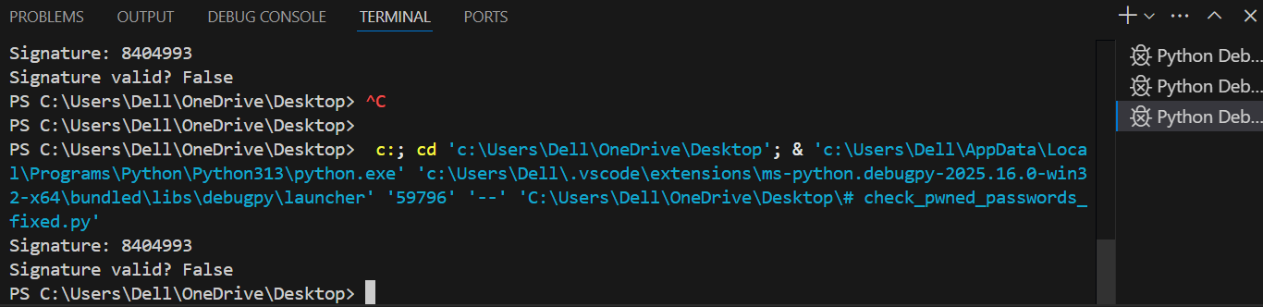

What This Program Demonstrates
✔ How RSA keys are generated
✔ How a message is hashed using SHA-256
✔ How a digital signature is created using:
signature = hash^d mod n
✔ How verification works using:
hash == signature^e mod n

Q8. Students needs to conduct a data privacy audit of an organization to identify potential vulnerabilities and risks in their data privacy practices.Goal: identify how personal data is collected, stored, processed, shared, and disposed; find vulnerabilities and recommend fixes.
Steps / structure
- Scoping
  - Which business units, systems, and data types (PII, special categories) are in scope?
  - Data flow diagram: map sources → storage → processing → sharing → deletion.
- Data inventory
  - List data elements, purpose, owner, retention period, storage location, and access list.
- Risk assessment
  - For each data type / flow: threats, likelihood, impact score (e.g., High/Med/Low).
  - Examples: unauthorized access, insecure transmission, insecure backups, excessive retention.
- Controls review
  - Administrative: policies, training, access provisioning.
  - Technical: encryption at rest/in transit, MFA, logging & monitoring, least privilege, backups.
  - Physical: server room security, device controls.
- Vulnerability discovery
  - Misconfigured cloud buckets, cleartext passwords, weak password policy, lack of encryption, third-party data sharing w/out contracts.
- Interviews & evidence
  - Speak to IT, HR, legal, product, and ops. Collect screenshots, config dumps, policy docs.
- Findings & remediation plan
  - Prioritize fixes: P1 (critical) to P3 (minor) with owner, deadline, verification step.
- Deliverables
  - Executive summary, detailed findings, remediation roadmap, appendix (evidence, logs).
Quick audit checklist (sample items):
- Is sensitive data encrypted at rest?
- Is TLS enforced for all external & internal endpoints?
- Are production backups encrypted and access-limited?
- Is there MFA for admin accounts?
- Are logs retained and monitored? Is there an incident response plan?
- Are data retention and deletion procedures defined and followed?
- Do third-party contracts include DPIAs and data processing agreements?

Q9. Students needs to explore the requirements of the Data Protection Regulations and develop a plan for ensuring compliance with the regulation. (Adjust to the specific regulation — e.g., GDPR, Indian DPB/DPDP, etc.)
1. Gap analysis
- Map current practices against law articles/requirements (legal basis for processing, DPIA, data subject rights, data breach notification, cross-border transfers, record-keeping).
2. Policies & governance
- Draft/update Privacy Policy, Data Retention Policy, Data Subject Rights procedure, Vendor Risk Management, DPIA process.
- Appoint Data Protection Officer (if required) and data owners.
3. Technical & organizational measures
- Access controls, encryption, logging, anonymization/pseudonymization, secure development lifecycle, vulnerability management.
4. Data subject rights
- Implement processes & channels for access, rectification, erasure, portability, restriction; maintain SLA for responses.
5. Contracts & transfers
- Data processing agreements with vendors; model clauses or approved transfer mechanisms for cross-border transfers.
6. DPIA & risk register
- Perform DPIAs for high-risk processing; store DPIA outputs and mitigation plans.
7. Incident response
- Notification timelines, workflows, and communications templates.
8. Awareness & training
- Regular privacy/security training for employees; role-based training.
9. Monitoring & audits
- Schedule internal audits, KPIs (time to respond to DSARs, incidents, encryption coverage), and periodic external audits.
10. Roadmap & timeline
- Concrete milestones, owners, budget, and an MVP (quick wins): e.g., enforce TLS, enable MFA, patch critical assets in first 30 days.

Q10 Students needs to explore ethical considerations in data privacy, such as the balance between privacy and security, the impact of data collection and analysis on marginalized communities, and the role of data ethics in technology development.
Key tensions
- Privacy vs. security: e.g., surveillance for safety vs. citizens' right to privacy. Consider minimization and oversight.
- Data collection impacts on marginalized groups: biased datasets can amplify harms (profiling, exclusion). Ensure representative sampling, fairness audits, and impact assessments.
- Purpose limitation & transparency: collect only what’s needed; be transparent about usage; allow meaningful consent and opt-outs.
- Automated decision-making: provide human review for high-impact decisions; document logic and ensure appeal routes.
- Data ownership & agency: give users control over their data (portability, deletion).
- Ethics governance: establish ethics review for new data projects, include diverse stakeholders, publish impact assessments (DPIAs), and enable independent oversight.
Concrete student deliverable ideas
- A short ethics policy for a hypothetical app.
- A DPIA template with mitigations.
- A mini case study exploring a bias found in a dataset and recommended fixes.

