RESTful CRUD Web Services Assignment

1] **Creating a new student**

* Need to provide the GradeBookID and Student Name, select the radio button for CREATE and click on SUBMIT.

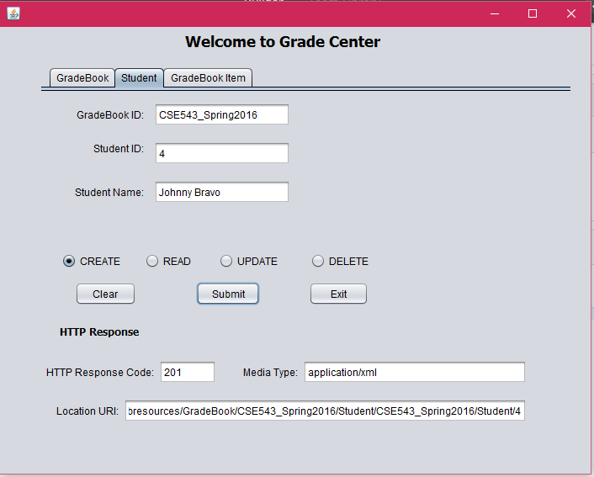

2] **Reading a student**

* Need to provide the GradeBookID and StudentID

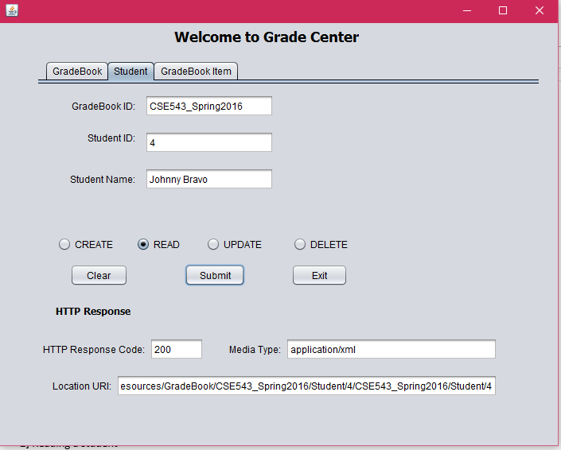

3] **Updating a student**

* You can first read a student’s data by specifying the GradeBookID and StudentID and then edit any information and update it.

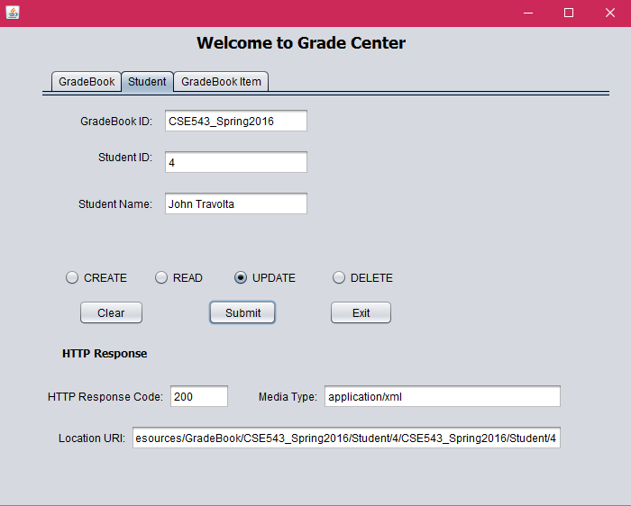

4] **Deleting a student**

* Need to provide the GradeBookID and StudentID

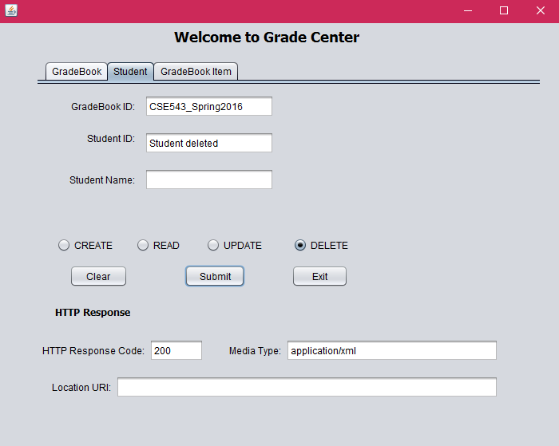

**5] Creating a new GradeBookItem**

* Need to provide the GradeBookID and StudentID and all fields needed for GradeBookItem, except the id.

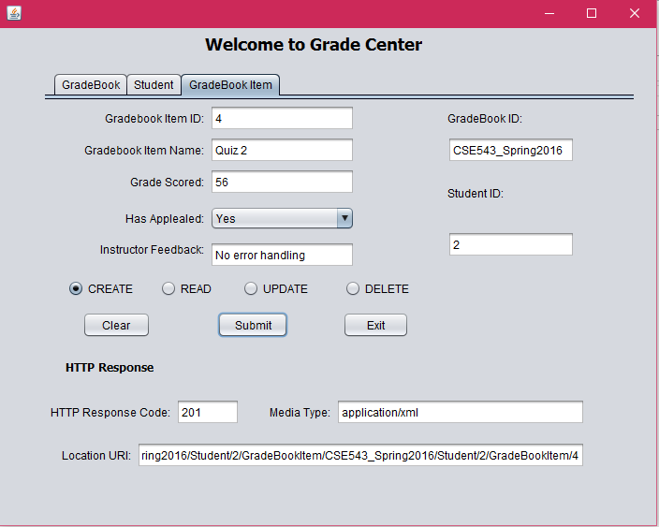

6] **Reading a GradeBookItem**

* Need to provide the GradeBookID, StudentID and GradeBookItemID.

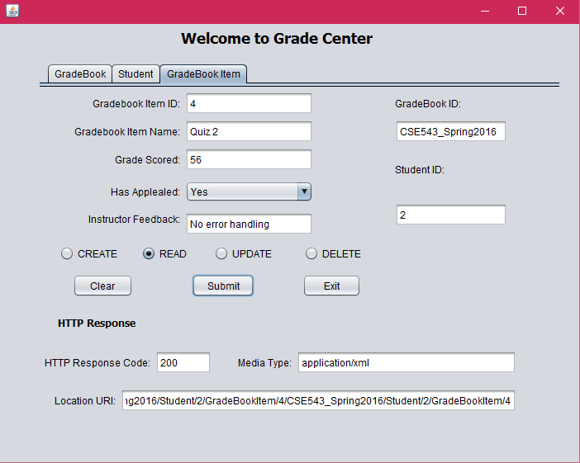

7] **Updating a GradeBookItem**

* You may first read a particular GradeBookItem, and the edit any of the fields, except the ID and update.

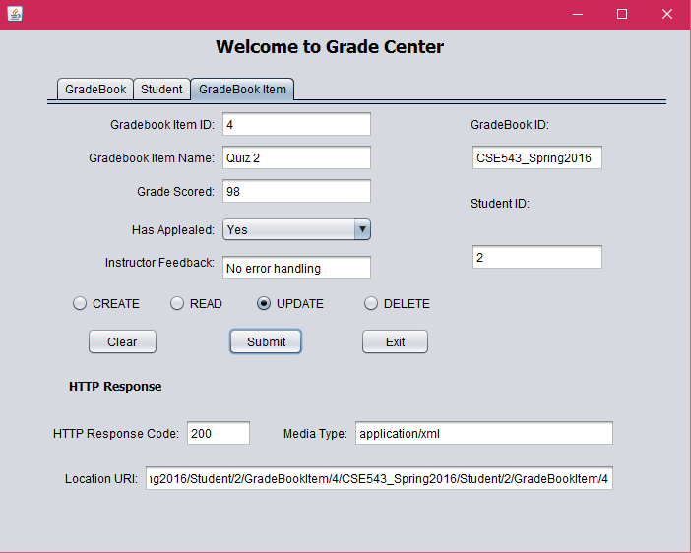

8] **Deleting a GradeBookItem**

* Need to provide the GradeBookID, StudentID and GradeBookItemID.

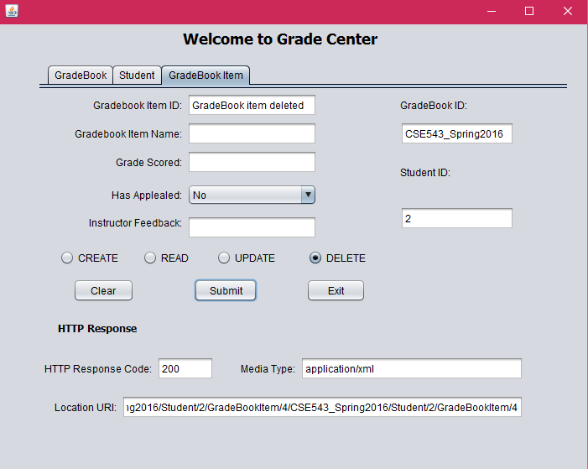

**9] Creating a new GradeBook**

* Simply need to specify the GradeBookID

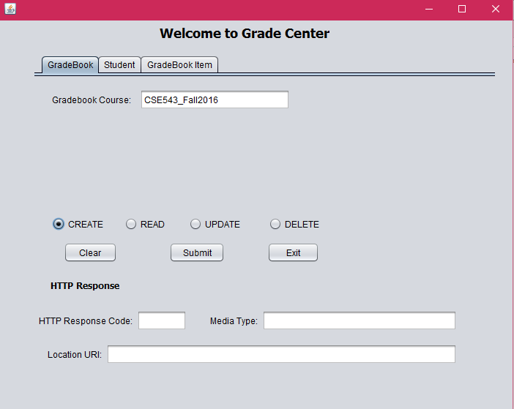

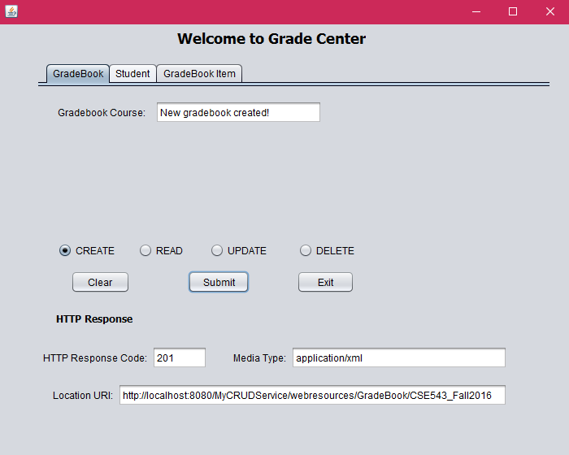

**10] Deleting a GradeBook**

* Simply need to specify the GradeBookID

**ERROR CONDITIONS**

* Most of the error conditions such as returning a NOT_FOUND if we try to update a student that does not exist, or delete a GradeBookItem that does not exist.
* In case we do try to update the ID of a student or GradeBookItem to a value of an existing student or GradeBookItem, then we might encounter a CONFLICT.