Shruti Srivastava

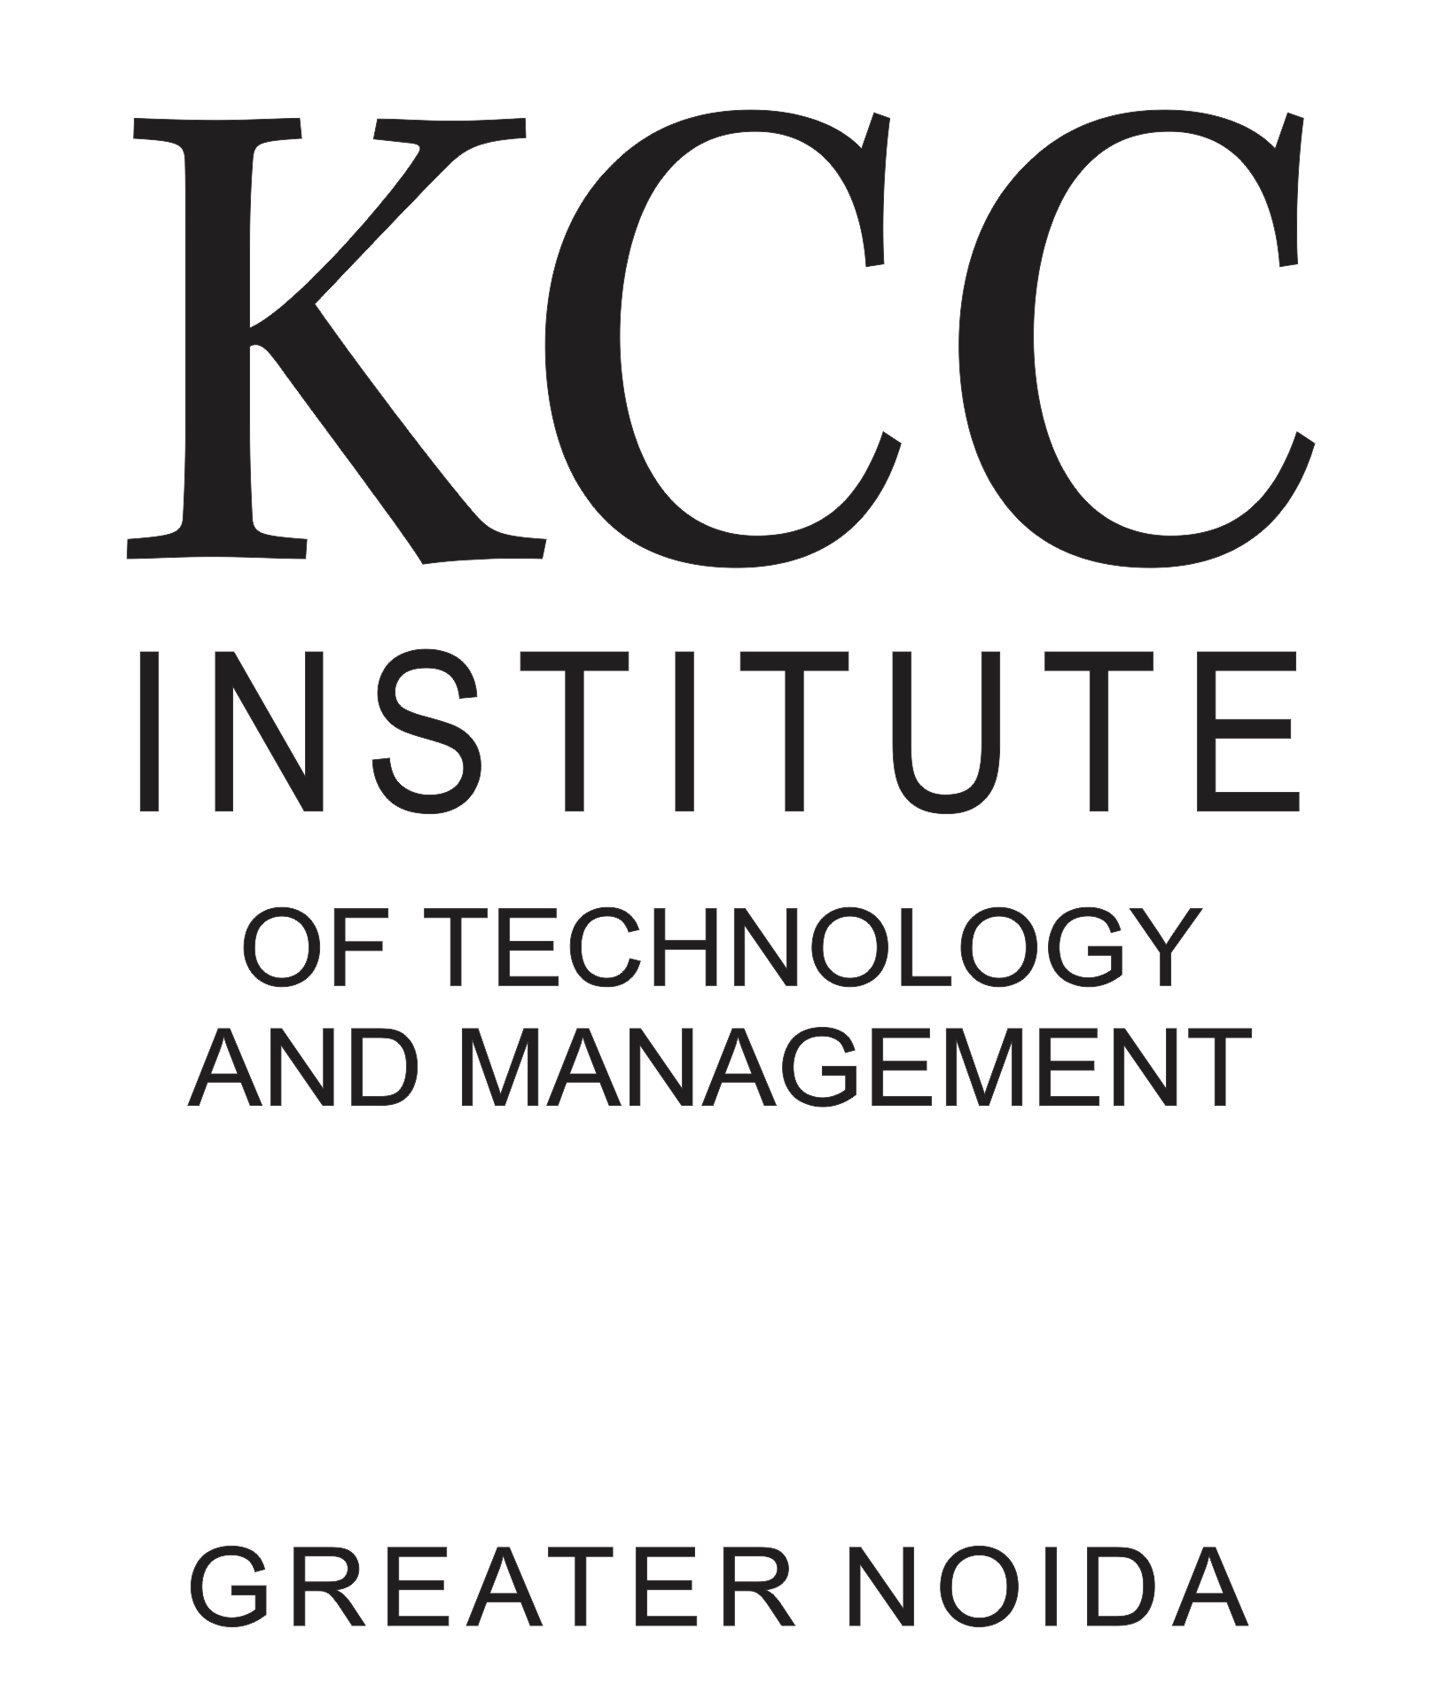

B.Tech, CSE (Final Year)

Contact No: +91-7428875314

Email: [shrutis263btechcse2023@kccitm.edu.in](mailto:shrutis263btechcse2023@kccitm.edu.in)

# EDUCATION

|  |  |  |  |
| --- | --- | --- | --- |
| 2023 | B.Tech (Pursuing) | KCC ITM Greater Noida (AKTU) | 7.88/10 |
| 2019 | Twelfth | St.Mary’s School, Delhi (CBSE) | 61.00 % |
| 2017 | Tenth | St.Mary’s School, Delhi (CBSE) | 7.4/10 |

**INTERNSHIPS**

**Software Developer Intern** | Feb’22 - Aug’22 | Diginique TechLabs | Greater Noida

* Got trained in C++, Data Structures and Algorithms, and Full Stack Development.
* Currently working on two projects: Chat App and Paytm like Wallet.

# PROJECTS

**Music Player App** | Mar’22 - May’22 | KCC ITM Gr.Noida

* + Worked on this group project and developed the online as well offline music player app with download feature.
  + Programming languages/frameworks used for frontend– HTML, CSS.

**Portfolio Website** | Jan’22 - Mar’ 22 | GitHub (Live) | Self

* A full stack website which has my professional information and achievements.
* It’s been developed using Node.js, and JavaScript.

**Face Detection App |** Apr’20 - Jun’20 | KCC ITM Gr. Noida

* Used to mark the attendance of students by recognizing their face.
* Programming languages/frameworks used – HTML, CSS, Python.

**SKILLS**

**Computer Languages**: **Proficient:** Java, HTML, CSS **Intermediate:** C, Python, C++, MySQL **Basic:**

Node.js, JavaScript

**Languages Known:** English (Proficient) and Hindi (Proficient) .

**Certifications:** Java by Coding Ninjas, Soft Skills by NPTEL (IITs), Developing Soft Skills by NPTEL(IITs), Internet of Things by NPTEL (IITs), Ethical Hacking by Ignite Technology

# ACHIEVEMENTS / EXTRACURRICULARS

* 3 star coder in problem solving on HackerRank.
* **4 star coder** in Java on HackerRank.
* Problem solving on leetcode.
* 2 star coder in Python on HackerRank.
* Member, Drama Society of the institute.