The Joy of Reading - Encourage a love for reading and literacy in young minds.

“If you want your children to be intelligent, read them fairy tales. If you want them to be more intelligent, read them more fairy tales.” — Albert Einstein

The habit of reading not only develops the mind but makes you more creative. Reading makes you enlightened, knowledgeable, and sustainable providing a whole new and transformational experience.
The advancement in technology has helped readers to access books digitally and instantly. You may have seen many people traveling, utilizing the hours to read so that their journey can be covered easily.
Reading not only helps in the development of mental health but it ensures the complete personality development of the reader.
Benefits of Reading:
Our childhood shapes our future, and the way we are trained and disciplined we maintain that consistency forever. So, children at a young age must be encouraged to read, play, and learn new skills so that they find the process of learning interesting.
The following are the major benefits of reading :
- Develops IQ
- Enlightened with knowledge
- Improve your analytical skills
- Increase focus and concentration
- Vocabulary expansion
- Better writing skills
- Ensure complete personality development
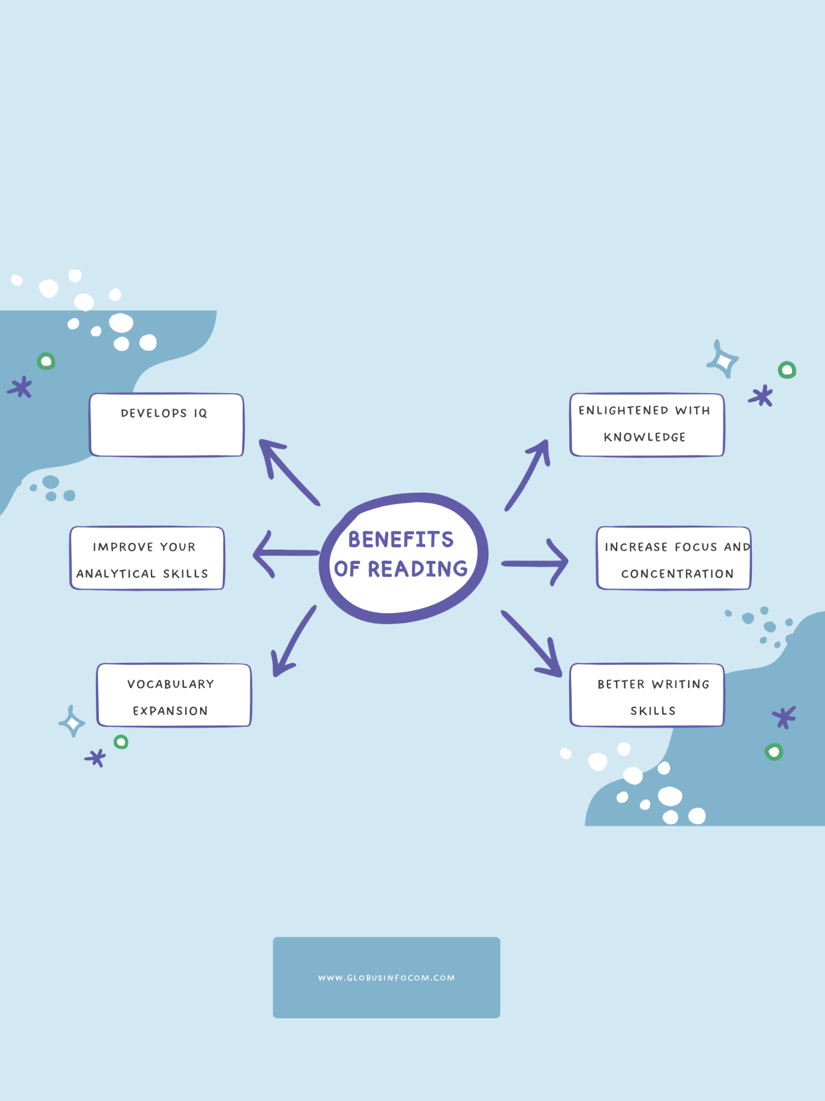

How to develop the habit of reading in children?
The habit of developing reading is not that easy! but interesting stories may attract learners to read. Today many new inventions have been embraced within the classrooms that have attracted some young sparkle in the class to learn with interest. Similarly, parents at home can also try some of the intellectually driven methods to make their children develop an interest in reading.
The concept of play and learn can be effectively taken into consideration when making them read something interesting. 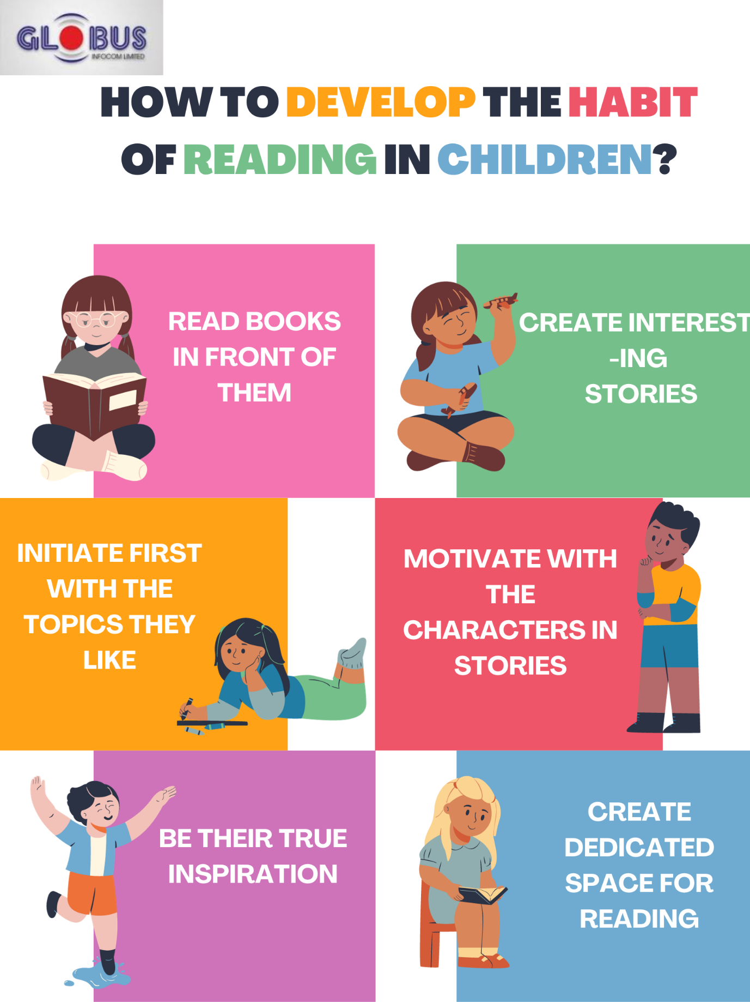

- Read books in front of them
- Create interesting stories
- Initiate first with topics they like
- Motivate with characters in stories
- Be their true inspiration
- Create a dedicated space for reading.

Some of the important quotes from famous authors:

- Today a reader, tomorrow a leader." – Margaret Fuller
- "Reading should not be presented to children as a chore, a duty. It should be offered as a gift." – Kate DiCamillo
- "If you don’t like to read, you haven’t found the right book." – J.K. Rowling
- Some books leave us free, and some books make us free." – Ralph Waldo Emerson
- "A book is a gift you can open again and again." – Garrison Kellor
- "A book, too, can be a star, a living fire to lighten the darkness, leading out into the expanding universe." – Madeleine L'Engle

