**DBMS MINI PROJECT SYNOPSIS**

**PARTNER:**- Simran Kucheria (111803126)

**Problem Statement**

Library Management System

**Introduction**

This is a basic Library Management System using python and SQL, It can be used in schools/colleges

to monitor the day to day requirements of the library.

**Functional Requirements of the system**

The system will have 2 modes depending on who is using it(Staff/Students)

Staff

1)Register-Books, Students, Authors, Genres, Personal info

2)View-Students(All, Department wise), Personal info of students

3)Delete-Students, Books, Authors

4)Update/Modify-Books(Restocking, changing info), Authors, Students

5)Manage fines, enquiries and comments

Student

1)Display- books(Genre wise, author wise), authors, borrowed books, fines

2)Issue/Return/Report lost books

3)Search for books using genre, author, title

4)Add enquiries/Comments

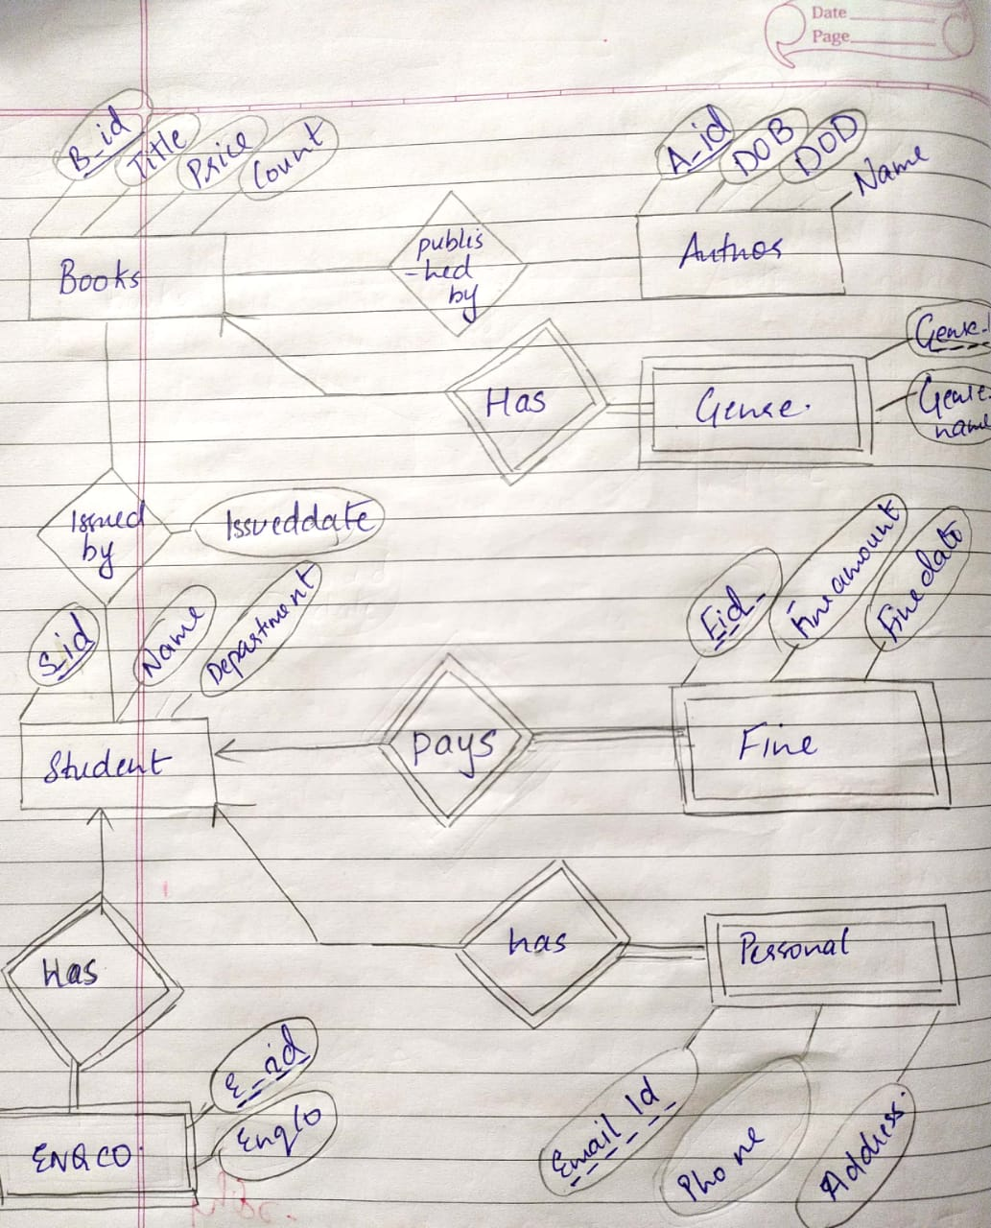

**ER Diagram**

**Relational Schemas**

STUDENT

|  |  |  |
| --- | --- | --- |
| S_ID | Name | Department |

AUTHOR

|  |  |  |  |
| --- | --- | --- | --- |
| A_ID | DOB | DOD | Name |

BOOKS

|  |  |  |  |  |
| --- | --- | --- | --- | --- |
| B_ID | Title | Price | Count | A_ID (f.k) |

PINFO

|  |  |  |  |
| --- | --- | --- | --- |
| S_ID (f.k) | City | Phone | Email |

ISSUED

|  |  |  |
| --- | --- | --- |
| B_ID (f.k) | S_ID (f.k) | Issueddate |

GENRE

|  |  |  |
| --- | --- | --- |
| G_ID | B_ID (f.k) | Genrename |

FINE

|  |  |  |  |
| --- | --- | --- | --- |
| F_ID | S_ID (f.k) | Fineamount | Finedate |

ENQCO

|  |  |  |
| --- | --- | --- |
| E_ID | S_ID (f.k) | Enqco |