DELHI URBAN HEAT INTELLIGENCE

A GIS and Remote Sensing Based Analysis of Urban Heat Patterns in Delhi

PROJECT REPORT

Submitted by: Shruti Verma

Department: Computer Science & Engineerimg

Institution: Sister Nivedita University

Academic Year: 2026–2027

ACKNOWLEDGEMENT

I would like to express my sincere gratitude to my teachers and my institution, Sister Nivedita University, for providing me with the opportunity to complete this project titled "Delhi Urban Heat Intelligence: A GIS and Remote Sensing Based Analysis of Urban Heat Patterns in Delhi."

I am thankful for the guidance, support and encouragement received throughout this project.

ABSTRACT

This project focuses on analysing urban heat patterns in Delhi using Geographic Information Systems (GIS) and Remote Sensing techniques.

The study uses satellite-based datasets, including NDVI (Normalized Difference Vegetation Index), UHI (Urban Heat Island) and LST (Land Surface Temperature), to understand the relationship between vegetation, urban development and surface temperature.

QGIS is used for raster analysis, visualization and statistical calculations. The findings help identify areas experiencing higher surface temperatures and understand the importance of vegetation in reducing urban heat.

Keywords: GIS, Remote Sensing, NDVI, Urban Heat Island, LST, QGIS, Delhi.

TABLE OF CONTENTS

1. Introduction
2. Objectives of the Study
3. Study Area – Delhi
4. Data Collection and Sources
5. Methodology
6. Software and Tools Used
7. NDVI Analysis
8. Urban Heat Island (UHI) Analysis
9. Land Surface Temperature (LST) Analysis
10. Statistical Analysis
11. Results and Discussion
12. Conclusion
13. References

1. INTRODUCTION

Urban Heat Island (UHI) is a phenomenon in which urban areas experience higher temperatures than surrounding areas. Rapid urbanization, buildings, roads and reduced vegetation contribute to this effect.

This project focuses on analysing urban heat patterns in Delhi using GIS and Remote Sensing techniques. QGIS software is used to study NDVI, Urban Heat Island and Land Surface Temperature (LST).

The study helps understand the relationship between vegetation, urban development and temperature distribution in Delhi.

2. OBJECTIVES OF THE STUDY

The main objectives of this project are:

1. To analyse vegetation distribution in Delhi using NDVI.
2. To study urban heat patterns using UHI data.
3. To analyse Land Surface Temperature (LST).
4. To understand the relationship between vegetation and temperature.
5. To use QGIS for mapping and spatial analysis.

3. STUDY AREA

The study area selected for this project is Delhi, India.

Delhi is a highly urbanized region with residential areas, commercial centres, roads, industries and green spaces. Due to rapid urbanization, the region experiences variations in surface temperature and vegetation cover.

The study focuses on understanding these spatial variations using satellite imagery and QGIS.

4. DATA SOURCES AND SOFTWARE USED

The project uses Landsat 8 Collection 2 Level-2 satellite imagery for analysing environmental conditions in Delhi.

The following software and tools were used:
1. Google Earth Engine: For satellite image processing and generating NDVI, LST and UHI maps.
2. QGIS 3.44: For raster visualization, statistical analysis and map preparation.
3. Microsoft Word: For preparing the project report.

The study uses three main parameters:
- NDVI – Normalized Difference Vegetation Index.
- LST – Land Surface Temperature.
- UHI – Urban Heat Island.
The satellite data was processed for the period April to June 2023.

5. METHODOLOGY

The project was carried out using satellite data and GIS techniques.

1. Data Collection: Landsat 8 Collection 2 Level-2 satellite imagery was selected for Delhi for the period April to June 2023.
2. Image Processing: Google Earth Engine was used to filter and process the satellite imagery.
3. NDVI Analysis: NDVI was calculated to study the distribution of vegetation across Delhi.
4. LST Analysis: The Land Surface Temperature layer was processed to examine surface temperature patterns.
5. UHI Analysis: The UHI layer was prepared to visualize variations in urban surface heat.
6. Map Preparation: The resulting maps were exported and displayed in QGIS 3.44 for visualization and preparation of the final maps.

6. RESULTS AND ANALYSIS

Three thematic maps were generated using Google Earth Engine and QGIS:

1.NDVI Map – Shows vegetation distribution across Delhi.
2. LST Map – Shows spatial variations in land surface temperature.
3. UHI Map – Shows the spatial pattern of urban heat.

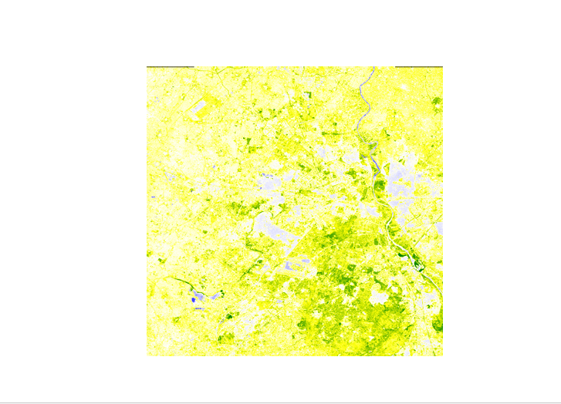
figure 1: NDVI Map of Delhi

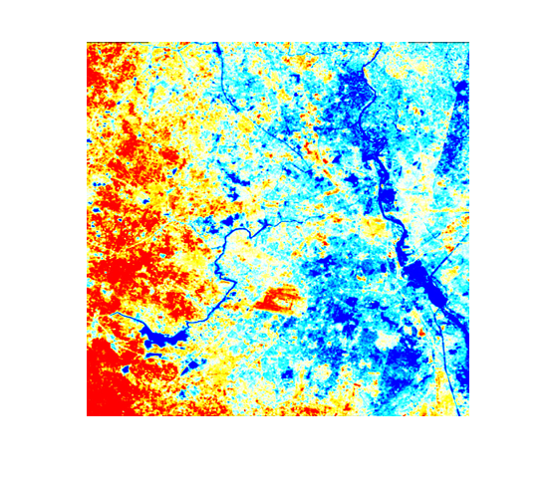
Figure 2: Land Surface Temperature(LST) Map of Delhi

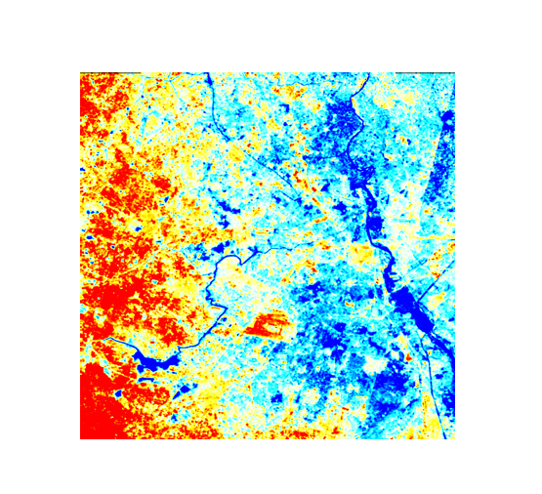
Figure 3: Urban Heat Island(UHI) Map of Delhi

The maps provide a visual understanding of vegetation and urban heat patterns. Quantitative interpretation requires calibrated raster values.

7. CONCLUSION

This project demonstrates the use of GIS and Remote Sensing for studying urban heat patterns in Delhi. NDVI, LST and UHI maps were generated using Google Earth Engine and QGIS.

The project highlights the importance of vegetation monitoring and geospatial technology in urban environmental planning.

8. REFERENCES

1. USGS – Landsat 8 Satellite Data.
2. Google Earth Engine Documentation.
3. QGIS Official Documentation.
4. NASA Earth Observatory – Urban Heat Island Information.

