**Voting Methods**

*Shruti Vangari, Merin Jose, Kashyap Uppuluri  
Department of Computer Science, University of Akron*[*sv47@zips.uakron.edu*](mailto:sv47@zips.uakron.edu)*,* [*mj65@zips.uakron.edu*](mailto:mj65@zips.uakron.edu)*,* [*ku10@zips.uakron.edu*](mailto:ku10@zips.uakron.edu)

**Abstract**

*This paper gives a new insight into the process of voting. Voting on a large scale during elections is always computed amongst two individuals. But, on a smaller scale such as sporting teams, government electoral systems and academic institutions, preference based voting is performed. To implement the same, various methods were proposed to declare the winner. Adapted from a paper at The Stanford Encyclopedia of Philosophy, we have implemented two outstanding proposed methods in Java. The two methods – Borda Count and Condorcet Winner Methods were implemented using a GUI interface. We have tabulated the preferences after the vote has been cast by a number of users. Using these tabulated results, we have compared the two methods.*

1. **Introduction**

Every year most citizens cast their vote to Let us consider that there are two prospective candidates contesting in an election. Who would be the winner? If there are more number of candidates, whom should the voters choose? This echoes an 18th-century debate between the two founding fathers of voting theory, Jean-Charles de Borda (1733–1799) and M.J.A.N. de Caritat, Marquis de Condorcet (1743–1794) [1]. It is obvious that statistically the winner would be the one with the majority of the votes amongst two candidates. The table below summarizes the discussion so far:

|  |  |
| --- | --- |
| Name | Number of Votes  Winner |
| Candidate 1 | 1300 |
| Candidate 2 | 1280 |

Figure 1: Calculating the winner amongst two candidates

Let’s now take the case where there are three prospective candidates. How would you conduct the election? Whom would it be between? Would you take all the possibilities? For these candidates, if you consider the majority concept, the computations would increase. The method stated above is tedious as the number of candidates increase. Hence our objective is to analyze different voting methods and implement the strategy used in two of the voting methods.

Although many interesting issues arise when a voters are asked to make a decision, such as variations in preferences or the innumerable preference options available. For an illustration, here is how the preference based voting would work for three candidates as assumed. The preferences are listed from P1 to P6. Also, the number of votes cased for the particular preference is listed in the last row of the table.

|  |  |  |  |  |  |
| --- | --- | --- | --- | --- | --- |
| P1 | P2 | P3 | P4 | P5 | P6 |
| A | A | C | C | B | B |
| B | C | B | A | A | C |
| C | B | A | B | C | A |
| 9 | 5 | 4 | 5 | 4 | 3 |

Table 1: The preference based voting for three candidates

The number of preferences for two candidates is 2. Similar for three candidates as shown in Table 1, it is 6 and for four candidates, the number of preferences is 24. The number of preferences can hence be computed by the following formula-

Number of Preferences = N!

Where: N = Number of Candidates

Figure 2: Formula to calculate the number of Preferences

Hence, implementing Preference based voting is indeed a tedious and herculean task for an election officer to tabulate, compute and declare the results. To simplify this, we have studied and implement two exemplary methods adapted from The Stanford Encyclopedia of Philosophy (winter 2011 Edition) [1].

1. **Methodology**

Various methods have been proposed to make preference based voting easy. Two of these various methods have been studied and implemented-

**2.1 Borda Count Method**

Each voter provides a linear ordering of the candidates. Each candidate is assigned a score (the Borda score) as follows: If there are *n* candidates, give *n*−1 points to candidates ranked first, *n*−2 points to candidates ranked second,…, 1 point to a candidate ranked 2nd to last and 0 points to candidates ranked last. So, the Borda score of *A*, denoted *BS* (*A*), is calculated as follows [1]

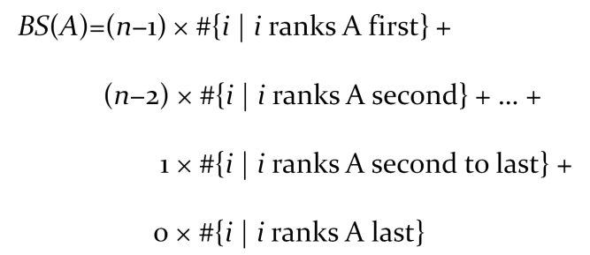

Figure 3: Formula for Borda Count Method

The candidate with the highest Borda score wins. The calculation for the sample table shown in Table 1 is shown below:

|  |  |  |  |
| --- | --- | --- | --- |
| Rank | **A** | **B** | **C** |
| I | 9+5 = 14 | 4+3 = 7 | 4+5 = 9 |
| II | 5+4 = 9 | 4+5 = 9 | 3+5 = 8 |
| III | 4+3 = 7 | 9+5 = 14 | 9+4 = 13 |

Table 2: Borda Count Method Calculation

Hence this can be applied to the formula in Figure 3 and can be computed as follows:

Winner

BS (A) = (3-1)*14 + (3-2)*9 + (3-3)*7 = 37  
BS (B) = (3-1)*7 + (3-2)*9 + (3-3)*14 = 23  
BS (C) = (3-1)*9 + (3-2)*8 + (3-3)*13 = 26

Hence A wins as per the Borda Count method.

* 1. **Condorcet Method**

In a one-to-one election, which ever candidate defeats the other, the candidate could be termed as a Condorcet Winner. Similarly we can define a Condorcet Looser. Suppose that there are three candidates A, B, C and the preferences are as denoted below:

**A >*M* B just in case *n*1+*n*2+*n*5 > *n*3+*n*4+*n*6 (otherwise B ≥*M* A)**

**A >*M* C just in case *n*1+*n*2+*n*3 > *n*4+*n*5+*n*6 (otherwise C ≥*M* A)**

**B >*M* C just in case *n*1+*n*3+*n*4 > *n*2+*n*5+*n*6 (otherwise B ≥*M* C)**

Figure 4: Condorcet Method Calculation

Hence, from Table 1, we can infer the following results-

19 rank A above B

Winner

37

18 rank A above C

11 rank B above A

27

16 rank B above C

12 rank C above A

26

14 rank C above B

Hence, the Condorcet Winner is A as per this method.

1. **Implementation**

We have implemented this interface as a GUI in Java. It has been configured from the Administrator and Users’ point of view. From the home page, the Administrator can login or the User as shown in Figure 7. Once the necessary election properties have been configured, one can run this GUI and study the results both for the Condorcet Method and the Borda Count Method.

**3.1 From the Administrator’s point of view before Voting**

Once the credentials are entered, the Administrator can perform the following tasks:

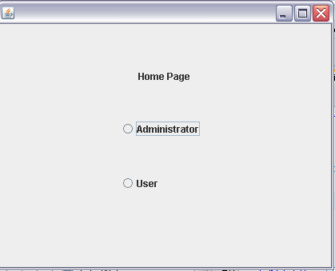 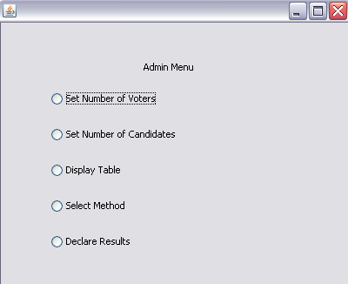

Figure 5: Home Page Figure 6: The Administrators’ Menu

**3.1.1 Set the Number of Voters**

Here, the total number of voters can be selected after which the Voting Procedure closes as shown in Figure 7.

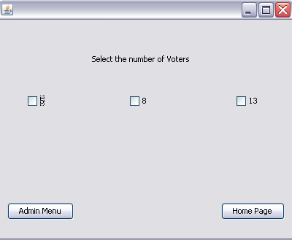 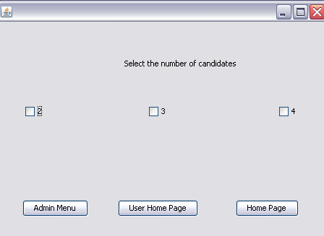

Figure 7: Number of Voters Figure 8: Number of Candidates

**3.1.2 Set Number of Candidates**

Here the number of candidates is set as shown in Figure 8. Once the number of candidates is selected, their names would be entered in the consecutive frame as shown in Figure 9.

**3.1.3 Display the Results**

The table generated can be viewed here as shown in Figure 10.

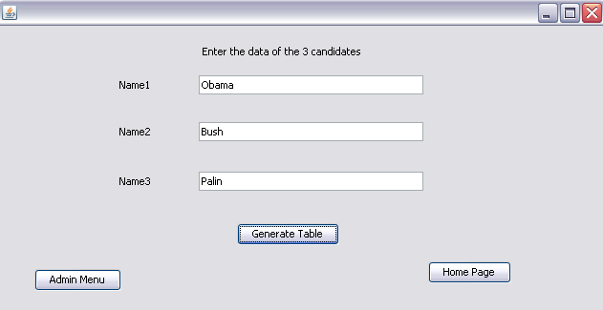 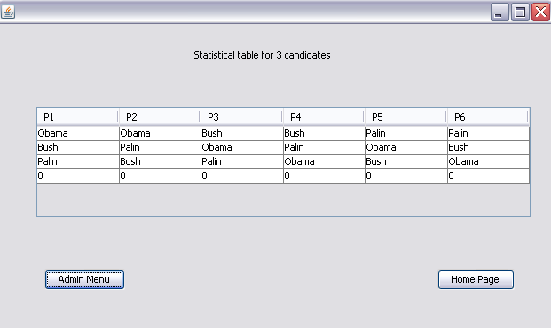

Figure 9: Enter the Details Figure 10: Display the Data

* 1. **From the Users’ point of view**

This is how the User’s Home Page would look like –

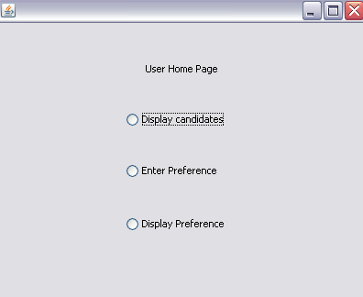

Figure 11: User’s Home Page

* + 1. **Display Candidates**

The List of names that the Administrator configures at the time of setting up the election would be displayed here based on the number of candidates selected. If 3 candidates are selected and their names are “Obama”, “Bush” and “Palin” for instance, this is how the Frame would look like with all the details of the candidates. Once the user notes down the names, they can click on the proceed button to continue voting as shown in Figure 14.

* + 1. **Enter Preference**

Based on the Preference table, the preferences are generated and the user can select the preference and this gets stored in the table generated by the Admin in Figure 12.

**3.3.3 Display Preference**

The application quits here.

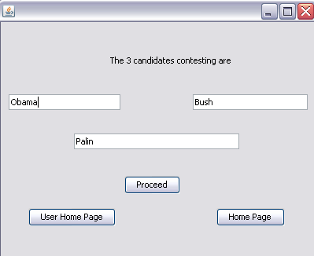 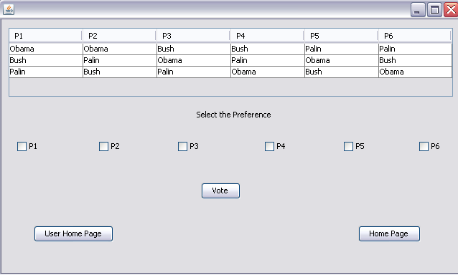

Figure 12: Display the Candidates Figure 13: Enter the Preference

* 1. **Administrator Functionalities after Voting**
     1. **Display the Table**

Now, let us assume that the number of Voters had cast their vote and the Administrator is ready to declare the results. The table would now look like this

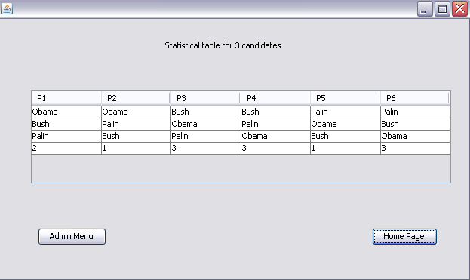

Figure 14: Statistical data after Voting

* + 1. **Method Selection**

The Administrator can now select the method he wants to choose according to which the results can be declared. He can now select the Condorcet Method or Borda Method. As already discussed earlier, the results are calculated based on the formulae shown in Figure 5 and Figure 6.

* + 1. **Declare Results**

Based on the method selected, the results can be declared. A detailed explanation is shown in the Results section of this document.

1. **Results**

**4.1 Condorcet Winner Method**

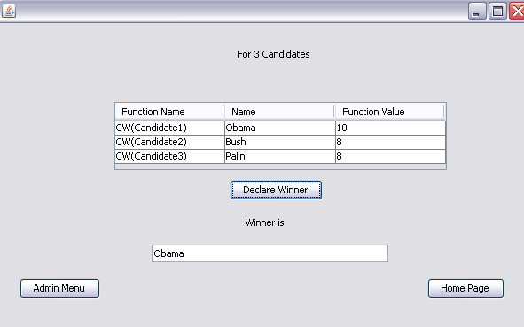 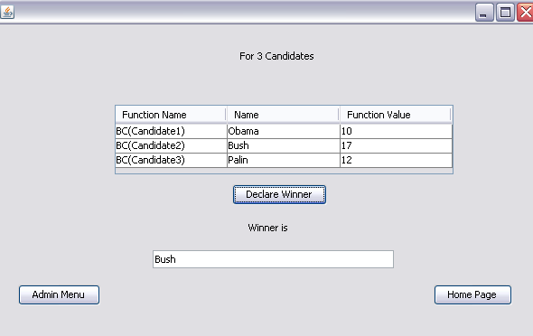

Figure 15: Winner - Condorcet Figure 16: Winner - Borda

* 1. **Borda Count Method**

Since there were conflicting results from these two methods, it drove us to study and compare these methods further using the Natural Language Processing tool – WEKA.

* 1. **Comparison between Condorcet and Borda Count Methods**

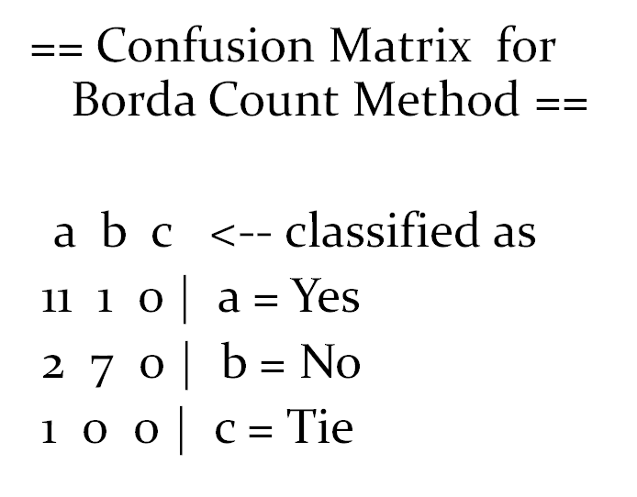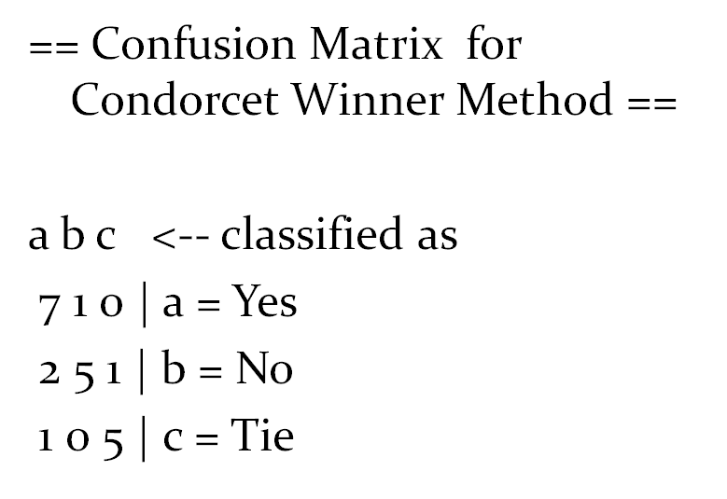

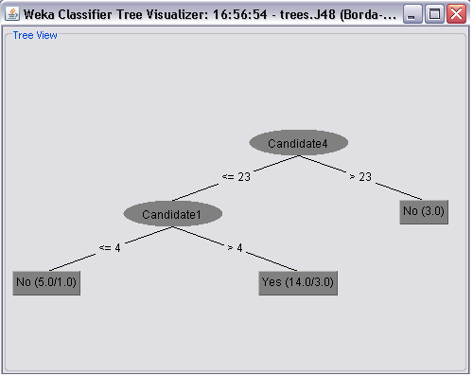 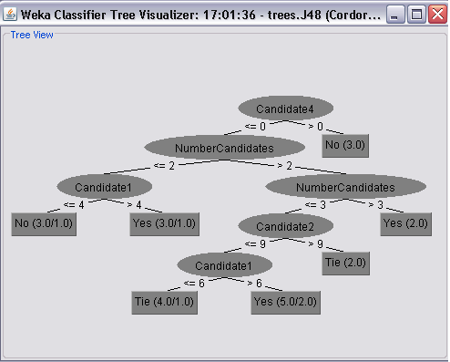

Figure 17: Decision Tree for Borda Figure 18: Decision Tree for Condorcet

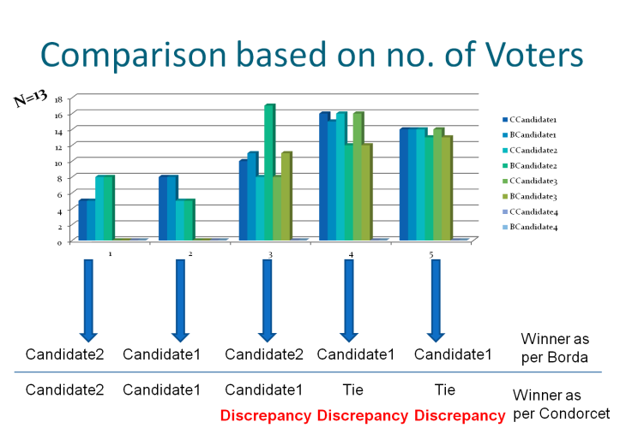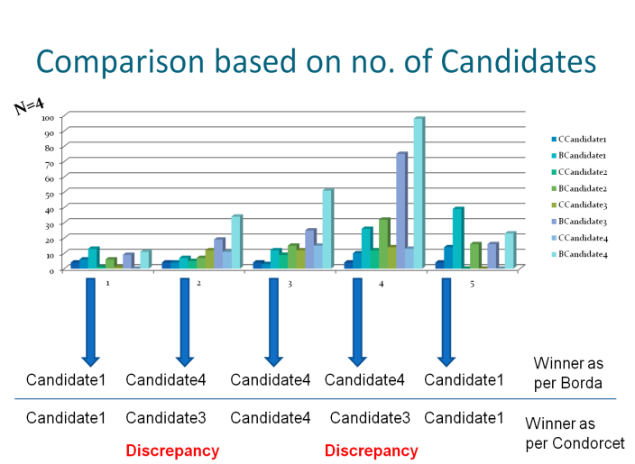

Figure 19: Discrepancy in data - # Voters Figure 20: Discrepancy in data - # Candidates

1. **Conclusion and Future Work**

Borda count does not satisfy the Condorcet winner criterion. As the number of voter’s increases, the Borda method elects the Condorcet winner with increasing frequency. When there are a large number of voters Condorcet Method is preferred for better results. When more number of candidates is contesting in the election, Borda Method is preferred. The Borda Count Method - *Rank sporting teams* or *academic institutions*. The Condorcet Method is used in – *Government Electoral System*. Further methods can be explored and the number of candidates can be increased and implemented for the same.

1. **References**

[1] Pacuit, Eric, "Voting Methods", *The Stanford Encyclopedia of Philosophy* (Winter 2011 Edition), Edward N. Zalta (ed.), forthcoming URL = <http://plato.stanford.edu/archives/win2011/entries/voting-methods/>

[2] <http://www.ctl.ua.edu/math103/voting/4popular.htm>

[3] <http://theorem.ca/~mvcorks/code/voting_methods.html>

[4] <http://www.nctm.org/resources/content.aspx?id=7934>

[5] <http://archives.math.utk.edu/software/msdos/discrete.math/voting/.html>