**Features of Website ranking report application**

1. On load, lists top 5 most visited websites of all time.

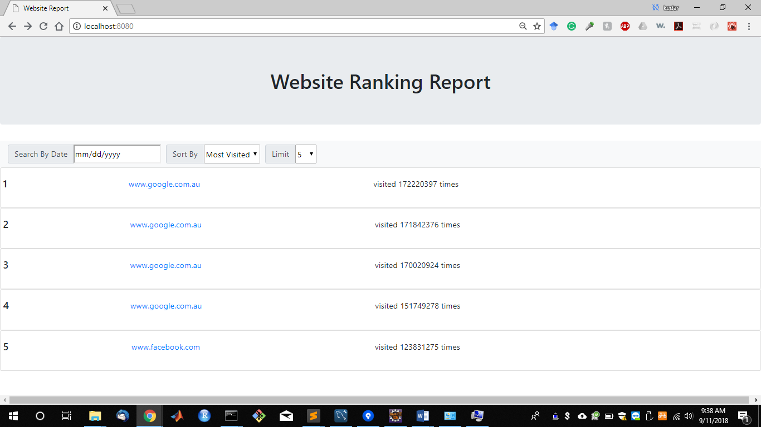

1. Allows to rank least visited websites as well as most visited websites using sort by filter.
2. Allows to choose specific date as filter parameter.
3. Allows user to limit the number of ranked websites to be retrieved using limit filter.
4. When no results are returned proper message is shown

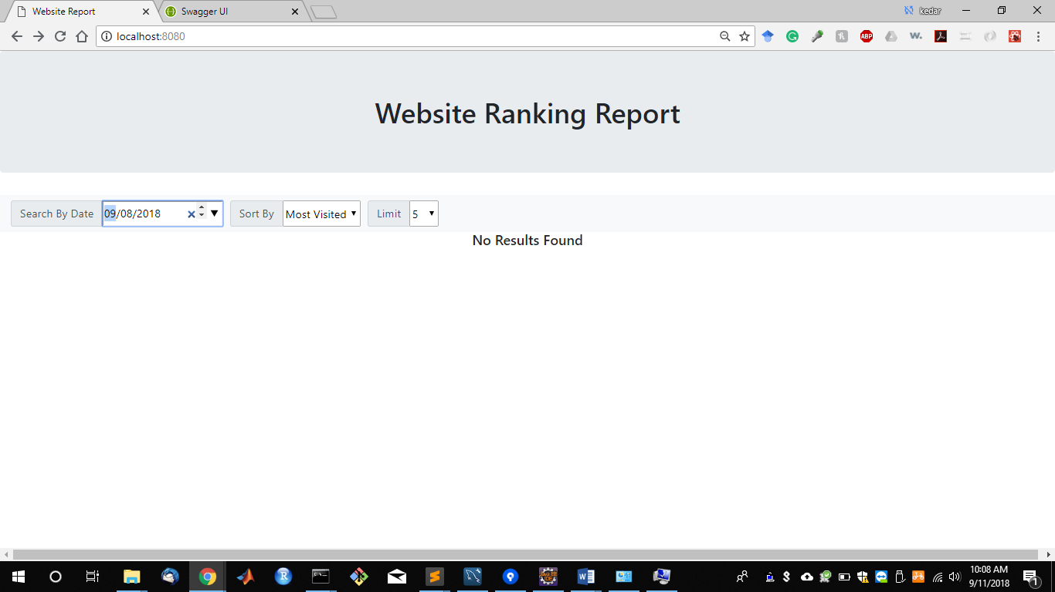

1. Traceability –

In case of error during api call, response header for trace-id is set.

On backend, issue can be traced by searching logs with this trace-id.

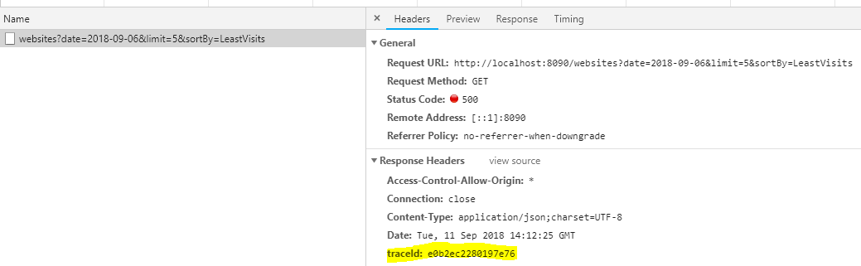

1. Documentation –

You can view the api documentation at

<http://localhost:8090/swagger-ui.html>



Json contract for all apis can be viewed at

<http://localhost:8090/v2/api-docs>

1. JUnit test are implemented

**What more can be done?**

1. Filter websites ranking during a period i.e. from, to date
2. Add on each results Item on UI, a way to open its website details

Details will be - on which days/month/year, this website was visited the most/least

Or a graph