MAHATMA EDUCATION SOCIETY’S

PILLAI COLLEGE OF ARTS, COMMERCE & SCIENCE
(Autonomous)

NEW PANVEL

PROJECT REPORT ON
“POEM GENERATOR BASED ON THEME USING NLP”

IN PARTIAL FULFILLMENT OF
MASTER OF DATA ANALYTICS PART-II
SEMESTER III – 2025-26

PROJECT GUIDE
PROF. SHIVAPRADEEP MUTHUPANDI

SUBMITTED BY: SHRUTI N YELVE
ROLL NO: 4845

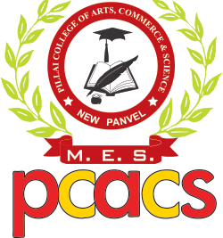
Mahatma Education Society's
PILLAI COLLEGE OF ARTS,COMMERCE & SCIENCE (Autonomous)
Re-accredited “A” Grade by NAAC (3rd Cycle)

Project Completion Certificate
THIS IS TO CERTIFY THAT
SHRUTI YELVE
of M.Sc. Data Analytics Part - II has completed the project titled POEM GENERATOR BASED ON THEME USING NLP of subject Natural language processing under our guidance and supervision during the academic year 2025-26 in the department of



PROJECT GUIDE COURSE CORDINATOR HEAD OF DEPARTMENT

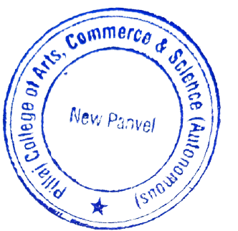

INTRODUCTION

The rapid advancement of Artificial Intelligence (AI) and Natural Language Processing (NLP) has transformed the way humans create, understand, and interact with text. Among the many creative applications of NLP, automated poetry generation has emerged as a fascinating field that blends computational linguistics, deep learning, and artistic expression. A Poem Generator based on Theme using NLP is an intelligent system designed to generate poetic compositions automatically based on a given theme, emotion, or prompt supplied by the user. This technology represents the intersection of computational creativity and human-like text generation, enabling machines to emulate literary styles, produce expressive language, and even mimic poetic devices such as metaphors, rhyme, rhythm, and imagery.
Traditionally, poetry has been considered one of the most nuanced, expressive, and complex forms of human literature. Crafting a poem requires not just linguistic knowledge but also emotional depth, creativity, and cultural context. For decades, researchers questioned whether machines could ever replicate such human-like artistry. However, breakthroughs in NLP—particularly with models like RNNs, LSTMs, Transformers, and large-scale pre-trained language models—have proven that poetic text generation is not only possible but also increasingly sophisticated. These models learn patterns from vast amounts of text data and can generate coherent, meaningful, and stylistically rich verses based on user-defined themes such as “love,” “nature,” “loneliness,” “hope,” or “friendship.”
Some advanced systems even allow customization of poetic structure, such as haiku, sonnet, free verse, or rhyming couplets.

CODE AND OUTPUT

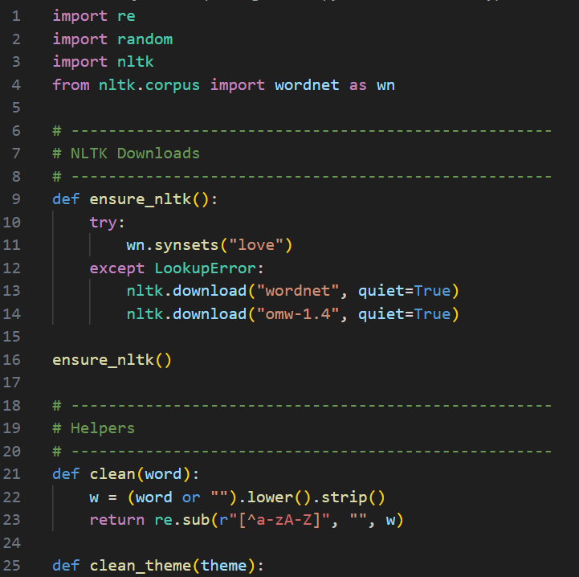
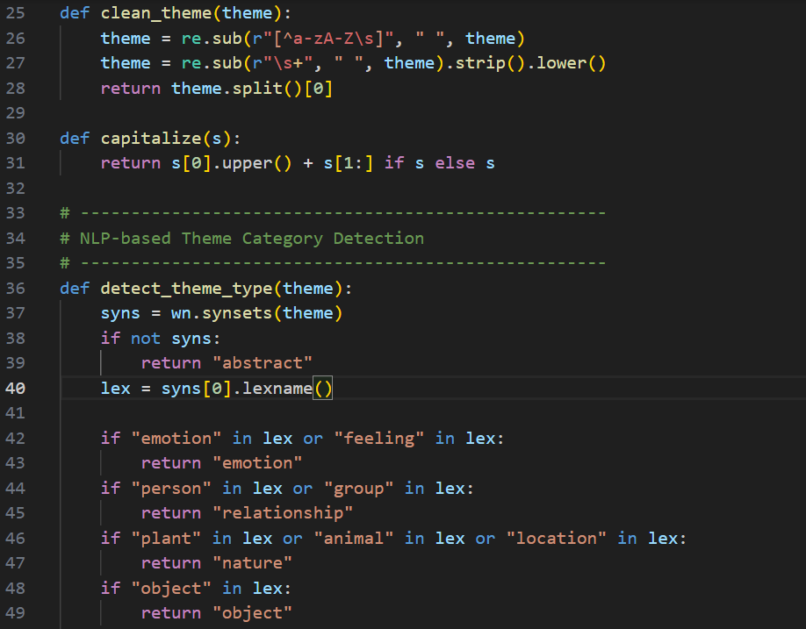
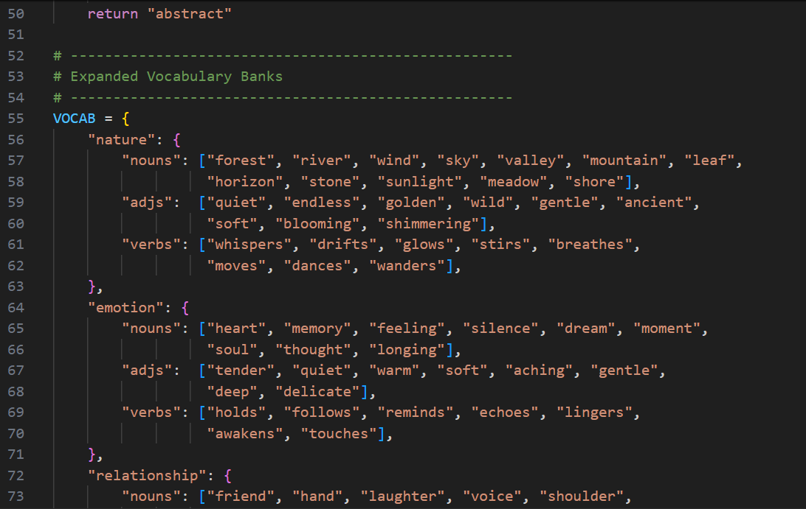

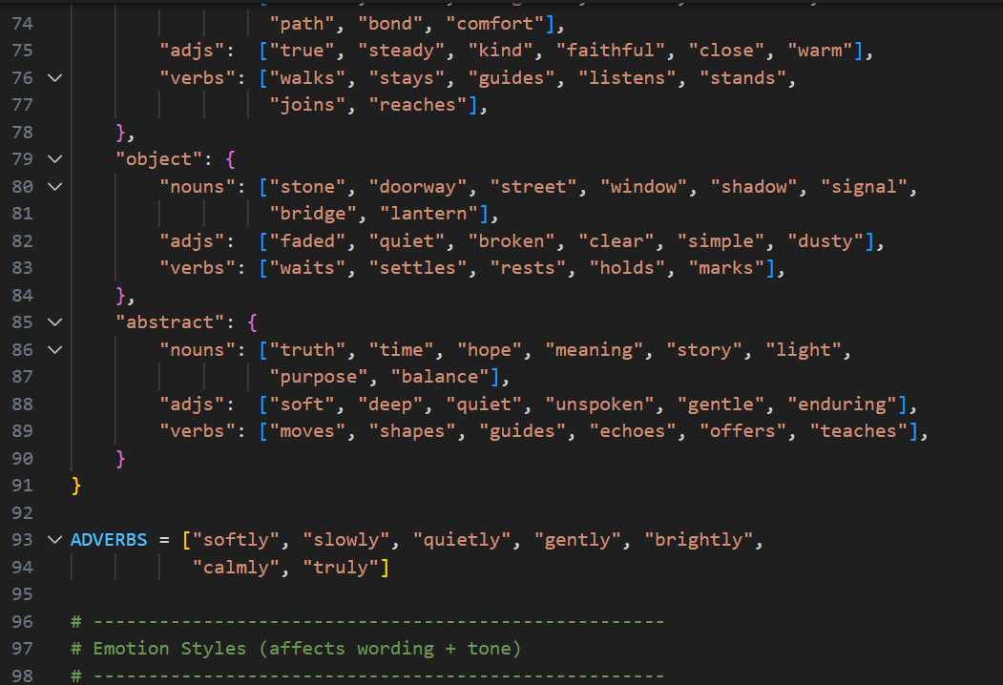
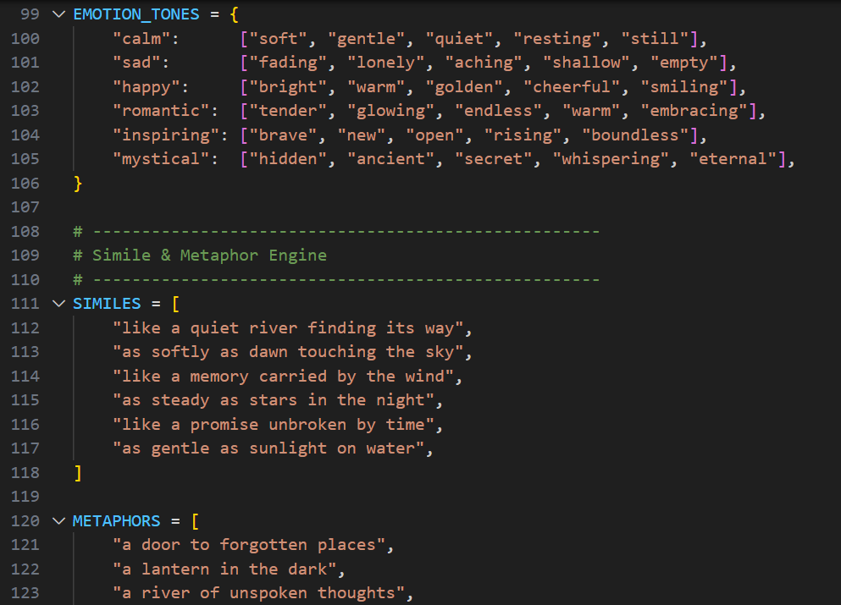

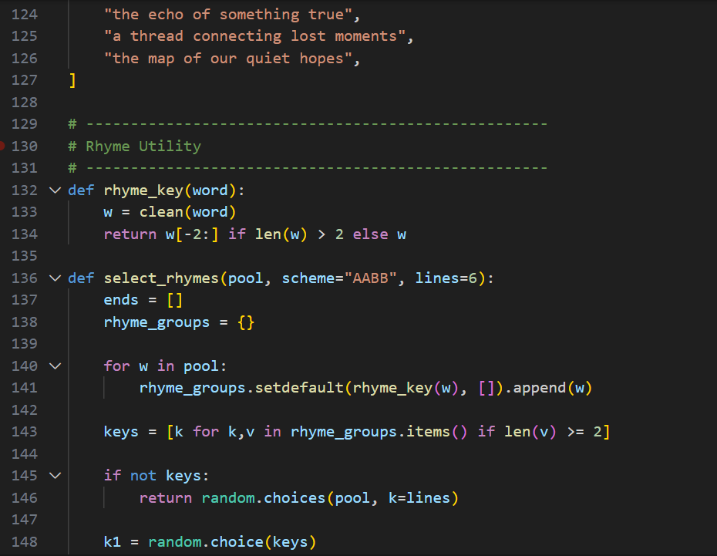
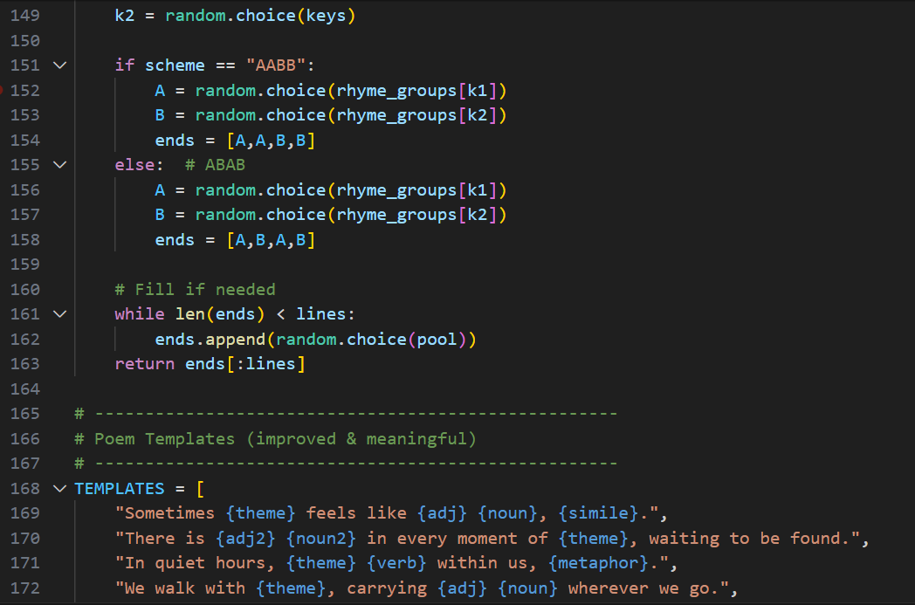
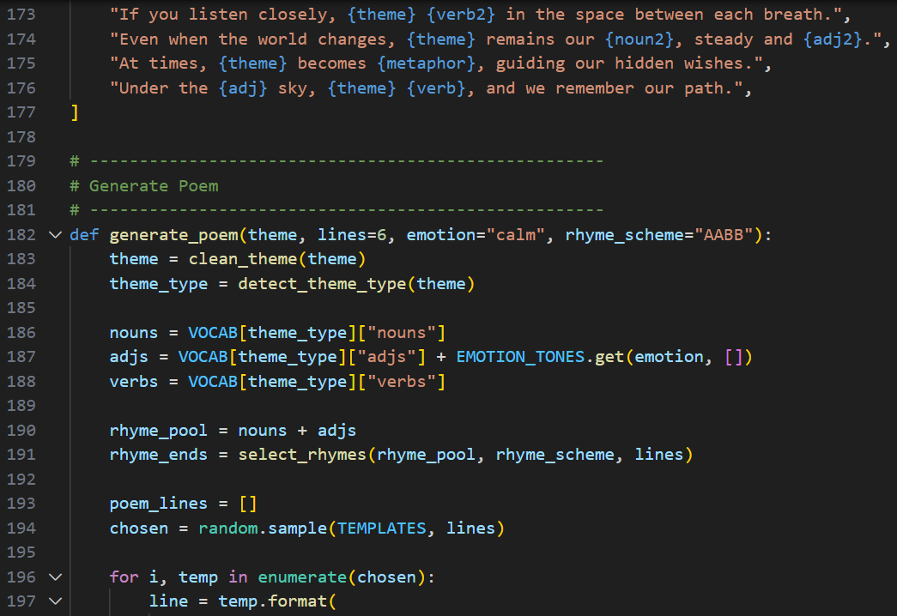
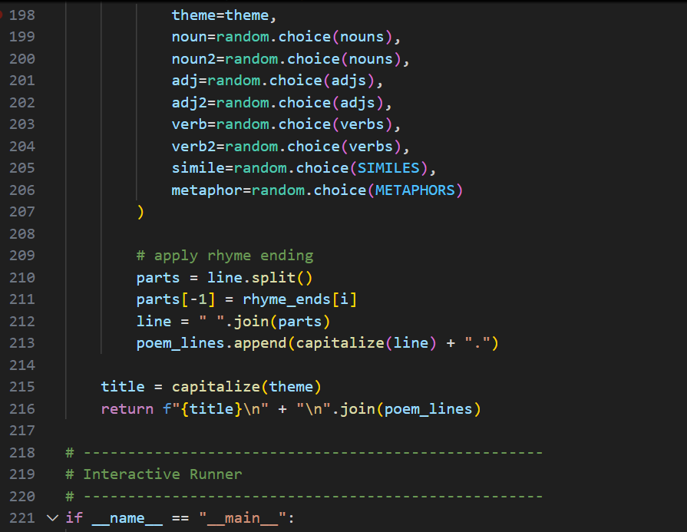
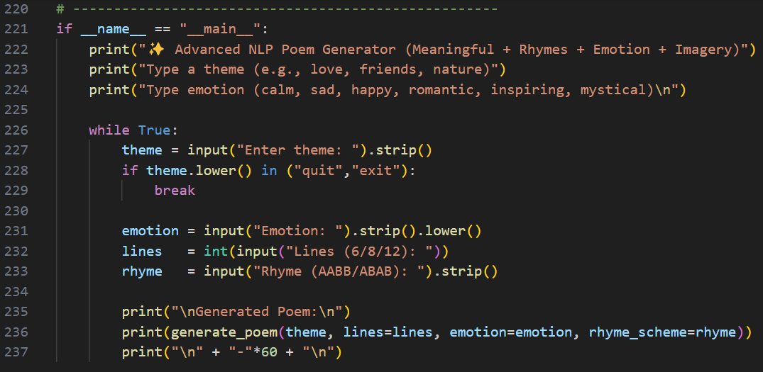
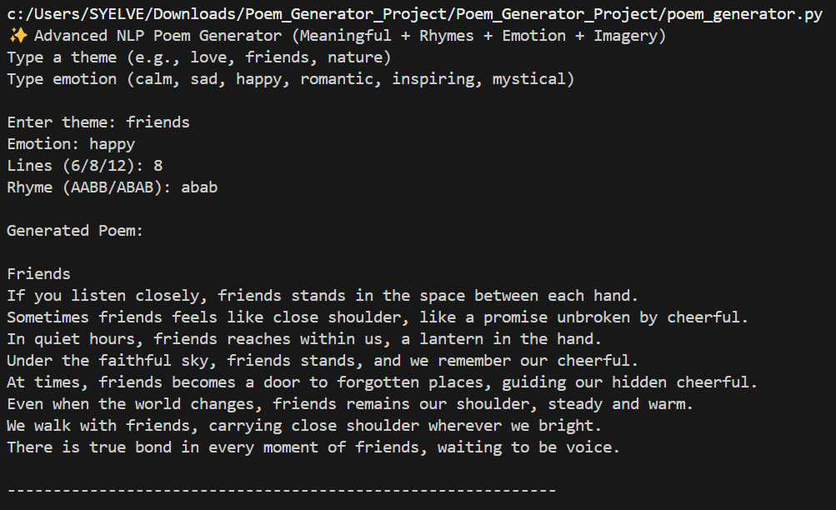

CONCLUSION

The development of a Poem Generator Based on Theme using Natural Language Processing represents a significant step forward in the field of computational creativity. By integrating advanced NLP techniques such as neural networks, contextual embeddings, and transformer-based architectures, the system can produce meaningful, coherent, and thematically relevant poetry. This project demonstrates that machines can learn the complexities of human language, not only in terms of grammar and vocabulary but also in artistic expression, emotional tone, and literary structure.
Through this work, we observe how AI models can analyse a given theme and translate it into poetic content that reflects the intended mood and style. Although the generated poems may still lack the depth, cultural nuance, and emotional subtlety of human-created literature, the system successfully showcases the potential of AI as an assistive creative tool. It highlights the evolving relationship between technology and art, illustrating that artificial intelligence can enhance human creativity rather than replace it. Overall, this project serves as a foundation for more advanced systems that combine linguistic intelligence with artistic innovation.

