**Steps to test Travel Boulevard**

**Step 1 : Download code from github path :** <https://github.com/shrutizoomie/HolidayPlanner/>

**Step 2 : Import the project in Netbeans and run the same**

**Step 3 : Home page is displayed as shown below**

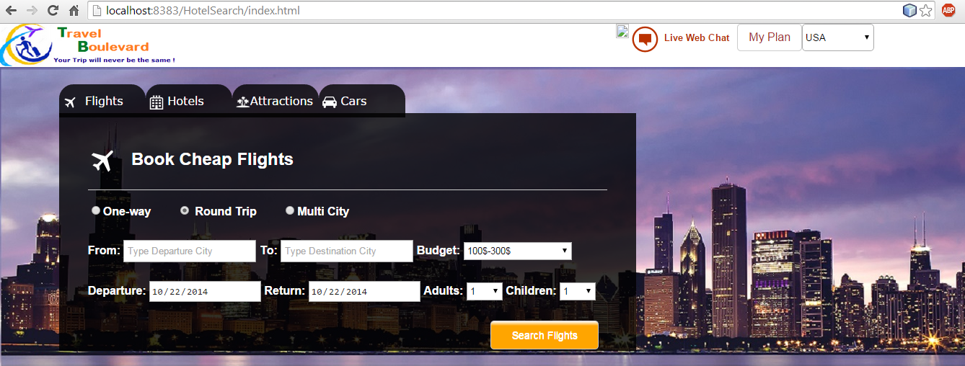

**Step 4 : Book a round trip flight from Los Angeles to San Francisco**

**Select Departure City : Los Angeles and Arrival City : San Francisco, Set budget 100-300$ and select the arrival and departure dates. Select the number of adults and click on Search flights**

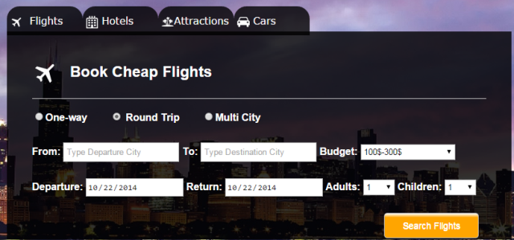 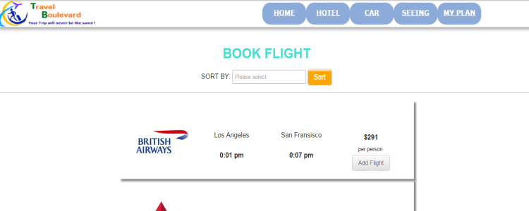

Click on Add Flight button and flight is added to plan

**Step 5 : Press home key and go back to the main page. Click on Hotels and try to book a hotel in San Francisco.**

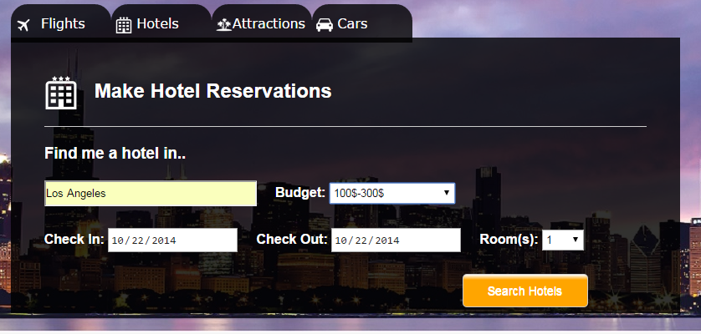

**Select City San Francisco, Set budget 100-300$ and select the checkin and check out dates. Select the number of rooms and click on Search hotels**

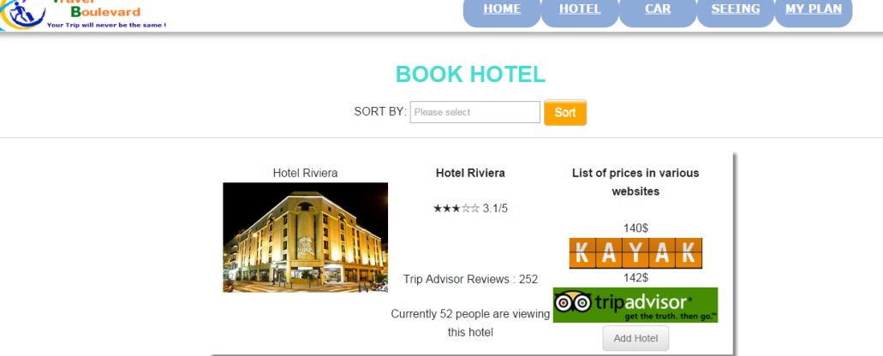

Click on Add Hotel button and Hotel is added to plan

**Step 6 : Add Attractions and Rental cars**

**In the home page select the Attractions tab. Select the city as San Francisco and Budget as 100$-300$ then click on Search Attractions.**

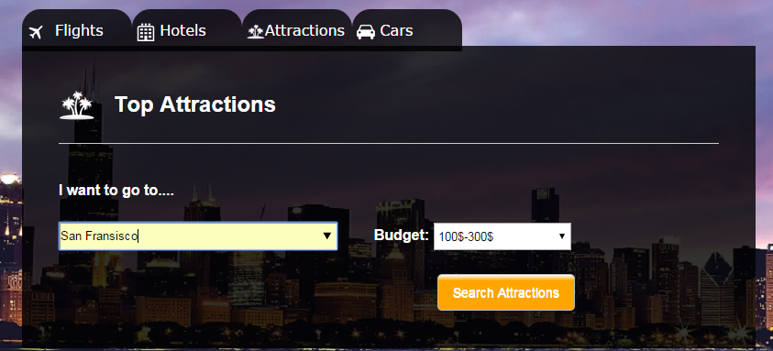 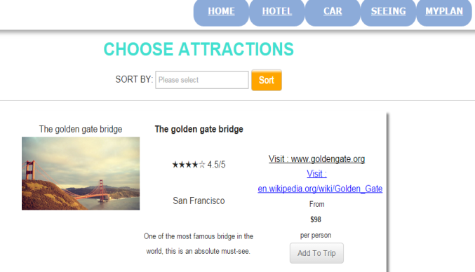

Click on Add Trip button and Trip is added to plan

**In the home page select Cars. Select the city where you would like to rent the car, pick up and Drop off points, pick up and drop off date and time and click on Search Cars**

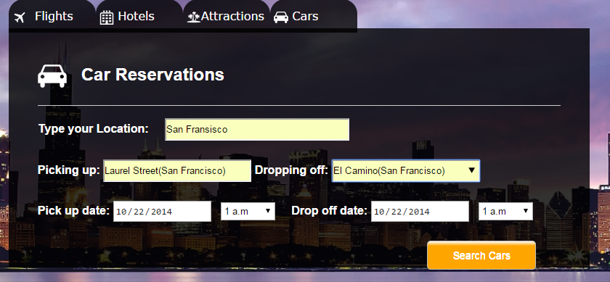 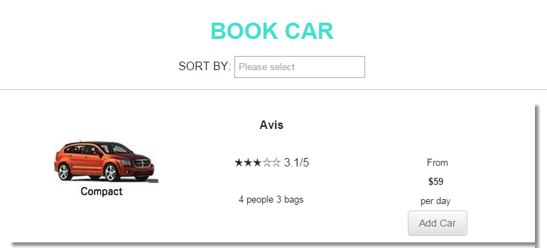

Click on Add Car button and Car is added to plan

**Step 7 : View your travel itinerary : Click on MyPlan from any of the pages**

