VLSI (Very Large Scale Integration) Internship
TASK 1 REPORT
Introduction to VLSI Design Flow and Basic Digital Logic Implementation
Name: Shruti Vyas
Internship/Organization: Maincrafts
Date: 12-07-2026

1. Objective
The objective of this task is to understand the fundamentals of VLSI, study the major stages of the VLSI design flow, revise basic digital logic gates and Boolean expressions, and implement and verify a Half Adder using digital logic simulation.

2. Introduction to VLSI
VLSI stands for Very Large Scale Integration. It is the process of integrating a very large number of transistors and electronic components onto a single integrated circuit (IC). VLSI technology is widely used in processors, memories, communication systems, embedded systems, mobile devices and many other modern electronic products.

3. VLSI Design Flow
A typical VLSI design flow converts a system requirement into a manufacturable integrated circuit. The major stages are:
- System Specification: Defines the required functionality, performance, power, area and other design constraints.
- Architecture Design: Divides the system into functional blocks and determines how the blocks interact.
- RTL Design: Describes the digital hardware at Register Transfer Level, commonly using Verilog or VHDL.
- Functional Verification: Checks whether the RTL design behaves according to the specification.
- Logic Synthesis: Converts RTL code into a gate-level netlist using standard logic cells.
- Physical Design: Includes floorplanning, placement, clock-tree synthesis and routing.
- Sign-off and Fabrication: Timing and physical checks are completed before the final layout is sent for chip manufacturing.

4. Basic Digital Logic Gates
Logic gates are the fundamental building blocks of digital circuits. Their outputs are determined by binary inputs, where 0 represents LOW and 1 represents HIGH.
Gate | Boolean Expression | Operation
AND | Y = A · B | Output is 1 only when both inputs are 1.
OR | Y = A + B | Output is 1 when at least one input is 1.
NOT | Y = A̅ | Output is the complement of the input.
NAND | Y = (A · B)̅ | Complement of the AND operation.
NOR | Y = (A + B)̅ | Complement of the OR operation.
XOR | Y = A ⊕ B | Output is 1 when the two inputs are different.

5. Truth Tables
Truth table for two-input gates:
A | B | AND | OR | NAND | NOR | XOR | NOT A
0 | 0 | 0 | 0 | 1 | 1 | 0 | 1
0 | 1 | 0 | 1 | 1 | 0 | 1 | 1
1 | 0 | 0 | 1 | 1 | 0 | 1 | 0
1 | 1 | 1 | 1 | 0 | 0 | 0 | 0

6. Half Adder
A Half Adder is a combinational logic circuit that adds two single-bit binary inputs, A and B. It produces two outputs: Sum and Carry.
Sum = A ⊕ B
Carry = A · B
Therefore, the Sum output is implemented using an XOR gate and the Carry output is implemented using an AND gate.

7. Half Adder Truth Table
A | B | Sum | Carry
0 | 0 | 0 | 0
0 | 1 | 1 | 0
1 | 0 | 1 | 0
1 | 1 | 0 | 1

8. Simulation and Verification
The Half Adder was simulated by applying all four possible combinations of the two input signals. The waveform contains the input signals a and b and the output signals sum and carry. The simulation results match the expected Half Adder truth table.
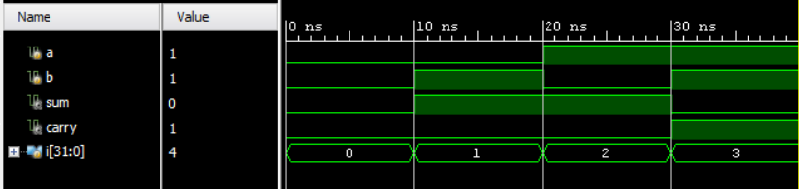
Figure 1: Half Adder Simulation Waveform
The waveform verifies the four input conditions. For A = 0 and B = 0, both outputs are 0. For inputs 01 and 10, Sum is 1 and Carry is 0. For A = 1 and B = 1, Sum is 0 and Carry is 1. At the displayed cursor position, a = 1, b = 1, sum = 0 and carry = 1, confirming correct operation.

9. Result
The basic VLSI design flow and fundamental digital logic concepts were studied successfully. The Half Adder was implemented and verified through simulation. The simulated Sum and Carry outputs agree with the theoretical Boolean equations and truth table for all possible input combinations.

10. Conclusion
This task provided an introduction to the VLSI design process and the role of digital logic in hardware design. The study of logic gates, Boolean expressions and truth tables established the foundation for combinational circuit design. The successful Half Adder simulation demonstrated how a digital design can be implemented and functionally verified before moving to more advanced VLSI design stages.

11. Tools/Resources
Digital logic/HDL simulation environment used for Half Adder verification, along with the learning resources and simulator recommendations provided in the Task 1 internship document.

