Executive Summary: Employee Attrition Analysis

1. Executive Overview
This report analyzes historical HR data to uncover the root causes of employee turnover. The goal is to provide actionable strategies that reduce replacement costs and stabilize our most vulnerable departments.

2. Primary Flight Risks
Using predictive analytics, we identified the three strongest warning signs of employee resignation:
- Burnout: Employees consistently logging overtime are at a critically high risk of quitting.
- Compensation & Tenure: Turnover peaks dramatically in the first two years. Departing employees average roughly $2,000 less in monthly income than those who stay.
- Role Vulnerability: Sales Representatives face the highest flight risk (40% turnover), closely followed by Laboratory Technicians (24%).
Figure 1: Attrition Rates by Department and Role
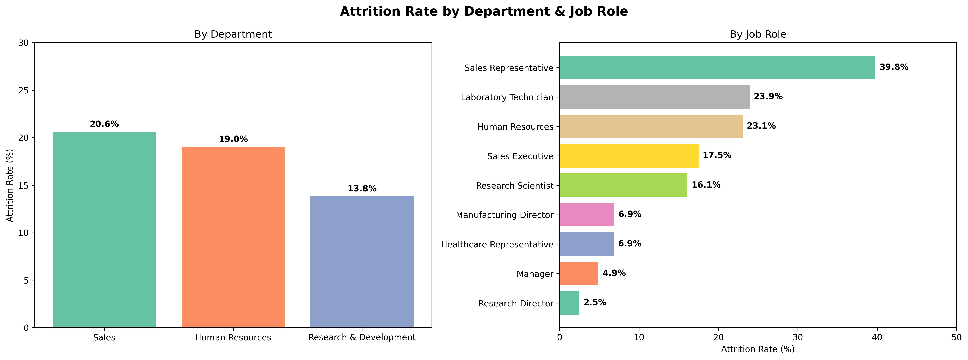

3. Note on Data Reliability
To ensure our predictions reflect real-world behavior, we built guardrails against historical bias in our modeling. Moving forward, proactive behavioral interventions will be prioritized over algorithmic tracking to maintain employee trust.

4. Recommended Actions
Targeted Mentorship: Launch a structured onboarding and mentorship track for the first 24 months to close the critical 0-2 year turnover gap.
Overtime & Comp-Off Policies: Conduct regular workload audits for Sales and Lab roles. Where overtime is unavoidable, introduce mandatory compensatory time-off to prevent burnout.

