Sales Forecasting & Demand Intelligence

1. Executive Summary
This report analyzes four years of sales data across three product lines and four regions. Overall growth is steady, driven by the Technology category and the West region. We anticipate a reliable revenue surge in Nov/Dec, consistent with historical trends. However, past data reveals inventory strain during unexpected demand spikes. By implementing predictive stock adjustments and tracking anomalies early, the supply chain can meet Q4 demand while minimizing excess warehouse costs.

2. Key Findings from Sales History
- Technology Leads: Technology is the primary revenue driver, outpacing Furniture and Office Supplies.
- West Region Growth: The West region shows the strongest year-over-year growth.
- Fulfillment Bottlenecks: Shipping times average 3.9 days but exceed 5 days in lagging regions, impacting retention.

3. Three-Month Sales Forecast (Oct - Dec)
Our predictive model projects strong growth over the next 90 days. Because real-world demand fluctuates, these forecasts come with a 'confidence range'—giving us a safe upper and lower bound for planning inventory.
Month | Expected Revenue | Confidence Range (Low to High)
October | ~238,500 | 190,000 to 275,000
November | ~252,000 | 205,000 to 295,000
December | ~275,000 | 225,000 to 320,000

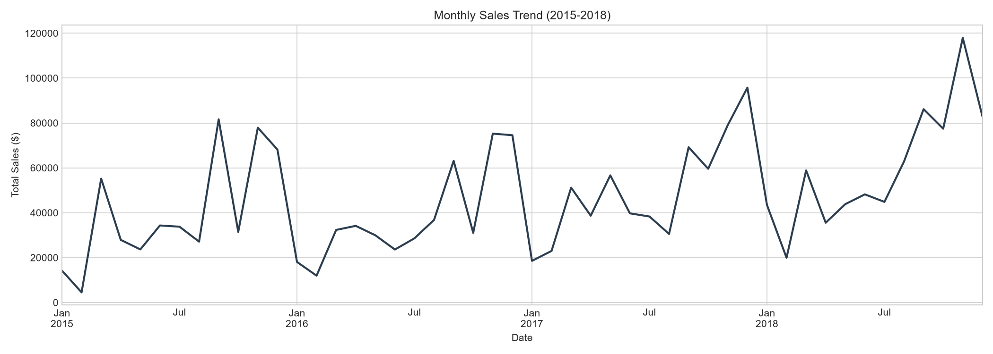  Fig 1: Clear Upward Sales Trend & Strong Q4 Seasonality | 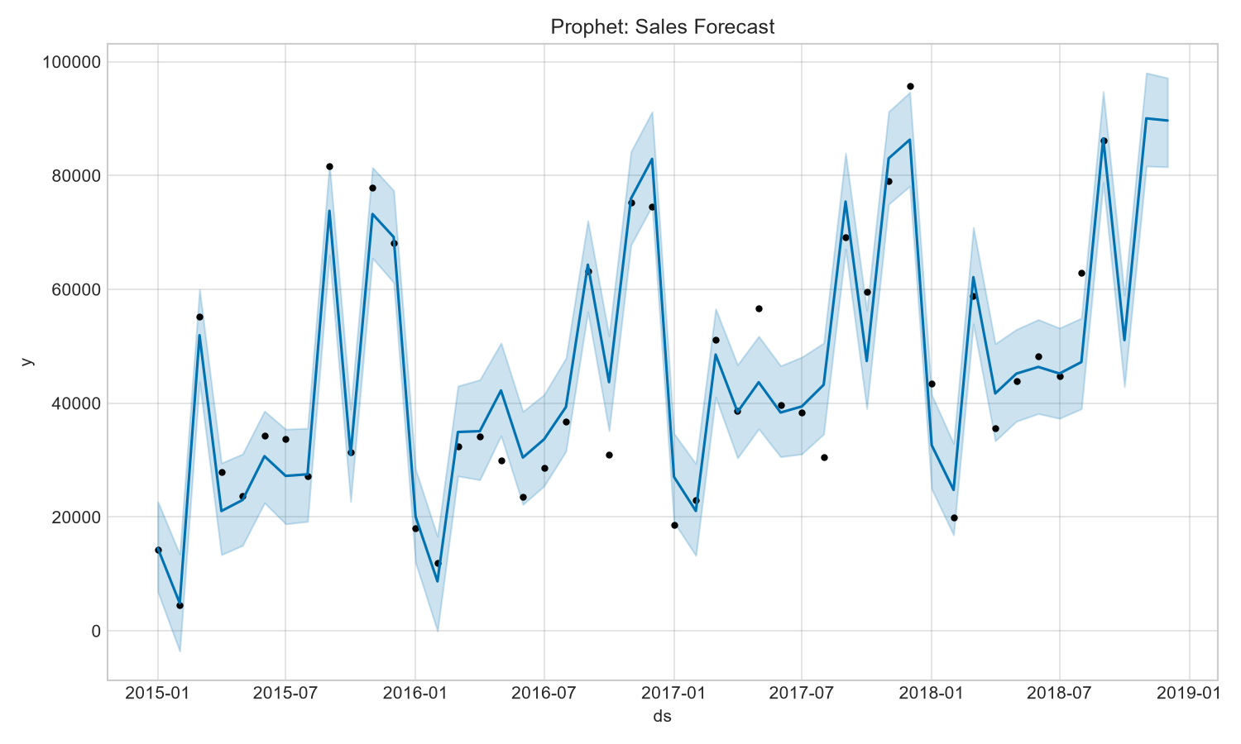  Fig 2: Q4 Revenue Forecast with Confidence Bounds

4. Top 3 Demand Anomalies Detected
We reviewed historical data to find unexpected demand shocks that strained inventory:
- November 2016 Surge: A massive 61% spike above average, likely a major promotional event. Strains supply chains if not pre-planned.
- March 2015 Revenue Drop: A sharp 38% drop in expected orders, likely a system outage or unrecorded sales.
- September 2017 Institutional Buy: A sudden wave of orders, matching a classic B2B stockpiling pattern before Q4.

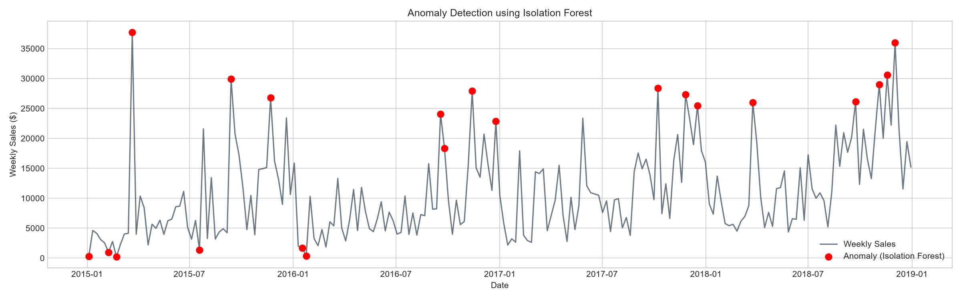  Fig 3: Unforeseen Order Spikes | 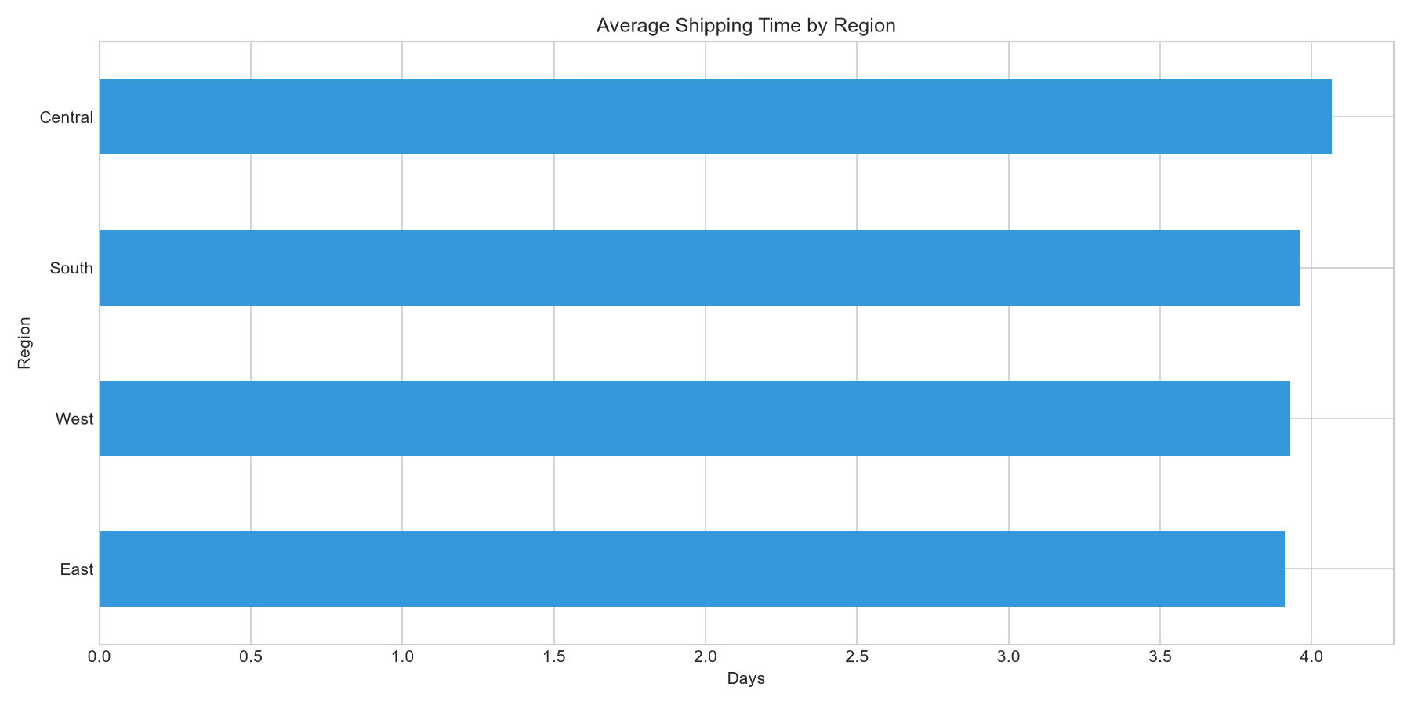  Fig 4: Shipping Delays Impacting Fulfillment

5. Product Demand Segmentation & Strategy
By analyzing product volume, order frequency, and volatility, we segmented inventory into four groups:
Product Group | Behavior | Recommended Stocking Strategy
Stable High-Volume  (Paper, Binders) | Sells constantly. Low variance. | Maintain deep safety stock. Automate re-ordering.
Low-Freq High-Value  (Copiers, Machines) | Sells rarely, but huge margins. | Hold moderate stock. Negotiate faster supplier lead times.
Growing Demand  (Accessories, Labels) | Demand is steadily rising. | Increase quarterly order sizes proactively.
Volatile / Declining  (Tables, Supplies) | Erratic demand, tying up cash. | Shift to Just-In-Time ordering to free up warehouse space.

6. Concrete Business Recommendations
- 1. Pre-Stock Technology for Q4: Nov/Dec generate 40-60% above average revenue. Increase Q4 Purchase Orders for Technology by 35% before Oct 1st to prevent stockouts.
- 2. Implement Automated Shock Alerts: Deploy an automated weekly alert flagging the supply chain team if order velocity deviates 1.5x from expected, buying 5-7 days of reaction time.
- 3. Shift Volatile Goods to Just-In-Time: Move volatile SKUs (like Tables) to a Just-In-Time fulfillment model, reserving premium warehouse space for high-volume runners.

7. System Risk & Limitation
Risk factor: Models rely entirely on historical data and cannot predict macroeconomic shocks or supply chain breakdowns. Combine forecasts with real-time operational context.

