ALLWAYS VIP
Site Analysis & Migration Assessment

https://www.allwaysvip.com

February 18, 2026

Table of Contents
1. Templates Inventory
2. Blocks / Components Catalog
3. Page Counts by Template
4. Integrations Analysis
5. Complex Use Cases & Observations
6. Migration Estimates

Executive Summary
ALLWAYS VIP (allwaysvip.com) is a Drupal-based airport concierge services platform operated by Plaza Premium Group. The site enables travelers to discover and book airport services including Meet & Assist, Concierge, Fast Track, Porter, Limousine, and more across 113+ airports worldwide.
This document provides a comprehensive analysis of the site's structure, templates, components, integrations, and complexity to inform migration planning to Adobe Edge Delivery Services (AEM Sites).

Metric | Value
Total Pages | ~54
Unique Templates | 10
Reusable Blocks/Components | 19
Third-Party Integrations | 12
Languages Supported | 3 (EN, ZH-CN, ZH-TW)
Currencies Supported | 20+
Airport Locations | 113+
CMS Platform | Drupal (custom theme)
Booking Platform | Separate subdomain (booking.allwaysvip.com)
Estimated Migration Effort | 31–47 working days

1. Templates Inventory
The site uses 10 distinct page templates. Each template defines a unique layout structure, content model, and interaction pattern.
# | Template Name | Complexity | Description | Reference URL
T1 | Homepage | High | Unique layout with hero image, interactive booking search widget (location autocomplete, date/time pickers, service type radios, guest selector, promo code), embedded YouTube video, service cards grid. Heavy JavaScript interactivity. | https://www.allwaysvip.com/
T2 | Service Listing | Medium | Card grid layout with search/filter. Cards dynamically filtered by location (?loc= param). Breadcrumb + title + search bar + card grid. | https://www.allwaysvip.com/our-services
T3 | Service Detail | Medium | Hero image + rich text body + dynamic airport availability list (up to 113 airports). Includes 'Other Services' related content section. | https://www.allwaysvip.com/our-services/meet-and-assist
T4 | Offers Listing | Medium | Hero banner with geometric design + card grid with search. Same card pattern as Service Listing but different content type. Location-filtered. | https://www.allwaysvip.com/offers
T5 | Offer Detail | High | Two-column layout: left with promotional image, language tabs (EN/ES), rich text T&C; right with embedded booking widget. 'Other Offers' section at bottom. | https://www.allwaysvip.com/offers/madrid-opening-offer
T6 | Content Page | Low | Simple single-column: breadcrumb, title, optional YouTube video, body text paragraphs. | https://www.allwaysvip.com/about-us
T7 | Contact Form Page | High | Multi-field Drupal webform (enquiry type, personal info, booking ref, location, date/time) + 116-row contact directory table + headquarters info. | https://www.allwaysvip.com/contact_us
T8 | Registration Form | High | Smart Traveller registration: personal details, GDPR toggle, data privacy accordion, T&C checkbox. External rewards system integration. | https://www.allwaysvip.com/form/arrture-register
T9 | Legal / Policy Page | Low | Long-form text with numbered sections, bullet lists, hyperlinks. No interactive elements. | https://www.allwaysvip.com/terms-of-use
T10 | FAQ Page | Low | Q&A list with styled question headings and answer paragraphs separated by horizontal rules. | https://www.allwaysvip.com/faqs

Template Screenshots
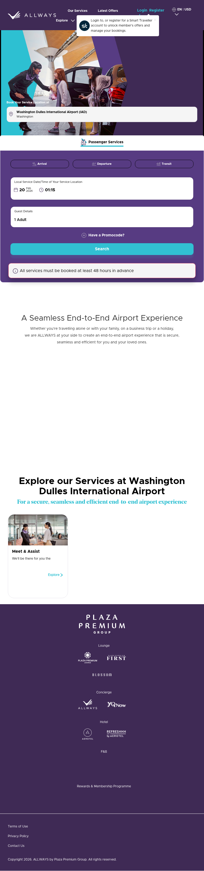
T1 — Homepage with booking widget and service cards

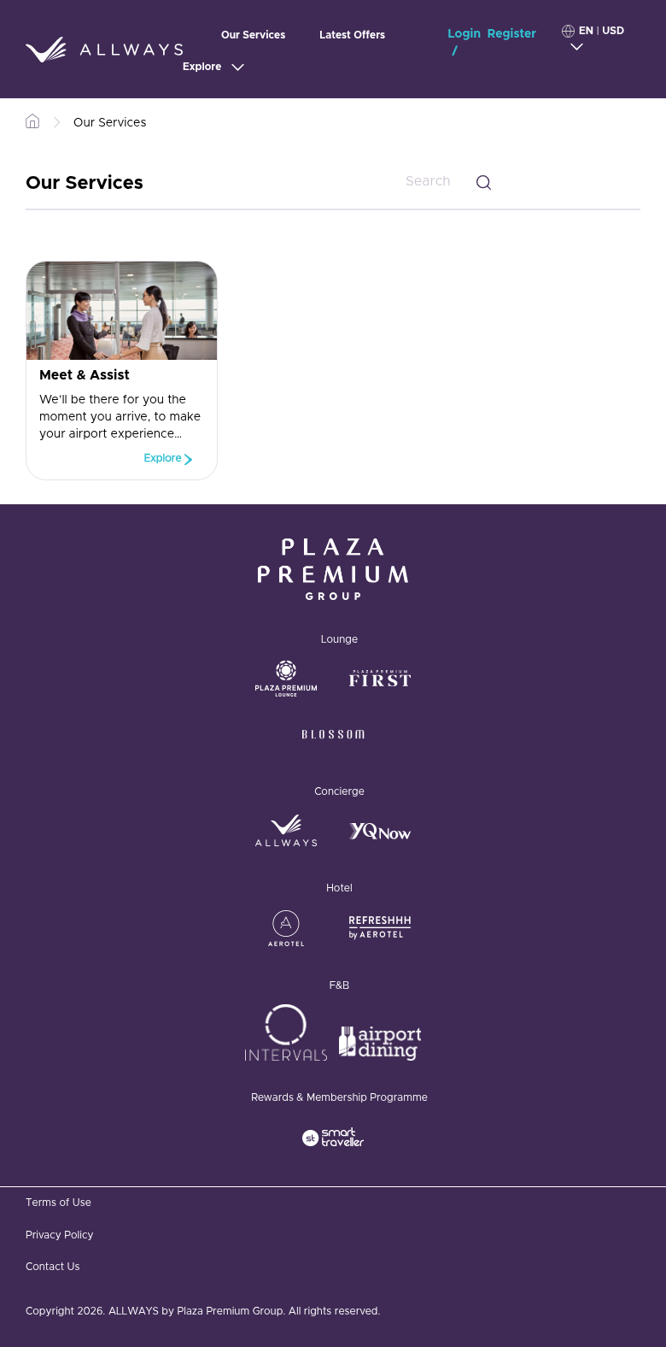
T2 — Service Listing with card grid

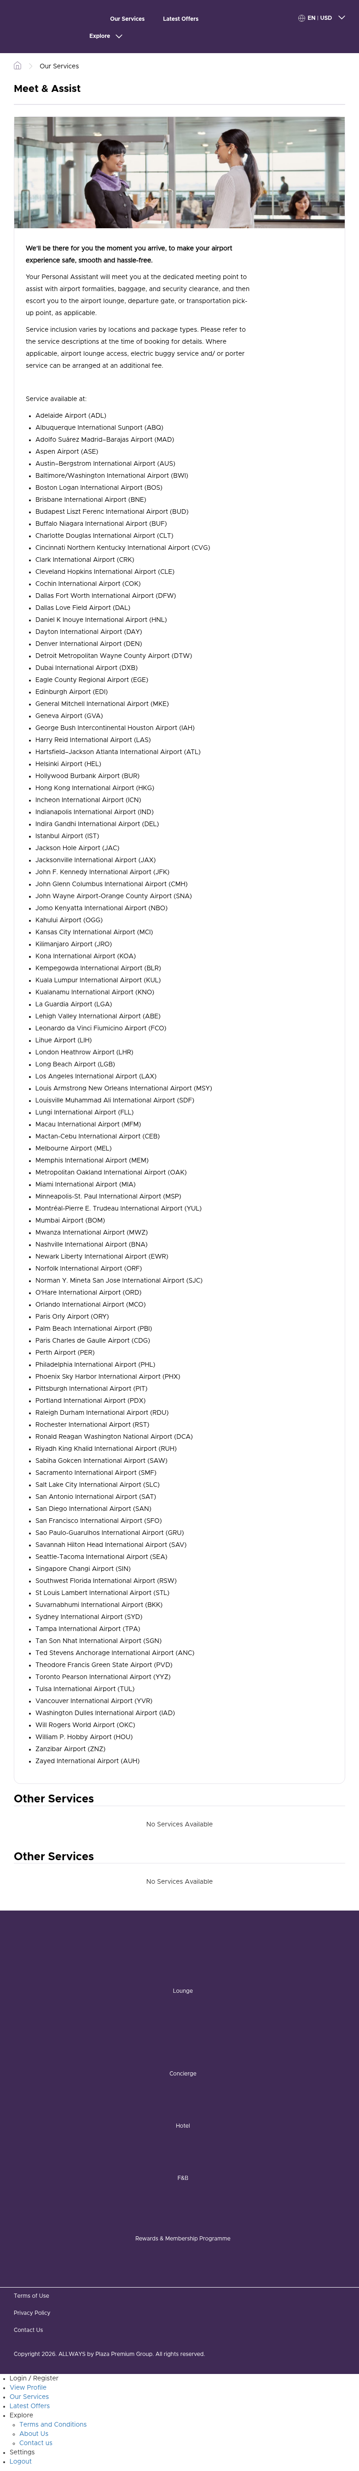
T3 — Service Detail (Meet & Assist)

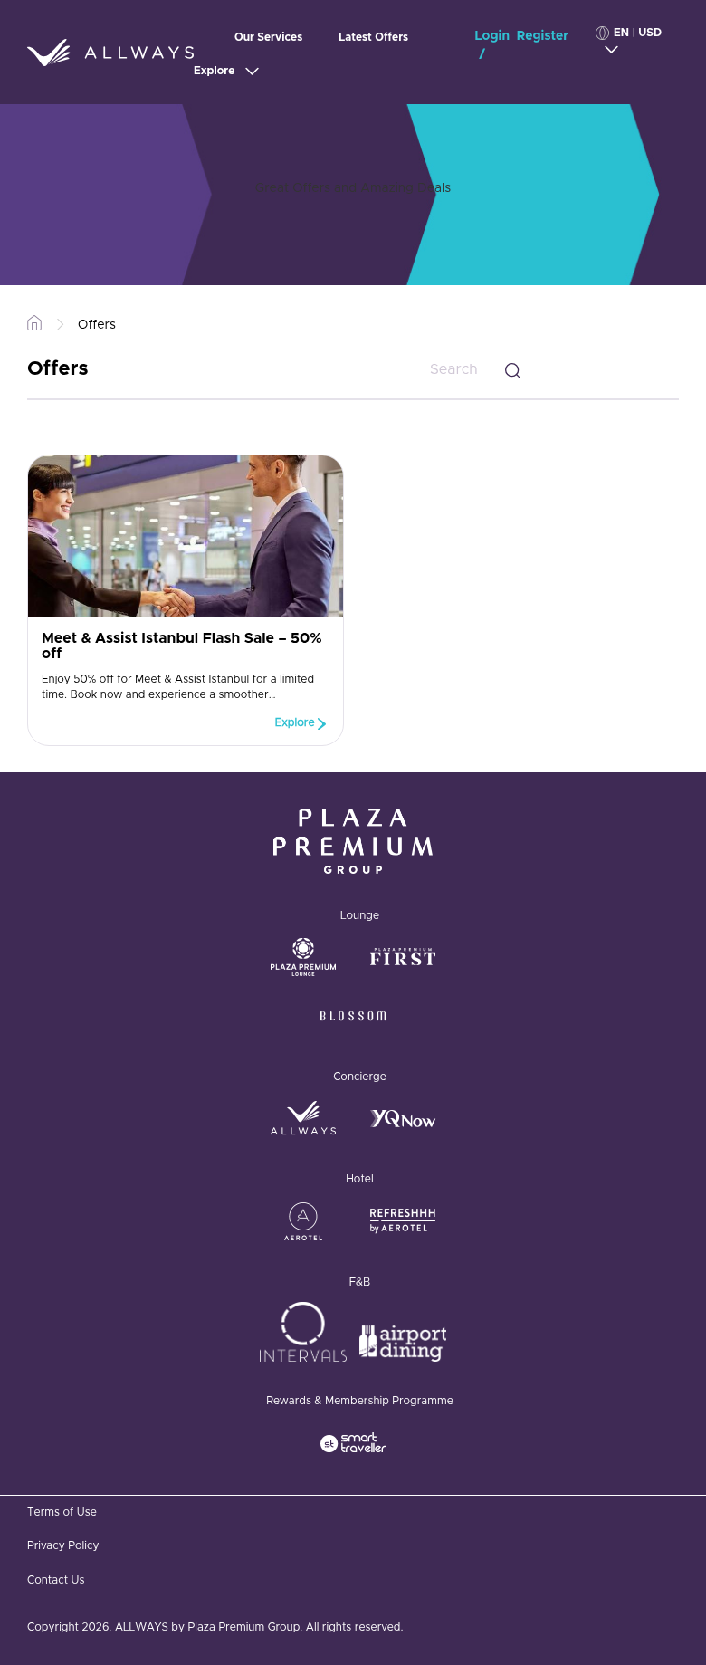
T4 — Offers Listing with hero banner

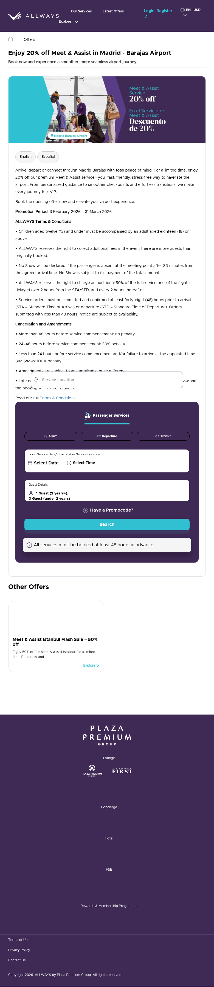
T5 — Offer Detail with two-column layout and booking sidebar

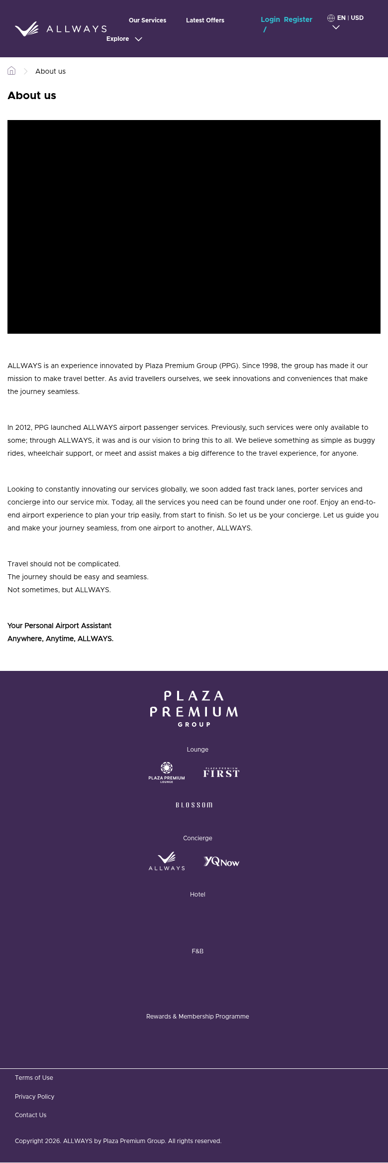
T6 — Content Page (About Us) with video embed

T7 — Contact Form Page with directory table

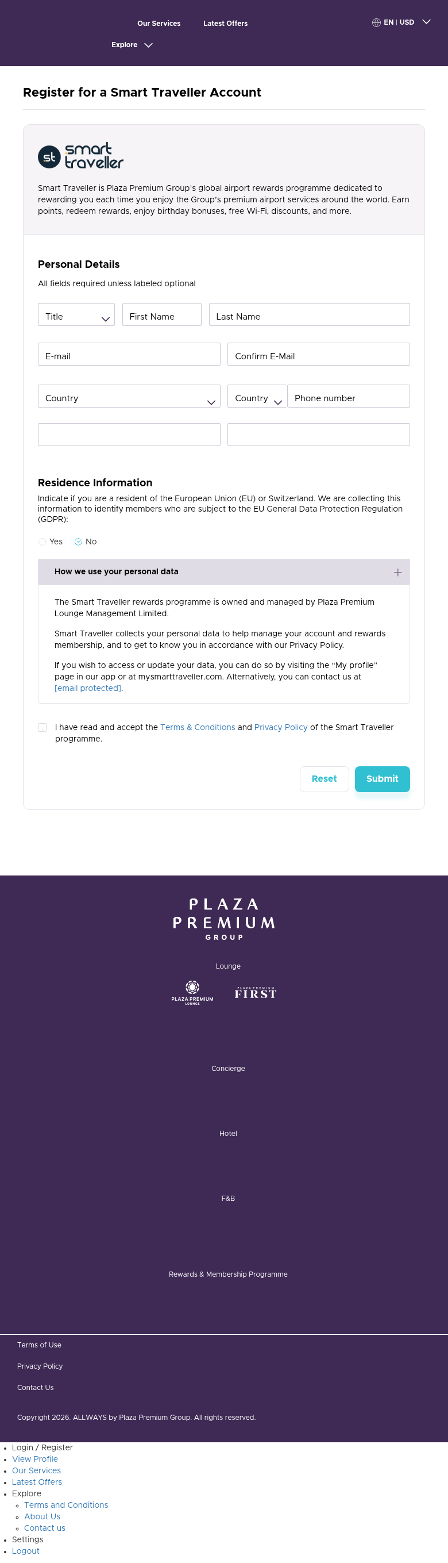
T8 — Registration Form (Smart Traveller)

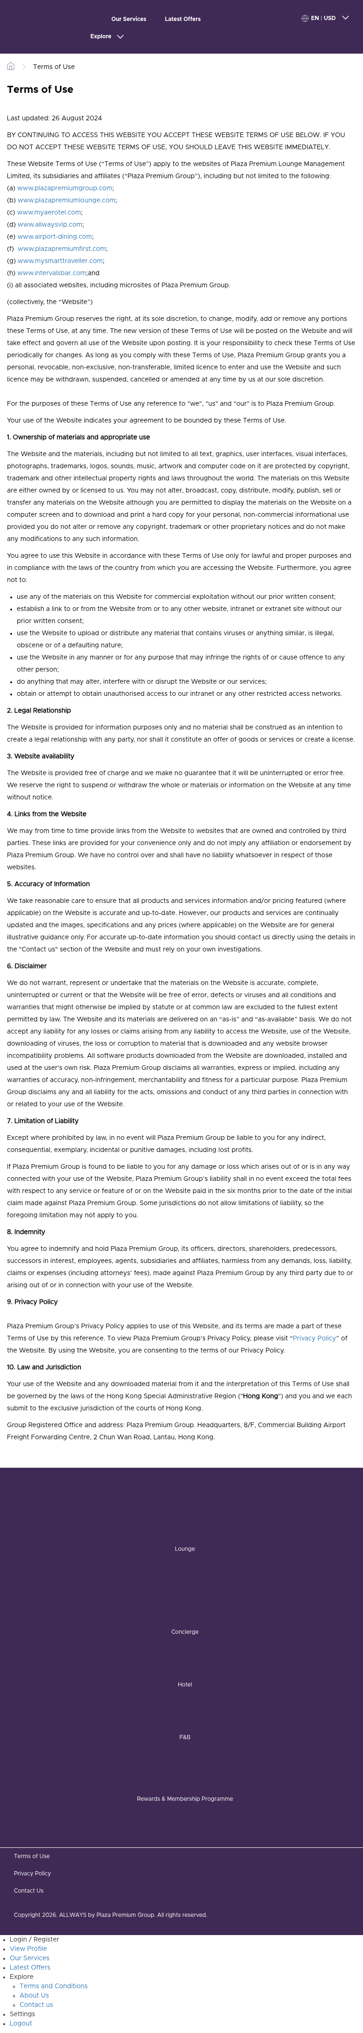
T9 — Legal Page (Terms of Use)

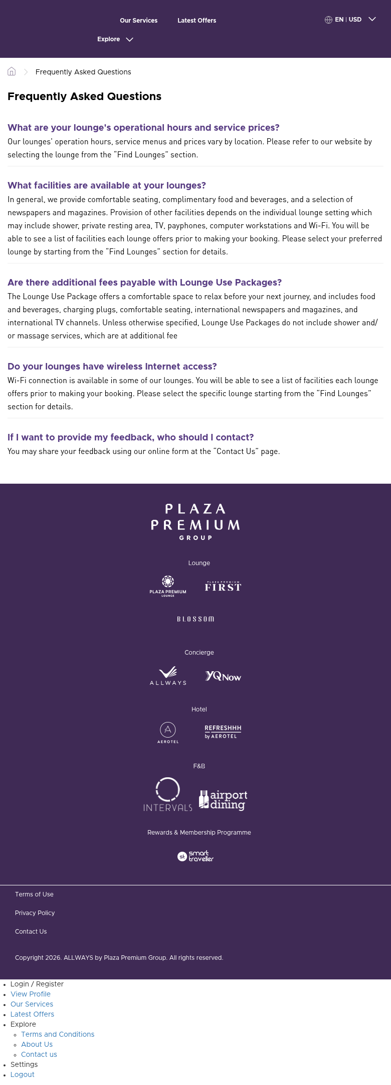
T10 — FAQ Page

2. Blocks / Components Catalog
The site uses 19 reusable blocks/components. Where blocks share the same content model but differ visually, they are cataloged as design variations rather than separate blocks.
# | Block Name | Complexity | Description & Behaviour | Reference URL(s)
B1 | Header / Navigation | High | Sticky dark purple header: ALLWAYS SVG logo, 3-item main nav (Our Services, Latest Offers, Explore dropdown), Login/Register, language/currency selector (3 langs, 17+ currencies), off-canvas mobile hamburger menu. | All pages
B2 | Footer — Brand Showcase | Medium | Dark purple section: Plaza Premium Group master logo, categorized brand logos (Lounge, Concierge, Hotel, F&B, Rewards). External links to sibling brands. | All pages
B3 | Footer — Navigation Bar | Low | Dark gray bar: Terms of Use, Privacy Policy, Contact Us links + copyright notice. | All pages
B4 | Hero Banner with Booking Widget | High | Large hero image with diagonal geometric overlay. Interactive booking form: location autocomplete, service type tabs, journey type radios, date/time pickers, guest selector, promo code, Search CTA. AJAX-powered. | Homepage, Offer Detail sidebar
B5 | Service / Offer Card | Low | Reusable card: thumbnail image, H4 title, excerpt text, teal 'Explore >' CTA. Same model for services and offers. Responsive grid layout. | Services Listing, Offers Listing, Related sections
B6 | Breadcrumb | Low | Horizontal breadcrumb: Home icon > Section > Page. All interior pages. | All interior pages
B7 | YouTube Video Embed | Low | Standard YouTube iframe embed within content area. | Homepage, About Us
B8 | Section Heading with Subtitle | Low | Centered H2 heading with optional styled subtitle. Used for content section introductions. | Homepage, Listing pages
B9 | Related Content Section | Medium | Dynamic section showing related items using card component (B5). Two variants: location-aware and non-location-aware. Drupal Views-powered. | Service Detail, Offer Detail
B10 | Contact Form (Webform) | High | Drupal webform: enquiry dropdown, name fields, email, phone with country code, booking ref, location, journey type, IATA code, date/time, message, submit. Includes validation. | Contact Us
B11 | Contact Directory Table | Medium | Large data table (116 rows × 4 cols): Service Location, Airport, Contact Number, Operating Hours. Alphabetical. Headquarters section below. | Contact Us
B12 | Registration Form | High | Smart Traveller registration: personal details, email confirmation, phone with country code, password, GDPR toggle, data privacy accordion, T&C checkbox, Reset/Submit. | Register page
B13 | FAQ List | Low | Q&A list: styled teal question headings, answer paragraphs, horizontal rule separators. Static content. | FAQs
B14 | Cookie Consent Banner | Low | Fixed dialog: privacy notice text, 'here' details button, 'Understood' dismiss. ConsenTag + Drupal EU Cookie Compliance. | All pages (first visit)
B15 | Login Modal | Medium | Hidden popup: email/password fields, Forgot Password, Register link. Triggered by header Login link. Arrture auth integration. | All pages (via header)
B16 | Language / Currency Selector | Medium | Header dropdown: 3 languages (EN, ZH-CN, ZH-TW), 17+ currencies. sessionStorage persistence. Page reload on change. | All pages (header)
B17 | Offers Hero Banner | Low | Decorative banner: diagonal turquoise geometric shapes on purple + overlaid text. Design variation of B4 without booking widget. | Offers Listing
B18 | Search / Filter Bar | Low | Inline search input with magnifier icon, right-aligned next to page title. Text-based card filtering. | Services Listing, Offers Listing
B19 | Language Tabs (Content) | Low | Horizontal tab switcher (e.g., English | Español) within offer content to toggle translated versions. | Offer Detail pages

3. Page Counts by Template
Template | Page Count | Migration Approach
T1 — Homepage | 1 | Manual — Unique layout, complex booking widget, video, dynamic location detection
T2 — Service Listing | 1 | Semi-Auto — Standardized card grid, but location-aware dynamic filtering requires custom logic
T3 — Service Detail | 12 | Automatic — Consistent template: image + body text + airport list. Standardized structure.
T4 — Offers Listing | 1 | Semi-Auto — Same pattern as Service Listing. Location-filtered card grid.
T5 — Offer Detail | 26 | Semi-Auto — Consistent two-column layout, content varies (language tabs, T&Cs, images). Booking widget sidebar is dynamic.
T6 — Content Page | 3 | Automatic — Simple text + optional video. Low complexity.
T7 — Contact Form | 1–2 | Manual — Complex webform + 116-row contact directory. Form logic needs reimplementation.
T8 — Registration Form | 2 | Manual — External Smart Traveller/Arrture auth system. Cannot be static content.
T9 — Legal / Policy | 3 | Automatic — Pure long-form text. No interactivity.
T10 — FAQ | 1 | Automatic — Simple Q&A content. No dynamic behavior.

Migration Category Summary
Category | Page Count | Details
Automatically migratable | 19 | 12 service details + 3 content pages + 3 legal + 1 FAQ
Semi-automatically migratable | 28 | 26 offer details + 1 service listing + 1 offer listing
Manual migration required | 5–7 | Homepage + contact form + 2 registration/auth forms + booking pages
Total | ~54 | All pages from sitemap and navigation

4. Integrations Analysis
# | Integration | Type | Complexity | Description | Reference URL(s)
I1 | Booking Platform  (booking.allwaysvip.com) | Custom Application | High | Separate subdomain with custom booking/reservation system. Bootstrap + Swiper.js. Full booking workflow: service selection, date/time, guest details, payment. | booking.allwaysvip.com
I2 | Stripe Payment Gateway | API / Embed | High | Stripe Elements for PCI-compliant credit card processing on booking checkout. | booking.allwaysvip.com (checkout)
I3 | Smart Traveller / Arrture Auth | API / Custom | High | User registration, login, profile management. GDPR consent collection. Separate profile at booking.allwaysvip.com/profile. | /form/arrture-register, login modal
I4 | Google Tag Manager | Embed | Medium | Container GTM-N6GBBND. Orchestrates all analytics/marketing tags. Likely deploys GA4, Facebook Pixel via server config. | All pages
I5 | ConsenTag (Cookie Consent) | Embed / Plugin | Medium | Container 67407556. Cookie consent management controlling tracking scripts. silentMode: true. Coordinates with GTM. | All pages
I6 | Drupal EU Cookie Compliance | Plugin | Low | Drupal module providing cookie consent banner UI with dismiss button. | All pages
I7 | AffiliRed (Affiliate Tracking) | Embed | Medium | Merchant ID 4805. Affiliate marketing network for partner referral tracking and conversion attribution. | All pages (global script)
I8 | Currency Conversion API | API (Internal) | Medium | AJAX POST endpoint at /currency_convert. 20+ currencies (AED, AUD, BRL, CAD, CNY, EUR, GBP, HKD, JPY, USD, etc.). | Homepage, booking widget
I9 | Location Autoselect | Custom Code | Medium | Custom Drupal module detecting user location, auto-selecting nearest airport. Drives ?loc= URL parameter. Partner/white-label detection. | All pages
I10 | YouTube Embeds | Embed | Low | Standard YouTube iframe player for promotional videos. | Homepage, About Us
I11 | Netcore Smartech | Embed | Low | Marketing automation / push notification service from osjs.netcoresmartech.com. | All pages
I12 | White-Label Partner System | Custom Code | High | Partner code detection via sessionStorage (e.g., 'VISACHINA' triggers rebrand to 'YQNow'). B2B distribution with custom branding per partner. | Booking platform, offer pages

5. Complex Use Cases & Observations
# | Complex Behaviour | Instances | Where Found | Why It's Complex
C1 | Location-Aware Content Filtering | All pages | Every page uses ?loc= parameter; services/offers filtered by airport. ~113 airports supported. | Content varies dynamically per airport. Migration must replicate logic or create location-specific pages.
C2 | Booking Search Widget | 2 instances + booking platform | Homepage (full-page), Offer Detail (sidebar), booking.allwaysvip.com | Complex interactive form: location autocomplete (AJAX), date/time pickers, guest counter. Cannot be replicated as static EDS content.
C3 | Multi-Currency Display | All priced pages | Currency selector in header, AJAX conversion API | Real-time conversion across 20+ currencies without page reload. Requires client-side API or pre-computed variants.
C4 | Multi-Language Content | All pages + offer details | Header switcher (EN/ZH-CN/ZH-TW), content language tabs on offers | 3 languages. Some offer pages have inline tabs (English/Español). Session-based language persistence.
C5 | White-Label Partner Branding | 10+ partners | Booking platform, offer pages (Perkopolis, MTA Travel, VIP Ontario Tours, etc.) | Partner-specific branding via session storage. Changes logos, colors, services per partner code.
C6 | Authentication & User Profiles | 3 pages + modal | /form/arrture-register, /form/forgot-password, /view-profile, login modal | External Arrture/Smart Traveller auth system. Session-dependent content (logged-in vs. guest).
C7 | Location Redirect Modal | All pages (conditional) | Triggered when user is at location without digital booking | Modal warns of redirect to 'original booking site'. Conditional logic based on airport capabilities.
C8 | Dynamic Airport Lists | 12 service detail pages | Each service detail page | Airport lists vary per service (Meet & Assist: 113, Limousine: 3). Centrally managed, filtered per service.

6. Migration Estimates

Effort Breakdown
Phase 1: Foundation Setup
Task | Scope | Effort | Notes
Project scaffolding & design tokens | Global styles, fonts, colors, CSS custom properties | 2–3 days | Extract from Drupal theme, establish EDS global styles
Header / Navigation block | Responsive header, mobile menu, language selector | 3–4 days | Complex: dropdown, off-canvas mobile, language/currency switcher needs custom JS
Footer block | Brand showcase + nav footer | 2 days | Multi-section footer with logo grid, categorized brands

Phase 2: Content Templates
Task | Scope | Effort | Notes
Content pages (T6, T9, T10) | About, Legal, FAQ — 7 pages | 1–2 days | Simple text, auto-migratable with import script
Service Detail (T3) | 12 pages | 2–3 days | Consistent template. Build once, import script handles rest.
Service Listing (T2) | 1 page | 1–2 days | Card grid with search filter. Custom block for card rendering.
Offer Detail (T5) | 26 pages | 3–4 days | Two-column layout, language tabs, T&C. Semi-automated after template.
Offer Listing (T4) | 1 page | 1 day | Same pattern as Service Listing
Homepage (T1) | 1 page | 3–5 days | Unique layout, hero, video, cards. Booking widget = link/redirect.

Phase 3: Complex Components
Task | Scope | Effort | Notes
Booking Widget integration | Homepage + Offer Detail sidebar | 2–3 days | Options: iframe embed, redirect to booking.allwaysvip.com, or simplified CTA.
Contact Form (T7) | 1 page | 2–3 days | Webform replacement (AEM Forms or third-party). Contact directory table.
Registration / Auth (T8) | 2 pages | 1 day | Likely remain on Arrture platform. Migration = redirect links.

Phase 4: Dynamic Features
Task | Scope | Effort | Notes
Location-aware content | All pages | 3–5 days | Strategy: static pages per location vs. client-side filtering. Major decision.
Multi-language support | All pages | 3–4 days | EDS multi-language setup. Content authoring in 3 languages.
Currency conversion | Booking-related pages | 1–2 days | Client-side API call or redirect to booking platform for pricing.

Phase 5: QA & Testing
Task | Scope | Effort | Notes
Visual regression testing | All 54 pages | 3–4 days | Compare EDS output against original site screenshots
Functional testing | Forms, navigation, links, responsive | 2–3 days | Cross-browser, mobile responsiveness, link validation
Performance testing | Lighthouse, Core Web Vitals | 1–2 days | Target Lighthouse score of 100
Content review | All migrated content | 2–3 days | Accuracy check, missing content, broken images

Total Effort Summary
Category | Effort
Automated Migration (content, service details, legal) | 3–5 days
Semi-Automated Migration (offers, listings) | 5–7 days
Manual / Custom Migration (homepage, forms, booking) | 8–12 days
Dynamic Features (location, language, currency) | 7–11 days
QA & Testing | 8–12 days
Total Estimated Effort | 31–47 days (~6–9 weeks, 1 developer)

Key Migration Decisions Required
Decision | Options | Impact
Booking Widget | (A) Embed as iframe from booking.allwaysvip.com  (B) Redirect to booking platform  (C) Rebuild simplified version in EDS | High — central to user journey
Location-Aware Content | (A) Static pages per airport (113 × N pages)  (B) Client-side JS filtering  (C) Single content with location API | High — affects page count and content model
Authentication | (A) Keep on Arrture platform (redirect)  (B) Integrate via client-side SDK  (C) Rebuild in AEM | High — affects user session handling
Multi-Language | (A) EDS folder-based i18n (/en/, /zh-cn/, /zh-tw/)  (B) Client-side language switching | Medium — triples content authoring effort
Contact Form | (A) AEM Forms  (B) Third-party service (Typeform, JotForm)  (C) Simple mailto link | Medium — functional replacement needed

Risk Factors
- Booking platform dependency: The booking flow at booking.allwaysvip.com is a separate application and is out of scope for EDS migration. Integration strategy (iframe vs. redirect) is the highest-risk decision.
- Location logic complexity: 113 airports with location-specific service availability creates significant content modeling challenges.
- White-label partner system: Partner-specific branding may require custom EDS middleware or separate microsites.
- Content freshness: Offer pages are time-sensitive (flash sales, seasonal promotions). Authoring workflow must support rapid content updates.

