**Apriori**

**- Programming assignment #1**

**2013011060**

**양승호**

**1. Environment**

Ubuntu Linux 18.04

Python 3.6.7

**2. How to run**

$ python3 apriori.py [support] [input_file_name] [output_file_name]

**3. Algorithm Summary**

1. Find frequent 1-itemsets.

2. Generate combinations from the set.

3. Check whether the each combination satisfies the support and abandon the sets which don’t satisfy.

4. Print the remaining results and iterate from [Procedure 2] until there is no candidates happen.

**4. Details**

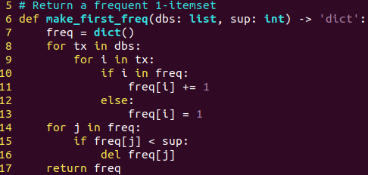

- Return a frequent 1-itemset from the dbs(input file)

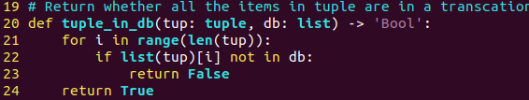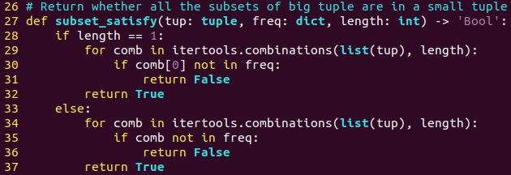- check whether the each combination is in the db(transacton of input file)

- check whether the subsets of each candidates are in frequent itemsets

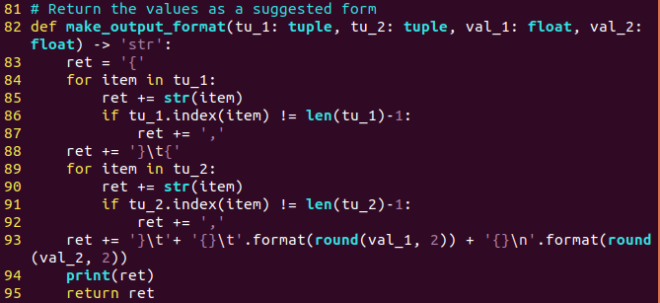- return an output form using each itemsets, support and confidence

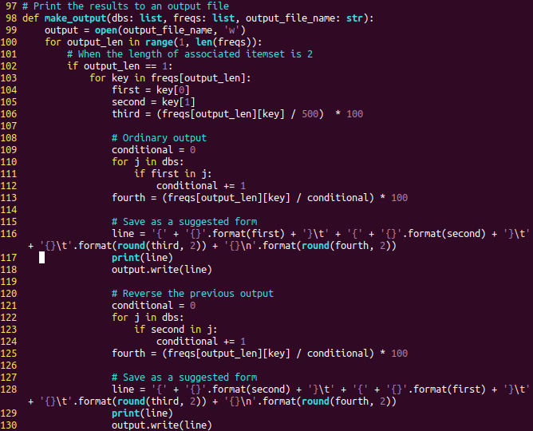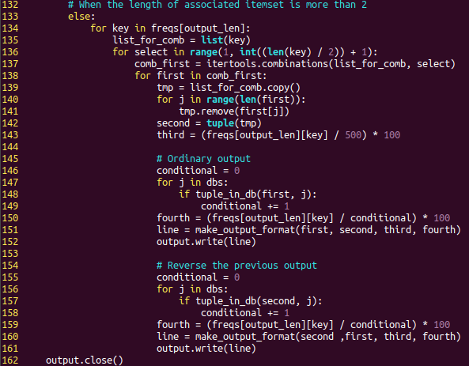

- Print the result as a suggested form using make_output_format(params) function

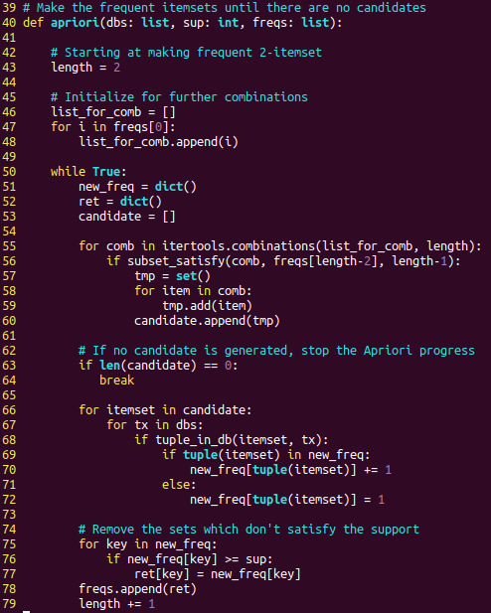- Make frequent itemsets using candidates until there are no candidiates

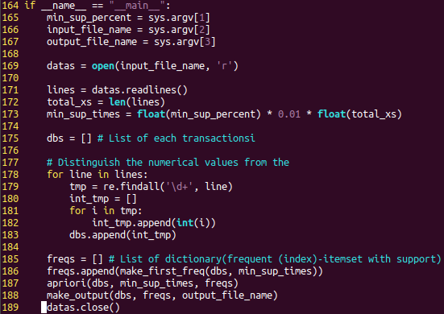- main func

- first get the command line arguments, and convert the percentage to appear_times

- and refine the datas from input file

-and make progress to Apriori, output file