**Clustering**

**- Programming assignment #3**

**2013011060**

**양승호**

**1. Environment**

Ubuntu Linux 18.04

Python 3.6.7

**2. How to run**

$ python3 clustering.py [input_file_name] [number_of_clustering] [Eps] [minPts]

(example: python3 clustering.py input2.txt 5 2 7)

**3. Algorithm Summary**

**- DBSCAN**

1. Arbitrary select a starting point.(I used the first object of the input file)

2. Get the density-reachable points from the prior selected point

3. Merge the new cluster with prior cluster if the core points are density-reachable each other.

4. Repeat until all the points are checked at least once.

**4. Details**

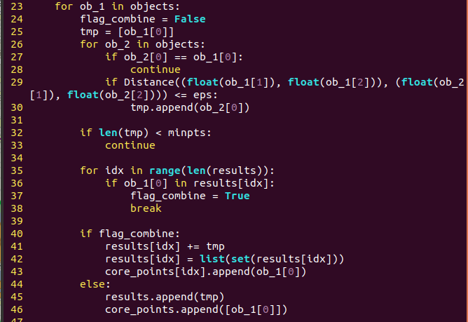- main function of DBSCAN

- Iterating in each objects of inputfile, find all points which are closer than the range of epsilion, and check the condition whether the number of satisfying points is more than minPts.

- Check whether the core point is already in the other cluster.

- If so, then combine the clusters and repeat the process.



- return the distance between two points