https://github.com/adam-p/markdown-here/wiki/Markdown-Cheatsheet
- Headers:
- # H1
- ## H2
- ### H3
- #### H4
- ##### H5
- ###### H6
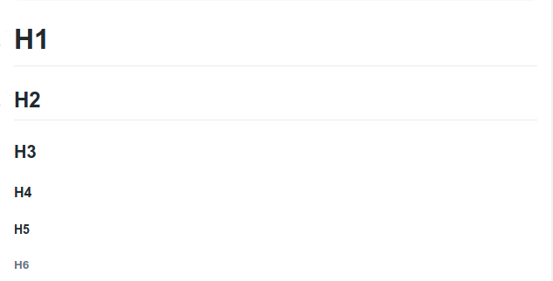
Output:

- Emphasis:

Code:
- Emphasis, aka italics, with *asterisks* or _underscores_.
- Strong emphasis, aka bold, with **asterisks** or __underscores__.
- Combined emphasis with **asterisks and _underscores_**
- Strikethrough uses two tildes. ~~Scratch this.~~

Output:
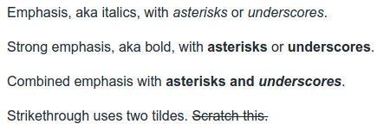

- Lists:

- Links:
- Images:
- Code and Syntax Highlighting:
- Tables:
- Block quotes:
- Inline HTML:
- Horizontal Rule:
- Line Breaks:
- YouTube Videos:

