This idea involves the design and inteface of an app known as Reverseso.

**Logo of the app**

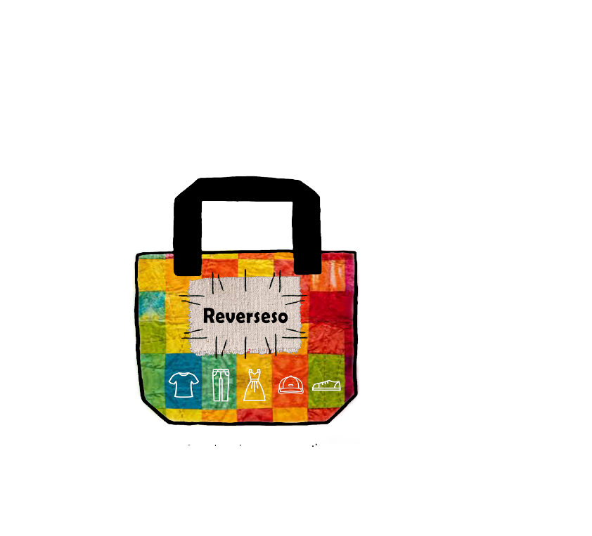

**INTRODUCTION**

The primary aim of this app is to create a virtual trial room for the online consumers this app is mainly for the teenagers who mostly buy their things online and feels annoying to visit shopping mall and also for them who shops most of the things online. It basically focuses on the clothes or we can say outfit and accessories like shades or sunglasses and scarfs just think for once before buying clothes from online if you can wear and see the clothes how amazing it would be. Just think for once you liked a good outfit on online shopping and you want to buy that outfit but you are confuse whether it would suit you or not my app will solve that problem in minutes it will create a virtual trial room for you and it will provide you an analyse how good or bad are you looking at your outfit which you want to buy and you can also share your virtual trial room images to your near and dear ones to take the view point of them. Exactly what do you mean by a trial room it is that area where you can try the outfits or dresses you buy so my app is also doing the same thing for online consumers. They can easily sit at home and try their outfits which they want to buy from online and accessories before ordering from online. The app works in a simple manner the proccess you do when you visit a shopping mall is the same process my app will do. First you visit a shopping mall select your favourite brand shop then you choose your favourite outfit and before buying you trial that outfit on you whether it is looking good or bad on you.

The kind of problem my app will solve are:

1. When you buy online you can’t try that outfit or that accessories (shades, sunglasses, scarfs) before buying. You can only try that outfit or accessories when it is received by you which is major disadvantage of online shopping.
2. Often when you received your parcel you find they don’t fit very well. Its always annoying when a dress is little too big, or when sleeves are awkwardly short.
3. When order has to be returned by you that’s the worst and annoying part of online shopping and hectic job.
4. You have to pay for your’s order delivery, and for an item to be returned to the warehouse. So extra expenses is also an headache for the consumer.

For this kind of problems people don’t choose to shop online.

And this kind of problem can be easily solved by an app.

Name as “**Reverseso**”

**Target market**: The target market according to me wil be firstly the mind of the teenagers and the person who shops most of the things online as this app helps the teenagers and others to shop online more effectively and efficiently by providing them a virtual trial room and a analyser and secondly the most important target market is the online shoppers this app will increase the sales of online shoppers and less return of order will take place which will also reduce the headache of online shoppers and which will help them to save their resources.i am not capable of developing a app right now i need good knowledge for it i will try to promote my idea as hard as i can and try to acquire knowledge and i will get familiar with app developing techniques and then i will start developing my app.

**Manifesto ;**

**Interactions with developers :** Interactions with developers or client department for easy interface between user and application i.e making amateur tools that any age of person can use moderately.

**Customer collaboration** : We can collab accessing or surfing our application. Collaborating with customer not only give us support for better application but along we get innovative ideas that we can implement in application.

**Respond to Change :** As we get reviews from user and problems related to application or product, but as ability to making changes decrease & cost increases. By through reviews we can our update application to fulfill customer basic needs and Our team will approach planning, working & giving priorities to feedback/ reviews and giving them a quick change for nil disturbance.