**The Application of Trigonometry in Real Life**

**Introduction—What is Trigonometry?**

In the vast expanse of mathematics, few disciplines hold the same importance as trigonometry. Transcending the boundaries of a mere triangle, beyond the basic sine, lies a complex organization of structure for the ancient and modern worlds.

Trigonometry has been uncovering cryptic, hidden patterns of the universe for centuries, overlooking the angles, shapes, and movements of our world. As a branch of mathematics dedicated to the study of triangles, trigonometry delineates the attributes and interconnections between their sides and angles. It stands as a cornerstone within the realms of mathematical sciences, playing a crucial role in various aspects of everyday life, including architecture, engineering, music production, and industrial manufacturing. The study of triangles is also crucially involved in the intricate details of life, such as the precise design of architectural elements such as pillars and domes, as well as everyday household furnishings.

**Definition of Trigonometry—How do you define the functions of trigonometry?**

Trigonometry, simply known as the study of triangles, is defined scientifically as “the study of angles and the angular relationships of planar and three-dimensional figures” (Wolfram Math World).

Theta θ:

* Theta is the eighth letter of the Greek alphabet, as well as the way to define an angle in trigonometry. When performing a function upon an angle, the angle is defined as θ.

Below are the six basic functions of trigonometry:

* Sine (sin) is the ratio between the opposite side of the angle θ and the hypotenuse of the triangle, or mathematically,
$$\frac{opposite}{hypotenuse}$$

* Cosine (cosine) is the ratio between the adjacent side of the angle θ and the hypotenuse of the triangle or mathematically,
$$\frac{adjacent}{hypotenuse}$$

* Tangent (tan) is the ratio between the opposite side of the angle θ and the adjacent side of the same angle θ, or mathematically,
$$\frac{opposite}{adjacent}$$

* Cosecant (csc) is the ratio between the hypotenuse of the triangle and the opposite side of the angle θ, or mathematically, . It is also the reciprocal of the trigonometric function sine.
$$\frac{hypotenuse}{opposite}$$

* Secant (sec) is the ratio between the hypotenuse of the triangle and the adjacent side of the angle θ, or mathematically, . It is also the reciprocal of the trigonometric function cosine.
$$\frac{hypotenuse}{adjacent}$$

* Cotangent (cot) is the ratio between the adjacent side of the angle θ and the opposite side of the angle θ, or mathematically, . It is also the reciprocal of the trigonometric function tangent.

$$\frac{adjacent}{opposite}$$

**Application in Real Life—How Does Trigonometry Affect Our Daily Life?**

In real-life applications, trigonometry is utilized in various objects, from the smallest and simplest designs to magnificent and towering architectural wonders. Its relevance is particularly pronounced in fields such as astronomy and architecture.

**Astronomy**

* Trigonometric parallax: the direct measurement of the distance of a celestial body from a baseline of known length and the angles at the ends of the baseline

Formulas Used:

$$\frac{\sin{A}}{a}={\frac{\sin{B}}{b}=\frac{\sin{C}}{c}}$$

* Law of Sine:
* Law of Cosine:

$$\text{ b}\text{2}\text{= a}\text{2}\text{ + c}\text{2}\text{ - 2ac cos(}{B )}$$

$$\text{c}\text{2}\text{ = a}\text{2}\text{ + b}\text{2}\text{ - 2ab cos(}{C )}$$

$$\text{a}\text{2}\text{ = b}\text{2}\text{ + c}\text{2}\text{ - 2bc cos(}{A )}$$

Trigonometry has been instrumental in facilitating many remarkable advancements in the field of astronomy, including the precise determination of the distance between the Earth and various other celestial bodies. Trigonometry has also opened discoveries such as our fascinating exploration of Mars. In modern astronomy, people use a method defined as *trigonometric parallax* to measure distances in space.

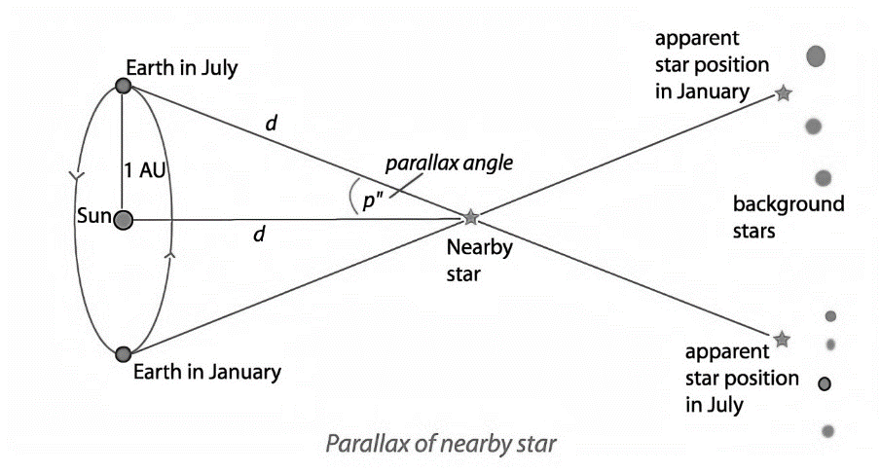Using trigonometric parallax, astronomers can measure the distance between Earth and another star by observing their positions. Two measurements are taken: one during the summer solstice and one during the winter solstice, the two days when Earth is perpendicular to the sun. A star acts as a reference point for the two bodies, helping to form the parallax angle. By knowing the distance between the reference point and Earth, astronomers can use triangle-solving methods to determine the distance between Earth and the faraway star.

**Architecture**

* Truss: an assemblage of beams forming a rigid framework

Trigonometry can be used to deduce the height of architectural wonders, but this study also plays a role in balancing practicality with appearance. Trigonometry helps determine details in construction that make houses functional, such as the ideal slope for a roof.

One method for measuring the height of tall buildings does not involve physically scaling the building but instead relies on a more consistent and reliable approach. In this method, an individual stands at a known distance from the building and uses a clinometer to measure the angle between their line of sight and the top of the building. By defining the distance between the person and the building as ‘*d*,’ the angle as ‘*θ’* and the height of the person's eyes as *‘a’*, the building's height can be calculated using the tangent function, yielding the formula *d tan θ + a*.

Additionally, more complex applications of trigonometry in architecture focus on aspects with more contributing factors. For example, the *basic structural theory* allows architects to understand forces and loads acting upon objects.

As the adage says, “The triangle is the strongest shape.”

In architecture, the special right triangle with a 3:4:5 ratio is considered to be the strongest and most stable. Architects frequently use trusses to assess forces and determine stresses at work, ensuring that buildings can withstand weather conditions. Stable structures also enable engineers to construct taller buildings, as evidenced by iconic structures like the Burj Khalifa in Dubai and Pearl Tower in Shanghai, famous for their exceptional quality and harmoniously balanced proportions.

**Practice Problems**

1. Alice’s eyes are 1.5 meters above ground. If she stands 5 meters from the base of a building and sees the tip of the building at a 75-degree angle, how tall is the building?
2. Given that Bob knows two sides and one angle of a triangle arranged in SAS, which formula must he use, the law of sine or cosine?
3. In triangle ABC, it is given that angle B has a measure of 60 degrees, angle C has a measure of 35 degrees, and side A has a length of 4 meters. Solve triangle ABC.
4. **Creative Thinking**: Aside from astronomy and architecture, think of another field trigonometry is used in and, with research, provide specific examples.

**三角函数在现实生活中的应用**

**引言——什么是三角学？**

在浩瀚的数学领域，很少有学科能像三角学那样重要。超越简单三角形的边界，超越基本正弦曲线，是古代和现代世界复杂的结构组织。

几个世纪以来，三角学一直在揭示宇宙中神秘、隐藏的模式，俯瞰着我们世界的角度、形状和运动。作为专门研究三角形的数学分支，三角学描绘了三角形边和角之间的属性和相互联系。它是数学科学领域的基石，在日常生活的各个方面发挥着至关重要的作用，包括建筑、工程、音乐制作和工业制造。三角形的研究也与生活的复杂细节息息相关，例如柱子和圆顶等建筑元素的精确设计，以及日常家居用品。

**三角函数的定义——你如何定义三角函数？**

三角法，简称三角形研究，在科学上被定义为“研究平面和三维图形的角度和角度关系”（Wolfram Math World）。

Theta θ:

* Theta是希腊字母表中的第八个字母，也是三角学中定义角度的方法。当对一个角度执行函数时，该角度被定义为θ。

以下是三角学的六个基本功能：

* 正弦（sin）是角度θ的对边与三角形斜边之间的比值，或者 $\frac{对边}{斜边}$.
* 余弦（cos）是角度θ的相邻边与三角形斜边之间的比率，或者 $\frac{邻边}{斜边}$.
* 正切（tan）是角度θ的相对边与相同角度θ的相邻边之间的比率，或者 $\frac{对边}{邻边}$.
* 余弦（csc）是三角形斜边与角度θ对边之间的比率，或者 $\frac{斜边}{对边}.$ 它也是三角函数正弦的倒数。
* 割线（sec）是三角形斜边与角度θ相邻边之间的比率，或者 $\frac{斜边}{邻边}.$ 它也是三角函数余弦的倒数。
* 余切（cot）是角度θ的相邻边与角度θ的相对边之间的比率，或者 $\frac{邻边}{对边}$.它也是三角函数正切的倒数。

**现实生活中的应用——三角学如何影响我们的日常生活？**

在现实生活中，三角学被用于各种物体，从最小和最简单的设计到宏伟和高耸的建筑奇观。它的相关性在天文学和建筑学等领域尤为明显。

**天文**

三角视差：直接测量天体与已知长度基线的距离以及基线两端的角度

运用的公式：

$$\frac{\sin{A}}{a}={\frac{\sin{B}}{b}=\frac{\sin{C}}{c}}$$

* 正弦定律:
* 余弦定律

$$\text{c}\text{2}\text{ = a}\text{2}\text{ + b}\text{2}\text{ - 2ab cos(}{C )}$$

$$\text{ b}\text{2}\text{= a}\text{2}\text{ + c}\text{2}\text{ - 2ac cos(}{B )}$$

$$\text{a}\text{2}\text{ = b}\text{2}\text{ + c}\text{2}\text{ - 2bc cos(}{A )}$$

三角测量在促进天文学领域的许多显著进步方面发挥了重要作用，包括精确确定地球和其他各种天体之间的距离。三角测量也开启了一些新的发现，比如我们对火星的迷人探索。在现代天文学中，人们使用一种被定义为三角视差的方法来测量空间距离。

利用三角视差，天文学家可以通过观察地球和另一颗恒星的位置来测量它们之间的距离。进行了两次测量：一次在夏至，一次在冬至，也就是地球垂直于太阳的两天。恒星作为两个物体的参考点，有助于形成视差角。通过知道参考点和地球之间的距离，天文学家可以使用三角形求解方法来确定地球和遥远恒星之间的距离。

**建筑**

* 特拉斯：形成刚性框架的梁的组合

三角法可以用来推断建筑奇观的高度，但这项研究也在平衡实用性和外观方面发挥了作用。三角测量有助于确定使房屋实用的建筑细节，例如屋顶的理想坡度。

一种测量高层建筑高度的方法不涉及物理缩放建筑，而是依赖于更一致和可靠的方法。在这种方法中，一个人站在离建筑物已知距离处，使用测斜仪测量他们的视线与建筑物顶部之间的角度。通过将人与建筑物之间的距离定义为“d”，角度定义为“θ”，人眼睛的高度定义为“a”，可以使用切线函数计算建筑物的高度，得到公式d=tanθ+a。

此外，三角学在建筑中更复杂的应用集中在影响因素更多的方面。例如，基础结构理论使建筑师能够理解作用在物体上的力和载荷。

正如谚语所说，“三角形是最强的形状。”

在建筑中，比例为3:4:5的特殊直角三角形被认为是最强、最稳定的。建筑师经常使用桁架来评估力并确定工作中的应力，以确保建筑物能够承受天气条件。稳定的结构也使工程师能够建造更高的建筑，迪拜的哈利法塔和上海的珍珠塔等标志性建筑就是明证，这些建筑以其卓越的品质和和谐平衡的比例而闻名。

**练习题**

1） 爱丽丝的眼睛高出地面1.5米。如果她站在距离建筑物底部5米的地方，以75度的角度看到建筑物的顶端，那么建筑物有多高？

2） 假设Bob知道SAS中排列的三角形的两条边和一个角，他必须使用哪个公式：正弦定律还是余弦定律？

3） 在三角形ABC中，给定角度B的度量为60度，角度C的度量为35度，边a的长度为4米。解三角形ABC。

4） 灵活思考：除了天文学和建筑学之外，想想三角学在另一个领域的应用，并通过研究提供具体的例子。