**Permutations and Combinations and Their Importance**

8(12) Chris

**Introduction**

Mathematics is the most basic language of the universe, and within its vastness, permutations and combinations hold a special place. Permutations and combinations are two fundamental concepts in mathematics that are essential for counting and arranging objects in various situations. They play crucial roles in multiple fields, such as statistics, computer science, and cryptography, as well as in everyday decision-making, like organizing groups or determining probabilities. Understanding permutations and combinations is important for anyone who wants to delve deep into the quantitative aspects of the world around us.

Permutations and combinations are ways of selecting a certain number of objects from a larger group. In math, they are commonly used in solving probability and expected value problems. Be careful when differentiating permutations and combinations, where permutations consider the order in which the objects are chosen while combinations do not.

**Definitions of the Two Terms**

1. **Permutations**:
   * A permutation is the way a set or number of objects can be ordered or arranged.
   * The specific order of the elements matters in a permutation.
   * The number of permutations of n objects taken r at a time is given by the formula $P_{n}^{r}$ = $\frac{n!}{(n-r)!}$,where n! (n factorial) is the product of all positive integers up to n.
2. **Combinations**:
   * A combination is a selection of objects from a set where the order DOES NOT matter.
   * The order of the elements does not matter in a combination
   * The number of combinations of n objects taken r at a time is given by the formula $C_{n}^{r}=\frac{n!}{(n-r)! r!}$ .

**Examples**

For example, we use permutation when we want to find out the number of ways to arrange the letters in the word “MATHEMATICS” because the order of the letters matter. Additionally, when considering permutations, the same elements are considered equivalent. So, the answer of this problem is not 11! because there are 2 “A” s and 2 “T” s. Therefore, it is necessary to divide the previous answer by 2! twice in order the remove the repeating answers, resulting in $\frac{11!}{2!2!}$.

For another example, we use combination when we want to find out how many ways there are to choose 4 people from a class with 26 people to give a presentation. We use combination because order doesn’t matter as choosing person A first and then choosing person B is the same as choosing person B first and then person A. Thus, the answer to this question is $C_{26}^{4}=\frac{26!}{(22)! 4!}=14950$.

**Extensions**

The Pascal’s Triangle is often used when solving combination problems. The Pascal’s Triangle is a magical triangle of numbers with first row “1”, and every following number is equal to the sum of the two numbers above it. It turns out that every number in the Pascal’s triangle is equal to $C_{n-1}^{m-1}$, where n is the row, it is in and m is the position of the number in the row, both starting with 1.

**1**

**1 1**

**1 2 1**

**1 3 3 1**

**1 4 6 4 1**

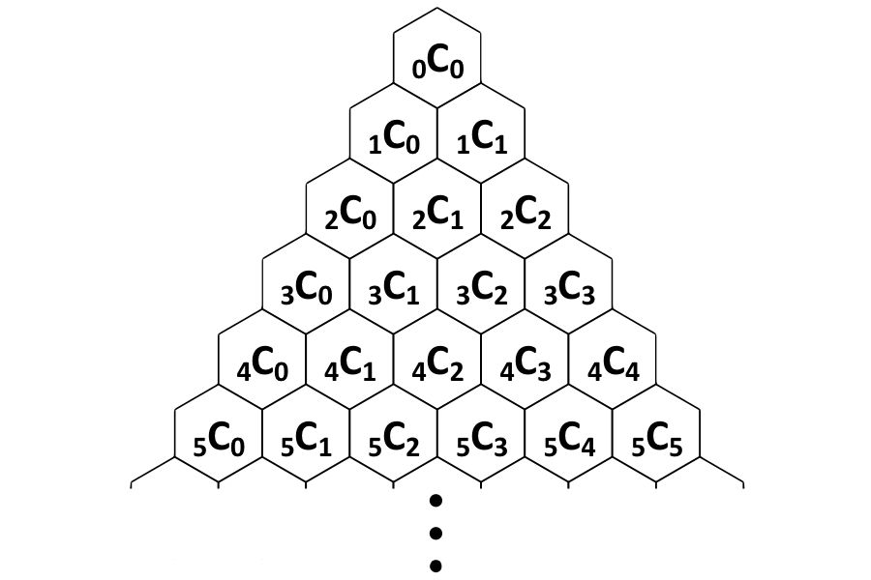

Combining this with the definition of the Pascal’s Triangle, we can prove multiple combinatorial identities, such as:

1. $C_{n - 1}^{m - 1} + C_{n - 1}^{m} = C_{n}^{m}$

2. $\sum_{i = 0}^{n}{C_{n}^{i}} = C_{n}^{0} + C_{n}^{1} +C_{n}^{2} + ... + C_{n}^{n - 1} + C_{n}^{n} = 2^{n}$

3. $\sum_{i = n}^{m}{C_{i}^{n}} = C_{n}^{n} + C_{n + 1}^{n} +C_{n + 2}^{n} + ... + C_{m - 1}^{n} + C_{m}^{n} = C_{m + 1}^{n + 1}$

**Practice Problems To Test Yourself**

（The answers will be revealed in the next article, so please subscribe to our account!）

1. In how many different ways can you arrange the letters in the word “PRIMOMATH”?
2. From a class of 25 people, in how many ways can you choose 3 people to be a part of the Student Board, with 1 person as the president and 2 people as the vice-president?
3. From 7 different Math books and 5 different English books, in how many ways can you select 4 Math and 3 English books?
4. Robert decided to pick six balls from n balls, while Joe picked nine balls from another pile of n balls. They soon realize that the number of choices Joe has is $\frac{13}{3}$ times the number of choices Robert has. Find n.

**排列组合及它们的重要性**

8(12) Chris

**背景介绍**

数学是宇宙最基本的语言，而排列组合在其中占据着独特的位置。排列与组合是数学中的两个关键概念，对于计数问题和各种情况下的对象排序至关重要。它们不仅在统计学、计算机科学、密码学等多个领域发挥着重要作用，它们在日常决策中，如组织团体或计算概率时，也同样不可缺少。想要深入探索我们生活中的量化现象，我们必定需要理解和掌握有关排列组合的知识。

排列和组合是从一组较多的对象中选取一定数量对象的不同方式。在数学中，它们常用于解决概率和期望值的问题。区分排列和组合时要注意，排列强调选择对象的顺序，而组合则忽略顺序。

**定义**

**排列**:

* 排列是对一组物品进行排列的方式。
* 每个物品的具体顺序都需要被考虑。
* 从n个物品中选取r个物品进行排列的公式为： $P_{n}^{r}$ = $\frac{n!}{(n-r)!}$, 其中n! (n的阶乘)表示小于等于n的所有正整数的乘积。

**组合**:

* 组合是从一组物品中选择若干个物品，其中顺序无关紧要。
* 每个物品的具体顺序不被考虑。
* 从n个物品中选取r个物品进行组合的公式为： $C_{n}^{r}=\frac{n!}{(n-r)! r!}$ 。

**范例**

例如，当我们想要找出单词“MATHEMATICS”中字母的排列方式时，我们使用排列，因为字母的顺序很重要。此外，在排列问题中，相同的元素被认为是等效的。因此，这道题的答案不是简单的11!，因为其中有2个“A”和2个“T”。为了避免重复排列，我们需要将前面的答案除以两次2!，来消除重复的答案, 最终得到 $\frac{11!}{2!2!}$。

再例如, 当我们想找出从一个由26人组成的班级中选择4个人来进行演讲的所有方法时，我们会使用组合。因为无论先选同学A再选同学B，还是先选同学B再选同学A，结果都不变，顺序不重要。 因此，这道题的答案是: $C_{26}^{4}=\frac{26!}{(22)! 4!}=14950$.

**拓展**

在解决组合问题时，人们经常使用杨辉三角。杨辉三角具有有趣的结构，它的第一行是“1”，而后面一行的每个数字都是由其上方两个数字相加得到的。通过观察，我们可以发现，这个三角形中的每个数都可以用 $C_{n-1}^{m-1}$ 的形式表达出来，其中n 代表该数所在行数，m 代表该数在这一行中的位置（两个数都从1开始）。

**1**

**1 1**

**1 2 1**

**1 3 3 1**

**1 4 6 4 1**



结合杨辉三角的定义，我们可以证明多个公式，例如:

1. $C_{n - 1}^{m - 1} + C_{n - 1}^{m} = C_{n}^{m}$

2. $\sum_{i = 0}^{n}{C_{n}^{i}} = C_{n}^{0} + C_{n}^{1} +C_{n}^{2} + ... + C_{n}^{n - 1} + C_{n}^{n} = 2^{n}$

3. $\sum_{i = n}^{m}{C_{i}^{n}} = C_{n}^{n} + C_{n + 1}^{n} +C_{n + 2}^{n} + ... + C_{m - 1}^{n} + C_{m}^{n} = C_{m + 1}^{n + 1}$

**考验自己的小练习：**

（答案将在下一篇文章中公布，所以请关注我们的公众号!）

1: 有多少种方式可以对单词“PRIMOMATH”进行排列?

2：你有多少种方法可以从一个25人的班级中选择3人成为学生会中的一个主席和2个副主席？

3：有多少种方法可以从7本不同的数学书和5本不同的英语书中选择4本数学书和3本英语书?

4：罗伯特决定从n个不同的球中选出6个，而乔从另一堆n个不同的球中选出9个。他们很快意识到乔的选择数是罗伯特的 $\frac{13}{3}$ 倍。请问n是多少？

答案将在下一篇文章中公布，所以请关注我们的公众号!