Applications of Minimum Value Problems in Real Life

8(7) Oscar

最小值问题在现实生活中的应用

8(7) Oscar

**Introduction**

German physicist Albert Einstein once said, “Mathematics is, in its way, the poetry of logical ideas.” Not only is mathematics a beauty of its own, but it also surrounds our daily life. One part of algebra that can be applied is minimum value problems. From business profits to geometric measurements, it is certainly a helpful tool for solving problems.

**引入**

德国物理学家阿尔伯特·爱因斯坦曾经说过：“数学是逻辑思想的诗歌。”数学不仅是它自身的一种美，也围绕着我们的日常生活。代数中可以用于解决的问题就有是最小值问题。从商业利润到几何测量，它无疑是解决问题的有用工具。

**How to Find the Minimum Value**

In the quadratic equation $f(x)=ax^{2}+bx+c$ (a≠0), the minimum value is the least value of $y$ that would satisfy the equation. As shown below, a parabola where $a<0$ has no minimum 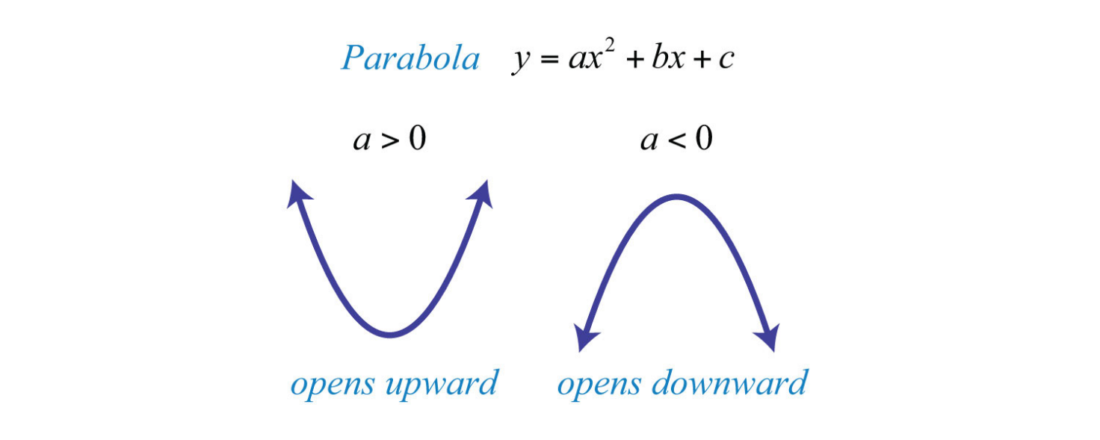value. In a parabola where $a>0$, the minimum value is simply the vertex.

To find the vertex without graphing, we see the axis of symmetry on which it lies. In the equation y=ax ²+bx+c (a≠0), c corresponds to the graph’s intersection with the y axis, which determines the parabola’s location up and down the coordinate plane. This does not affect the vertical axis of symmetry, so we can set c to 0, and simplify the equation to get y=ax ²+bx+c This gives us y=x(ax+b), which means x=0 or $x=-\frac{b}{a}$. Because the parabola intersects the $x$ axis at these points, we can conclude the vertex is located right between them, which gives us $x=-\frac{b}{2a}$. To find the minimum value, plug in the equation to solve for the $y$ coordinate of the vertex.

**如何找到最小值**

在二次方程 $f(x)=ax^{2}+bx+c$ (a≠0)中，最小值是满足该方程的y中的最小值。如下

所示，一个抛物线，其中在 $a<0$ 时没有最小值。在 $a>0$ 的抛物线中，最小值就是它的顶点。

为了在使用图像的情况下找到顶点，我们尝试寻找它所在的对称轴。在方程y=ax²+bx+c（a≠0）中，c对应着图与y轴的交点，它决定了抛物线在坐标平面上下的位置。因此这并不影响抛物线的对称轴，所以我们可以将c设置为0，并简化方程得到y=ax²+bx+c这给了我们y=x(ax+b)，即x=0或 $x=-\frac{b}{a}$.。因为抛物线与x轴在这些点上相交，我们可以得出顶点位于它们中间的结论，这就给出了 $x=-\frac{b}{2a}$。如果要求出最小值，代入方程来求解顶点的y坐标。

**Applications of Minimum Values**

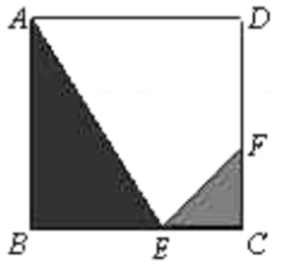

Figure 1

**Example Problem 1:** The floor tile in Figure 1 has side length 0.4 m and is made of 3 different materials. The materials that make up △CFE, △ABE, and quadrilateral AEFD cost $3, $2, and $1 per m², respectively. 4 tiles are pieced together in Figure 2 to make up Square EFGH. Find the length of CE so that the cost of the floor tiles is at a minimum value.

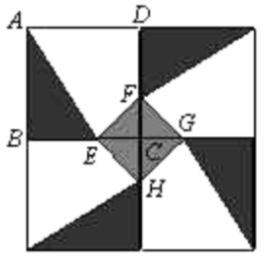

Figure 2

**Solution:** Let $y$ be the cost of one floor tile and $x$ be the length of CE. We get $y=A_{△CFE}×C_{△CFE}+A_{△ABE}×C_{△ABE}+A_{AEFD}×C_{AEFD}$ where A refers to the area and C refers to the cost per m². Plug in the values and simplify to get y=10x²-2x+2.4(0<x<0.4). Because a>0, we can use the axis of symmetry formula $x=-\frac{b}{2a}$ to get $x=\frac{1}{10}$. Thus, when $CE=0.1$, the cost is at its minimum value.

**Extension**

In a quadratic equation where a<0, if its parabola faces downward, its vertex is the maximum value of y. To find the maximum value, we use the formula $x=-\frac{b}{2a}$ to find the $x$ coordinate of the vertex before plugging in the $y$ value.

**Example Problem 2:** A company’s profit is calculated to be p(x)=-0.1x²+50x+300, where x is the number of units sold. Find the maximum profit of the company in dollars, and the value of $x$ that achieves the maximum profit.

Plug in the values to $x=-\frac{b}{2a}$ to get x=250, then we can solve for p(x)=6550. 250 units sold will give the maximum profit of $6550.

**最小值的应用示例问题**

**例题1**：图1中的地砖的边长为0.4 m，由3种不同的材料制

成。组成△CFE、△ABE和四边形AEFD的材料每个m²的成本分别为3美元、2美元和1美元。4瓷砖在图2中拼接在一起，组成正方形EFGH。找到CE的长度，以使地砖的成本处

于最小值。

**解**：设y为一块地砖的成本，x为CE的长度。我们得到 $y=A_{△CFE}×C_{△CFE}+A_{△ABE}×C_{△ABE}+A_{AEFD}×C_{AEFD}$，其中A表示面积，C表示每个m²的成本。插入值并简化得到y=10x²-2x+2.4(0<x<0.4)，我们可以使用对称轴公式 $x=-\frac{b}{2a}$ 来得到 $x=\frac{1}{10}$。因此，当CE=0.1时，成本为其最小值。

**拓展**

在二次方程中，a<0，如果它的抛物线向下，它的顶点是y的最大值。为了找到最大值，我们使用公式 $x=-\frac{b}{2a}$ a找到顶点的x坐标，然后代入得到y的值。

**示例问题2：**一个公司的利润通过函数p(x)=-0.1x²+50x+300，其中x是销售的单位个数。按美元计算，找出公司的最大利润，和能够达到最大利润的价值x。

**解**：将值代入入到 $x=-\frac{b}{2a}$ 中，得到x=250，然后我们就可以求解p (x)=6550。250套将获得最高利润6550美元。

**Practice Problems to Test Yourself**

（The answers will be revealed in the next article, so please subscribe to our account! ）

1. In the quadratic equation y=ax²+bx+c(a≠0), express the $y$ coordinate of its vertex in terms of $a$, $b$, and $c$.
2. If two real numbers have a difference of 11.4, find the minimum value of their product.
3. A ball is thrown upward from a cliff before it falls to the ground. The height $h$ of the ball in meters is a function of the time $t$ in seconds after the throw, where $h(t)=h_{0}+v_{0}t+\frac{1}{2}at^{2}$. If $h_{0}=100$, $v_{0}=30$, and $a=9.8$, find the maximum height of the ball and when it is reached.

**练习题以测试自己**

（答案将在下一篇文章中揭示，所以请订阅我们的帐户！）

1. 在二次方程y=ax²+bx+c（a=0）中，用a、b和c表示其顶点的y坐标。
2. 如果两个实数的差值为11.4，则求出它们乘积的最小值。
3. 球从悬崖上向上起，然后掉到地上。球的高度h（米）是关于自投掷后的总时长t（秒）的函数，其中 $h(t)=h_{0}+v_{0}t+\frac{1}{2}at^{2}$。如果 $h_{0}=100$, $v_{0}=30$ 0且 $a=9.8$，请找到球的最大高度和达到此情况的所需时间。