**The Secrets of Imaginary Numbers**

8(3) Jimmy

**Introduction**

Mathematics is the most commonly studied field in STEM, as it explains phenomena in our daily life and inspires innovative inventions in technology and other areas. In addition, mathematics can also deal with abstract concepts, one of which is imaginary numbers. It isn’t easy to think of its actual usage in real life (except things such as AC circuits), but it can truly play an important role in mathematics and help us solve problems either directly or indirectly.

Imaginary number is another type of number which adds on to the category of real numbers to form the set of complex numbers. We usually use *ki* to represent an imaginary number, where $i^{2} = -1$ and $k ∈ R$. Note that we DO NOT say $i = \sqrt{-1}$, so we cannot compare two imaginary numbers with each other.

To dive deeper into imaginary numbers, we must introduce another term: complex numbers.

**Complex Numbers**

-Written in the form $a + bi$ (*a, b* ∈ $R$).

-A complex number is often referred as the letter *z*.

-We define its ***modulus*** by $\sqrt{a^{2} + b^{2}}$, written as *|z|*.

-We also define its ***conjugate*** by $a - bi$, written as $\overline{z}$.

- $z + \overline{z} = 2a$, where $z = a + bi$.

-Notice that $(a + bi)(a - bi) = a^{2} + b^{2}$, by the difference of squares. Meanwhile ${|z|}^{2} = a^{2} + b^{2}$ too. Thus we can also get $z ∙ \overline{z} = {|z|}^{2}$.

**Examples**

Ex 1: Given that z is a complex number, compute z if $z + \overline{z} = 7$, and ${|z|}^{2} = 12.5$.

Solution: let $z = a + bi$, because $z + \overline{z} = 7$, therefore $2a = 7$, $a = \frac{7}{2}$.

∵ ${|z|}^{2}=\frac{25}{2}$, so we can rewrite it as $a^{2} + b^{2} = 12.5$.

Plug in $a = \frac{7}{2}$, we get $b^{2} = \frac{25}{2} - \frac{49}{4} = \frac{1}{4}$.

$b = ±\frac{1}{2}$.

Thus $z = \frac{7}{2} ± \frac{1}{2}i$.

**NOTE**: you can’t say $z = \frac{7}{2} + \frac{1}{2}i$ is bigger than $\overline{z} = \frac{7}{2} - \frac{1}{2}i$ because you CANNOT compare *0.5i* with *-0.5i*, as the definition of *i* is $i^{2} = -1$.

Ex 2: Given the equation $x^{2}+2x+5=0$, compute $x$.

This is a quadratic equation. To solve it, we can plug into the quadratic formula to get $x=\frac{-2±\sqrt{-16}}{2}$. Using the knowledge we have just learned, we can solve and get $x=-1±2i$. Thus the answer is $x=-1±2i$.

**Extensions**

There are many other ways to write and express a complex number. For example, we can construct a coordinate plane, where the x-axis represents the *a* of *a + bi*, *a* is a real number, and the y-axis represents *bi* with the unit *i*. We can draw a complex number on the complex plane. Notice that any real number can be written as *a + 0i*, so it must lie on the x-axis.

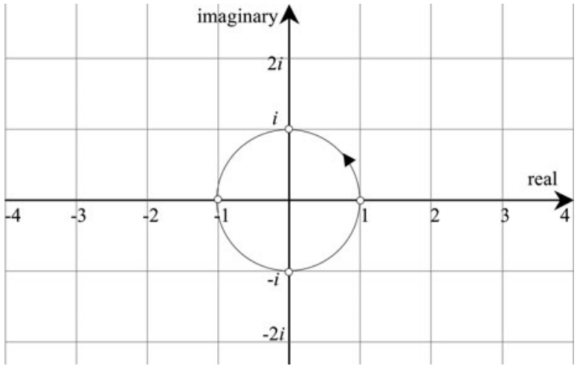 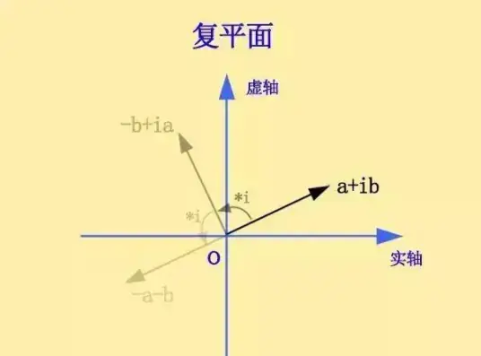

We can draw *z* and $\overline{z}$ on the complex plane, corresponding to the coordinates *(a, b)* and *(a, -b)*, as shown in the graph below. By observing the graph, we can understand more about a complex number and its conjugate. They are always symmetric across the x-axis.

The complex plane also enhances the understanding of complex number multiplication. Here, we only talk about the simplest and most straightforward way to multiply two complex numbers.

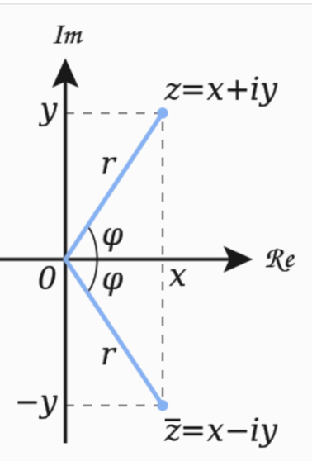

We have two complex numbers x and y, written as *a + bi* and *c + di*.

Multiply *x* and *y*: {"mathml":"<math style=\"font-family:stix;font-size:16px;\" xmlns=\"http://www.w3.org/1998/Math/MathML\"><mstyle mathsize=\"16px\"><mfenced><mrow><mi>a</mi><mo>+</mo><mi>b</mi><mi>i</mi></mrow></mfenced><mo>&#xB7;</mo><mfenced><mrow><mi>c</mi><mo>+</mo><mi>d</mi><mi>i</mi></mrow></mfenced><mo>=</mo><mi>a</mi><mi>c</mi><mo>+</mo><mi>a</mi><mi>d</mi><mi>i</mi><mo>+</mo><mi>b</mi><mi>c</mi><mi>i</mi><mo>+</mo><mi>b</mi><mi>d</mi><msup><mi>i</mi><mn>2</mn></msup></mstyle></math>","origin":"MathType for Microsoft Add-in"}.

{"mathml":"<math style=\"font-family:stix;font-size:16px;\" xmlns=\"http://www.w3.org/1998/Math/MathML\"><mstyle mathsize=\"16px\"><mo>&#x2235;</mo><msup><mi>i</mi><mn>2</mn></msup><mo>=</mo><mo>-</mo><mn>1</mn><mo>,</mo><mo>&#x2234;</mo><mi>x</mi><mo>&#xB7;</mo><mi>y</mi><mo>=</mo><mi>a</mi><mi>c</mi><mo>+</mo><mi>a</mi><mi>d</mi><mi>i</mi><mo>+</mo><mi>b</mi><mi>c</mi><mi>i</mi><mo>-</mo><mi>b</mi><mi>d</mi><mo>.</mo></mstyle></math>","origin":"MathType for Microsoft Add-in"}

Draw the resulting answer on the complex plane, and call the point that represents *x* point *X*, the point that represents *y* point *Y*, and call the point *(ac - bd, (ad + bc)i)* *A*. Then we can find the relationship between *γ*, the angle that line *AO* forms with the *x*-axis (counted counter-clockwise), *α*, the angle formed by *XO*, and *β*,the angle formed by *YO*, which is, *γ* ≡ *α* + *β* (mod 360). We can also know that *|x · y| = |x| · |y|* from the complex plane.

To explain this, we need knowledge of the trigonometry summation formulas, which isn’t the main topic of this article, so we will not go too deep into it. However, there are a lot of other mathematical concepts to discuss about complex numbers, which requires more time to fully understand it.

**Practice Problems To Test Yourself**

1. Given that z is a complex number. If $z + 2\overline{z} = 3 + 4i$, compute *z*.
2. Compute 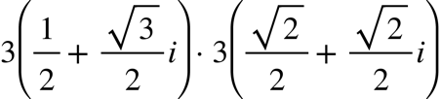
3. Given that *x* and *y* are two complex numbers. The angle that vector *x* forms with the x-axis counter-clockwisely is *p*, and the angle that vector *y* forms with the x-axis counter-clockwisely is *q*, so that *p* = 2*q*. If *x*:*y* = 2:1, compute *p* (expressions only).

**虚数的奥秘**

8(3) Jimmy, 翻译8(8) Leo

**介绍**

数学是STEM体系中被最普遍研究的领域，因为它解释了我们日常生活中的现象，并激发了科学和其他领域的创新。此外，数学还可以处理抽象概念，其中之一就是虚数。很难想象它在现实生活中的实际用途（除了交流电路等），但它确实可以在数学中发挥重要作用，直接或间接地帮助我们解决复杂的问题。

虚数是另一种类型的数，将它添加到实数的范畴中，就形成了复数集。我们通常使用 $ki$ 来表示一个虚数，其中 $i^{2} = -1$， $k ∈ R$。请注意，不能直接说 $i = \sqrt{-1}$，所以我们不能比较两个虚数。

为了更深入地研究虚数，我们必须引入另一个术语：复数。

**复数**

-通常写成 $a + bi$ (*a, b* ∈ $R$)的形式。

-题中的复数通常被设为字母*z*。

-复数的模用 $\sqrt{a^{2} + b^{2}}$ 来计算，记为*|z|*。

-复数的共轭是 $a - bi$，记为 $\overline{z}$。

-z+z̅=2a，其中z=a+bi。

-注意到根据平方差， $(a + bi)(a - bi) = a^{2} + b^{2}$。同时， ${|z|}^{2} = a^{2} + b^{2}$。因此，也可以得到 $z ∙ \overline{z} = {|z|}^{2}$。

**示例**

例1：假设z是一个复数，如果z+z̅=7，并且 ${\left|z\right|}^{2}$ =12.5，则计算z。

解：设z=a+bi，因为z+z̅=7，所以2a=7，a=7/2。

${\left|z\right|}^{2}$ =12.5，因此我们可以将其改写为 $a^{2}+b^{2}$ =12.5。

插入a=7/2，我们得到 $b^{2}$ = $\frac{25}{2}-\frac{49}{4}=\frac{1}{4}$。

b=± $\frac{1}{2}$。

因此，z= $\frac{7}{2}±\frac{1}{2}i$。

注意！你不能说z= $\frac{7}{2}+\frac{1}{2}i$ 大于z= $\frac{7}{2}-\frac{1}{2}i$，因为你不能将0.5i与-0.5i进行比较，因为i的定义是 $i^{2}$ =-1。

例2： $x^{2}+2x+5=0$，计算 $x$。

解：这是一个二次方程，我们可以把它代入二次方程解公式得到 $x=\frac{-2±\sqrt{-16}}{2}$。使用我们刚刚学到的知识，我们可以解得 $x=-1±2i$。因此，答案就是 、 $-1±2i$。

**扩展**

还有许多其他形式可以表达复数。例如，我们可以构造一个坐标平面，其中x轴表示a+bi中的a，a是实数，y轴表示单位为i的bi。我们可以在复平面上绘制一个复数。请注意，任何实数都可以写成a+0i，因此实数都位于x轴上。 

我们可以在复平面上绘制z和z̅，对应于坐标（a，b）和（a，-b），如图所示。通过观察，我们可以更多地了解复数及其共轭；它们在x轴上总是对称的。

复平面也增强了对复数乘法的理解。在这里，我们只讨论将两个复数相乘的最简单、最直接的方法。



我们有两个复数x和y，分别表示为a+bi和c+di，将x和y相乘：{"mathml":"<math style=\"font-family:stix;font-size:16px;\" xmlns=\"http://www.w3.org/1998/Math/MathML\"><mstyle mathsize=\"16px\"><mfenced><mrow><mi>a</mi><mo>+</mo><mi>b</mi><mi>i</mi></mrow></mfenced><mo>&#xB7;</mo><mfenced><mrow><mi>c</mi><mo>+</mo><mi>d</mi><mi>i</mi></mrow></mfenced><mo>=</mo><mi>a</mi><mi>c</mi><mo>+</mo><mi>a</mi><mi>d</mi><mi>i</mi><mo>+</mo><mi>b</mi><mi>c</mi><mi>i</mi><mo>+</mo><mi>b</mi><mi>d</mi><msup><mi>i</mi><mn>2</mn></msup></mstyle></math>","origin":"MathType for Microsoft Add-in"}

{"mathml":"<math style=\"font-family:stix;font-size:16px;\" xmlns=\"http://www.w3.org/1998/Math/MathML\"><mstyle mathsize=\"16px\"><mo>&#x2235;</mo><msup><mi>i</mi><mn>2</mn></msup><mo>=</mo><mo>-</mo><mn>1</mn><mo>,</mo><mo>&#x2234;</mo><mi>x</mi><mo>&#xB7;</mo><mi>y</mi><mo>=</mo><mi>a</mi><mi>c</mi><mo>+</mo><mi>a</mi><mi>d</mi><mi>i</mi><mo>+</mo><mi>b</mi><mi>c</mi><mi>i</mi><mo>-</mo><mi>b</mi><mi>d</mi><mo>.</mo></mstyle></math>","origin":"MathType for Microsoft Add-in"}

在复平面上绘制得到的答案，并称代表x的点为X，代表y的点为Y，代表*(ac - bd, (ad + bc)i)* 的点为A。然后找到线段AO与x轴形成的角度γ（逆时针计数）、XO形成的角度α和YO形成的角度β之间的关系，即γ≡α+β（mod 360）。除此之外，我们还可以从复平面知道|x·y|=|x|·|y|。

为了解释这一点，我们需要三角求和公式的知识，这不是本文的主要主题，所以不会深入探讨。然而，关于复数还有很多其他数学概念需要讨论，需要更多的时间来完全理解它。

**练习**

1.假设z是一个复数。如果z+2z̅=3+4i，求z？

2.计算 

3.假设x和y是两个复数。向量x与x轴逆时针形成的角度为p，向量y与x轴顺时针形成的角为q，已知p=2q。如果x:y=2:1，求p（仅表达式）？