**Paradoxes- the Unraveling of Mathematical Mysteries**

Article By Elaine Fan 8(8)

**Introduction**

You might be familiar with philosophical paradoxes. One example is the barber paradox where the barber is the “one who shaves all those, and those only, who do not shave themselves”. The question is whether the barber shaves himself. However, any answer results in a contradiction: The barber cannot shave himself, as he only shaves those who do not shave themselves. These intriguing intellectual challenges are not only seen in philosophy but are also present in the field of mathematics. A paradox is a statement or a group of statements that leads to a contradiction or a situation that defies intuition and conventional logic. Paradoxes are not just brain teasers: they also play a crucial role in mathematics, by challenging established norms, leading to advancements in existing theories.

**Examples**

Say that you're taking a particular bus route. When you get to the bus stop, you often find yourself waiting longer for a bus than what the schedule suggests, yet the buses aren’t actually late. This is known as the Inspection Paradox, suggesting that you're more likely to catch the bus during its longer intervals than its shorter ones. So, even though the buses are perfectly on time, your wait seems longer because the longer gaps between buses are more likely to be the ones you encounter. It is like that the longer waits take up more of the timeline, making them more noticeable. This paradox challenges our intuitive expectations, as we would expect the average wait time to be a straightforward calculation based on the schedule. However, due to the longer intervals being more frequently 'inspected,' we end up with a skewed perception.

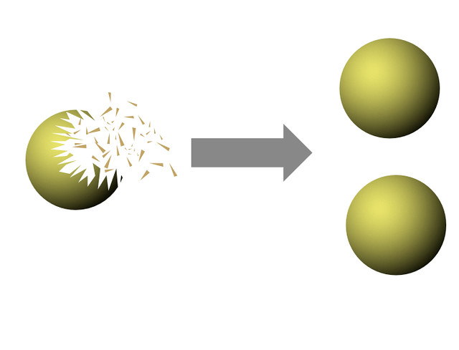

Imagine taking a solid sphere and breaking it into a finite number of pieces. Now, what if I told you that you could rearrange these pieces to form two identical spheres, each the same size as the original? This is the Banach-Tarski Paradox stating that a solid sphere in 3-dimensional space can be divided into a finite number of non-overlapping pieces and then reassembled into two identical copies of the original. This paradox relies on the Axiom of Choice and highlights the counterintuitive nature of infinite sets and volumes. Its implications require thinking beyond conventional geometry. It introduces the necessity to work with the abstract concept of non-measurable sets, encouraging mathematicians to explore and develop new areas, such as fractals and higher-dimensional spaces.

Another example is in set theory, where Russell's Paradox presents a problem with naive set theory. Consider the set of all sets that do not contain themselves. If such a set exists, does it contain itself? If it does, it contradicts its definition. If it doesn't, by definition, it should contain itself. This paradox led to the development of more rigorous axiomatic set theories. Paradoxes like Russell's Paradox have revealed inconsistencies in naive set theory, pushing mathematicians to develop more rigorous frameworks. The resolution led to the establishment of the Zermelo-Fraenkel set theory with the Axiom of Choice (ZFC), now the standard form of axiomatic set theory. This new framework avoids self-referential paradoxes and supports the formal foundation of mathematics. Paradoxes challenge our understanding, forcing us to refine theories and often leading to breakthroughs.

**Conclusion**

Paradoxes serve as a reminder that intuition is not always a reliable guide in mathematics. By exploring paradoxes, mathematicians develop deeper insights into the nature of reality and the limits of human understanding. Mathematical paradoxes are powerful tools for exploration and understanding, pushing the boundaries of what we know and revealing the intricate dance between logic and intuition. They inspire rigorous thinking and highlight the beauty and complexity of mathematics.

**Practice Problems to Test Yourself**

（The answers will be revealed in the next article, so please subscribe to our account!）

1. Please answer true / false / neither: “This statement is false.” (Provide an explanation for your answer).

Solution: This statement creates a paradox and cannot be definitively true or false. If the statement "This statement is false" is true, then it is indeed false, contradicting itself. Conversely, if it's false, it must be true. This self-referential loop is a classic example of a logical paradox.

1. What other paradoxes do you know? Feel free to share it with us!

**悖论-对数学奥秘的探索**

**背景介绍**

你可能听说过一些哲学悖论。其中一个例子是理发师悖论，理发师是“为所有不给自己刮胡子的人刮胡子的人”。问题是理发师是否给自己刮胡子。然而，任何答案都会导致矛盾：理发师不能给自己刮胡子，因为他只为不给自己刮胡子的人刮胡子。这些有趣的智力挑战不仅出现在哲学领域，也出现在数学领域。悖论是一个或一组，导致矛盾或违反直觉或传统逻辑的情况。悖论不仅是脑筋急转弯，而且在数学中也发挥着至关重要的作用，通过挑战既定的限制，走向理论的进步。

**例子**

假如你乘坐某条公交线路。当你到达公交车站时，经常会发现自己等待公交车的时间比时刻表上显示的时间要长，但实际上公交车并没有晚点。这就是所谓的 “检查悖论”，表明你更有可能在较长的间隔时间内赶上公交车，而不是在较短的间隔时间内。因此，即使公交车非常准时，你等待的时间似乎也更长，因为你更有可能遇到的是间隔时间较长的公交车。 这就好比，较长的等待时间占据了更多的时间轴，使其更加容易被注意到。这个悖论挑战了我们的预期，因为我们本以为平均等候时间可以根据时间表直接计算出来。然而，由于较长的时间间隔被更频繁地 “检查”，我们的感知最终出现了偏差。



想象一下，有一个实心球体，把它分成有限数量的碎片。如果我说，你可以把这些碎片重新排列成两个相同的且和原来篮球一样大的篮球，你相信吗？这就是巴拿赫-塔斯基悖论，它表明三维空间中的实心球体可以被分割成有限数量的不重叠的碎片，然后重新组装成原始球体的两个相同的副本。这个悖论依赖于选择公理，并强调了无限集和体积的反直觉性质。悖论的含义需要超越传统几何的思考。介绍了处理不可测集抽象概念的必要性。这种创新鼓励数学家探索和发展新的领域，如分形和高维空间。

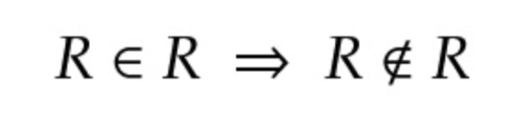

另一个例子是集合论，罗素提出了这样一个问题：如果存在一个不包含自身的所有集合的集合，它包含它自己吗？如果是这样，它就违背了它的定义。如果不是，根据定义，它应该包含它自己。这个悖论导致了更严格的公理集理论的发展。像罗素悖论这样的悖论揭示了朴素集合论的不一致性，促使数学家开发更严格的框架。这个决议导致了策梅洛-弗兰克尔集合论和选择公理（ZFC）的建立，也就是现在公理集合论的标准形式。这个新的框架避免了自我参照的悖论，并支持数学的形式基础。悖论引起了我们对数学更崭新的讨论，迫使我们完善理论，并常常带来突破。

**总结**

悖论告诉了我们，在数学中，直觉并不总是可靠的向导。通过探索悖论，数学家对现实的本质和人类理解的局限性有了更深刻的认识。数学悖论是探索和理解的有力工具，突破了我们所知的界限，揭示了逻辑和直觉之间复杂的舞蹈。它们激发了严谨的思维，突出了数学的美和复杂性。

**考验自己的小练习：**

（答案将在下一篇文章中公布，所以请关注我们的公众号!）

1. 请回答正确或错误或两者都不是：“这个陈述是错误的。”（并提供适当解释）

解决方案：这个陈述产生了一个悖论，不能明确地为真或为假。如果陈述“这个陈述是错误的”是正确的，那么它确实是错误的，与自身相矛盾。相反，如果它是假的，它一定是真的。这种自指循环是逻辑悖论的典型例子。

1. 你还知道什么其他悖论？欢迎与我们分享！