斐波那契数列：在自然和艺术中的应用

The Fibonacci Sequence: Applications in Nature and Art

By 8(11) Wei

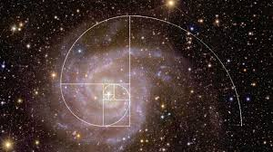斐波那契数列，是由数学家莱昂纳多·斐波那契在13世纪时发现的。年少的他在与父亲在北非做生意时学习了阿拉伯数字，并撰写了一本《计算之书》。在书中，斐波那契提出了一个有趣的问题：有一对成年兔子，每隔一个月就生一对小兔子，而小兔子一个月后也成年了，加入生小兔子的行列。如果每对兔子都经历这样的出生、成熟、生育的过程，并且永远不死，那么N个月后会有多少对兔子？如果用数列表示，也就是1,1,2,3,5,8,13,21,34,55,89,144等等。而这就是著名的斐波那契数列，我们也可以把它称作“兔子数列”。

The Fibonacci Sequence was discovered by mathematician Leonardo Fibonacci in the early thirteenth century. During his early years, Fibonacci learned Arabic numerals alongside his father. While doing business in North Africa, Fibonacci was fascinated by these numbers and authored a book of calculations. In the book, he proposed an intriguing question: a pair of adult rabbits gives birth to a pair of bunnies each month, and the baby bunnies soon come of age in a month. Assuming each rabbit lives an eternal life and undergoes this process of birth, maturation, and fertility each month, how many fully grown and newborn rabbits will there be after N months? Expressed in a number sequence, the terms go 1, 1, 2, 3, 5, 8, 13, 21, 34, 55, 89, 144, and so on. These numbers are the leading components of the well-known Fibonacci Sequence, otherwise called the “rabbit sequence”.

但是这个数列，是如何在现实和自然中出现？

However, how does this sequence unfold in reality and nature?

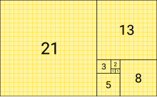 在数学中，它和帕斯卡三角有着密切的关联。帕斯卡三角的对角线之和，就是斐波那契数列。1611年，著名天文学家开普勒在《Strena seu de Nive Sexangula (六角雪花) 》一书中指出，当数列趋于无穷大时，斐波那契数列中的数字之比无限接近黄金分割比，即1.618033987498948482…。

In mathematics, the Fibonacci Sequence is closely related to Pascal’s Triangle. The sum of the diagonals within Pascal’s Triangle adds to terms in the Fibonacci Sequence. In the year 1611, astronomer Johannes Kepler proposed in his book “Strena seu de Nive Sexangula” (The Six-Cornered Snowflake) that when the sequence extends to infinite terms, the ratio of the numbers is infinitely close to what we call the “golden ratio”, or about 1.618033987498948482….

按着斐波那契数列，分别取边长为 1,1,2,3,5,8,13,21……的正方形，再以每个正方形的一个顶点作为圆心，画一个四分之一的曲线，连接每个曲线，便可以得到一个斐波那契螺旋线。

According to the Fibonacci Sequence, if we take the side lengths of various squares as 1, 1, 2, 3, 5, 8, 13, 21, and so on, then utilize one vertex of a square as the center to draw a quarter circle, and lastly connect each curve, it will result in a Fibonacci spiral.

那帕斯卡三角形和这个数列又有什么神秘的关联？

Then what is the mysterious and fascinating relationship between the Fibonacci Sequence and Pascal’s Triangle?

如果沿着帕斯卡三角形的斜线去加每一行中的数字，就能得到斐波那契数列！比如说：

If we follow a diagonal of Pascal’s Triangle and calculate the sum of each row, the Fibonacci Sequence becomes apparent. For example:

在帕斯卡三角形的最左边，从顶端的1往下看，我们依次加上每一行的第一个数字：1, 1, 2, 3, 5, 8……结果就是斐波那契数列！

On the left of Pascal’s Triangle, if we look down from the topmost 1 and add the first term in each row in turn: 1, 1, 2, 3, 5, 8…The result is the Fibonacci Sequence!

植物学的叶序就完全符合这个数列。这些植物的叶子的排列以螺旋的样式向上，不同植物的叶序有着斐波那契数列的排列规律。斐波那契螺旋线也很常在植物种出现，就比如向日葵花盘，松果种子，菠萝上的鳞片，这些都是常见的例子。有些科学家觉得，这样对于植物的种子堆积和繁衍有利。

The sequence of leaves in botany completely aligns with the Fibonacci Sequence: different plants have a leaf count according to this sequence. Additionally, Fibonacci spirals are commonly found in numerous plant species, such as sunflowers, pinecones, and pineapples, which are some common examples. Some scientists believe this circumstance is beneficial for plant reproduction from the accumulation of their seeds.

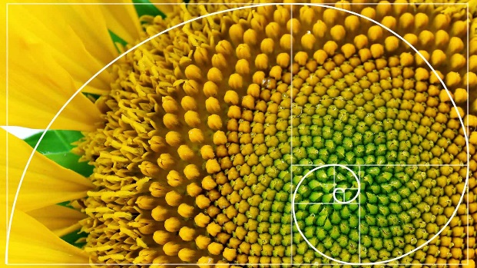 在动物界，斐波那契数列也有自己的身影。比如众多贝壳和蜗牛壳的形状，就是一种斐波那契螺旋线。有时猫尾巴的弯曲程度，也可以说是一种斐波那契螺旋线。

In the realm of animals, the Fibonacci Sequence also has a significant impact. For example, many shells—such as beach shells and snail shells—follow the Fibonacci spiral. Sometimes, the curve of a cat’s tail can also be identified as a real-life example of the Fibonacci spiral.

大家都知道在网上很火的黄金比例脸吧，这就是通过斐波那契数列的黄金分割比例，来把脸变成斐波那契数列的另一种形式。

Online, the “golden ratio face” is a popular trend, which is another form of the Fibonacci Sequence through the golden ratio mentioned earlier.

再回到物理学，可依据斐波那契数列，算出黄金分割数、白银分割数、白金分割数的三维物理空间的准周期。在量子力学中，两粒子纠缠态，也离不开这个数列。这个数列甚至还可以被广泛运用到股市当中，用以揭示股票涨落的奥秘。

Returning to the study of physics, we can calculate the quasi-period of a three-dimensional space of the golden ratio, the silver ratio, and the platinum ratio—according to the Fibonacci Sequence. In quantum mechanics, the entanglement of two particles is also closely related to this sequence. This sequence can even be utilized in the stock market to predict the mystery of stock trading.

斐波那契数列不仅在数学和科学领域展现了其独特的魅力，更在自然界中无处不在，揭示了宇宙的和谐美。无论是植物的叶序，还是动物的形态，我们都能感受到这种数列带来的美学和结构。通过深入探索斐波那契数列，我们不仅能够更好地理解自然法则，也能欣赏到隐藏在日常生活中的数学之美。这一发现让我们更加敬畏和珍惜这个充满奇妙规律的世界。

The Fibonacci Sequence is unique in the fields of mathematics and science, yet it is much more significant in nature and reality. It is ubiquitous, revealing the harmonious beauty of the universe. Whether it is through the leaves of a plant or through the study of animals, we can feel the aesthetics and structure of the Fibonacci Sequence. By delving deeper into this phenomenon, we can enhance our understanding of the laws of nature and appreciate the beauty of mathematics hiding in the circumstances of everyday life. Through this discovery, we can further admire and cherish our world full of wonderful laws.