**AMC8 Review Lecture**

The American Mathematics Competition 8 (AMC 8) is a highly regarded and well-known math competition designed for middle school students. It serves as an exciting and important math competition for students all around the world. The age limit for AMC8 is eighth grade, making it the last opportunity for many eighth graders to show their talent in mathematics. All of the problems and answers are carefully designed with a similar structure each year.

The competition is composed of 25 multiple choice questions, mainly organized in ascending difficulty. Students have 40 minutes to complete this test and challenge their knowledge of various concepts, such as arithmetic, algebra, geometry, and probability. With no scope or range, the competition is a test to students’ accuracy, speed, and overall ability in mathematics, requiring extra practice to excel. The best and most credible website to practice beforehand is [Art of Problem Solving](https://artofproblemsolving.com/wiki/index.php/AMC_8_Problems_and_Solutions), which provides free, detailed problems and solutions for all AMC8 test papers from 1999 to 2024 and also all AJHSME test papers from 1985 to 1998[[1]](#footnote-1). Because AMC8 test papers have been seen to be increasing in difficulty over the years, test papers from 2018 are most accurate to what 2025 may bring. Earlier test papers can be used to practice speed and accuracy in doing earlier questions from 1 to 15.

**2024 AMC8. 25.**  A small airplane has $4$ rows of seats with $3$ seats in each row. Eight passengers have boarded the plane and are distributed randomly among the seats. A married couple is next to board. What is the probability there will be $2$ adjacent seats in the same row for the couple?



**2023 AMC8. 24.** Isosceles triangle $ABC$ has equal side lengths $AB$ and $BC$. In the figures below, segments are drawn parallel to $\overline{AC}$ so that the shaded portions of $\triangle ABC$ have the same area. The heights of the two unshaded portions are 11 and 5 units, respectively. What is the height $h$ of $\triangle ABC$?

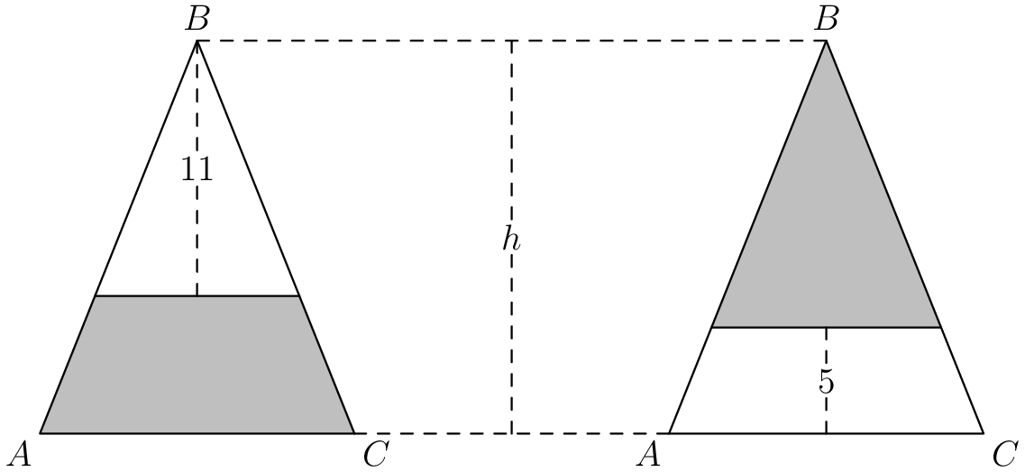



**2023 AMC8. 25.** Fifteen integers $a_1, a_2, a_3, \dots, a_{15}$ are arranged in order on a number line. The integers are equally spaced and have the property that\[1 \le a_1 \le 10, \thickspace 13 \le a_2 \le 20, \thickspace \text{ and } \thickspace 241 \le a_{15}\le 250.\]What is the sum of digits of $a_{14}?$

$\textbf{(A)}\ 8 \qquad \textbf{(B)}\ 9 \qquad \textbf{(C)}\ 10 \qquad \textbf{(D)}\ 11 \qquad \textbf{(E)}\ 12$

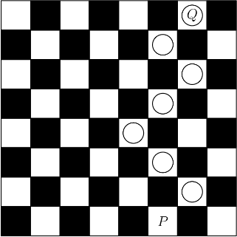**2020 AMC8. 21.** A game board consists of $64$ squares that alternate in color between black and white. The figure below shows square $P$ in the bottom row and square $Q$ in the top row. A marker is placed at $P.$ A step consists of moving the marker onto one of the adjoining white squares in the row above. How many $7$-step paths are there from $P$ to $Q?$

$\textbf{(A) }8\qquad\textbf{(B) }9\qquad\textbf{(C) }12\qquad\textbf{(D) }24\qquad\textbf{(E) }36$

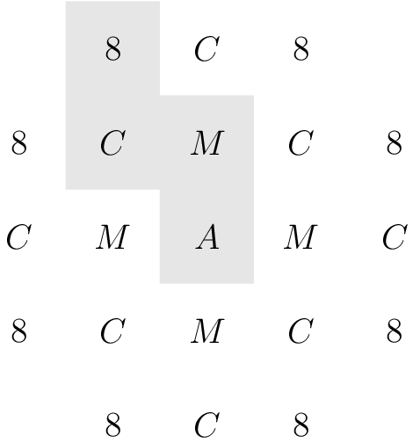**2017 AMC8. 15.** In the arrangement of letters and numerals below, by how many different paths can one spell AMC8? Beginning at the A in the middle, a path only allows moves from one letter to an adjacent (above, below, left, or right, but not diagonal) letter. One example of such a path is traced in the picture.

$\textbf{(A) }28 \qquad \textbf{(B) }30 \qquad \textbf{(C) }32 \qquad \textbf{(D) }33 \qquad \textbf{(E) }35$

1. AJHSME stands for the American Junior High School Mathematics Examination and is a mathematics competition proceeding AMC8 with the same qualities. It also consists of 25 multiple choice questions from A to E and 40 minutes to complete. [↑](#footnote-ref-1)