**Solutions:**

1. Using the chart below, where each point’s value is the sum of the value of the point below, left, and diagonally down and left, we get the answer **681**.

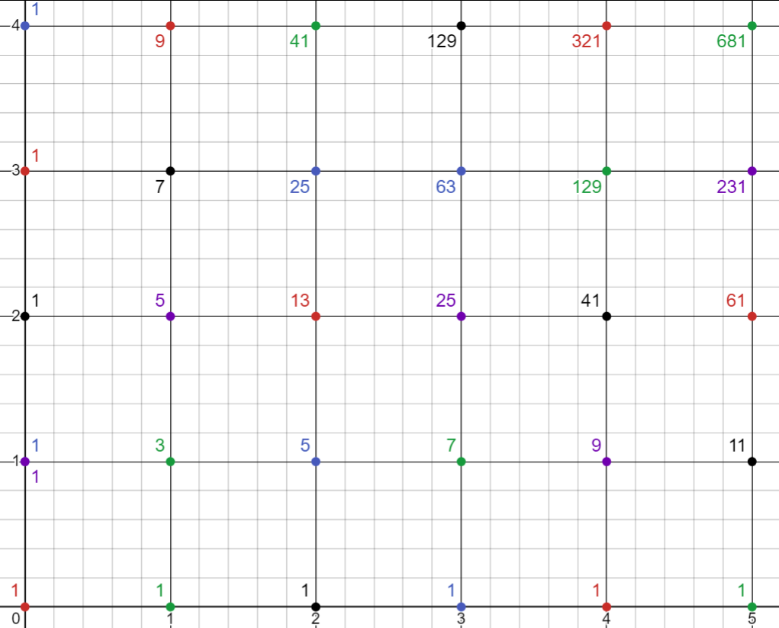

1. By transforming the timeline into the graph below, we can calculate the area $\frac{3.75}{16}$ = $\frac{15}{64}$.

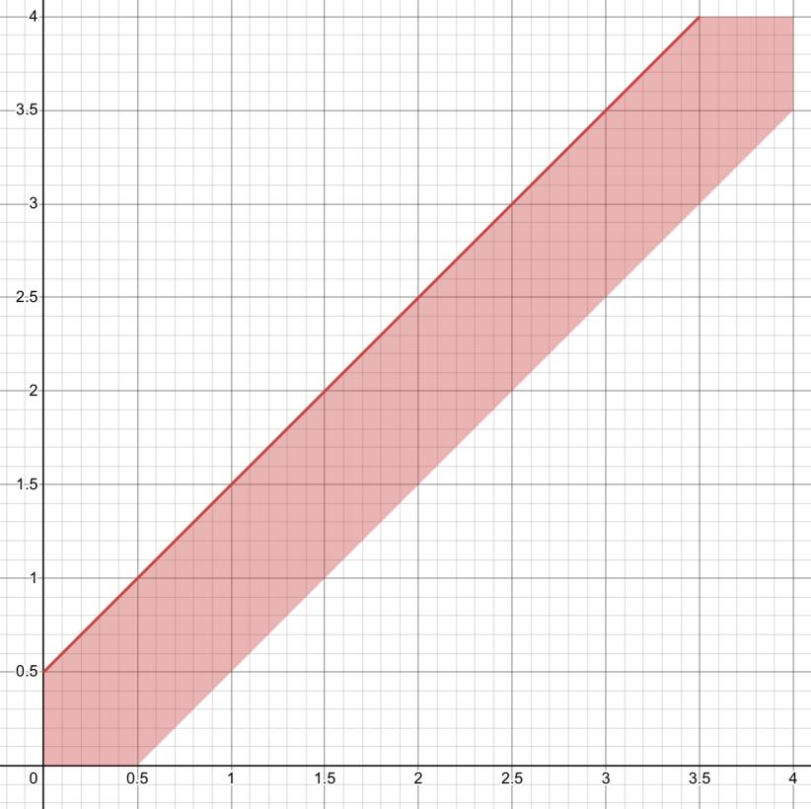

1. Mark numbers by the number of rounds and the number of points, and we get the answer **231**.

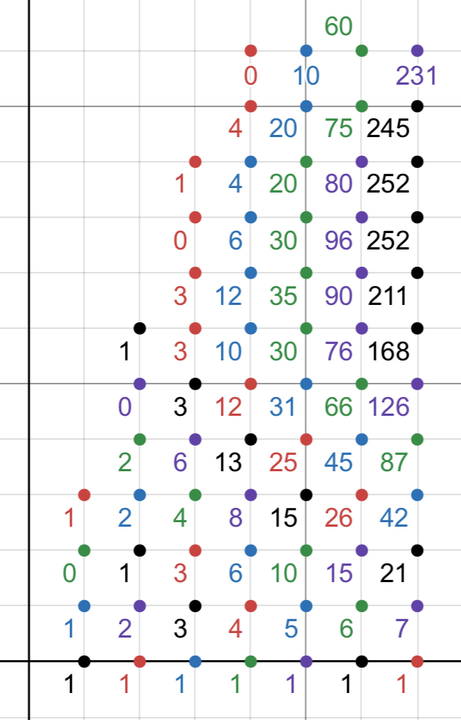

4. Since Gey wins in exactly 13 rounds, the result must be 10 for Gey and 3 for Jay. But this is with constraints, so the result by marking numbers is as follows, returning the answer **8**.

