**PRIMO Lesson Five Handout**

**Coordinate Geometry**

Geometry is a category of math involving the understanding of shapes, lines, angles, and solid figures, as well as their transformation, similarity & congruence, and linear & angular properties. Sometimes, geometry questions can be solved not only by using the theorems and properties of shapes, but also the utilization of functions on a coordinate plane, like planning linear functions in replacement for lines and finding coordinates through solving algebraic equations. (Editor’s note: 俗称建系/坐标系法) Coordinate geometry is a straightforward and sometimes quick way to solve geometry problems, but DO NOT use it in proof questions (And do not use it in exams because its steps cannot be expressed in geometric terms). (Editor’s note: its advantage is that it can be used on almost any kind of problem. Disadvantage, slow and painstalking most of the time)

The first step in utilizing coordinate geometry is finding the origin (0, 0). A good origin should be on a vertex of a polygon or a central intersection of lines, and through the origin a Cartesian Plane will be drawn. The most basic function in coordinate geometry is a ***linear function***, expressed in $y = kx + b$, where *k* is the slope of line (sometimes replaced by *tan θ*) and *b* is the *y*-intercept (with respect to the origin). This represents a line, line segment, or a ray in the geometric figure, and is useful when finding specific side lengths and intersection coordinates.

To find the intersection of two lines (or functions), we use the method of ***construction***, where we combine the two functions together and find the common point *(x, y)*. A construction of linear functions would be directly making an equation out of the two linear expressions, for example:

$$\left\{\begin{aligned}y = 11x - 4 \\ y = -5x + 14\end{aligned}\right. → 11x - 4 = -5x + 14$$

Which gives us the values of $x = \frac{9}{8}$ and $y = \frac{67}{8}$, and we then know the two lines meet at point ($\frac{9}{8}$, $\frac{67}{8}$).

There are a lot of other coordinate geometry properties, like two perpendicular (not vertical and horizontal lines) lines will have negative reciprocal slopes, and two parallel lines will have the same slope. The distance between two points *A* and *B* can be calculated through the *Pythagorean Theorem*, where

$$d = \sqrt{{(x_{A} - x_{B})}^{2} + {(y_{A} - y_{B})}^{2}}$$

The perpendicular distance from a point to a line can be calculated through constructing a linear function with a negative reciprocal slope, passing through the point, and then using the two coordinates to evaluate the distance.

The function for circles is also important in coordinate geometry. The function for circles is

$${(x - a)}^{2} + {(y - b)}^{2} = r^{2}$$

Where *a, b* are the *x* and *y* coordinates of the center of the circle, and *r* is the radius of the circle. Elliptical shapes can also be modeled through functions, but it will not appear as often as circles do, and therefore will not be included in this handout.

**Q1.** Given A(0,4) B(2,0) C(5,4), find the equation of triangle ABC’s height on A.

**Q2.** Right triangle *ABC* has ∠*B = 90*°, *AB* = 4, *BC* = 3. Point *B* is reflected across line *AC* to form point *B’*, find *BB’****.***

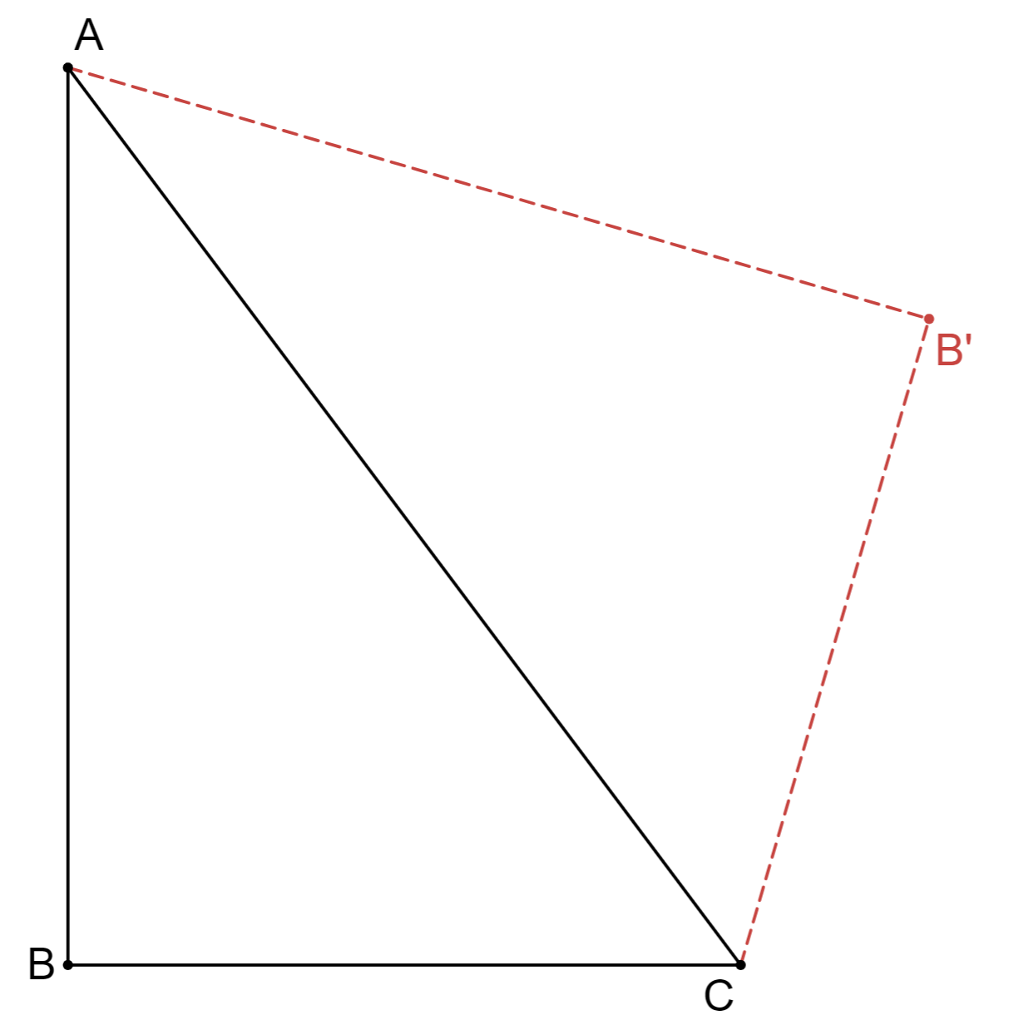

**Q3.** Circle *O* has center at *O* and radius 2. Line *PA* is tangent to circle *O* at *A*, so that ∠*APO* = 30°. *PO* intersects circle *O* at point *B*, where *B* is between points *P* and *O*. Find *PB*.

**Q4.** (2011 AMC10 B problem 20) Rhombus $ABCD$ has side length $2$ and $\angle B = 120^\circ$. Region $R$ consists of all points inside the rhombus that are closer to vertex $B$ than any of the other three vertices. What is the area of $R$?



**Q5.** For what ranges of a does $y=x^{2}+2x$ have four distinct intersections with ${(y+a)}^{2}+{\left(x+1\right)}^{2}=1$