**Solutions:**

**S1)** We know the coordinates, so we can get the equation of the line AB to be $y=-2x+4$. We need to find the line perpendicular to AB going through C, so $y=\frac{1}{2}x+k$ goes through (5,4), $k=\frac{3}{2}$. The answer is $y=\frac{1}{2}x+\frac{3}{2}$.

**S2)** In this problem, using coordinate geometry is unnecessary, since by connecting BB’ where BB’ is perpendicular to AC at D, it is significant that BB’ = 2BD = $2 * \frac{\frac{1}{2} * 3 * 4}{\frac{1}{2}\sqrt{3^{2} + 4^{2}}} = \frac{24}{5}$ through calculation of the area of the triangle.

**S3)** Construct Cartesian Plane with origin at point *O*, with PA perpendicular to the *x*-axis, so that since ∠*APO* = 30°, the function of line PA will be $x = 2$ and the function of line PO will be $y = \sqrt{3}x$. The function of the circle will be $x^{2} + y^{2} = 4$, and through construction, circle O and line PO intersects when $x^{2} = 1$. But since B is between P and O, this keeps only the answer *x = 1, y = $\sqrt{3}$,* and therefore PB will be $\sqrt{{(2 - 1)}^{2} + {(2\sqrt{3} - \sqrt{3})}^{2}} = 2$.

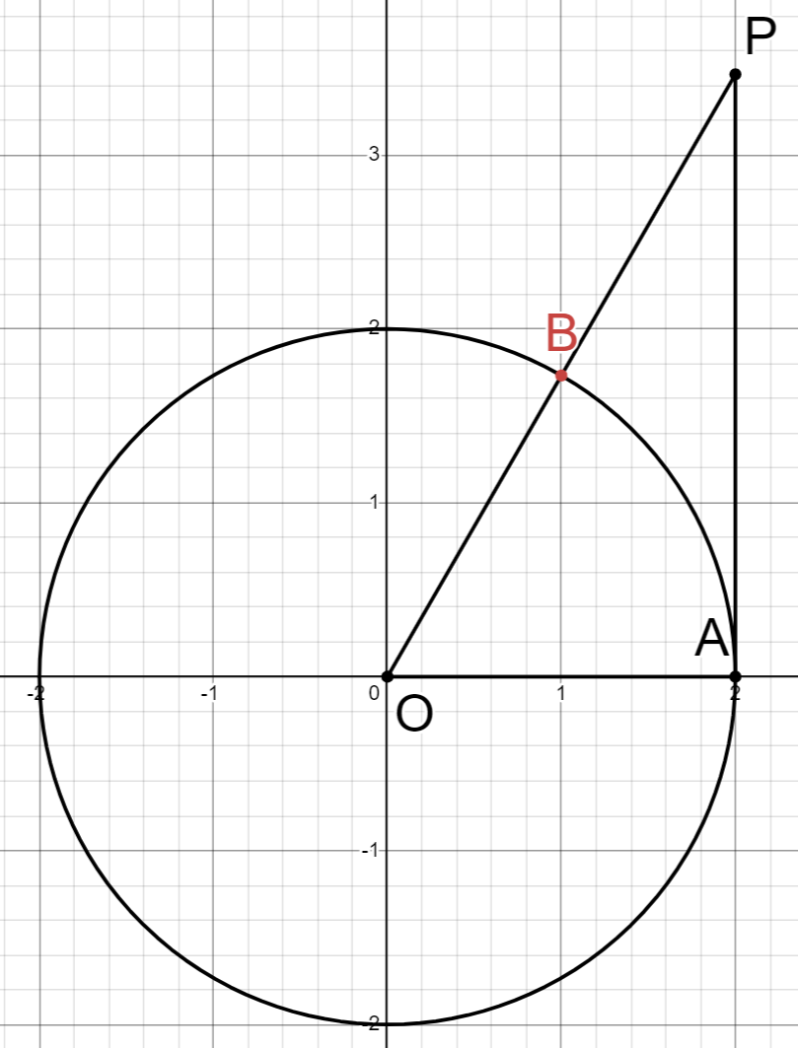

**S4)** Define BC as the x-axis and write out the functions for the lines needed, keeping in mind that “closer to vertex $B$ than any of the other three vertices” means that region R is decided by perpendicular bisectors of CB, AB, and DB. Once all the needed information is expressed through the cartesian plane, it is not hard to calculate, by dividing R into triangles, that R has area of $\frac{2\sqrt{3}}{3}$.

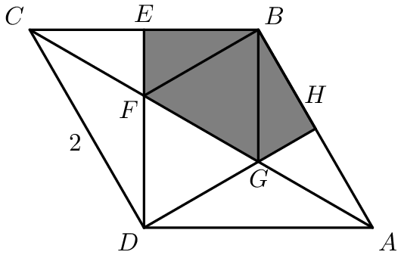

**S5)** By equating the two functions, we find that as a increases, the graph of the circle is shifted down, and the range of a starts with when the graph of the circle goes from being tangent to the parabola to having four intersections with it as it moves downward. The range ends when the vertex of the parabola lands on the circle. By simple calculation, $-\frac{1}{4}<a<0$.