**AMC8 Review Lecture Answer Key**

**2024 AMC8. 25.**

**Answer:** There are $12\cdot 11 = 132$ for two people (the married couple) to be seated. This will be our denominator.

There are $8$ pairs of seats that are next to each other in the diagram ($2$ per row; left-middle and middle-right). This will be our numerator.

Since there are $8+2=10$ total people on the plane, we should multiply our numerator by that to account for all ways the 10 people could be seated (ex. the husband and the wife could be switched around and it would still work, same applies to the other passengers)

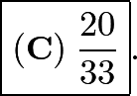Therefore, our numerator is $8 \cdot 10 = 80$.

This creates the fraction 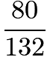, which simplifies to

**2023 AMC8. 24.**

**Answer:** Since the length of AC does not matter, we can assume the base of triangle ABC is $h$. Therefore, the area of the trapezoid in the first diagram is 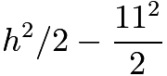.

The area of the triangle in the second diagram is now 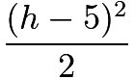.

Therefore, 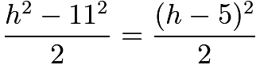. Multiplying both sides by $2$, we get $h^2 - 121 = h^2 - 10h + 25$. Subtracting $h^2 + 25$ from both sides, we get $-146 = -10h$ and $h$ is $\boxed{\textbf{(A)}14.6}$.

**2023 AMC8. 25**

**Answer:** Let the common difference between consecutive $a_i$ be $d$. Since $a_{15} - a_1 = 14d$, we find from the first and last inequalities that $231 \le 14d \le 249$. As $d$ must be an integer, this means $d = 17$. Substituting this into all of the given inequalities so we may extract information about $a_1$ gives\[1 \le a_1 \le 10, \thickspace 13 \le a_1 + 17 \le 20, \thickspace 241 \le a_1 + 238 \le 250.\]The second inequality tells us that $1 \le a_1 \le 3$ while the last inequality tells us $3 \le a_1 \le 12$, so we must have $a_1 = 3$. Finally, to solve for $a_{14}$, we simply have $a_{14} = a_1 + 13d = 3 + 13(17) = 3 + 221 = 224$, so our answer is .

$2 + 2 + 4 = \boxed{\textbf{(A)}\ 8}$

**2020 AMC8. 21.**

**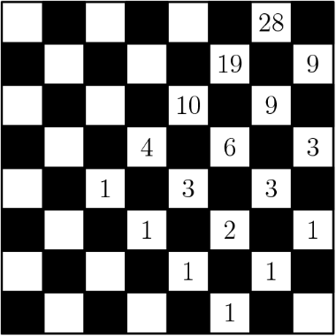Answer:** Notice that, to step onto any particular white square, the marker must have come from one of the $1$ or $2$ white squares immediately beneath it (since the marker can only move on white squares). This means that the number of ways to move from $P$ to that square is the sum of the number of ways to move from $P$ to each of the white squares immediately beneath it(also called the Waterfall Method). To solve the problem, we can construct the following diagram, where each number in a square is calculated as the sum of the numbers on the white squares immediately beneath that square.

**The answer is therefore $\boxed{\textbf{(A) }28}$.**

**2017 AMC8. 15.**

**Answer:** There are three different kinds of paths that are on this diagram. The first kind is when you directly count $A$, $M$, $C$ in a straight line. The second is when you count $A$, turn left or right to get $M$, then go up or down to count $8$ and $C$. The third is the one where you start with $A$, move up or down to count $M$, turn left or right to count $C$, then move straight again to get $8$.

There are 8 paths for each kind of path, making for $8 \cdot 3=\boxed{\textbf{(D)}\ 24}$ paths.