**PRIMO Lesson One Handout**

**Permutations and Combinations**

Combinations and permutations are ways of selecting objects from a larger group of objects. They are commonly used in solving probability and expected number problems. The difference between combinations and permutations is that permutations consider the order of the objects chosen, while combinations does not. The formula for permutation, written as $P_{n}^{r}$, meaning choosing *r* objects from *n* in order, is $\frac{n!}{(n-r)!}$, where “!” is the factorial function. The formula for combination, written as $C_{n}^{r}$, is $\frac{n!}{(n-r)! r!}$. In addition, when considering permutations, the same elements are considered equivalent. For example, the number of ways to order the word “LEOMESSI” is not 8! since there are 2 “e”s and 2”s”s , and therefore, the answer should be $\frac{8!}{2!2!}$ in order to remove the repeating answers.

The Pascal’s Triangle is often used when solving combination problems. The Pascal’s Triangle is a triangle of numbers with first row “1”, and every following number is equal to the sum of the two numbers above it. It turns out that every number in the Pascal’s triangle is equal to $C_{n-1}^{m-1}$, where n is the row it is in and m is the position of the number in the row, both starting with 1.

1

1 1

1 2 1

1 3 3 1

1 4 6 4 1

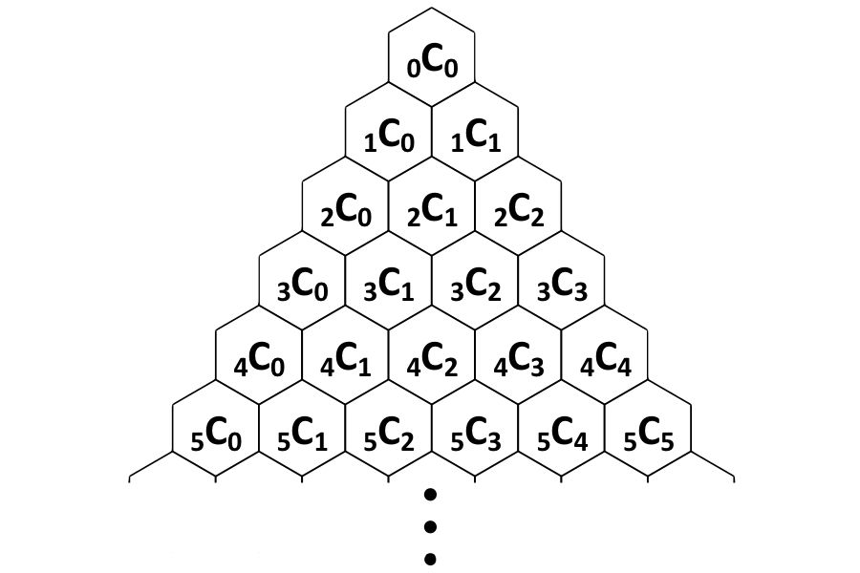

Combining this with the definition of the Pascal’s Triangle, we can prove multiple combinatorial identities,

such as:

1. $C_{n - 1}^{m - 1} + C_{n - 1}^{m} = C_{n}^{m}$

2. $\sum_{i = 0}^{n}{C_{n}^{i}} = C_{n}^{0} + C_{n}^{1} +C_{n}^{2} + ... + C_{n}^{n - 1} + C_{n}^{n} = 2^{n}$

3. $\sum_{i = n}^{m}{C_{i}^{n}} = C_{n}^{n} + C_{n + 1}^{n} +C_{n + 2}^{n} + ... + C_{m - 1}^{n} + C_{m}^{n} = C_{m + 1}^{n + 1}$

**Q1.** How many ways are there to order the letters in the word “APPROXIMATE”?

**Q2.** Ms. Yan wants to group her class of fifteen into three groups of five. In how many ways can she do this?

**Q3.** Robert decided to pick six balls from *n* balls, while Joe picked nine balls from another pile of *n* balls. They soon realize that the number of choices Joe has is $\frac{13}{3}$ times the number of choices Robert has. Find *n*.

**Q4.** Consider all 1145-element subsets of the set {1, 2, 3, ... , 2023, 2024}. From each such subset choose the least element. Find the arithmetic mean of all of these least elements.

**Q5.** Alvin is washing 6 dishes. After he finished washing each dish, we will stack it onto the pile of dishes, and continue washing the next dish. Tixi, on the other side, takes the dishes (one by one from the top) that Alvin washed and places them into the cabinet (by stacking the dishes) at a random rate and amount. After Alvin finished washing and Tixi finished stacking, how many possible arrangements of the stacked plates in the cabinet are there?