**Solutions:**

**S1) $\frac{11!}{2! · 2!}$**  = 9979200

**S2) $\frac{C_{15}^{5} × C_{10}^{5} × C_{5}^{5}}{3!} = 126126$**

**S3) $C_{n}^{9} = \frac{13}{3}C_{n}^{6}$**

$$\frac{n(n - 1)(n - 2)(n - 3)(n - 4)(n - 5)(n - 6)(n - 7)(n - 8)}{9!} = \frac{13n(n - 1)(n - 2)(n - 3)(n - 4)(n - 5)}{6! × 3}$$

$$(n-6)(n-7)(n-8)=\frac{13 × 9 × 8 × 7}{3}$$

The only possible *n* here is 20.

**S4)**  Notice that the sum of all of the least elements in all subsets can be discussed by calculating the number of cases for each least element *m* to appear. The sum will then be:

$$1 * C_{2023}^{1144} + 2 * C_{2022}^{1144} + 3 * C_{2021}^{1144} + ... +880 * C_{1144}^{1144}$$

We can expand every following term into the sum of multiple $1 * C_{n}^{1144}$ s:

$$= (C_{2023}^{1144} + C_{2022}^{1144} + ... + C_{1144}^{1144}) + (C_{2022}^{1144} + C_{2021}^{1144} + ... + C_{1144}^{1144}) + ... + (C_{1145}^{1144} + C_{1144}^{1144}) + {(C}_{1144}^{1144})$$

Using the Hockey-stick property inside of each parenthesis, the expression becomes another summation:

$$= C_{2024}^{1145} + C_{2023}^{1145} + C_{2022}^{1144} + ... + C_{1146}^{1145} + C_{1145}^{1145}$$

Observe that we can use the hockey-stick property again:

$$= C_{2025}^{1146}$$

Since there are a total of $C_{2024}^{1145}$ subsets, the arithmetic mean will be

$$\frac{C_{2025}^{1146}}{C_{2024}^{1145}} = \frac{2025}{1146} = \frac{675}{382}$$

Therefore, the final answer is $\frac{675}{382}$.

**S5)**  We can simplify this problem into ordering 6 “wash”s and 6 “place”s, where when reading from left to right, there is no point when the number of “place”s is greater than the number of “wash”s. We can graph this using a triangular-counting method:

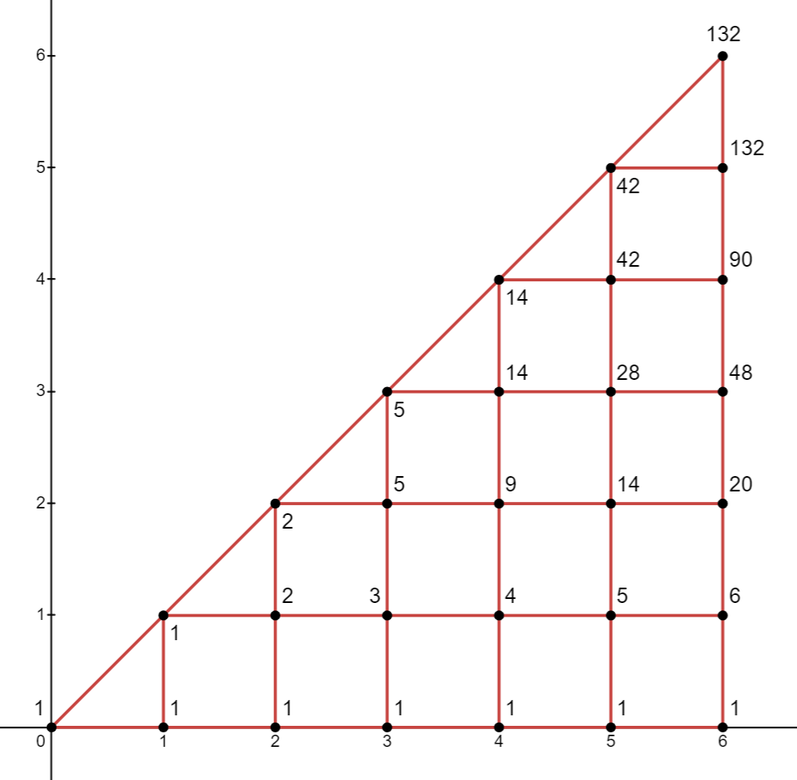

Where the x-axis is the number of dishes washed, and the y-axis is the number of dishes placed in the cabinet. The triangular graph gives a total of 132 possible arrangements, which will be the final answer for the question.