Hello Coaches!  
Besides this confirmation letter, please save and print out:

1.  Solon Invitational event schedule   
     2.  Team numbers & Home base assignments & School/Coach contact list

**All Event Supervisors:**    
     You MUST BRING with you:   
     1.  60 copies of your test for students to use during the event

     2.  All materials/equipment necessary to run your event in each

assigned time slot (if you need common lab equipment, let me know ASAP and we’ll try to accommodate)  
 3. Enough adults to supervise your own team members and home base while you are running your event.

**PLEASE email by Friday, Feb. 3rd:**

1. **Electronic copy of your test, blank answer sheet and completed answer key**  
     *If you are running "stations", plan for* ***15 teams each hour****.  You are still expected to*

*provide electronic copies of the questions, pictures, answers for the coaches.*

*If you are listed under “assisting event” you are expected to provide set-up, proctoring,*

*take-down and grading help for the coach running the event.*

**  
**Building Event Supervisors:**

Electronic sign-up for mechanical event time slots will be another email sent out when this is up and running.

If you are scheduled to bring 2 teams but decide to only bring 1, please contact me ASAP.

I have a waiting list. Also, (If bringing 2 teams) Ensure BOTH teams registration fees are paid!

If on the day before or day of tournament, for some reason you cannot make it, please contact me ASAP.

Please **DO NOT bring in outside food/beverages for your teams. Concessions will be sold for lunch, snack and beverage needs.**

Breakfast and lunch will be provided for **2 coaches per team** ☺ in room 119.

**Please remind** bus drivers that the **teachers’ cafeteria** will be available for bus drivers to watch TV, socialize, etc.



**Brief Coaches meeting** will be at **8:00AM** in the **Lecture Hall.**

**Have teams CLEAN UP Home Base areas BEFORE going to awards.**

**Please** respect materials, equipment, desk accessories, etc. We need your help to ensure all materials and the room was left as neat as you found it.

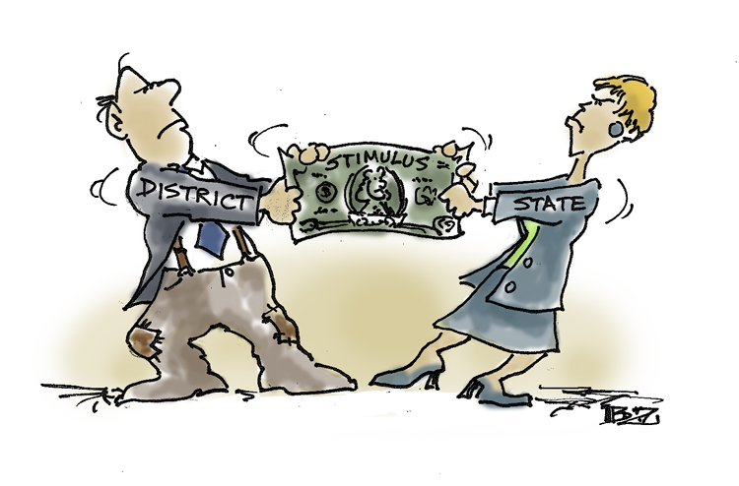Awards will be in the auditorium as soon as scores are in, exact time is dependent on how fast you grade!**(no food/beverages in auditorium).** Medals will be awarded for 1st through 3rd place for each event, ribbons will be places 4th-8th place. Trophies will be awarded to the top 6 teams with 1 trophy per school.

Once the award ceremony is over, any score adjustments brought to my attention that change the top 6 award recipients will not result in awards being collected and/or reissued.

Invitational Address: Solon H.S., 33600 Inwood Dr., Solon, Oh 44139.  School is located on the south side of Inwood Drive.  **Teams should unload and enter through the main entrance doors near the flag pole, or through the pool lobby entrance.** Buses/vans/cars should park in the main lot on the west side of the building.  School maps will be at the **registration desk** **in the main entrance lobby** upon check-in.  There is a basketball tournament at 10am, so pool lobby will be inaccessible after that point.

C:\Documents and Settings\nicolegeiger\Local Settings\Temporary Internet Files\Content.IE5\GJMLGVGI\dglxasset[1].aspxIf weather does not cooperate, and there are concerns invitational being cancelled due to weather conditions, please check your email Friday, and Sat. morning.

If I forgot something, or you have any questions, please contact me, by email or by cell phone (216)-469-4413.

Looking forward to hosting the 23rd Solon Science Olympiad Invitational!

Nicole Geiger  ☺