Conics

* General equation: Ax2+Cy2+Dx+Ey+F=0
* Circle
  + Produced when a double cone is cut with a plane parallel to a base
  + A set of all points equidistant from the center
  + Center-radius form: , where r is the radius, (h, k) is a the center and (x, y) is a point on the circle
  + Conics form: has both a x2 and y2 term with equivalent coefficient
  + Eccentricity: 0
* Ellipse
  + Formed when a double cone is cut with a plane not parallel to a base and also doesn’t touch base
  + A set of points whose distances from the foci sum to the length of the major axis
  + Horizontal standard form:
  + Vertical standard form:
  + Where (x, y) is a point on the ellipse, (h, k) is the center, a is the length of the semi-major axis (half of the longest distance across the ellipse), b is the length of the semi-minor axis (half the shortest distance across the ellipse)
  + Vertex: the endpoints of the major axis (longest)
  + Co-vertex: the endpoints of the minor axis (shortest)
  + A is also the distance from a co-vertex to a focus
  + Conics form: coefficients of both x2 and y2 terms are different, but not equal to zero and has the same sign
  + Focal length:
  + Eccentricity: (0, 1)
* Parabola
  + Created by cutting a double cone with a plane in a way in which the plane only intersects one base face
  + A set of all points where their distance to focus equals their distance to the directrix
  + Vertical focus directrix form: 4p(y-k)=(x-h)2
  + Horizontal focus directrix form: 4p(x-h)=(y-k)2
  + p is the distance from vertex to focus or directrix
  + Standard Parent: f(x)=ax2+bx+c
    - A may reflect graph over the minimum and will dilate horizontally by reciprocal
    - C translates vertically
  + Vertex form
    - f(x)=a(x-h)2+k
    - Vertex is (h, k)
    - Can be derived from completing the square
    - A = 0.25p, where p is the distance from a point to focus or directrix
  + Intercept form
    - f(x) = a(x-p)(x-q)
    - P and q are roots, “x lies”
  + Conics form: has only one quadratic term
  + a=0.25p
  + Eccentricity: 1
* Hyperbola
  + Formed by cutting a double cone with a plane that intersects both base faces
  + Vertical:
  + Horizontal:
  + To draw:
    - (h, k) is center
    - The square root of the number under the (x-h)2 term is the number of units left and right of the center
    - The square root of the number under the (y-k)2 term is the number of units up and down of the center
    - Using those 4 points, draw a rectangle, where those 4 points are on their own side
    - Draw and extend the diagonals of the rectangle out of the rectangle
      * These are the asymptotes
    - If the equation is vertical, use the points above and below of the center as vertices
    - If the equation is horizontal, use the points to the right and left of the center as vertices
    - From the vertex, draw the hyperbola in a manner where the curve runs next to but not on the asymptotes
    - Focal length:
    - Eccentricity: >1
* Eccentricity
  + How far away a conics section is away from being a circle
  + Also ratio of a point's distance to focus over the point's distance to the directrix
  + Closer to 0 means closer to being a circle

Limits

* To approach a value means as x gets closer to some value, y also gets closer to something, without reaching it
* The direction of approach is specified with + or - right after the value to approach
  + If no direction is specified, it means approach from both left and right
    - The value being approached is DNE (does not exists) if value approached from left is different from value approached from the left
  + A direction of + means approach towards the left, or as x decreases towards the value to be approached
  + A direction of - means approach towards the left, or as x increases towards the value to be approached

Polynomial and Rational functions

* Polynomial: an equation with one or more terms with real coefficients and non-negative integer exponents
* Degree: exponent of leading term
* Odd degree functions
  + If the leading coefficient is >0, function approaches negative infinity as x approaches negative infinity, and approaches positive infinity as x approaches positive infinity
  + If the leading coefficient is <0, function approaches positive infinity as x approaches negative infinity, and approaches negative infinity as x approaches positive infinity
* Even degree functions
  + If the leading coefficient is >0, function approaches positive infinity as x approaches both approaches positive and negative infinity
  + If the leading coefficient is <0, function approaches negative infinity as x approaches both approaches positive and negative infinity
* Zeros are when y=0, or roots, or x-intercepts
  + Has n roots, where n is the degree
* Y intercepts are when x = 0
* Extremas are points where the function turns the other direction
  + Can have up to n-1 extremas, where n is the degree
* Points of inflection: at the “shoulders” of the “flat” parts
* Multiplying polynomials graphically
  + Product shares the same roots as its factors
  + If f(x) is the product and a(x) and b(x) are the factors, then graph f(d)=a(d)\*b(d)
* A root with even multiplicity (even #) will touch x axis but won’t cross
* A root with odd multiplicity will sway through x axis at root value
* The greater the degree of a factor, the “flatter” it gets
* Sum of roots:
* Product of roots
  + Even degrees:
  + Odd degrees:
* Division
  + Long division
    - Rewrite in standard form
    - Use 0xpower placeholder to ensure that all degrees from the greatest one to one is present
    - Divide leading term of dividend by leading leading term of divisor
    - Multiply result to divisor
    - Write it under dividend starting from right
    - Subtract and bring down next term
    - Repeat, but use the difference from prev step instead of dividend
    - After subtraction, if the difference doesn’t have variable, then it’s remainder
    - Remainder over divisor is the last term
    - no remainder means divisor a factor for the dividend
  + Synthetic division
    - Only for linear divisors
    - Set the divisor equal 0 and solve for x. Write that number in the box
    - Use 0xpower placeholder to ensure that all degrees from the greatest one to one is present
    - Write in order the coefficients of the terms
    - Bring down leftmost number
    - Multiply it by number in box and add to next number
    - Multiply sum and add to the next number and so on
    - Last number is remainder
    - Multiply resulting numbers by the coefficient of x in the divisor
    - To find quotient, first number is coefficient for a power of x 1 degree below degree of dividend, rest are constants for powers of x descending from the first term’s power.
    - Remainder over divisor is the last term
  + Factor theorem: if a polynomial divided by another polynomial and there is no remainder, then the divisor is a factor of the dividend
    - Ex: if f(x)/(x-a) has no remainder, (x-a) is a factor of f(x)
  + Remainder theorem: When a polynomial is divided by a linear divisor, set divisor equal to 0 and solve for x. Solve the polynomial for that value to get the remainder that would occur from dividing polynomial by the divisor
    - Ex: the remainder of f(x)/(x-a) is f(a)
* Rational root theorem: possible rational roots of a polynomial is p/q, where p are possible integers factors of the constant and q are possible integer factors of the leading coefficient
* Location of principle: if output signs change between 2 input values, there’s a root between those 2 input values
* Rational functions
  + Vertex form: , where h is horizontal translation and k is vertical translation of the respective asymptotes, a is vertical dilation
  + Standard form is a polynomial divided by another polynomial
  + Before finding features, factor both the numerator and denominator. Eliminate out factors that appear in both the numerator and denominator. Those are holes, or omitted values.
  + Asymptotes: values being approached when x or y approaches something
  + Vertical asymptotes: factor the denominator. Solve each factor for the root. VA = x = ?
  + Horizontal asymptotes: place function into standard form and rewrite numerator and denominator to share the same degree, using 0 as placeholder as necessary. Take ratio of numerator’s leading coefficient to denominator’s leading coefficient. HA = y = ?
  + slant/oblique asymptotes: an asymptote that isn’t horizontal nor vertical. Literally divide the function, and the non-remainder portion is the oblique asymptote. Remainder is negligible since x is in its denominator, so as x approaches infinity (def of an asymptote), remainder approaches 0.
  + Locations of holes: substitute in the x values of hole to get y. (x, y)
  + If a factor representing a vertical asymptote (denominator) has even multiplicity, the branches travel in the same direction at that asymptote
  + If a factor representing a vertical asymptote has odd multiplicity, the branches travel in opposite directions at that asymptote
  + If a factor representing a root (numerator) has even multiplicity, the graph is tangent to that root
  + If a factor representing a root has odd multiplicity, the graph will sway through that root
  + Rational function inequalities
    - Manipulate inequality to have 0 on one side
    - Adjust inequality to have rational function on other side
    - Remember that a function changes directions/signs through x axis at an odd multiplicity root or odd mult vertical asymptote
    - Draw an x axis marking points where function changes direction
    - Take a random point and plug into the function to determine the sign in its interval
    - Use that to find the sign of the other intervals
* Partial fraction decomposition
  + Break down a rational function into the sum of multiple rational functions, to make them easier to work with in calculus
  + First, do division if possible (when numerator is a greater degree than denominator)
  + Factor the denominator as much as possible
  + For each factor, use each as their own fraction, having the factor in the denominator. Sum up each of these. Ex: (x+1)(x2-3) →
  + If a factor has a multiplicity greater than 1, repeat it by creating a fraction with that factor in the denominator, then another fraction with that factor of one lesser degree in the denominator, repeating until you reach first degree. Ex:
  + The numerator of a fraction is one degree less than the denominator. Use variables as placeholders. Ex:
  + Multiply terms by fractions equivalent to 1 to make them have a common denominator
  + Eliminate denominators from equation, since they’re all equal now
  + Expand equation
  + Create a system of equations by comparing the terms on both sides that share the same degree. Ex: Ax+2A+Bx-B3-6x-8; Ax+Bx=6x, 2A-3B=-8
  + Let x = 1 and solve system of equation

Functions and Inverses

* Inverse
  + Functions are inverse when domain of one is range of the other, range of other is domain of one, and so on. (g(f(x))=x, (f(g(x))=x so g-1(x)=f(x)
  + Reflects over y=x
  + Indicated with -1
  + When composite, output = input
  + To find inverse, switch domain (x) and range (y) and put into y= form
* Composition: , meaning take output of g when x is input, and use that as input for f
* One to one: each range value corresponds to only one domain value
* Onto: each range value corresponds to at least one domain value
* Piecewise: a different rule over different domains
  + The pieces go right of a brace. Each piece is made of a rule written as an expression, then a comma, then a restriction written as an inequality
* Even
  + Has y axis a line of symmetry
  + f(x) = f(-x)
* Odd
  + Symmetric through origin
  + -f(x) = f(-x)

Exponential and Logarithmic Functions

* Exponents
  + ab\*ac = ab+c
  + = ab-c
  + (ab)c = abc
  + a-b =
  + a0 = 1
* Logs
  + logBN=E, where B is base, E is exponent, and N is BE > 0
  + Inverse of an exponential function
  + Rules
    - Logxab = logxa+logxb
    - logx()=logxa-logxb
    - logxab=blogxa
    - logaa=1
    - logx1=0
    - logaax=x
    - a(=x
    - logbx=
      * Proof: let logBA=y. Rewrite to By=A. take the log of both sides of the new equation: ylogB=logA. y=logA/logB, = logBA as previously defined
    - logbx =
      * Based on previous point, but making a = x, and noting that logxx = 1
    - If logba=logbc, a=c
  + Natural log: ln, aka loge
  + Common log: log, aka log10
  + To find the number of digits in a number, take base 10 log of it. Take the result of that, and look at the whole number portion of the result. That result +1 is the number of digits in the number you took the log of
  + Solving log equations
    - When logs terms are on one side
      * First, condense the log term. Then, convert to exponential form. Next, solve, and make sure to not take the log of a negative number
    - When log terms are on both sides
      * First, condense log terms. Then, If logax=logay, cancel the loga’s. Solve and check that you won’t take a log of negative numbers.
    - Variable in exponent
      * First, isolate the exponential term. Then, take the natural or common log of both sides. Next, isolate the variable using log rules and solve.
* Applications
  + General case: Prt, where P is the initial amount, r is rate and t is time
  + Interest: , where P is principle, r is rate, t is time in years and n is number of times compounded in a year
  + Continuous: Pert, where P is the initial amount, r is the rate, t is time and e is Euler’s constant
    - e is , which is about 2.17
  + Half life decay: where P is the initial amount, t is time passed and h is length of half life

Trigonometry

* Radians
  + 1 radian is the angle created by bending radius around circumference
  + 1 circle is 2π radians (or radius on a circle)
  + 2π rad = 360°,
  + 1° =rad
  + 1 rad = °
* Unit circle
  + Circle with center at (0,0) and radius of 1
  + Since the hypotenuse of a unit hypotenuse triangles is 1, using special triangle ratios, the sin, cos and tan of 0°, 30°, 45°, 60°, 90° (and other angles that use those as reference angles) can be found
    - Use line from (0,0) to (1, 0) as initial ray
    - Draw in terminal ray of angle
      * Counterclockwise for positive, clockwise for negative
    - Draw line from terminal ray’s intersection with circle to x axis, perpendicularly, forming a triangle
    - For angles greater than 90°, use a reference angle
      * Find smallest measure from terminal ray to x axis
      * Use that angle’s special triangle ratios
    - Using special triangle ratios, fill in lengths
    - Y coordinate of terminal ray’s intersection with unit circle is sine, x coordinate is cosine.
    - Slope of the ray is tangent
      * Tangent = sine/cosine = y/x = slope
  + Coterminal angles
    - Angles with coexisting terminal rays in unit circle
    - A multiple of 360° away from each other (60°, 420°, 780°)
    - Has same sine, cosine, tangent, and their inverses
* Ratios
  + 30°-60°-90° triangle
    - Side length ratio x:x():2x
  + 45°-45°-90° triangle
    - Side lengths ratio x:x:x()
  + Sine (sin)
    - Sin (Θ) = cos(90° - Θ)
      * Proof
        + In triangle ABC with hypotenuse c and right angle C, A + B = 90°, sin(A) = a/c and sin(B) = a/c
    - Pythagorean identity: sin2(Θ) + cos2(Θ) = 1
      * Proof
        + In triangle ABC with hypotenuse c and right angle C, sin(A) = a/c, cos(A) = b/c and cos2(A) + sin2(A) = () + () = =1
    - Parent domain: (-inf, inf)
    - Parent range: [-1, 1]
  + Cosine (cos)
    - cos(Θ) = sin (90° - Θ)
    - Parent domain: (-inf, inf)
    - Parent range: [-1, 1]
  + Tangent (tan)
    - Parent domain: (-inf, inf), except at multiples of 90° there’s a vertical asymptote
      * Tangent is the slope of the ray on a unit circle, and at multiples of 90°, the ray is vertical, which means undefined slope/tangent
    - Parent range: (-inf, inf)
  + Cosecant (csc)
    - Reciprocal of sine
    - Parent domain: (-inf, inf), except at multiples of 180°
      * Cosecant is like a rational function by being . There’s a vertical asymptote whenever the denominator equals 0. Sine is 0 at multiples of 180° (points on x axis on unit circle)
    - Parent range: (-inf, -1]U[1, inf)
      * Intersection with parent sine at maximums, because the sine at maximum equals 1 and reciprocal of 1 is 1
  + Secant (sec)
    - Reciprocal of cosine
    - Parent domain: (-inf, inf), except at multiples of 90°
      * Secant is like a rational function by being . There’s a vertical asymptote whenever the denominator equals 0. Cosine is 0 at multiples of 90°(points on y axis on unit circle)
    - Parent range: (-inf, -1]U[1, inf)
      * Intersection with parent cosine at maximums, because the cosine at maximum equals 1 and reciprocal of 1 is 1
  + Cotangent (cot)
    - Reciprocal of tangent
    - Parent domain: (-inf, inf), except at multiples of 180°
      * Cotangent is like a rational function by being . There’s a vertical asymptote whenever the denominator equals 0. Tangent is 0 at multiples of 180° (flat rays on unit circle)
    - Parent range: (-inf, inf)
  + Arcsine (sin-1)
    - Inverse of sine
      * Pass it a sine ratio and it returns an angle
    - Parent domain: [-90°, 90°]
      * Sine is the y axis on a unit circle. Since a function can’t have repeated domains, give it only one “side” of the y axis on the unit circle. Give it the “side” that has the initial ray, so restrict to quadrants 1 and 4, which goes from -90° to 90°
      * Since coterminal rays exist on a unit circle, restrictions are required so the inverse functions would only have one output
    - Parent range: [-1, 1]
  + Arccosine (cos-1)
    - Inverse of cosine
    - Parent domain: [0°, 180°]
      * Cosine is the x axis on a unit circle. Since a function can’t have repeated domains, give it only one “side” of the x axis on the unit circle. Give it the “side” that has the initial ray, so restrict to quadrants 1 and 2, which goes from 0° to 180°
    - Parent range: [-1, 1]
  + Arctangent (tan-1)
    - Inverse of tangent
    - Parent domain: (-inf, inf)
    - Parent range: [-90°, 90°]
      * Tangent is the slope of the ray. A semicircle is enough for a ray to express every slope it can possibly express. In the unit circle, choose the semicircle that contains the initial ray (restrict to quadrants 1 and 4)
* Graphing
  + Create a table: 1 column for x coordinate, one for y coordinate, one for radian measures and another for corresponding parent co/sine values
    - For radian measures, use 0, , π, and 2π
    - To find x coords, take radian measure, subtract c from it
    - To find y coords, first take the sin or cos value for the radian measures in a unit circle. Then multiply by a, then add d.
  + Plot dots and connect with smooth lines
  + Another way is to draw reference lines at midline, amplitudes and starting point. Then, draw the correct curves.
  + parent: a sin or cos(b(x+c))+d
    - a is amplitude, distance from midline to max/min
    - b is frequency, number of periods in 2π
    - d is vertical translation, shifts midline
    - d+a is max
    - d-a is min
    - is period, parent is 2π
    - -c is horizontal translation
* Identities
  + Reciprocal
  + Quotient
  + Pythagorean
    - * Divide the first one by sin2θ
      * Divide the first one by cos2θ
  + Sum
    - sin(x+y) = sinxcosy+sinycosx
    - cos(x+y) = cosxcosy-sinxsiny
    - tan(x+y) =
  + Difference
    - sin(x-y) = sinxcosy-sinycosx
    - cos(x-y) = cosxcosy+sinxsiny
    - tan(x-y) =
  + Double angle
    - sin(2x) = 2sinxcosx
    - cos(2x) = 2cos2x-1
      * = 1-2sin2x
        + Proof:
        + sin2x+cos2x=1
        + cos2x = 1-sin2x
        + 2cos2x-1
        + 2(1-sin2x)-1
        + 2-2sin2x-1
        + 1-2sin2x
      * = cos2x-sin2x
        + Proof:
        + sin2x+cos2x=1
        + 2cos2x-1
        + 2cos2x-(sin2x+cos2x)
        + 2cos2x-sin2x-cos2x
        + Cos2x-sin2x
    - tan(2x) =
  + Half angle
* Solving equations where x is an angle
  + Solve for the trig function terms as you would solve for variables
  + Once you know what each trig term is equal to, write them as equations. Take the arcfunction of each side
  + You end up with the angle argument being made equal to the arcfunction of a number
  + Find the reference angle that would result in that number through the trig function
  + Note whether the trig function corresponds to the x axis, y axis or slope of terminal ray
  + Given the information from the last 2 bullets, as well as the sign of the number, on a unit circle, draw in the possible locations of the terminal ray
  + For each terminal ray, write the rule for getting to that location, considering coterminals exist
  + Example:
  + 2cos2x-cosx-1=0
  + (cosx-1)(2cosx+1)=0
  + cosx-1=0 2cosx+1=0
  + cosx=1 2cosx=-1
  + cosx=-0.5
  + acos(cosx)=acos(1) acos(cosx)=acos(-0.5)
  + x=acos(1) x=acos(-0.5)
  + Reference: 0 reference: pi/3
  +  
  + 0+2k, k Z
* Geometry
  + Law of sines
    - Where A, B and C are angles, and a, b, c are sides opposite the respective angles
    - A, B and C are restricted (0, 180)
    - If one angle is given, 2 sides are given, and you’re solving for an angle, 2 different triangles can be made (ambiguous case), because its reference angle allows multiple angles within (0, 180). That’s why ASS can’t prove similarity; the other triangle could be the other case
  + Law of cosines
    - a2=b2+c2-2bccosA
    - Where a, b and c are sides and A is the angle opposite side a
    - A is restricted (0, 180) because triangle
  + Area of a triangle: 0.5absinC, where angle C is included in sides a and b
  + Heron’s formula: area of a triangle = , where S =

Complex Numbers

* Argand graph: horizontal axis is the REal part, the vertical axis is IMaginary part
  + Absolute value (magnitude/modulus) (r): the distance from a point to the origin
  + Argument (): the angle formed by the x-axis (part in quadrant 1) and the segment connecting the point to the origin. Use arctan
* Sum of perfect squares: x2+y2 becomes x2 - -y2, then do the difference of perfect squares
  + Binomials can be rewritten as a difference of perfect squares first too
* Rectangular form: a+bi, where a is RE and bi is IM
* Polar form: reiθ, or
  + Trig version derived from factoring r out of rectangular form
    - Looking on an argand graph, the cosine of the argument is RE/r and the sine of the argument is IM/r. That means when factoring r out of rectangular form, the real part becomes RE/r, which is aka cosine of argument, and imaginary part is iIM/r, aka isine of the argument
  + Put in terms of e when dividing or multiplying, so exponent rules can be used
  + As a result, in the trig version, when multiplying, the new modulus would be the product of the moduluses of the original numbers, and the new argument would be the sum of the arguments of the original numbers
  + When dividing, the new modulus would be the quotient of the moduluses of the original numbers, and the new argument would be the difference of the arguments of the original numbers
  + DeMoivre’s Theorem: as a result, raising a complex number to the nth power raises the modulus to the nth power, and multiplies the argument by n
* Finding all the roots, real or imaginary
  + Linear factorization theorem: a polynomial to the nth power has n roots, (real and imaginary roots combined)
  + Isolate the x term first
    - If x is part of a term that’s enclosed in parenthesis, where the parenthesis is raised to a power not equal to 0, 1 or -1, isolate that instead, so that you take the roots of that term first
    - Once you get all the roots of that term, then set that enclosed term equal to those roots to solve for x in each case
  + Exponential form: convert the side without x into exponential polar form. Add 2π to for the next iteration. Do this again to get the next iteration. Get z iterations, where z is the degree of the x term. Then take the z root of each iteration
  + Trig form: rewrite the side without x to trig form. Then, take the nth root of both sides, where n is the degree of the x term. Simplify with DeMoivre's theorem. Then take 360o (or 2π, if radians) and divide that by n. Add the resulting number to for the next iteration. Do this again to get the next iteration. Get up to n iterations.
    - Example:
      * 2(x-2)6-128 = 0
      * 2(x-2)6=128
      * (x-2)6=64 //find the roots of x-2 first. This is a 6 degree term, so by linear factorization theorem, it must have 6 roots
      * (x-2)6=64+0i
      * (x-2)6=64(cos0+isin0) //convert to trig form
      * //x term is raised to 6th power, so take 6th root of both side
      * x-2=2(cos0+isin0) //DeMoivre’s theorem. This is the first iteration
      * 360/6 = 60, so keep adding 60
      * x-2=2(cos60+isin60) //iteration 2
      * x-2=2(cos120+isin120) //iteration 3
      * x-2=2(cos180+isin180) //iteration 4
      * x-2=2(cos240+isin240) //iteration 5
      * x-2=2(cos300+isin300) //iteration 6. Stop, we reached 6 root
      * Now solve for x in each iteration:
      * x-2=2(cos0+isin0), x=2(cos0+isin0)+2
      * x-2=2(cos60+isin60), x=2(cos60+isin60)+2
      * x-2=2(cos120+isin120), x=2(cos120+isin120)+2
      * x-2=2(cos180+isin180), x=2(cos180+isin180)+2
      * x-2=2(cos240+isin240), x=2(cos240+isin240)+2
      * x-2=2(cos300+isin300), x=2(cos300+isin300)+2
      * You can simplify it into rectangular form to make it look neater
        + Ex: 2(cos0+isin0)+2 = 2(1+0i)+2 = 2+0+2 = 4
      * These are all the values you can plug into x to make the equation true

Parametric Equations and Polar Curves

* parametric equations: 3 variables
* x, y, t axis, making a 3d graph
* Parametric form: 2 equations: one of them describes how x changes as t changes. The other describes how y changes as t changes.
* The restrictions of the equation as a whole are based on the restrictions of the 2 portions. The domain (t) of both portions have to be the same, so if values of t have to be omitted from one of the portions, it’s omitted from both, and both portions’ ranges are adjusted as appropriate. The range (x) of the x= portion is the domain of the entire function, and the range (y) of the y= portion is the range of the entire function
* Rectangular form: function form, 2d graph, only x and y, as if looking at the 3d graph from a perspective where you’re looking straight on at the xy plane only
  + For parametric equations where both portions have a trig ratio, and their arguments are equal and contains t, the rectangular form is a conic section
* Converting from parametric to rectangular form: solve one portion for t and substitute into the other. Gives you a function
  + If both portions have a trig ratio and t is in the argument, solve both portions for the trig ratio, then plug them into an identity to simplify
* Converting from rectangular to parametric form
  + There are infinite options. X can be anything, as long as y adjusts accordingly
  + Isolate the y term in the rectangular
  + Let x be any function of t (any function with t in it)
    - That is the x portion
  + Substitute into the rectangular
  + Simplify
    - That is the y portion
* Polar coordinates system
  + Graph looks like a bunch of concentric circles

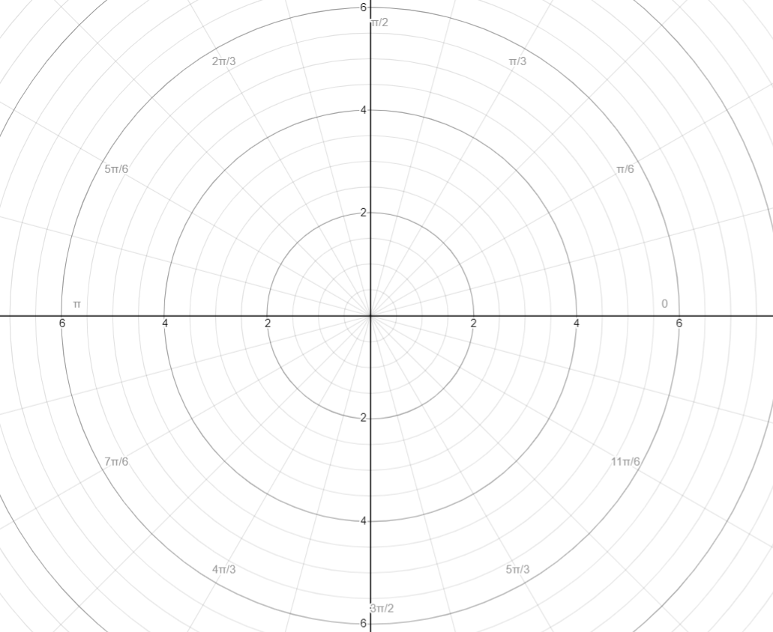

* + Coordinates:
  + The horizontal axis is called the polar axis
  + graphically, r represents the radius of the circle that contains the point
  + represents the radian measure along that circle between the point and the positive section of the polar axis
  + (think: r and from polar form of complex numbers)
  + If r is negative, then to graph, add pi to θ then pretend the r is positive
    - A reflection over the the pole (“origin”)
    - To plot with a negative r, you can just find where where the theta is, “face” that direction (“stand” on pole and look away towards that direction) and move backwards

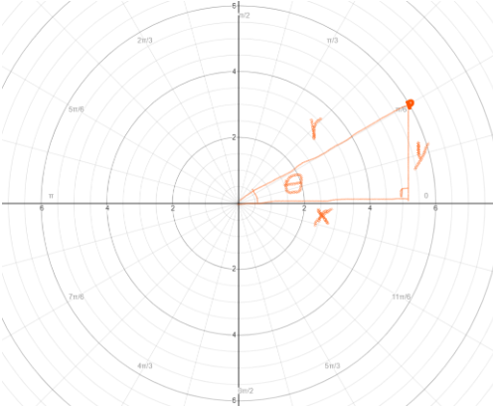

* + To convert from rectangular (x, y) to polar (r, ), imagine a right triangle being drawn in and use trig (think: like a trig circle)
  + Polar to rectangular: draw that trig circle triangle thing in. remember sine is opp/hyp, so it becomes y/r. Cosine is adj/hyp, so it becomes x/r. So…
    - (rcosθ, rsinθ)
* Polar equations
  + Since rectangular equations relate y position to x position, polar equations relate r to θ
  + Generally in r= form
  + Conversion between the 2 forms is like substitution
  + Remember the parent circle function x2+y2=r2. That describes a circle with radius r centered at the pole, which works the exact same way you would describe it on a polar coordinate grid, so… substitute x2+y2=r2
  + Remember that polar to rectangular is (rcosθ, rsinθ) = (x, y), so… substitute x=rcosθ and y=rsinθ
  + Remember that rectangular to polar is = (r, ), so… substitute r= and =
* Fun shapes
  + Circles

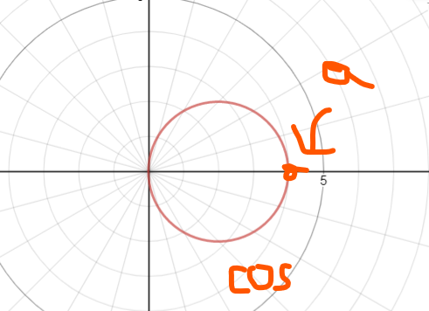

* + - r=a \* cos(theta)
      * a circle with symmetry over the polar axis and diameter of a
    - r=a\*sin(theta)
      * A circle with symmetry over pi/2 and a diameter of a
  + Rose petal

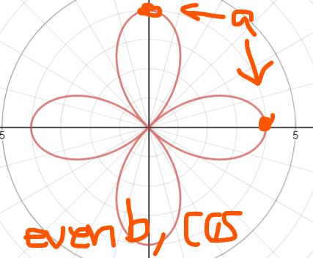

* + - r=a\*cos(b\*theta)
      * Petals are a long
      * If b is even, then there are b\*2 petals
      * If b is odd, then there are b petals
      * Symmetry over polar axis
    - r=a\*sin(b\*theta)
      * Like above, but symmetry over pi/2
  + Limacon

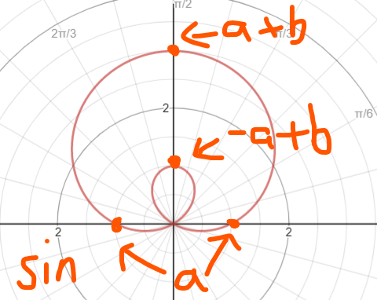

* + - r=a+bsin(theta)
      * X intercepts at (a, 0) and (-a, 0)
      * Symmetry across pi/2
      * First, envision a circle. The top most point is at (abs(a+b), pi/2)
    - r=a-bsin(theta)
      * Makes the above shape, but reflected over the polar axis
    - r=a+bcos(theta)
      * Makes the first shape, but rotated 90 degrees clockwise (pi/2 subtracted from theta)
    - r=a-bcos(theta)
      * Makes the above shape, but reflected over pi/2
    - Inner loop
      * a/b < 1
      * Loop on the bottom formed by “pushing in” the circle
      * The top of the loop is at (-abs(a)+b, pi/2). Bottom of the loop is at the pole
    - Cardioid
      * a/b = 1
      * Looks like a heart
      * push in point goes to the pole.
    - Dimpled limacon
      * 1 < a/b < 2
      * Like a heart, but the push in isn’t so sharp.
      * Push in (dimple) is at (-a+b, pi/2)
    - Convex limacon
      * a/b >= 2
      * push in makes a flat part
      * Flat part passes through (-a+b, pi/2)
  + Lemniscates

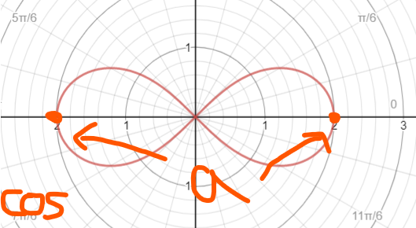

* + - r2=a2cos(2theta)
      * Creates an infinity sign
      * Center on pole
      * Symmetry over pi/2 and polar axis
        + Symmetry created by square root
      * a represents the length of each loop
    - r2=a2sin(2theta)
      * Creates the same shape as above, but rotated 45 degrees, so that symmetry is over pole
  + If symmetry over polar axis and pi/2 exists, it’s a cosine if a loop runs through the polar axis
* Symmetry
  + The coord of (r, θ) reflected over pi/2 is (r, pi-θ) or (-r, -θ)
  + The coord of (r, θ) reflected over the polar axis is (r, -θ) or (-r, pi-θ)
  + The coord of (r, θ) reflected over the pole is (r, pi+θ) or (-r, θ)
  + To check what symmetries a graph has, remember that for every point on that graph, the reflected version of that point must also be on the graph
    - Ex: if the graph is symmetrical over the pole, (r, θ) and its reflection (-r, θ) both must be on the graph
    - An easy way to check if something is on the graph is to plug in its coords into the graph’s equation and see if you end up with a true statement. Plug in a coord-when-reflected rule
    - The resulting statement is true if when manipulated to r=, it’s equivalent to the original equation when manipulated to r=
    - When given a table, just check that all points on the table follow the coord-when-reflected rule for that symmetry
* Intersections
  + Graph
    - Just because a graph looks to intersect on a graph doesn’t necessarily mean there’s a solution there
    - That’s because points may look to be in the same space, but it could’ve just been a negative r at another theta.
    - Use substitution to verify. Sub in the theta of supposed intersection. Make sure same theta doesn’t give different r
    - Or pull out that graphing calc. Under the calc section, choose value. Enter a theta. It will show the coord at that theta for the first equation. Hit the up/down arrow keys to cycle through equations to see the coords of the same theta for other equations. Make sure points are actually shared
  + Equations
    - Like rectangular. Solve for r or theta and substitution
    - Note: trig identities may be helpful here
    - If you’re solving for r and substituting r’s, you can generate a list of possible thetas. Plug that theta into each of the equations to get the corresponding r

Sequences and Series

* Arithmetic
  + A common difference between each term
  + Explicit: , where n refers to the term number and d is the common difference
  + Recursive:
  + Partial series:
    - proof
      * Let's say you want to calculate the partial series of the first 5 terms of a sequence with a common difference of 1, starting from 1 (1, 2, 3, 4, 5)
      * The series would be S=1+2+3+4+5
      * Because of commutative property, 1+2+3+4+5=5+4+3+2+1
      * Let’s call the sum S
      * 2S could be (1+2+3+4+5)+(5+4+3+2+1)
      * (1+2+3+4+5)+(5+4+3+2+1) = (6+6+6+6+6)
      * So, 2S = (6\*5)=(1+5)(5),
      * S= ((1+5)(5))/2
      * Or: ((starting+ending)(number of terms))/2
* Geometric
  + A common ratio between each term
  + Explicit: , where r is the common ratio
  + Recursive:
  + Partial series:
    - Proof
      * Sn=a1r0+a1r1+a1r2+...+a1rn-1
      * -rSn=-a1r1-a1r2-a1r3-...-a1rn
      * Sn-rSn=a1r0+a1r1+a1r2+...+a1rn-1-a1r1-a1r2-a1r3-...-a1rn
  + Infinite series: , if the absolute value of the rate is <1
    - Proof:
      * If the absolute value of r is <1,
* Triangular
  + Explicit:
  + Recursive:
  + Based on partial series of an arithmetic sequence
* Sigma notation:
* Convergent sequence: as n approaches infinity, the elements in the sequence approaches a specific real number
  + (hint: a geometric sequence where the absolute value of r is <1 converges to 0)
  + (hint: a rational function converges to its horizontal asymptote)
* Diverge sequence: as n approaches infinity, the elements in the sequence do not approach a specific real number
* Convergent series: a series that has a converging sequence of partial sums
  + Partial sums: let's say the series is 0.9+0.09+0.009…. The sequence of partial sums would be 0.9, 0.99, 0.999…. So it’s just adding all the elements before its index
  + Taking the series with just the first, then the series of the first 2, then the series of the first 3…
  + (hint: a sequence that converges to 0 has a converging series)
* Divergent series: a series that has a diverging sequence of partial sums
* Telescoping series
  + A series where after cancelations, there’s only a finite number of terms left for you to add
  + To determine if a sequence has a telescoping series
    - Perform partial fraction decomposition on the sequence’s rule to generate a new equivalent rule
    - Use the new equivalent rule to write out the first ~10 terms of what you would add to find the series
    - Analyze the sequence for cancelation patterns based on the new equivalent rule
    - If after the cancelations, there’s only be a finite number of elements to sum, then it has a telescoping series
  + Computing a telescoping series
    - Using the canceling pattern determined from determining if it was telescoping, determine which numbers are left to add
    - Add them for the solution
    - If you’re to take an infinite summation and the “last” element doesn’t get canceled out, then add what that “last” element should approach
  + Example
    - Determine if has a telescoping series
    - After partial fraction decomposition:
    - Write out what I would add: (½)-(⅙)+(¼)-(⅛)+(⅙)-(1/10)+(⅛)-(1/12)+(1/10)-(1/14)+...+(1/2n)-(1/(2(n+2))
    - Analysis: with the exception of ½, ¼ and (1/(2(n+2)), each term is canceled out by a term 3 after it
    - This has a telescoping series
    - Compute the series
    - Only ½, ¼ and (1/(2(n+2)) are left
    - ½ + ¼ + 0 = ¾
    - The series is approx. ¾