**Start this project with eclipse step by step**

1. Import this maven project

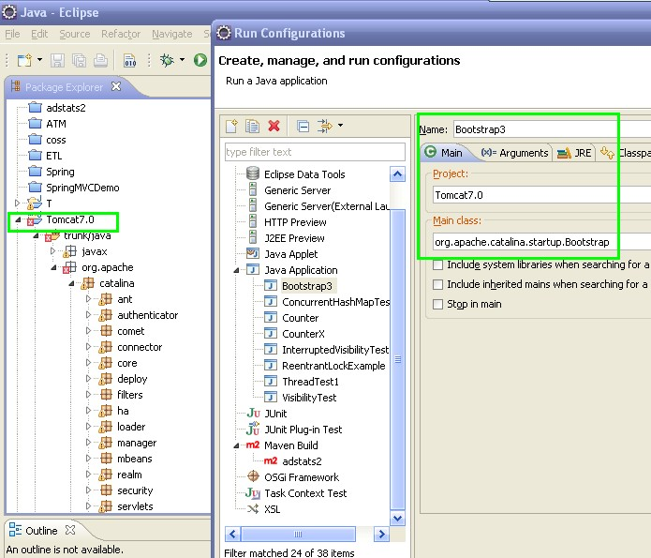

1. Set the VM-arguments as below:

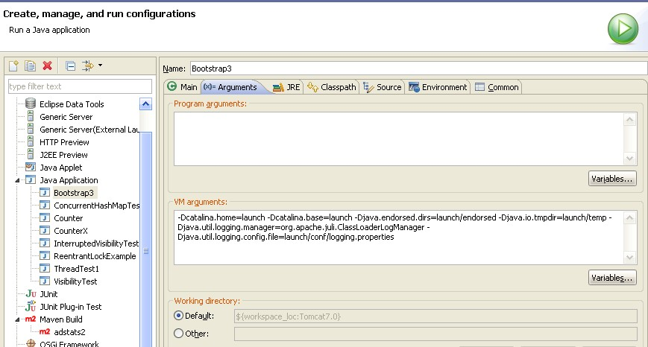

-Dcatalina.home=launch -Dcatalina.base=launch -Djava.endorsed.dirs=launch/endorsed -Djava.io.tmpdir=launch/temp -Djava.util.logging.manager=org.apache.juli.ClassLoaderLogManager -Djava.util.logging.config.file=launch/conf/logging.properties