**Task 11: Forms**

Add/Edit page enhancements

1. Implement all inputs as a form controls
2. Add validation with following rules:  
   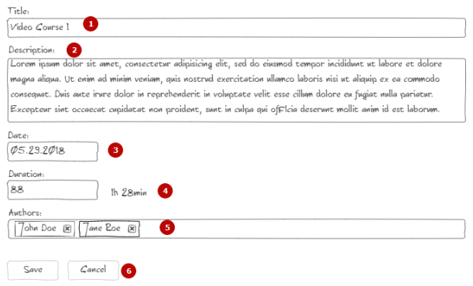
   1. Max length 50 symbols
   2. Max length 500 symbols
   3. Text input. Date format should be dd/MM/yyyy  
      Implement as separate component. Implement ng_value_accessor and ng_validators
   4. Text input. Only numbers allowed  
      Implement as separate component. Implement ng_value_accessor and ng_validato
   5. At least one author should be (see below details)  
      Implement as separate component. Implement ng_value_accessor and ng_validators
   6. Disable save button in case of any validation violation  
      All fields are required!  
      Errors should be displayed on top of input fields beside of label.  
      Apply red border to input fields in case of errors.  
      Do not show required error until touched.
3. Authors control:  
   Component should show list of available authors. Return value - list of checked authors.  
   Input - list of authors fetched from backend.  
   Call api from add/edit page and pass authors list to component. (Extract this [archive](https://drive.google.com/open?id=1ML05zZN0VbW6b8aWcQmLK9XlXG0lsTPk) into services/core/ of your json-server to get authors list)  
   Input should be implemented as cloud tags input  
   On type show suggested values.  
   On click - set the tag with selected author  
   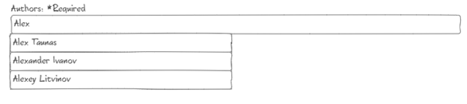  
     
   On click on remove icon - remove selected author
4. Rework login page to have form controls
5. Rework search on listing to form control

Criteria for evaluation

1. Nothing changed
2. Implemented form for edit page
3. Implemented basic validation. Course data grabbed from form and stored to local property.
4. Implemented ng_value_accessor, ng_validators
5. Done all above including authors component and login page.