**Task 7: Routing**

Add routing for the app

1. Implement routes for app if not done yet.  
   /courses  
   /courses/:id  
   /courses/new  
   Use /courses as a default route.
2. Implement 404 page. (any design).  
   Routing should redirect to 404 in case of not matched route.
3. Implement login page logic.  
   After successful login and fetching user info - redirect to /courses
4. Extend courses page behavior  
   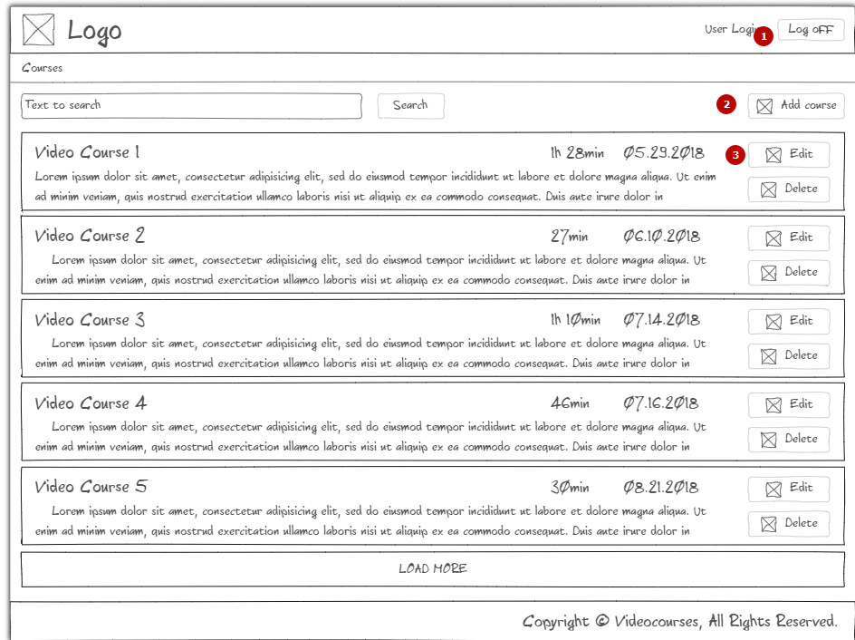

1. On logoff action - erase token and user data. Then - redirect to login page.

2. Add course should lead to /courses/new page  
3. Edit course should lead to /courses/:id page

5. Extend edit page.  
After redirect edit page should fetch course details by id (fake one). Just find course by id in your fake collection.

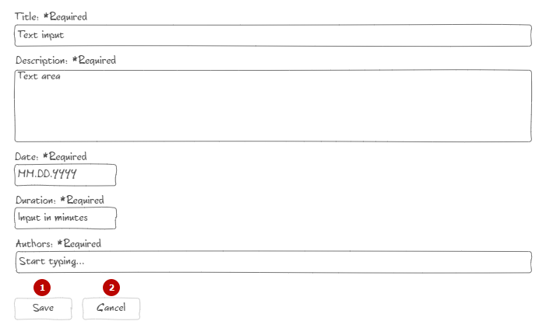

1. On save - call corresponding api method and redirect to courses list.
2. On cancel - redirect to courses list.

6. Implement breadcrumbs  


It should show current course name (not clickable) and link to courses page.  
7. Implement auth guard. Protect courses, edit course and add new course pages from unauthorized users. Redirect all unauthorized users. Refer to your method “IsAuthenticated”

Criteria for evaluation

1. Nothing changed
2. Implemented simple routing
3. Implemented all redirects on courses and edit pages
4. Implemented breadcrubms. All above with issues
5. Done all above including guard without major issues.