1. Adding devtools to your project

<dependency>

<groupId>org.springframework.boot</groupId>

<artifactId>spring-boot-devtools</artifactId>

<scope>runtime</scope>

<optional>true</optional>

</dependency>

1. Adding plugin to your pom.xml

<build>

<finalName>cloud2020</finalName>

<plugins>

<plugin>

<groupId>org.springframework.boot</groupId>

<artifactId>spring-boot-maven-plugin</artifactId>

<configuration>

<fork>true</fork>

<addResources>true</addResources>

</configuration>

</plugin>

</plugins>

</build>

1. Enabing automatic build

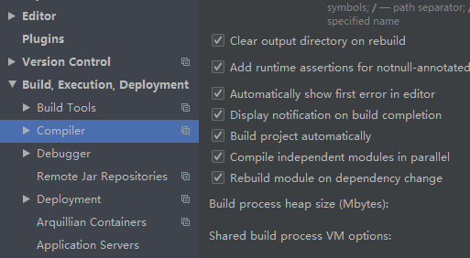

1. Update the value of

ctrl+shift+alt+/ 选择registry

