IT Projektarbeit – Gruppe 31
on¿on

User Manual
Ausgeführt von:
Kostenzer, Cosima, if25b187
Rank, Leonie, if25x038
Schober, Max, if25b025
Stutterecker, Sinja, if25b043

Betreuer*in: Lena Esther Oswald

Wien, 17. Juni 2026
Inhaltsverzeichnis
1 Introduction 3
2 Access the Application 3
2.1 Register 4
2.2 Login 4
2.3 User Credentials 5
3 Homepage Features 5
3.1 Location Selection 5
3.2 Outfit Recommendations 5
4 Profile 6
4.1 Managing Clothing Items 6
4.2 Managing Tags 8
5 Outfit Review 8
6 Settings 9

Introduction
This user manual describes the basic functionality and usage of the on¿on web application. on¿on is a weather-based outfit recommendation system that helps users choose suitable clothing based on current weather conditions and their personal wardrobe. Users can manage clothing items, organize them using tags, and receive outfit recommendations tailored to the current weather.
This document provides an overview of the application's features and explains how to use them.

Access the Application
The homepage is the main entry point of the application. From here, users can register, log in, access their profile, view weather information and receive outfit recommendations. In order to access the profile page and manage their personal wardrobe, users must first register and log in.

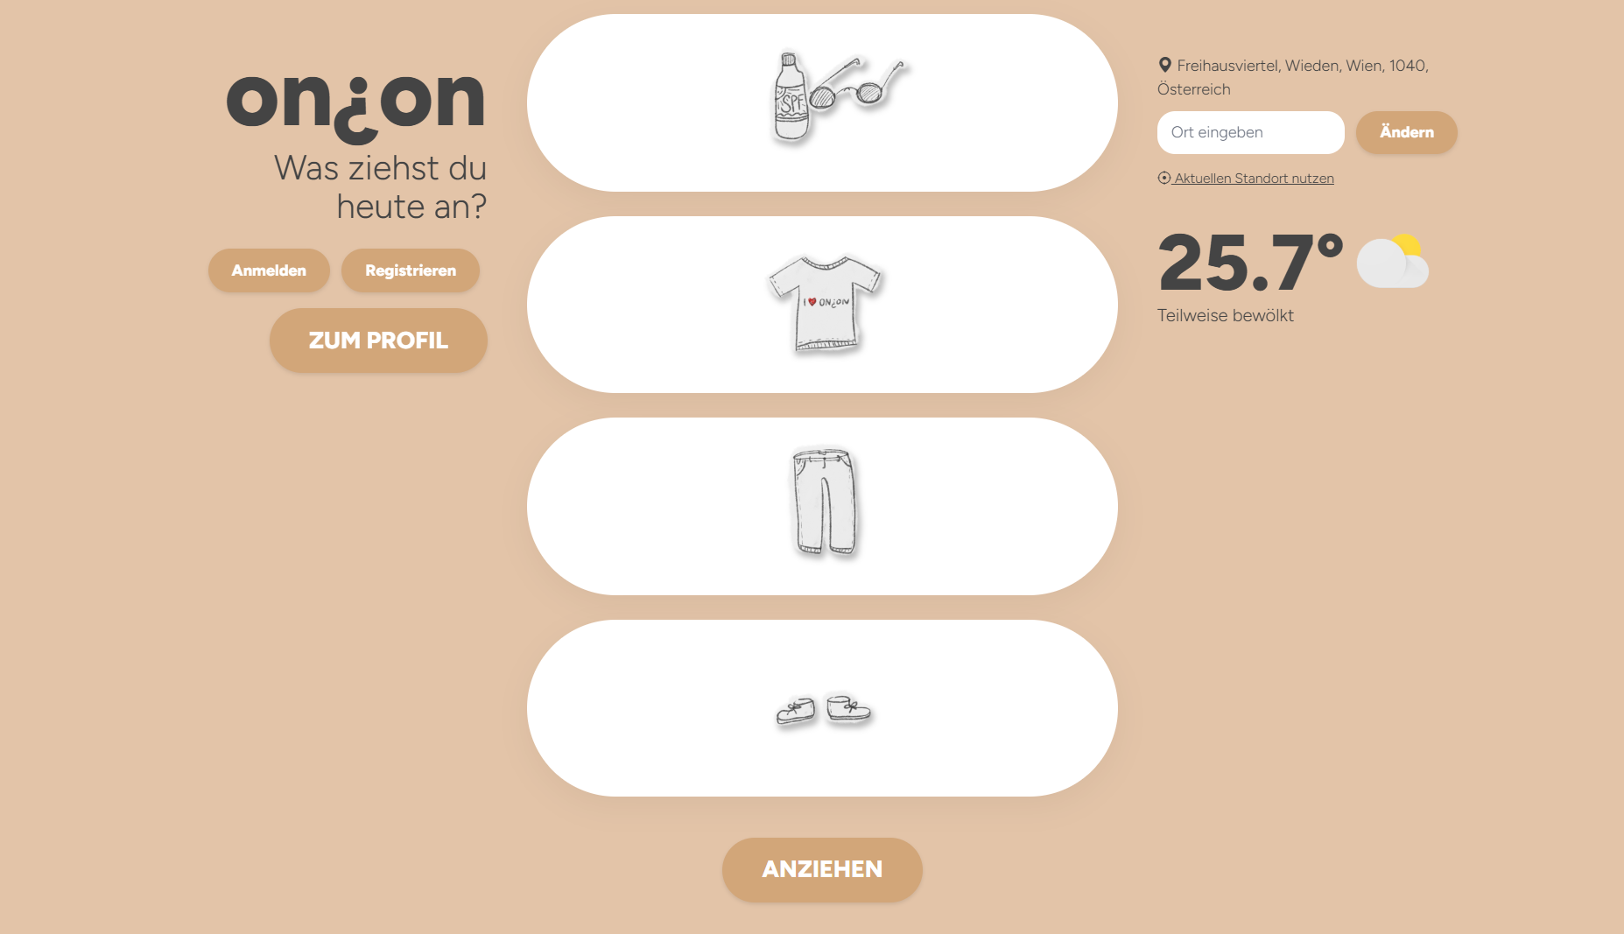

Register
Clicking the Register button opens the registration page. Users must enter a username, a valid email address and a password to create an account successfully.

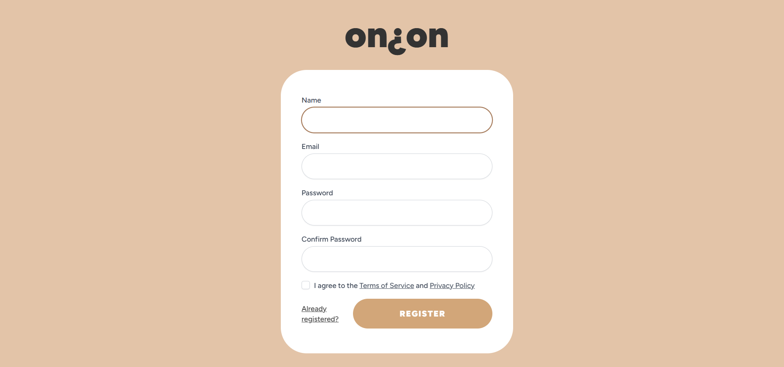

Login
After registering successfully, users can log in using their email address and password.

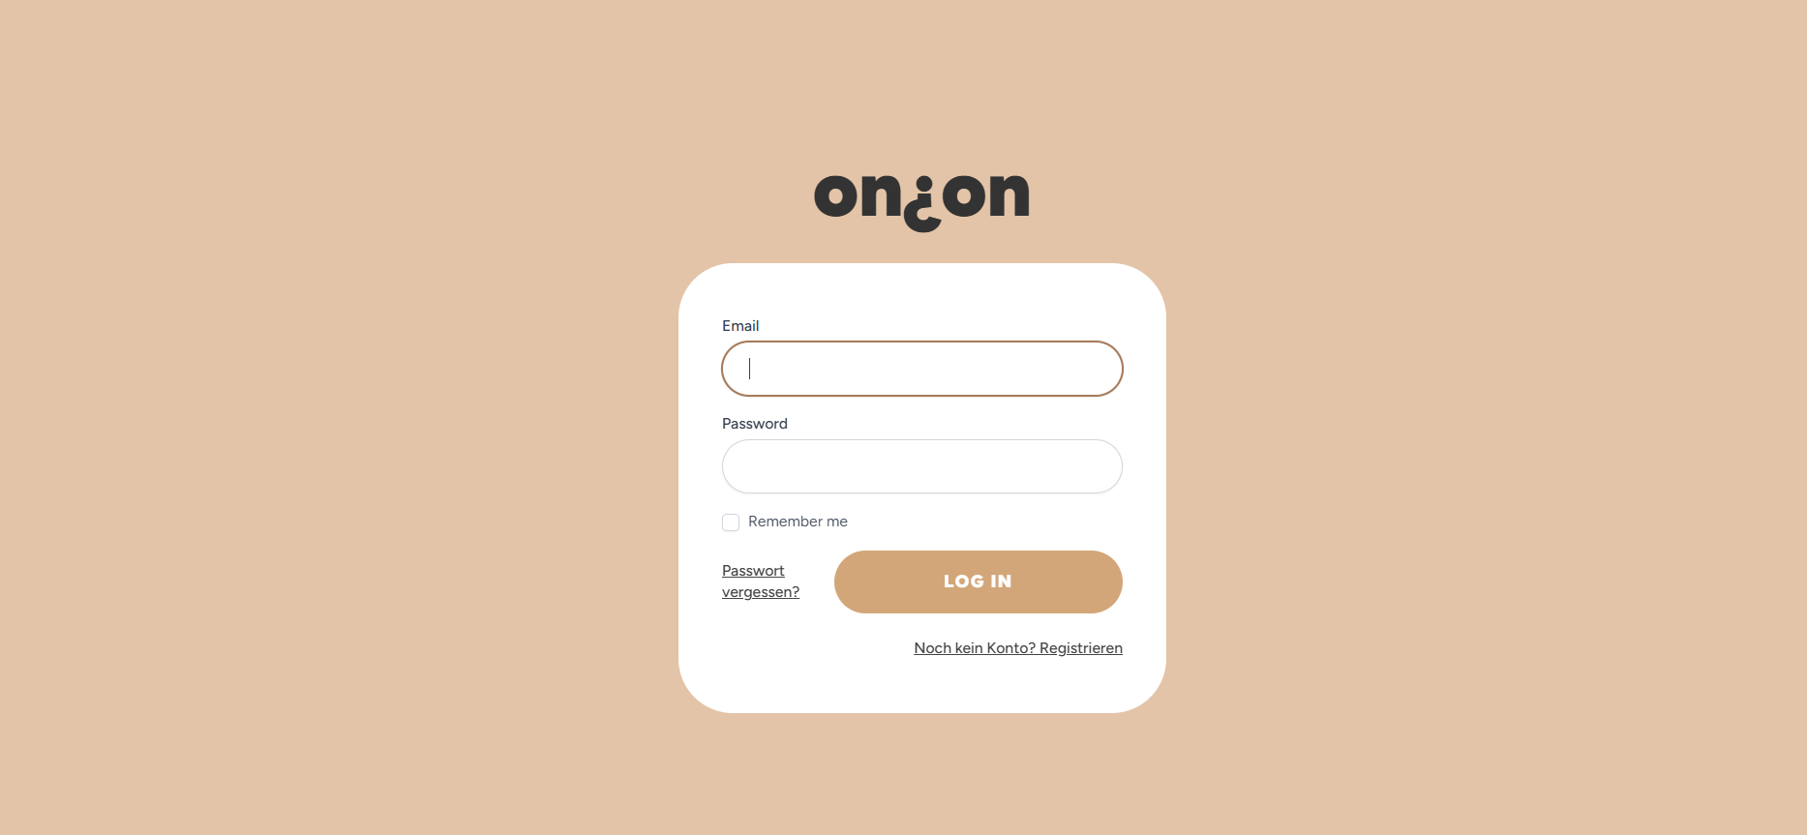

User Credentials
The following credentials are required to register and log in to the application:

Register:
- Username
- Valid email address
- Password (minimum 8 characters)

Login:
- Email address
- Password

Homepage Features
The homepage provides weather information, location management and outfit recommendations based on the current weather conditions.

Location Selection
Users can enter a location manually or use their current location. The selected location is used to retrieve weather information and generate recommendations.

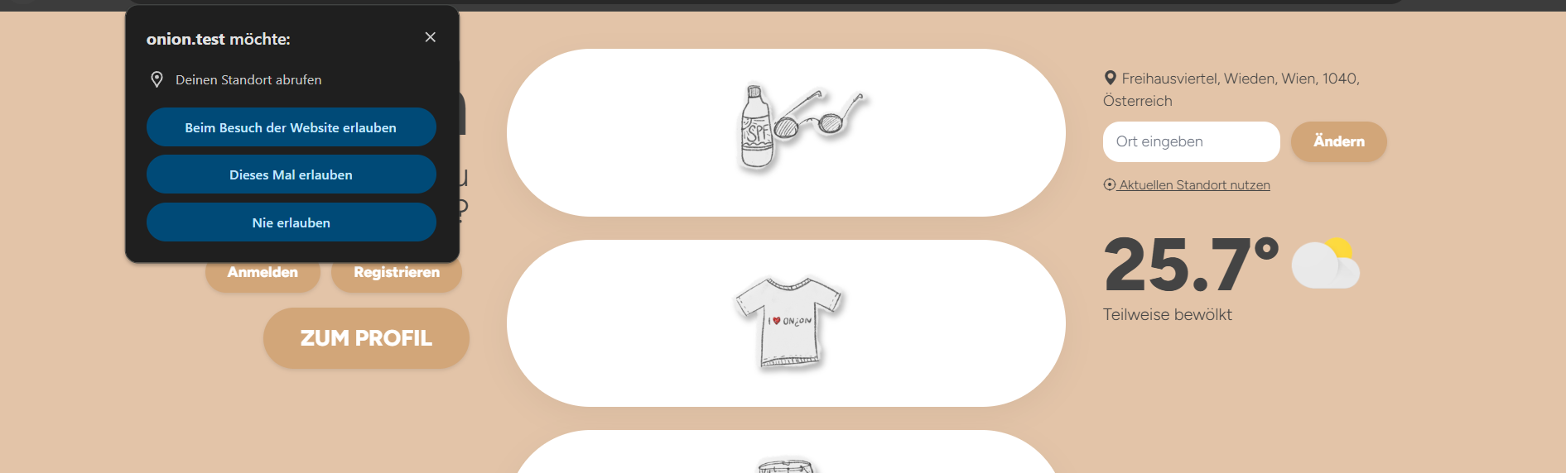

Outfit Recommendations
The outfit recommendation system combines weather data with the user's clothing items to generate suitable outfit suggestions. Recommended clothing items are displayed on the homepage and can be selected by clicking the "Anziehen" button.

Profile
As soon as users are logged in, they can access their profile. The profile contains their personal wardrobe, where clothing items are stored and organized. Users can add new clothing items, manage tags, access their settings and log out of the application.

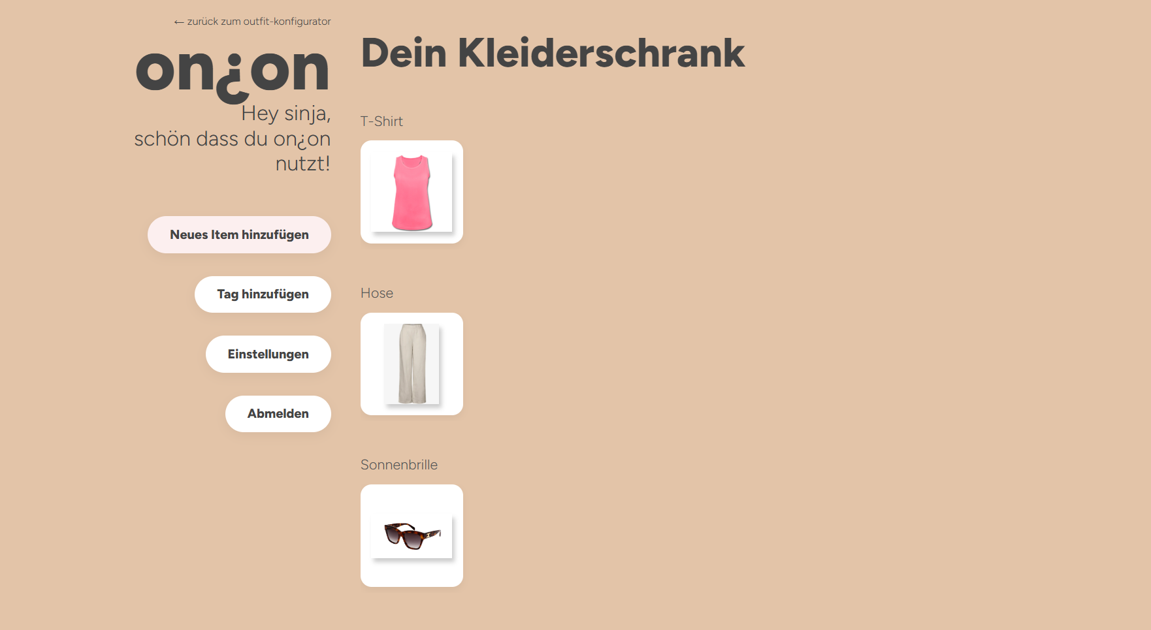

Managing Clothing Items
By clicking the "Neues Item hinzufügen" button, users can create a new clothing item. First, they must upload an image, enter a name, optionally select one or more tags and choose a suitable category from the dropdown menu.

The following categories are available:
Kopfbedeckung, T-Shirt, Pullover, Jacke, Hose, Strumpfhose, Socken, Schuhe, Accessoires, Sonnenbrille and Sonnencreme.

After clicking "Weiter", users can configure additional properties of the clothing item. Depending on the selected category, different settings may be available. These settings are used by the recommendation system to determine whether an item is suitable for the current weather conditions.
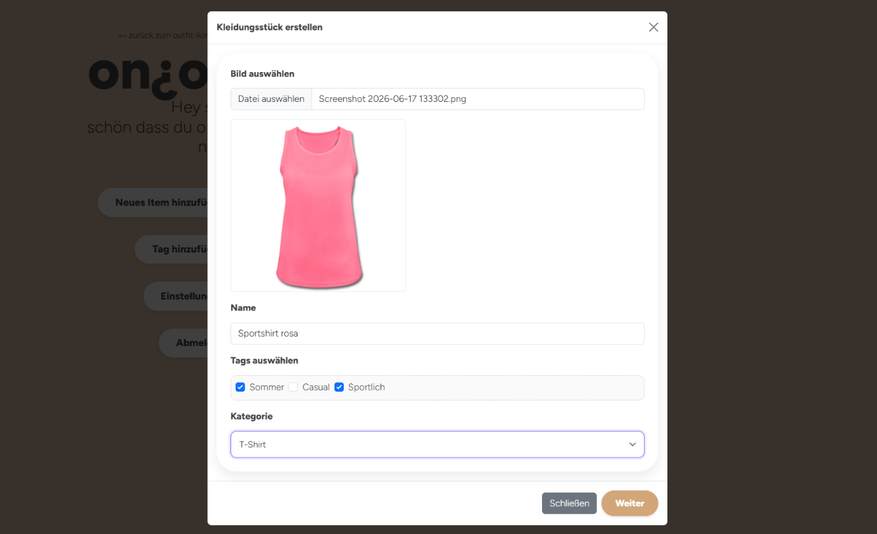

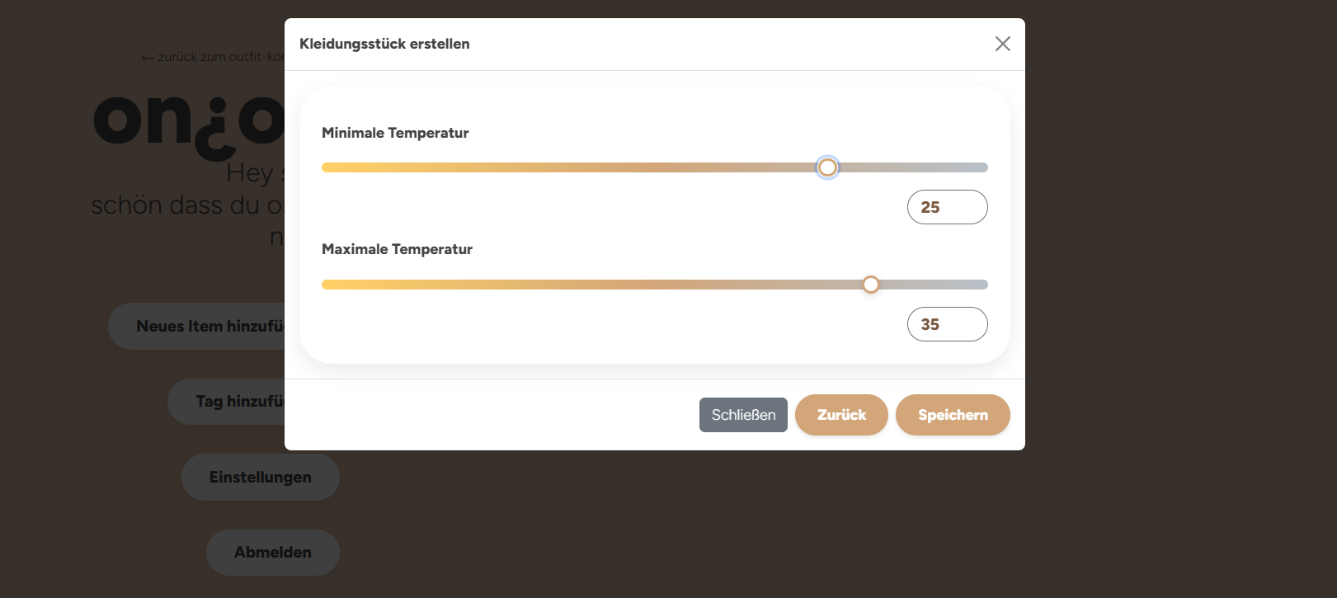

By clicking on an existing clothing item in the wardrobe, users can open the edit view, update the item's properties and save their changes.

Managing Tags
By clicking the "Tag hinzufügen" button, users can create new tags and save them by clicking "Tag speichern". These tags can later be assigned to clothing items for better organization. Existing tags can be edited by double-clicking on the tag name. To delete a tag, users can simply click the "x" button next to it.


Outfit Review
The outfit review page allows users to evaluate the recommended outfit. Users can indicate whether the recommendation was suitable, too warm or too cold. This feedback is used to improve and personalize future outfit recommendations.

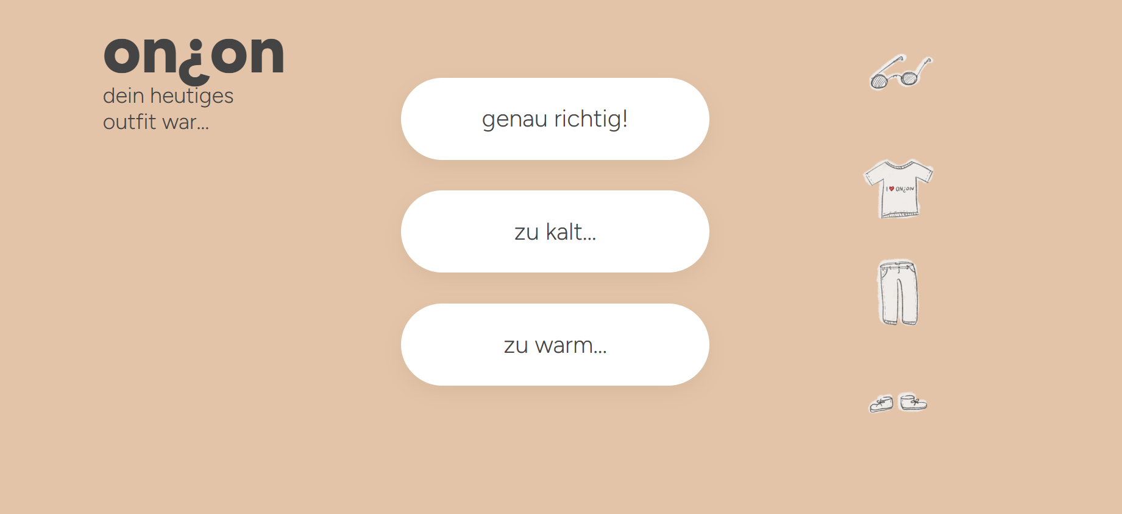

Settings
The settings page allows users to update their profile information, including their name, email address and temperature offset. The temperature offset can be adjusted to reflect the user's personal temperature preferences and is considered when generating outfit recommendations. Users can also change their password in the password settings section.
