Figure 1
[Elizabeth Holmes outside court for jury selection in her fraud trial]
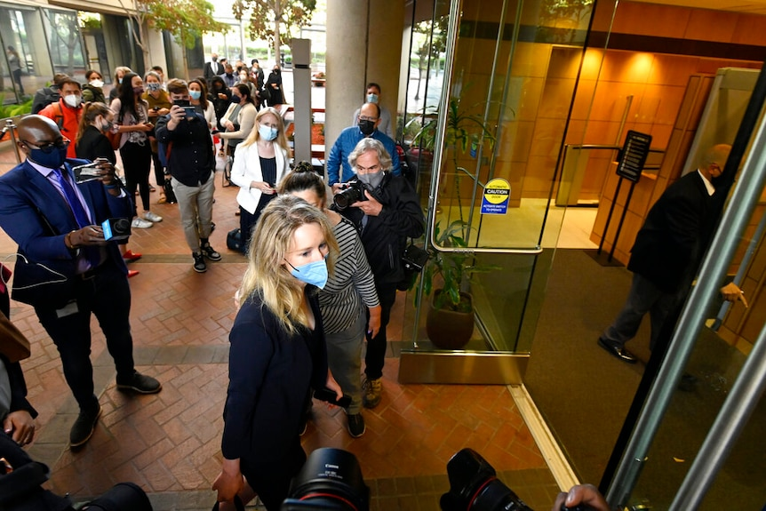
(Source: Hayne, 2022)
Figure 1 (Hayne, 2022) depicts Elizabeth Holmes outside the courthouse during jury selection for her fraud case. In this image, her gloomy expression and courthouse setting create a sharp contrast with her former identity as a successful entrepreneur, highlighting her unethical business practices resulted in legal consequences. Furthermore, the large presence of reporters around her reflects the widespread social impact caused by her unethical business practices. Therefore, this image effectively supports my argument that unethical business practices offer lessons for both corporates and society, as it visually reflects the negative impacts of Holmes’s business fraud on herself and public.

Reference list
Hayne, J. (2022, January 4). How Theranos founder Elizabeth Holmes went from the cover of Forbes to being found guilty on charges of fraud. ABC News. https://www.abc.net.au/news/2022-01-04/elizabeth-holmes-theranos-trial-verdict-guilty/100645818

