Project Design Report
Hotel Reservation System
CSE 3206 — Software Engineering Sessional · Lab 2 · Group #09, Section A

1. Project Title
Hotel Reservation System — a web application that lets guests of a single mid-sized hotel find an available room, reserve it for a date range and cancel it, while the front desk manages the room inventory and every reservation from one dashboard.
Item | Detail
Assigned scenario | Project 9 — Hotel Reservation System
Process model | Rapid Application Development (RAD)
Repository | github.com/shu-vro/cse3206-hotel-reservation-system
Deliverable | Minimum Viable Product (MVP) + this design report
Technology | Vite (vanilla JavaScript), Express 5, SQLite via node:sqlite

2. Problem Statement
The client runs a mid-sized hotel where every reservation is still written into a paper register at the front desk. A guest who wants a room has to telephone the hotel, and a receptionist reads back through the register to work out whether the room is free for those nights. The register is the only copy of the schedule, so only one person can answer at a time.
Three problems follow from this. First, double booking: two receptionists taking calls in the same hour can promise the same room for overlapping nights, and the mistake only surfaces when the second guest arrives. Second, no visibility: the manager cannot answer "how many rooms are free tonight" without counting rows by hand. Third, the guest has no self-service option at all — every question about price or availability costs a phone call, and the hotel loses bookings made after office hours.
The client asked for a system where guests check availability and reserve rooms themselves, where the software refuses an overlapping reservation instead of trusting the person entering it, and where the front desk sees the current state of the hotel on one screen. This milestone delivers that as an MVP: the core reservation loop, working end to end, with the engineering structure in place for later labs.

3. Project Objectives
- Let a guest register, sign in and manage their own reservations without phoning the hotel.
- Publish the room inventory with the attributes a guest actually decides on: type, capacity, nightly rate and a short description.
- Reject overlapping reservations in the software layer, so a double booking is not possible even when two guests submit at the same moment.
- Give the front desk a single dashboard with tonight’s occupancy, arrivals and the full reservation list.
- Keep room management (create, edit, archive) in staff hands, with archiving instead of deletion so historical reservations stay readable.
- Organise the code into replaceable modules (authentication, rooms, bookings) so later labs can add design patterns and automated testing without a rewrite.
- Practise a real collaborative Git workflow: feature branches, pull requests, code review and conflict resolution.

4. Stakeholder Analysis
Four groups interact with the system. Only the first two are users of the MVP; the other two shape requirements that the MVP deliberately defers.
Stakeholder | Interest in the system | Influence | In the MVP?
Guest | Find a room that fits the party size and budget, reserve it for specific nights, cancel when plans change, see what they have booked. | High — the reason the system exists | Yes
Front desk staff | See who is arriving, keep the room list accurate, cancel or adjust reservations on the guest’s behalf. | High — daily operator | Yes
Hotel manager / owner | Occupancy and booked value, confidence that bookings are not lost or duplicated, later on reporting and pricing control. | High — funds the project | Partly — occupancy tiles only
Housekeeping | Knowing which rooms are occupied tonight and which are being vacated in the morning. | Medium — consumes the schedule | No — planned for a later milestone
Development team (Group #09) | A modular, testable codebase that survives the remaining labs. | Medium | Yes

5. Functional Requirements
Twelve functional requirements were agreed with the client. Priority follows MoSCoW: M = must have for the MVP, S = should have, C = could have later.
ID | Requirement | Module | Priority
FR-01 | A visitor can register a guest account with name, email and password. Email must be unique. | Authentication | M
FR-02 | A registered user can log in and log out; the session is carried by a bearer token. | Authentication | M
FR-03 | The system distinguishes two roles, guest and staff, and restricts staff-only screens and endpoints. | Authentication | M
FR-04 | Any visitor can browse the list of rooms with type, capacity, nightly rate and description. | Rooms | M
FR-05 | A visitor can filter rooms by type, by required guest capacity and by maximum nightly rate. | Rooms | M
FR-06 | Staff can add a new room and edit an existing room’s number, type, capacity, rate and description. | Rooms | M
FR-07 | Staff can archive a room so it disappears for guests while its past reservations remain intact. | Rooms | S
FR-08 | A logged-in guest can reserve a room for a check-in and check-out date, stating the number of guests. | Bookings | M
FR-09 | The system rejects a reservation that overlaps a live reservation for the same room and reports the conflicting dates. | Bookings | M
FR-10 | The system computes the number of nights and the total price, and shows the total before the guest confirms. | Bookings | M
FR-11 | A guest can see their own reservations with status, and cancel one that has not started yet. | Bookings | M
FR-12 | Staff can view every reservation with guest details, filter by status, and cancel on a guest’s behalf, alongside tiles for rooms open, occupied tonight, arrivals today and booked value. | Dashboard | M

6. Non-functional Requirements
ID | Category | Requirement | How it is checked
NFR-01 | Security | Passwords are never stored in readable form; they are hashed with scrypt and a per-user random salt. | Inspect the users table — only salt:hash pairs appear.
NFR-02 | Security | Every write endpoint verifies the bearer token, and staff endpoints additionally verify the admin role. A guest cannot cancel another guest’s reservation. | Request a staff endpoint with a guest token; it answers 403.
NFR-03 | Reliability | Availability is decided by the server, never by the browser, so a stale page cannot create a double booking. | Two overlapping requests: the second returns 409.
NFR-04 | Data integrity | Rooms are archived rather than deleted, so reservations always resolve to a real room record. | Archive a booked room; the reservation still lists its number.
NFR-05 | Performance | A room search and the dashboard load respond in under 300 ms with the sample data set on a laptop. | Timed with curl against the running API.
NFR-06 | Usability | A guest can complete the booking flow — catalogue, room, dates, confirmation — in four screens with no manual, and the running total updates as the dates change. | Walkthrough with a classmate who had not seen the app.
NFR-07 | Portability | The project runs after `npm install` on any machine with Node 22+ and needs no database server, because SQLite ships inside Node. | Fresh clone on a second laptop.
NFR-08 | Maintainability | Authentication, rooms and bookings are separate route files and separate page modules; the booking rules live in one file with unit tests. | Code review during pull requests.
NFR-09 | Testability | The availability rules are pure functions over the database handle and are covered by `node --test`; the suite runs in under a second. | `npm test` — 7 cases, all passing.

7. User Stories and Use Cases

7.1 User stories
ID | User story | Acceptance criteria
US-01 | As a visitor, I want to create an account with my email so that I can keep track of my reservations. | A duplicate email is refused with a clear message; a password shorter than six characters is refused; a successful sign-up logs me straight in.
US-02 | As a guest, I want to filter rooms by party size and budget so that I only look at rooms I can actually use. | Filtering by three guests hides rooms that sleep fewer; filtering by a maximum rate hides dearer rooms; clearing the filters restores the full list.
US-03 | As a guest, I want to book a room for specific nights and see the price before I confirm so that there is no surprise at the desk. | The screen shows nights and total as soon as both dates are set; confirming creates the reservation; the total matches nights times the nightly rate.
US-04 | As a guest, I want a booking to fail if the room is already taken so that I am not promised a room twice. | An overlapping range is refused with the conflicting dates named; a range that starts on another guest’s check-out day is accepted.
US-05 | As front desk staff, I want one screen showing tonight’s occupancy and every reservation so that I can answer the phone without opening the register. | The dashboard shows rooms open, occupied tonight, arrivals today and booked value; the table lists every reservation with guest name and email; staff can cancel from the table.

7.2 Expanded use case: UC-01 Reserve a room
Field | Description
Use case | UC-01 Reserve a room
Primary actor | Guest (registered, logged in)
Secondary actor | Reservation service (server)
Preconditions | The guest is logged in. At least one active room exists.
Trigger | The guest presses Book on a room card in the catalogue.
Main flow | 1. The system opens the booking screen for the chosen room and shows its type, capacity and nightly rate.  2. The guest picks a check-in date; the check-out picker moves its earliest date to the following day.  3. The guest picks a check-out date and the number of guests.  4. The system shows the number of nights and the total price.  5. The guest confirms.  6. The server validates the dates, the party size against the room capacity, and searches for a clashing reservation.  7. The server stores the reservation with status "confirmed" and returns it.  8. The system confirms on screen and links to My bookings.
Alternate flow A — room taken | At step 6 the server finds a reservation sharing at least one night. It answers 409 and names the conflicting dates; the screen shows the message and the guest may pick other dates.
Alternate flow B — party too large | At step 6 the party size exceeds the room capacity. The server answers 400 stating how many the room sleeps.
Alternate flow C — session expired | At step 5 the token is no longer valid. The server answers 401, the app returns the guest to the login screen and, after a successful login, back to the same room.
Postcondition | A confirmed reservation exists for the guest and those nights, and the room is unavailable for any overlapping range.

8. Selected Software Process Model
The team selected Rapid Application Development (RAD). RAD replaces a long specification stage with short cycles of prototyping and user feedback, and it splits the system into modules that separate small teams build in parallel and then integrate.
The four RAD phases mapped onto this milestone as follows.
RAD phase | What we actually did
Requirements planning | Read the client scenario, listed stakeholders, and agreed the twelve functional and nine non-functional requirements above in a single session. No frozen specification document — the requirement list is expected to move.
User design | Sketched four screens (catalogue, booking, my bookings, front desk) and turned them into a running shell with a hash router and the stylesheet on day one, so the discussion was about a real screen and not a drawing.
Rapid construction | Three parallel modules, one per member: authentication and platform core, rooms, bookings. Each module was built on its own branch and demonstrated as soon as it ran, then corrected. Two of the three defects listed in section 15 were found this way.
Cutover | Integrated through pull requests into main, reseeded the database, walked the full flow as a guest and as staff, captured the screenshots in section 13 and tagged the milestone as the MVP.

9. Justification of the Process Model
RAD fits this project for five concrete reasons.
- The requirements are well understood but not final. Everyone on the team has stayed in a hotel and knows what a reservation is, so there is no research phase to justify — but the client changed their mind twice during the milestone (archiving instead of deleting rooms, and cancellation only before check-in). RAD absorbs that; a model with a signed-off specification would have treated both as change requests.
- The system decomposes cleanly into modules. Authentication, rooms and bookings have small, obvious interfaces — a token, a room record, a date range. That is exactly the shape RAD needs to let three people build in parallel without stepping on each other, and it is what made a three-way split honest rather than cosmetic.
- The timebox is short and fixed. One lab cycle is not enough for a full analysis and design stage; it is enough for three modules and an integration pass. RAD is designed for exactly this kind of deadline, where scope flexes and the date does not.
- A working prototype is the deliverable. The rubric asks for a demonstrable MVP, not a specification. Under RAD the prototype is the primary artefact and the documentation follows it, which matches what is being assessed.
- The tools support fast iteration. Vite reloads the UI on save, Express restarts in under a second, and SQLite needs no server, so the build-show-correct loop is measured in seconds. RAD depends on that loop being cheap.
The risks of RAD were real and were managed rather than ignored. Speed encourages sloppy structure, so the booking rules were kept in one file behind pure functions with unit tests. Parallel modules encourage divergent styles, so every branch went through a pull request that a second member read before merging.

10. Comparison with Alternative Models
Model | Why it is a weaker fit here | Verdict
Waterfall | Waterfall needs requirements frozen before design starts. Ours moved twice inside one week, and each change would have meant reopening a completed phase. It also delays the first running screen until late, whereas the lab is assessed on a working MVP. With one week of calendar time, a sequential pipeline spends most of it on documents. | Rejected
Spiral | Spiral pays for itself when technical or financial risk is high enough to justify a risk analysis at every turn. A single-hotel reservation CRUD application over SQLite carries no such risk; the ceremony would consume most of the timebox and produce risk registers instead of screens. | Rejected
Scrum | Scrum is a reasonable second choice and shares the iterative core. It was rejected on scale, not principle: sprint planning, daily stand-ups, review and retrospective are heavy for three people over one lab cycle, and a sprint boundary of one to two weeks is longer than the whole milestone. RAD gives the same fast feedback with less process. | Close second
Prototype model | Throwaway prototyping would answer questions about the interface we did not actually have, and the prototype is discarded afterwards. Under RAD the prototype became the product, which is the better use of the same effort. | Rejected

11. MVP Design Overview

11.1 Architecture
The MVP is a two-tier application. The browser runs a vanilla JavaScript single-page app served by Vite; it holds no business rules, only rendering and form handling. All decisions — who may do what, whether a room is free, what a stay costs — are made by the Express API, which is the only component that talks to the database. During development Vite proxies /api to the API port, so the browser sees one origin and the project needs no CORS configuration.
Layer | Technology | Responsibility
Presentation | Vite, vanilla JS, hash router, one stylesheet | Screens, forms, client-side route guards, session storage
Application | Express 5, route modules per domain | Validation, authorisation, availability rules, price calculation
Data | SQLite through Node’s built-in node:sqlite | users, rooms and bookings tables; schema applied on boot; sample data seeded once
Choosing node:sqlite rather than a database server or an ORM was deliberate: a teammate can clone the repository, run npm install and have a working database with sample data without installing anything else, which matters when three people set up the project on three different machines in one week.

11.2 Module split
Module | Owner | Server files | Client files
Platform core & authentication | Shirshen | index.js, db.js, schema.sql, seed.js, auth.js, routes/auth.js | main.js, api.js, styles.css, pages/login.js
Rooms | Shahrirar Hasan | routes/rooms.js | pages/rooms.js
Bookings | Riyon Chowdhury | availability.js, availability.test.js, routes/bookings.js | pages/booking.js, pages/bookings.js
Front desk dashboard | Shahrirar Hasan | — (reuses the rooms and bookings endpoints) | pages/admin.js

11.3 Data model
Table | Columns | Notes
users | id, name, email (unique), password_hash, role, created_at | role is guest or admin; password_hash stores salt:scrypt-hash
rooms | id, number (unique), type, capacity, price_per_night, description, active | active = 0 means archived: hidden from guests, still joinable from old bookings
bookings | id, room_id, user_id, check_in, check_out, guests, total_price, status, created_at | status is confirmed or cancelled; indexed on (room_id, check_in, check_out) for the clash query

11.4 The availability rule
The one piece of real logic in the MVP is deciding whether a room is free. Two stays clash when they share at least one night, which in date terms means the existing check-in falls before the requested check-out and the existing check-out falls after the requested check-in. Both comparisons are strict, which is what allows a guest to check in on the morning another guest checks out — the common case a naive overlap test gets wrong. Cancelled reservations are excluded, so cancelling truly frees the dates.
This rule, together with the date validation (no past check-in, at least one night, at most thirty) and the cancellation window, lives in server/availability.js and is covered by seven cases in server/availability.test.js, run with node --test.

11.5 API surface
Method and path | Access | Purpose
POST /api/auth/register | Public | Create a guest account, return a token
POST /api/auth/login | Public | Authenticate, return a token
POST /api/auth/logout | Authenticated | Invalidate the token
GET /api/auth/me | Authenticated | Current user
GET /api/rooms | Public | List rooms; filters type, guests, max_price, include_archived
GET /api/rooms/:id | Public | One room
POST /api/rooms | Staff | Add a room
PATCH /api/rooms/:id | Staff | Edit a room
DELETE /api/rooms/:id | Staff | Archive a room
GET /api/bookings | Authenticated | Own reservations; staff see all, ?scope=mine narrows
POST /api/bookings | Authenticated | Create a reservation (validated)
POST /api/bookings/:id/cancel | Owner or staff | Cancel a reservation that has not started

12. MVP Walkthrough
The screenshots below were taken from the running application against the seeded sample data.
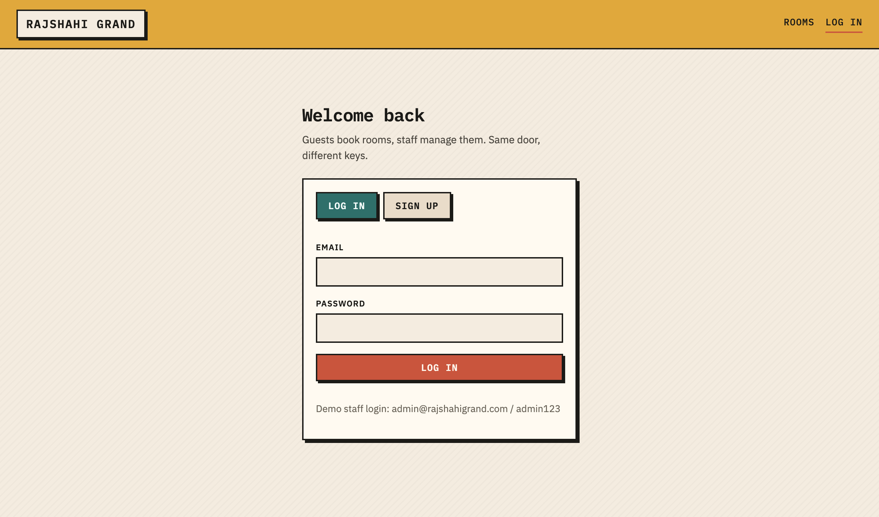
Figure 1 — Login and sign-up. One screen, two tabs; the staff demo credentials are printed for the demonstration.
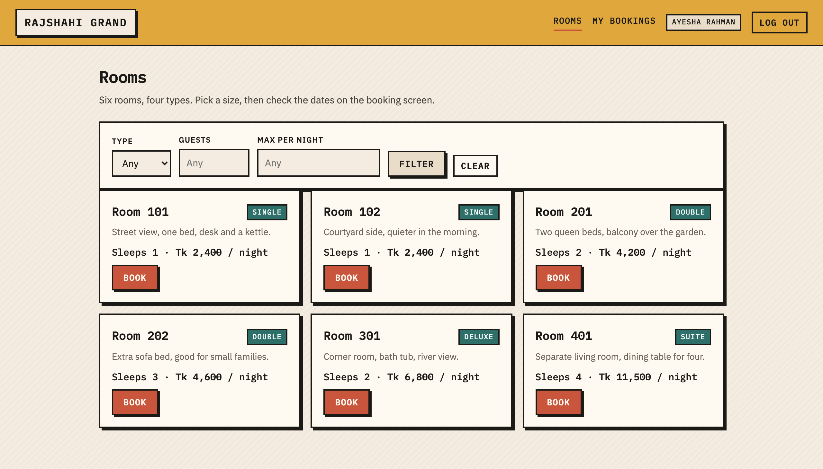
Figure 2 — Room catalogue with the filter bar. Six seeded rooms across four types.
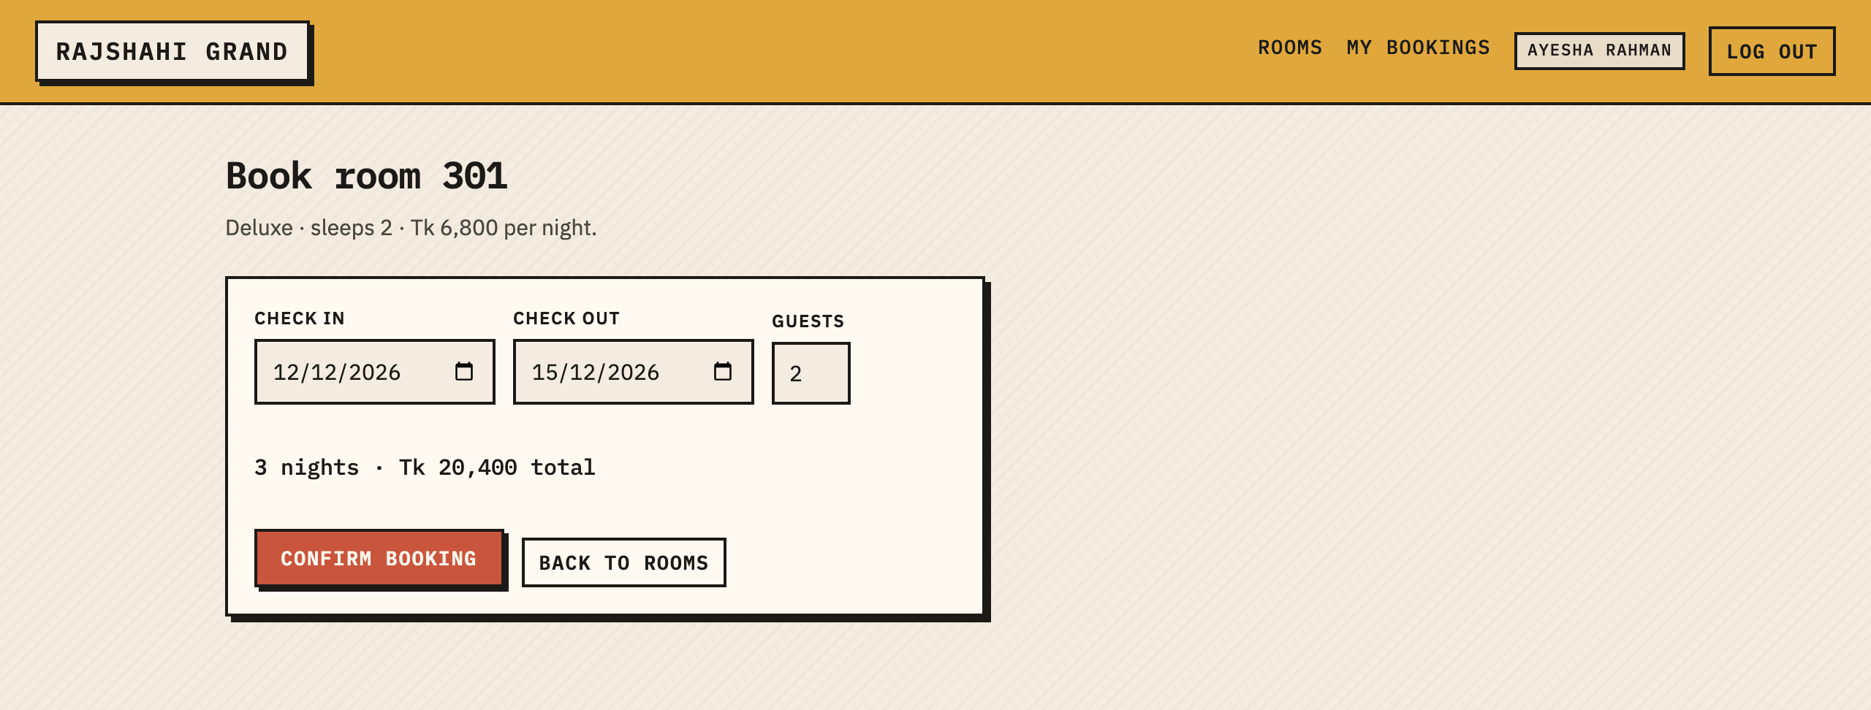
Figure 3 — Booking screen. Nights and total update as soon as both dates are chosen.
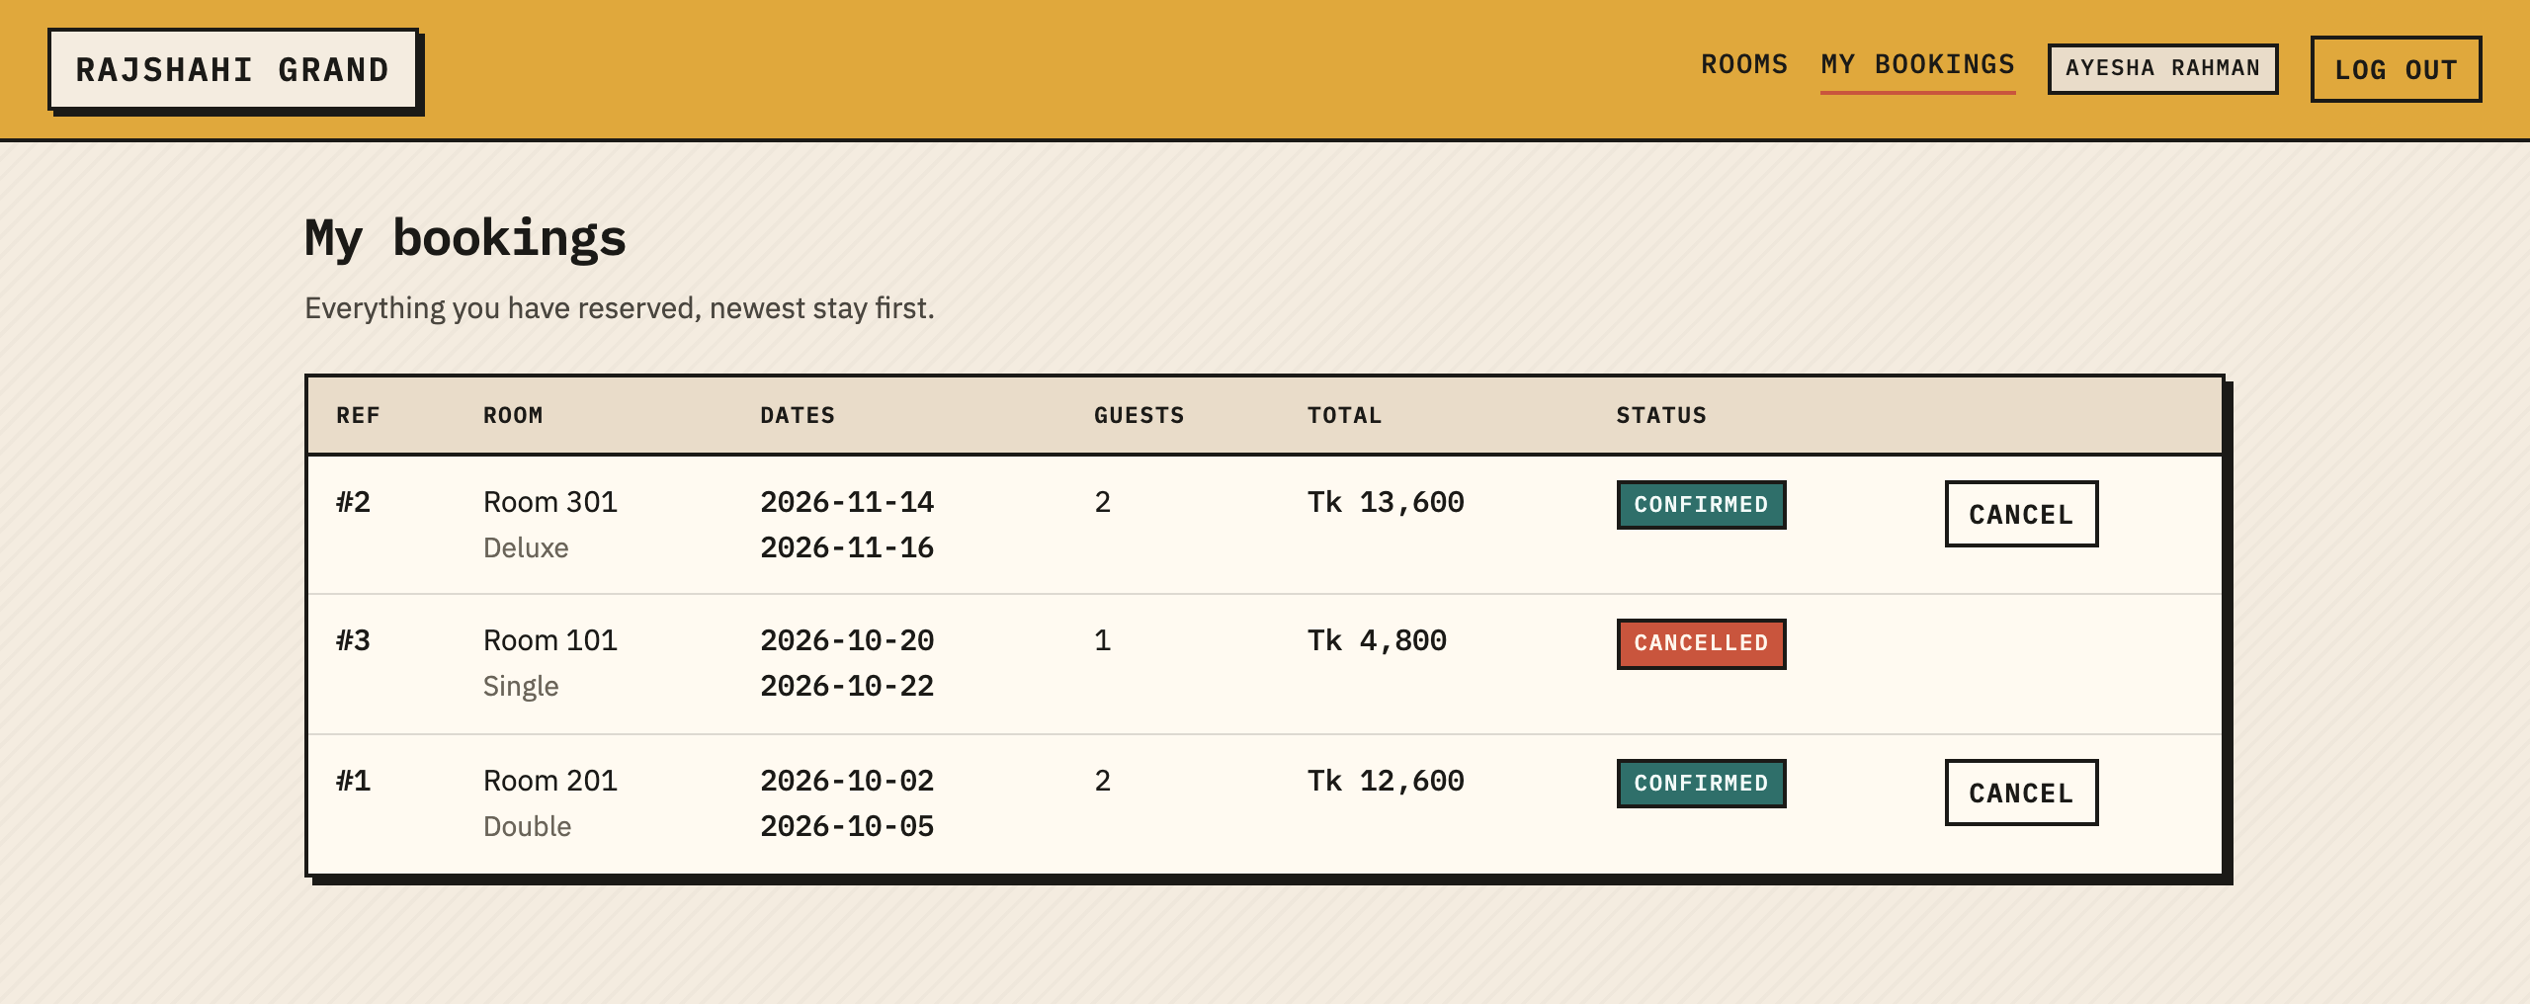
Figure 4 — A guest’s own reservations, including one that was cancelled.
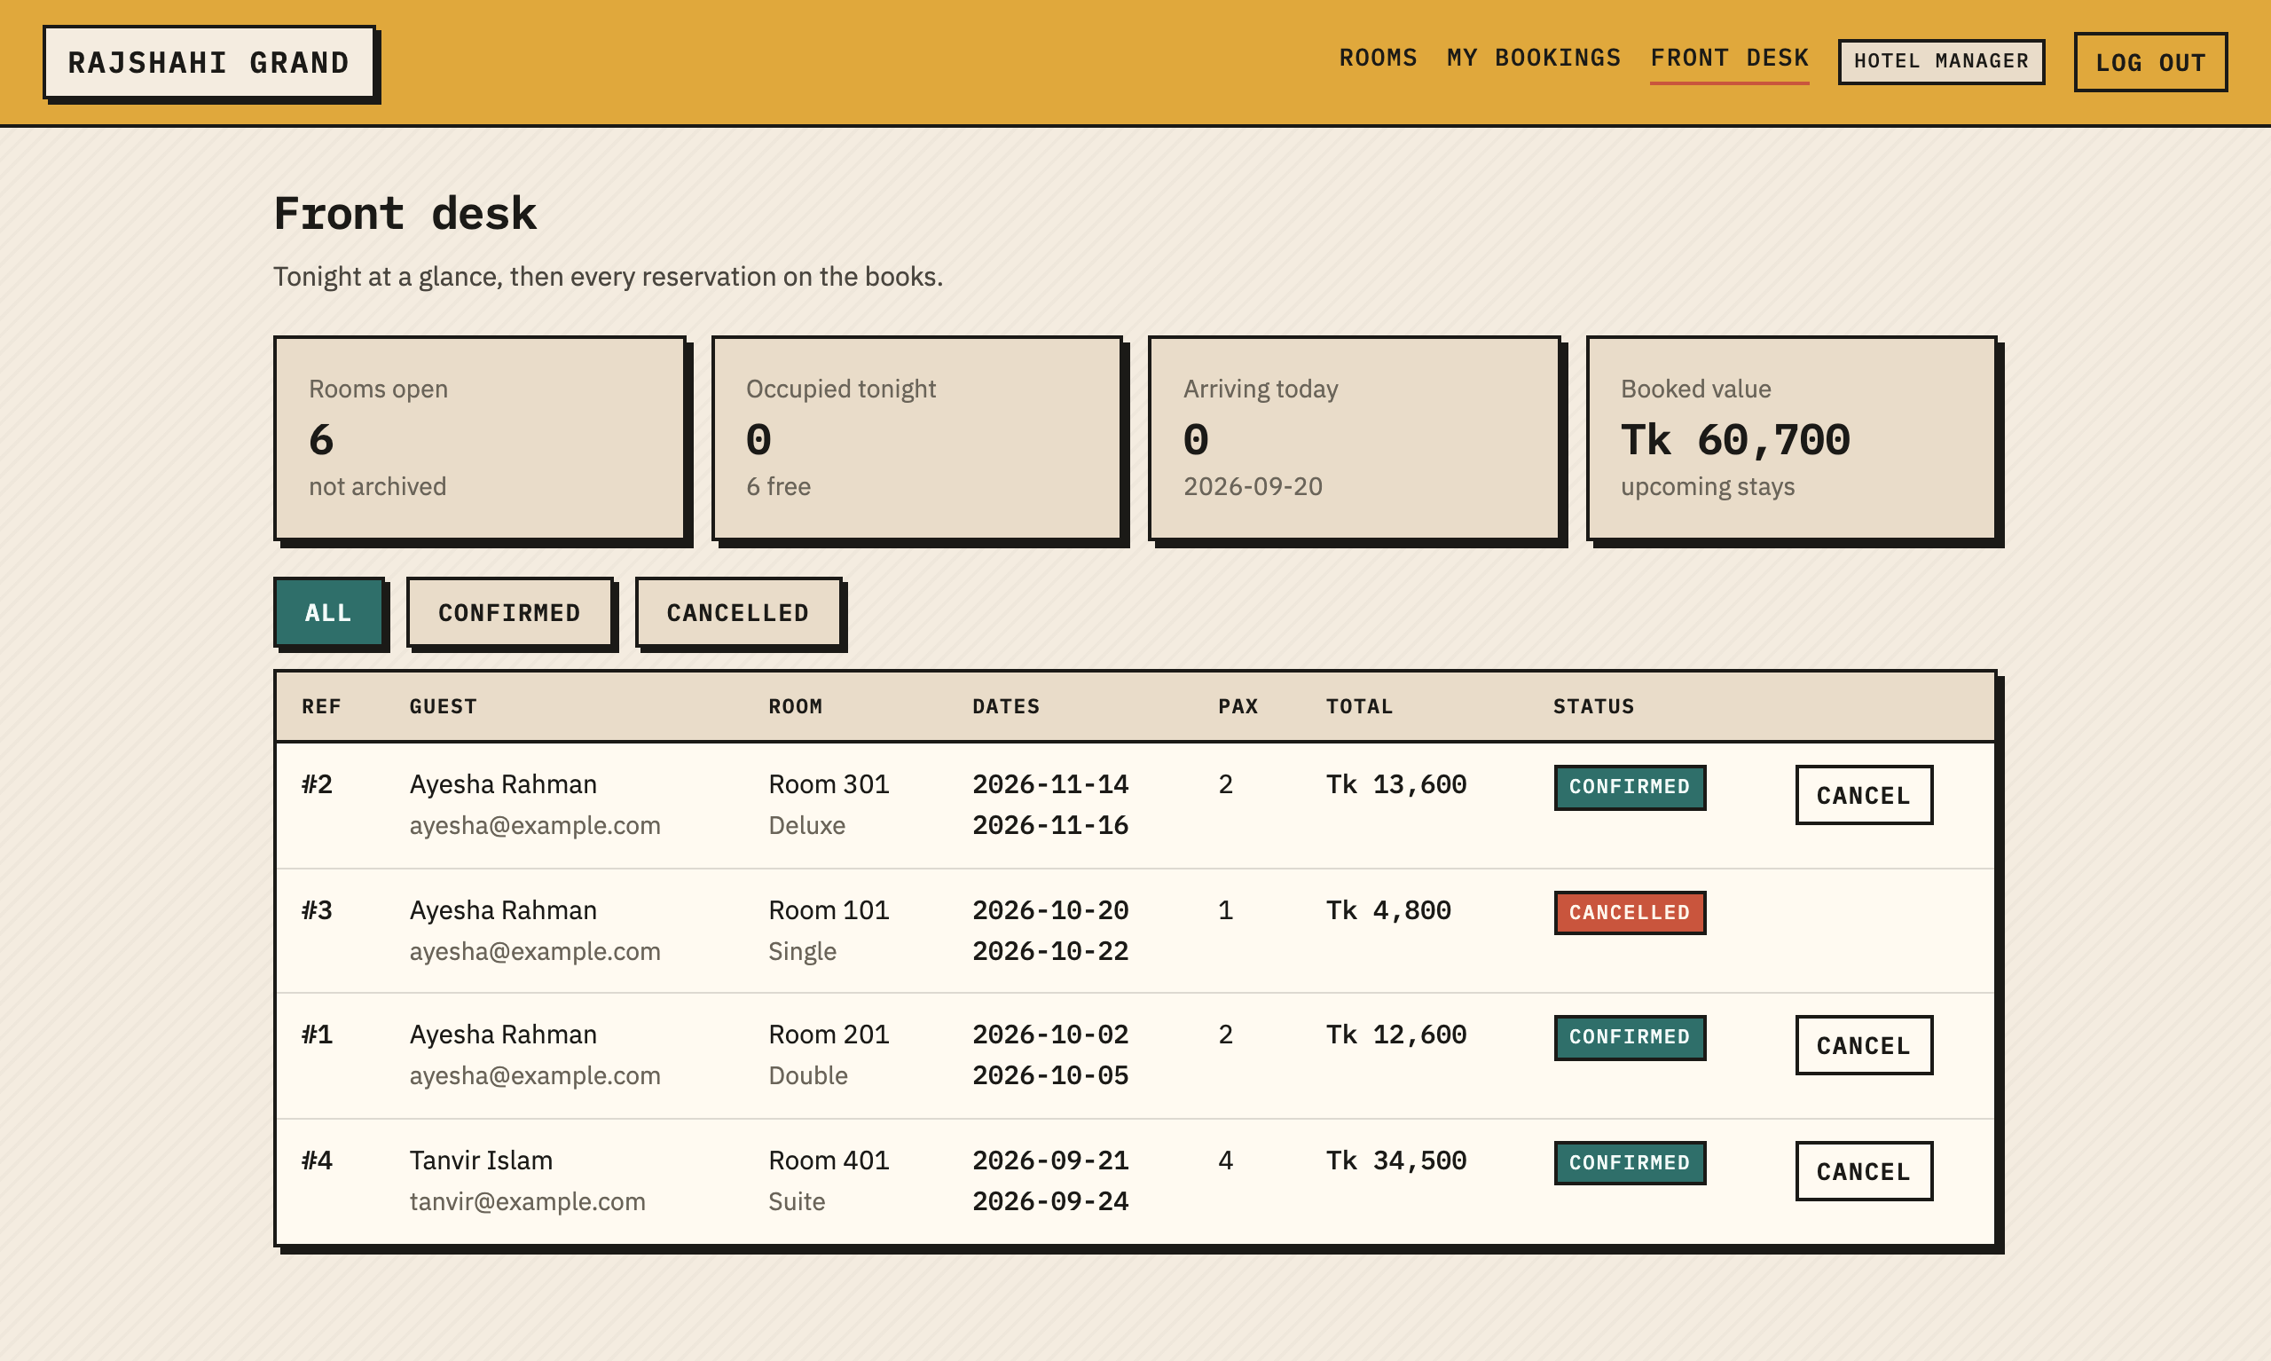
Figure 5 — Front desk dashboard: occupancy tiles, status filter and every reservation with guest details.
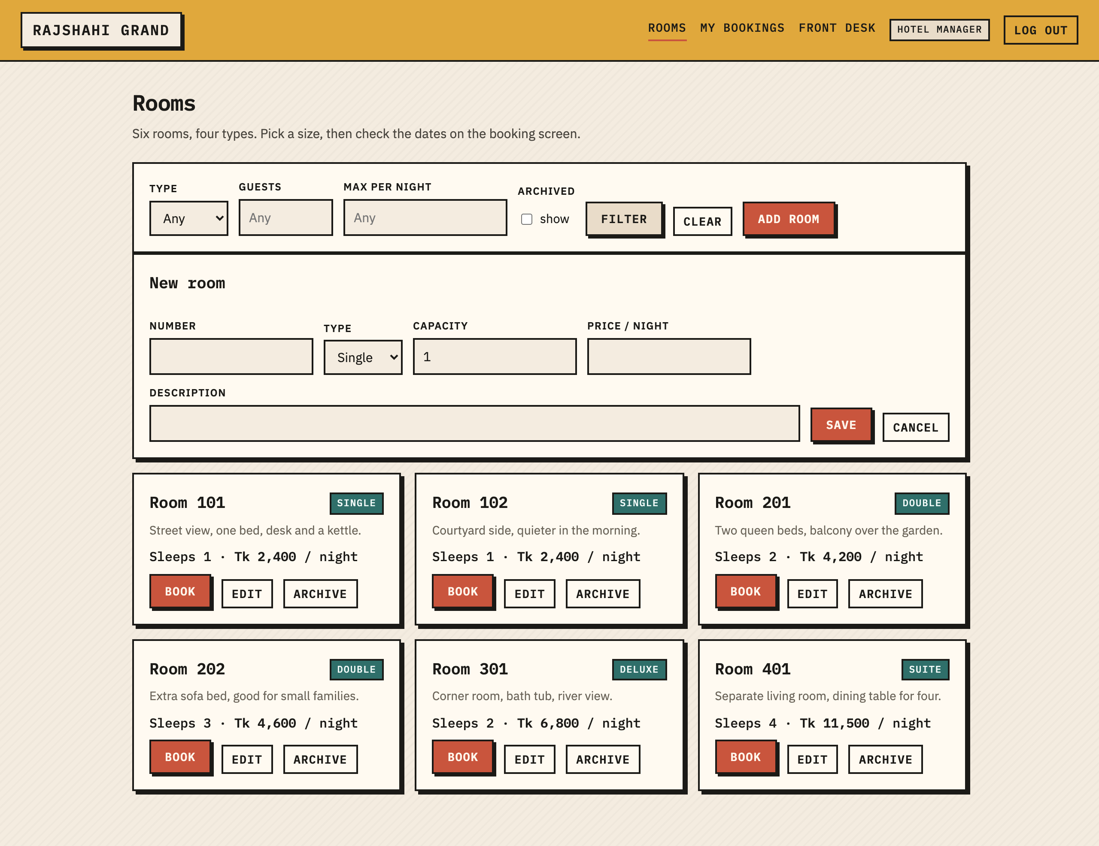
Figure 6 — Staff room management: the inline room form and the archive control on each card.

13. GitHub Collaboration Evidence
Repository: github.com/shu-vro/cse3206-hotel-reservation-system (public). Work was done on six feature branches, each merged into main through its own pull request. Nothing was committed straight to main after the initial scaffold.

13.1 Branches and pull requests
PR | Branch | Author of the work | Contents | State
#1 | feat/api-core-auth | Shirshen | SQLite bootstrap, users table, scrypt hashing, token sessions, auth endpoints, login screen, app shell guards | Merged
#2 | feat/rooms-module | Shahrirar Hasan | rooms table and seed data, rooms API with filters, staff CRUD, catalogue page, archived-room view | Merged
#3 | feat/booking-module | Riyon Chowdhury | bookings table, availability rules and tests, booking endpoints, booking screen, my bookings table | Merged
#4 | feat/admin-dashboard | Shahrirar Hasan | front desk dashboard, occupancy tiles, status filter, staff-only route and nav link | Merged
#5 | fix/booking-date-validation | Riyon Chowdhury | check-out picker fix, cancellation window, post-login redirect, nav menu refactor | Merged
#6 | docs/design-report | Shirshen | this report, README, screenshots, two UI fixes | Merged

13.2 Contribution summary
Member | GitHub handle | Commits on main | Main areas
Shirshen | shu-vro | 11 feature commits + 6 merge commits | Platform core, authentication, UI shell and styling, documentation
Shahrirar Hasan | Shahrirar-Hasan | 7 | Rooms module and the front desk dashboard
Riyon Chowdhury | Riyon-Chowdhury | 11 (including one branch merge) | Booking module, availability rules and unit tests
Total | — | 35 commits, 6 branches, 6 pull requests | —

13.3 Conflict resolution
One genuine merge conflict occurred, in src/main.js. PR #4 added a staff-only navigation link inside the header template, while PR #5 pulled the same block of markup out into a menu() helper. Git could not reconcile the two edits because they rewrote the same lines. It was resolved on the feature branch — main was merged into fix/booking-date-validation, the helper was kept and the staff link moved above the call to it — and the resolution is recorded in the commit "merge main into the fix branch". Keeping the resolution on the feature branch meant main was never left in a broken state.
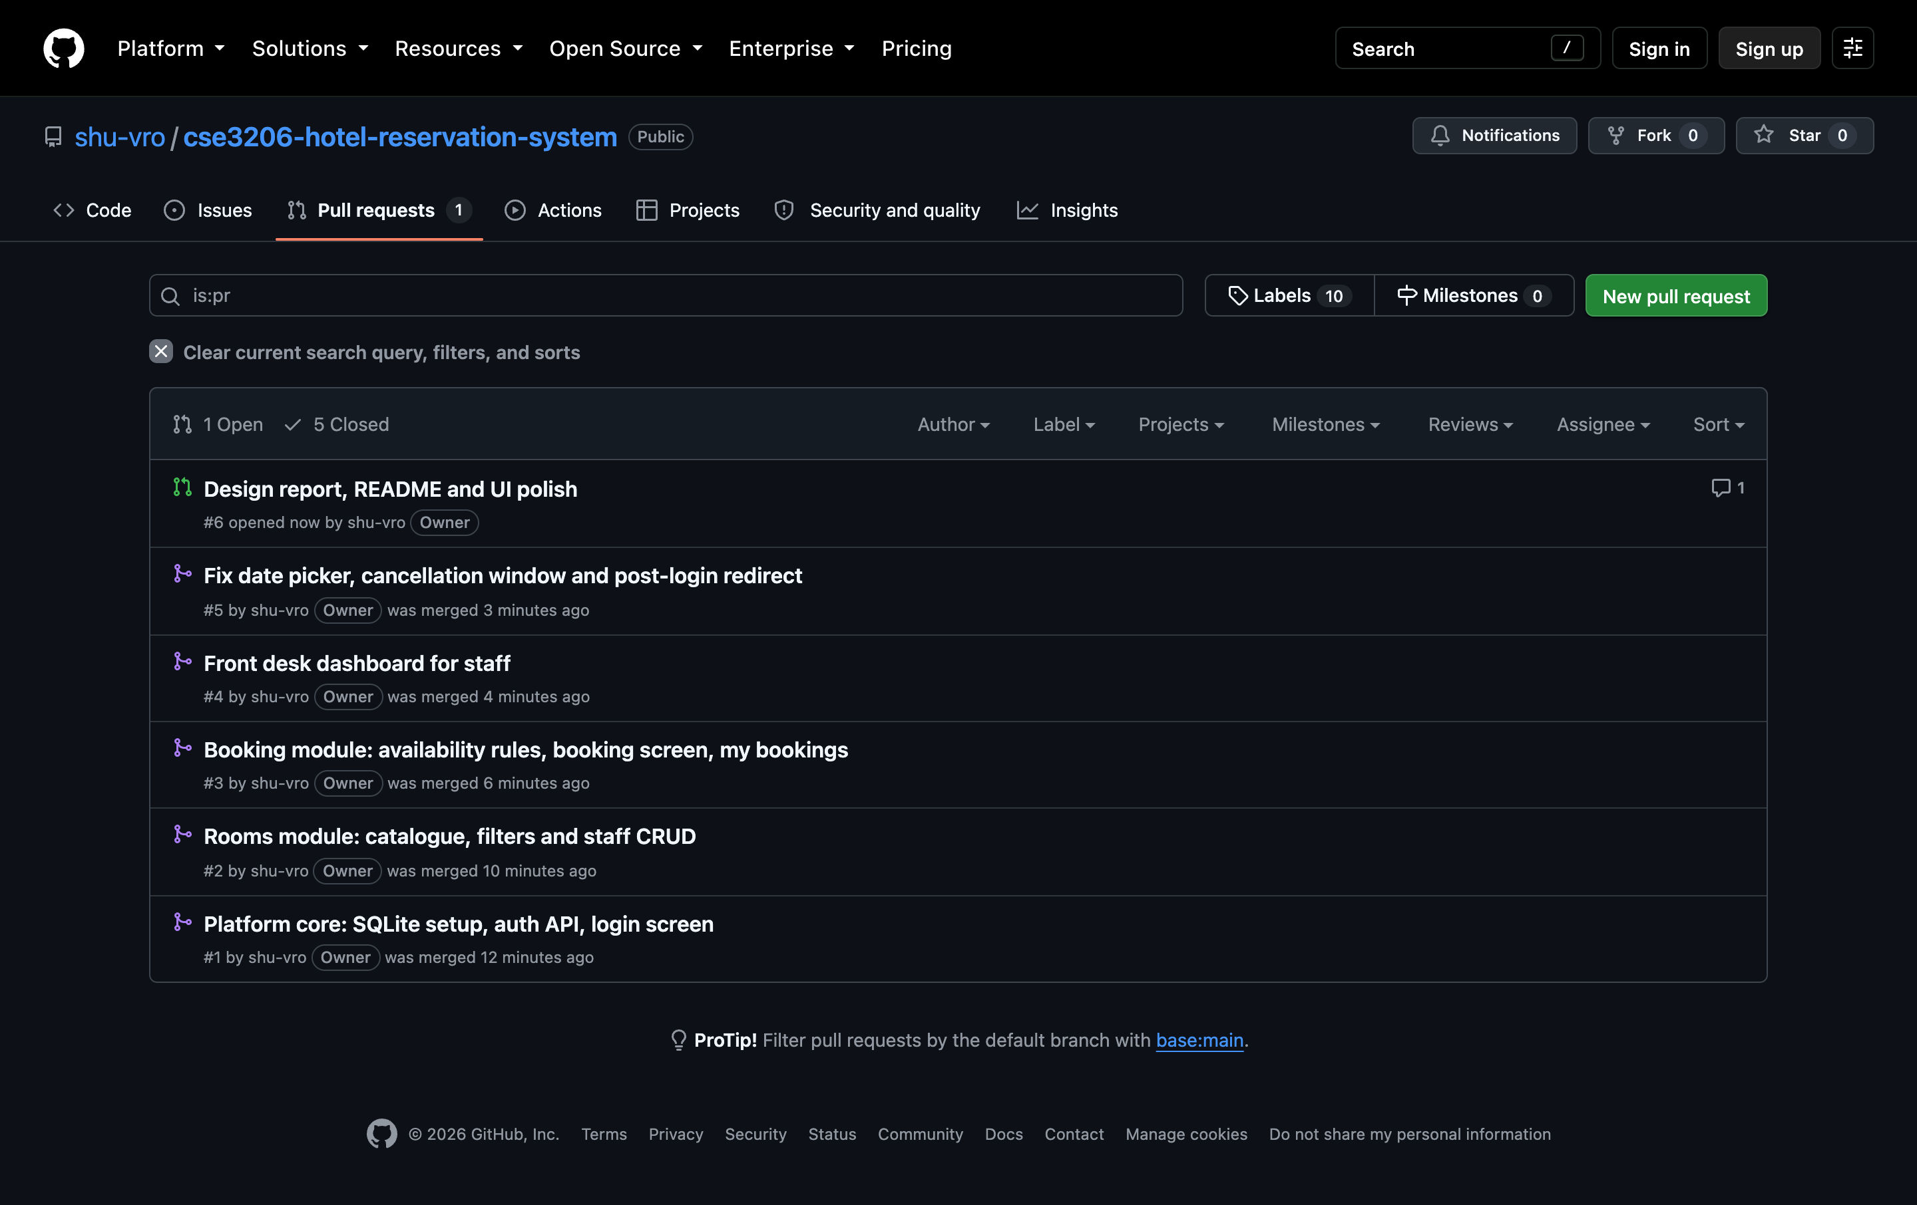
Figure 7 — All six pull requests.
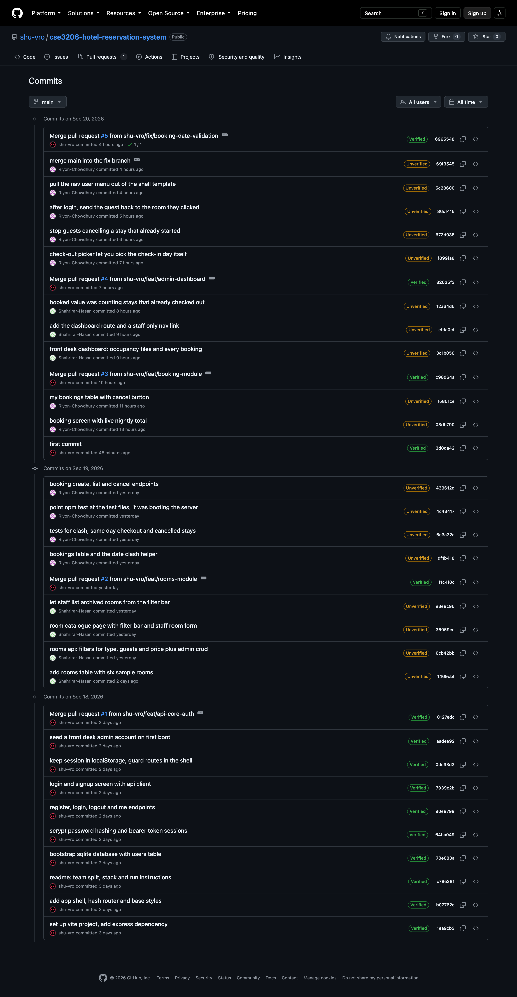
Figure 8 — Commit history on main, showing all three members and the merge commits.
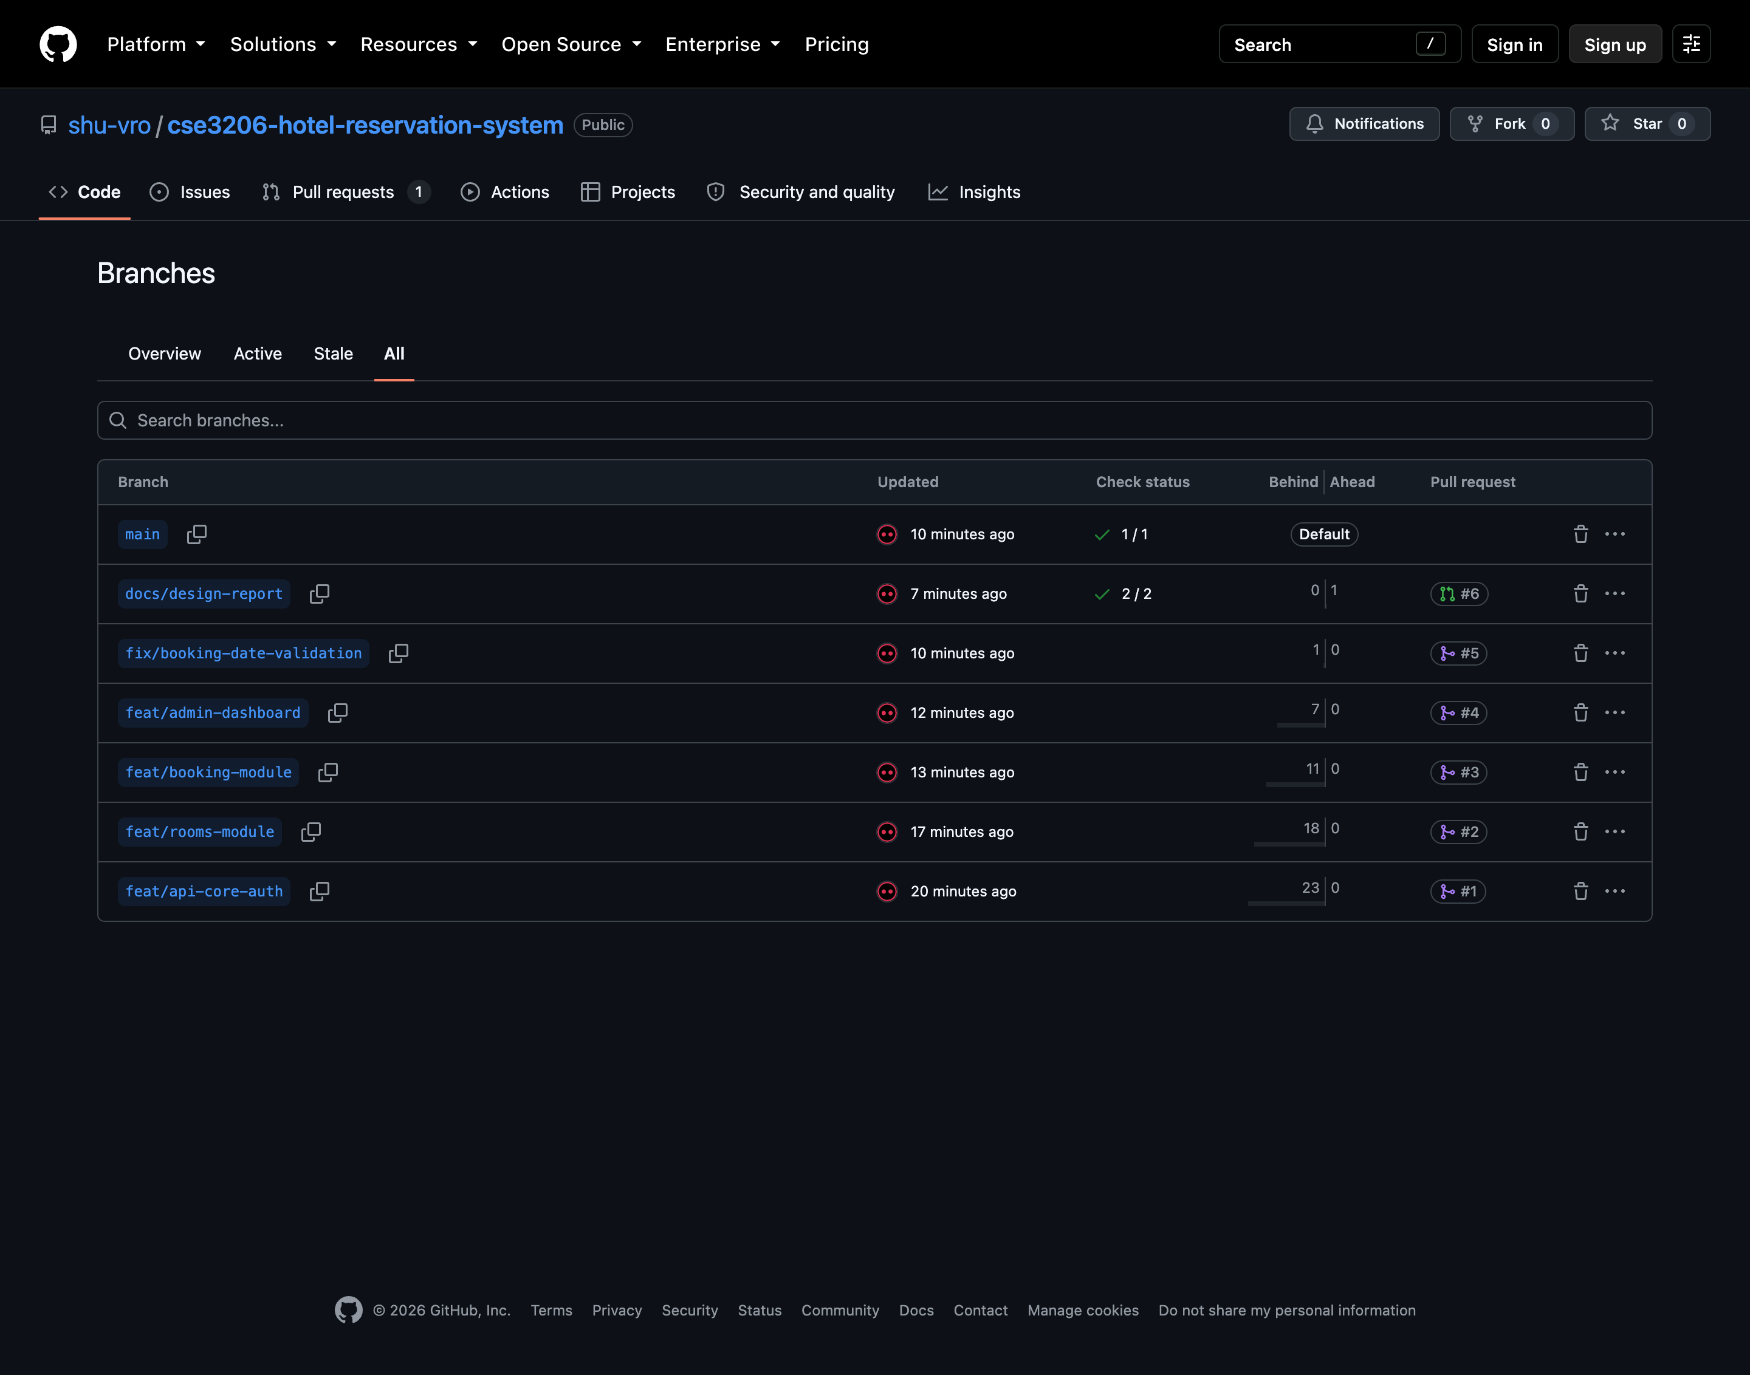
Figure 9 — The six feature branches, each linked to the pull request it was merged through.

14. Challenges Encountered
- Off-by-one in the availability rule. The first version of the clash query used inclusive comparisons, so a guest checking in on the day another guest checked out was refused. Writing the unit tests first for the boundary cases exposed it, and the strict comparison replaced it. This is the reason the booking rules were given their own file and test suite instead of living inside the route handler.
- The date picker and the server disagreed. The check-out input allowed the same date as check-in, so the only feedback was a server error after submitting. The fix moves the picker’s earliest date to the day after check-in and pulls an earlier value forward, so the invalid state cannot be reached.
- The test script ran the server. npm test was pointed at the whole server folder, which loaded index.js and started listening, so the command never exited. Narrowing the pattern to the test files fixed it — a small thing that cost twenty minutes because the failure looked like a hanging test.
- Losing the guest’s intent at login. Clicking Book while logged out sent the guest to the login screen and then dropped them on the catalogue. The intended route is now stored before the redirect and restored after a successful login.
- One real merge conflict. Two branches rewrote the same navigation markup. Resolving it on the feature branch rather than on main was the lesson, and it was the first time the team had to read a three-way diff rather than accept one side.
- Deciding what not to build. Payment, room images, a review system and email confirmations were all discussed and cut, because the milestone asks for the core loop to work rather than for feature count. Writing the scope down early made the cuts easy to defend later.

15. Limitations and Next Steps
The MVP is deliberately narrow, and the following are known gaps rather than oversights: sessions are held in server memory, so a restart logs everyone out; there is no payment step or invoice; there are no room photographs; cancellation does not calculate a refund; and there is no email notification. The next milestone will introduce design patterns and an automated test layer, at which point session storage moves into the database and the booking service becomes the first candidate for a repository pattern.

16. Conclusion
This milestone delivered a working Hotel Reservation System MVP: guests can register, filter the room catalogue, reserve a room for a date range with the price shown before confirming, and cancel; staff can manage the room inventory and run the front desk from a single dashboard. Overlapping reservations — the client’s main complaint about the paper register — are impossible, and the rule that guarantees it is unit tested.
Rapid Application Development suited the work. Three modules were built in parallel by three members, integrated through six pull requests, and corrected as soon as each was demonstrated; the two behavioural defects that surfaced were found by running the prototype, not by reading a specification. The result is small on purpose, modular by design, and ready for the design patterns and testing work the following labs require.

