ECE 495/ 595 Web Architectures/ Cloud Computing

Homework #2 Report

# Part 1. Using git and gitHub

This part required to create a new repo and a list for team mates to fork, edit, checkout, and merge. My list for part one was list something in backpack.

https://github.com/shu0925/495hw

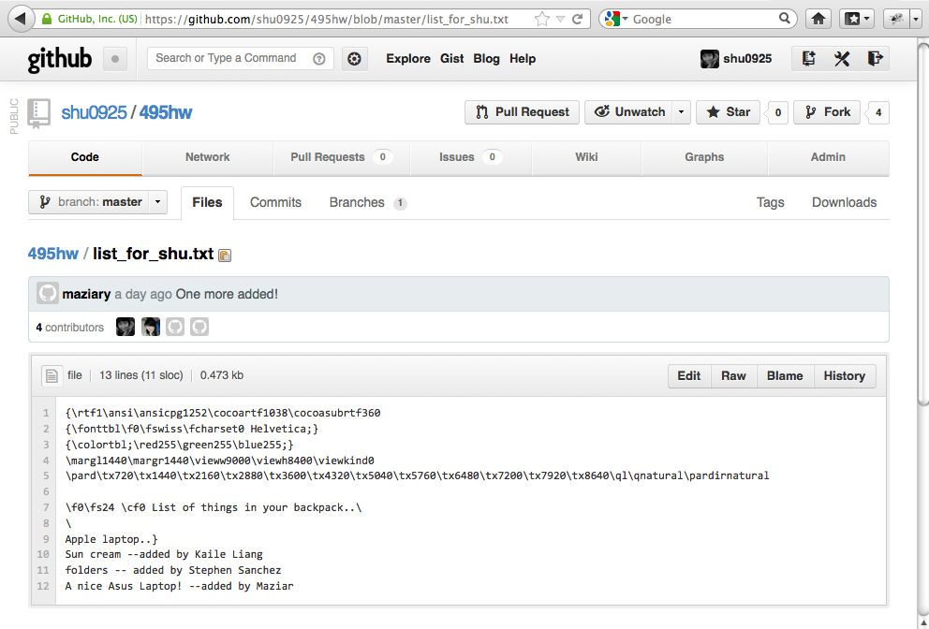

# Part 2. Ruby Programming

This part required a ruby program that allows a user to create and maintain an SQLite database, a list of reminder.

#

# hw2_2.rb

# task reminder

#

# Created by Shu Jie Chen on 9/27/12.

# File: ar_test.rb

require "active_record"

#Adapter for the SQLite3

active_record::Base::establish_connection(:adapter =>"sqlite3",:database =>"reminderdb.sqlite")

#Define database schema, and create database "people"

class PeoleTableScript < ActivRecord:: Mirgration

def self.up

create_table :reminders do |t|

t.string :task_title

t.text :task_memo

t.date :task_memodate

t.date :task_duedate

end

end

def self.down

drop_table :reminders

end

end

#Create the table that will be used in the database

PeopleTableScript.up

class Reminder < ActivRecord::Base

end

# Part 3 Rails Program.

Modify the blog application that was created in class, adding the feature of user authentication and display the name of the author of a post and also the name of commentators next to each

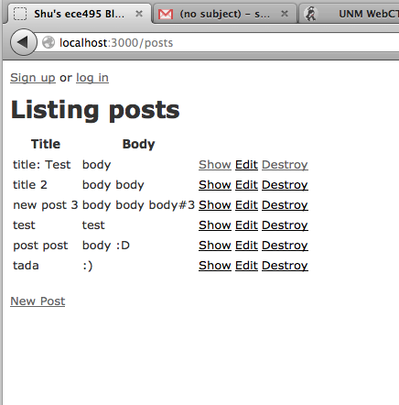

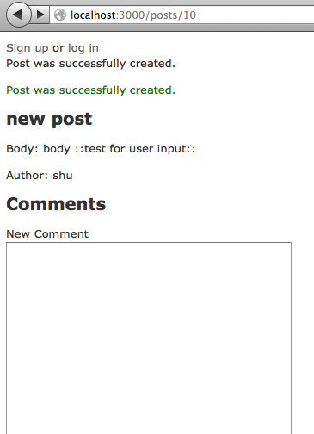

My intention was to create a hash so users can create their own User_id and password, However, after there are some parts of authentication is unable to route to the right page, so part 3 is still incomplete.