**TITLE:**

1. Gammai's Misadventures

2. Gammai's Misadventures: Journey to Sobborghi Town's Ruins

**GENRE:**

* Adventure and fantasy.

**Story Narrative** (Tentative)

Gammai’s world became chaotic when an unknown portal opened out of nowhere and dogs become lost their sanity as if they were being mind-controlled. Gammai worried as Thuy went missing. Now he became a warrior to save his beloved friend. Along his journey he fought dogs that turned into Halflings (Tentative name) and Fulldogs (tentative name) to face the mastermind.

Thuy is kidnapped and will be soon turned into demodogs

Gammai needs to defeat the mastermind to save Thuy.

**CHARACTERS:**

1. Gammai 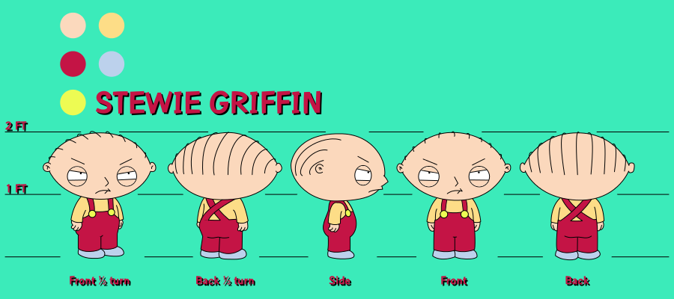

*Character reference for Gammai*

* He is the protagonist of our game.
* Gammai is a combination of "Gamma," which refers to one of the six male personalities and stands for "adventurous, energetic, aware, and empathetic," and "I," which is another way of saying oneself. Additionally, it comes from the bisaya term "Gamay," which means "little" which fits our character's description of physique.
* This character is inspired from “Stewie Griffin” from the American TV show “Family Guy”.

1. Thuy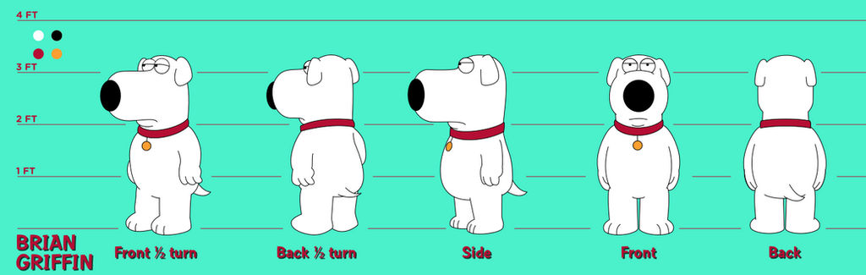

*Character reference for Thuy.*

* + He is the pet dog and beloved friend of our protagonist.
  + Thuy is from the Vietnamese word which translates to “loyal”.
  + Despite being imprisoned by the vicious master of evil lurking below the ruins of Sobborghi town, he has an unwavering will.
  + This character is inspired from “Brian Griffin” from the American TV show “Family Guy”.

1. Halflings (Tentative name)
   * Low rank antagonists of our game.
   * They are ordinary dogs that were transformed into monsters by the vicious master and make them his minions to sow terror in the once peaceful town of Sobborghi.
   * They are not fully developed demodogs. They are still half ordinary and half demodogs.
   * The traits of this character were inspired by "Demodogs" from the "Stranger Things" Netflix series franchise.
2. Fulldog (Tentative name)
   * High rank antagonists of our game.
   * They are ordinary dogs that were transformed into monsters by the vicious master and make them his minions to sow terror in the once peaceful town of Sobborghi.
   * They are fully developed demodogs.
   * The traits of this character were inspired by "Demodogs" from the "Stranger Things" Netflix series franchise.