1. A thousand people are asked there ages. The following are the results, alpha=.05



does this data come from a population where ages are normally distributed with mean = 33 and standard deviation =7?

Contingency Tables

* 1160 people are asked about where they live and how religious they are. The following are the results



Is there any relationship between where they liva and how religious they are, α.05

datact=as.matrix(my_data2)

dim(datact)

colnames(datact)<- c("har","dati","mes","hilo")

rownames(datact)=c("north","mercaz","jer","south")

datact

temp=chisq.test(datact)

temp$expected

Two Way Anova: A two-way ANOVA is used to estimate how the[mean](https://www.scribbr.com/statistics/mean/) of a [quantitative variable](https://www.scribbr.com/methodology/types-of-variables/) changes according to the levels of two categorical variables. Use a two-way ANOVA when you want to know how two independent variables, in combination, affect a dependent variable.

* Example: You are researching which type of fertilizer and planting density produces the greatest crop yield in a field experiment. You assign different plots in a field to a combination of fertilizer type (1, 2, or 3) and planting density (1=low density, 2=high density), and measure the final crop yield in bushels per acre at harvest time.

*You can use a two-way ANOVA to find out if fertilizer type and planting density have an*[*effect*](https://www.scribbr.com/commonly-confused-words/affect-vs-effect/)*on average crop yield.*

* Example: below is a table showing the response time to 3 different drugs

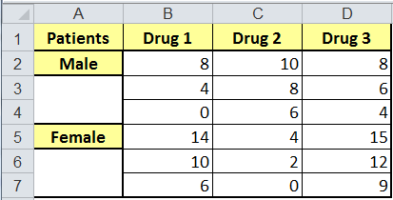

test whether the drugs are different, the genders are different, and is there an interaction. (α=.05)

A two-way ANOVA with interaction tests three null hypotheses at the same time:

* There is no difference in group means at any level of the first independent variable.
* There is no difference in group means at any level of the second independent variable.
* The effect of one independent variable does not depend on the effect of the other independent variable (a.k.a. no interaction effect).

A two-way ANOVA without interaction (a.k.a. an additive two-way ANOVA) only tests the first two of these hypotheses.

***Difference between Two Way Anova and Contingency Tables:***

* When you make use of contingency tables you want to see whether variables X and Y are related. When you make use of a two-way ANOVA test you want to see the influence of two variables X and Y on a third variable, say Z.