UIU CampusConnect
System Documentation
A social platform for United International University
September 2026

Contents

1. Introduction
UIU CampusConnect is a web application that brings the different parts of university life into one place. Instead of scattering announcements across notice boards, group chats and email, it gives every member of the university a single account and a single site where they can read the campus feed, follow official notices, join clubs, register for events, buy and sell within the campus, report lost property, and message each other.
The system recognises four kinds of account and treats them differently. Students get the social side of the platform and can connect with other students. Faculty members can reach anyone. University officials publish notices and manage academic sections. A developer administrator maintains the platform itself and reviews anything that has been reported.

1.1 Purpose of this document
This document explains how the system is built, where each feature lives in the source code, how the screens connect to one another, and how the database is organised. It is written so that any part of the application can be traced from the page a user sees, through the route, controller and model, down to the database tables involved.
The document is organised as follows.
- Chapters 2 and 3 cover the technology used and how to install and run the system.
- Chapter 4 explains the overall structure of the code and how a single request travels through it.
- Chapter 5 covers roles and permissions, which affect almost every feature.
- Chapter 6 is the site map, showing how the pages link together.
- Chapter 7 is the database design, including the entity relationship diagrams.
- Chapter 8 is the feature guide. This is the main reference: for each feature it states what it does, lists every file involved, traces one request end to end, and records the rules the code enforces.
- Chapters 9 to 11 cover the landing page, the security measures, and the known limitations.
- The appendices give a full route list and a file index for quick lookup.
Sections 4.5 and 8.18 cover the two parts that were added after the first version of the system: the React pages, and the picture galleries.

1.2 Scope
The application covers eleven functional areas: accounts and sign-in, profiles, the social graph of connections and follows, private messaging, the post feed, clubs, events, university notices, academic section announcements, community groups, and two classified boards for the marketplace and lost property. It also includes a moderation workflow and two separate administrative interfaces.
The system is a web application only. There is no mobile application, no email delivery in the default configuration, and no payment handling. Files uploaded by users are stored on the local disk through Laravel's public storage disk.

2. Technology

2.1 Stack
Layer | Technology | Role
Language | PHP 8.3 or newer | Server-side application code
Framework | Laravel 13 | Routing, ORM, validation, sessions, caching
Admin panel | Filament 5 | Second administrative interface at /admin
Database | MySQL 8 or MariaDB 10.6 | All persistent data
Templating | Blade | Server-rendered HTML
Page framework | Inertia 3 | Carries controller data straight into React pages
Client framework | React 19 | The converted pages, mounted by Inertia
CSS | Tailwind CSS v4 | Styling, compiled by Vite
Client scripting | Alpine.js 3 | Small interactive parts of the Blade pages
HTTP client | Axios | Background requests from the browser
3D graphics | Three.js r185 | The campus scene on the landing page
Build tool | Vite 6 | Compiles CSS and JavaScript

2.2 Why these choices
Laravel supplies routing, an object relational mapper, validation, session handling, file storage and caching as one coherent set, which removes most of the boilerplate a project of this size would otherwise need. Its Eloquent ORM maps each database table to a model class, so a query such as fetching a post with its author, reactions and comments reads as one chain of method calls rather than a hand-written join.
Filament is built on Laravel and generates administrative tables and forms from a short class definition. It is used for the routine record keeping (users, clubs, events, notices, reports, audit log) so that the hand-written administrative pages could be reserved for the workflows that need custom screens, such as the moderation queue.
Alpine.js covers the small interactive parts of a server-rendered page directly in the markup: the composer dialog, the reaction bar, infinite scroll, the messenger. It needs no component tree and no build step of its own, which suits a page that is mostly static HTML.
The listing pages outgrew that. A page such as the network directory has a search box, a role filter, pagination and four different per-person actions, and in Blade each of those meant a full page reload. Those pages were moved to React, with Inertia carrying the controller's data into the component as props. Inertia was chosen over a separate API because it keeps the routing, validation and authorisation in Laravel: the controller still returns a response to a route, it simply returns a page name and an array instead of a view. The two styles run side by side, share one stylesheet, and look identical; section 4.5 explains how a request reaches each of them.

2.3 Directory layout
Path | Contents
app/Http/Controllers | One controller per feature area, 25 in total
app/Http/Middleware | Request filters: forced password change, theme sharing, shared React props
app/Models | 34 Eloquent models, one per main table
app/Policies | Ownership rules for posts and comments
app/Services/SocialRules.php | Role rules for connections, messaging and club posting
app/Support | Notification sender, mention parser, gallery rules, generated covers
app/Rules | Custom validation rules
app/Filament | Admin panel resources, pages and widgets
app/Providers | Service registration, the admin gate, view composers
resources/views | Blade templates, one folder per feature
resources/views/components | Shared layout and card components
resources/js | Alpine components and the Three.js landing scene
resources/js/Pages | React pages, one folder per feature area
resources/js/Layouts | The shared React application shell
resources/js/Components | React icon, avatar and pagination components
resources/css/app.css | Tailwind theme and shared component classes
routes/web.php | Every URL in the application
database/migrations | Schema definitions, grouped by feature area
database/seeders | Demonstration data
app/Console/Commands | Faculty import, data wipe and sample-content commands
config | Framework and application settings
public | Web root, compiled assets, uploaded files

3. Installing and running the system

3.1 Requirements
- PHP 8.3 or newer, with the pdo_mysql, gd, mbstring and fileinfo extensions enabled
- Composer 2
- Node.js 20 or newer with npm
- MySQL 8 or MariaDB 10.6

3.2 First-time setup
composer install
cp .env.example .env
php artisan key:generate
Open .env and set the database name, user and password:
DB_DATABASE=uiu_campusconnect
DB_USERNAME=root
DB_PASSWORD=
Then create the schema, link the storage folder so uploaded files are reachable, and build the front-end assets:
php artisan migrate --seed
php artisan storage:link
npm install
npm run build
php artisan serve
The site is then available at http://127.0.0.1:8000.

3.3 Working on the code
While editing CSS or JavaScript, run npm run dev in one terminal and php artisan serve in another. Vite then rebuilds assets as files change, so the browser picks up edits without a manual build.
If a change to routes, configuration or views does not appear, clear the framework caches:
php artisan optimize:clear

3.4 Loading accounts and sample content
Three console commands manage the contents of the database. Each lives in app/Console/Commands.
php artisan uiu:wipe-demo empties every content table and deletes every account except the administrator. It refuses to run if no administrator exists, so the system cannot be left with no way in.
php artisan uiu:import-faculty <csv> --photos=<dir> creates one account per row of the faculty list, hashing a temporary password and setting must_change_password so each member of staff must choose their own on first sign-in. Running it again updates names and departments but never touches a password that has already been changed. Pass --dry-run first to see what it would do. The CSV holds one-time passwords in plain text, so it must be kept outside the project folder and deleted once the import has run.
php artisan uiu:demo-content fills an empty site with sample students, clubs, events, marketplace listings, lost property and notices, which is what makes the pages worth looking at before real use begins. Everything it creates belongs to accounts on the demo.uiu.test domain, so php artisan uiu:demo-content --wipe removes all of it and leaves the real records untouched.
The sample accounts share one password, printed when the command runs. They exist for testing only and must be removed with --wipe before anybody else can reach the site.
Role | Email
Administrator | admin@uiu.ac.bd
Student | tanvir@demo.uiu.test
Student | mehjabin@demo.uiu.test
Official, Registrar desk | registrar.office@demo.uiu.test

4. How the application is put together

4.1 The pattern
The application follows the Model, View, Controller pattern that Laravel is built around. A URL is matched to a controller method by the route file, the controller asks one or more models for data, and it passes that data to a Blade view which produces the HTML.
Three additional layers sit alongside those three, and knowing where they are saves a lot of searching:
- Middleware runs before the controller and can redirect the request. ForcePasswordChange sends any account holding a temporary password to the password screen, and ShareThemePreference reads the theme cookie so the correct light or dark class is on the page from the first byte.
- Services and support classes hold logic that more than one controller needs. SocialRules answers questions such as whether one user may message another. Notifier creates notification rows. Mentions parses @name out of a post body.
- Policies hold ownership rules. PostPolicy and CommentPolicy decide whether the current user may edit a given record.

4.2 The path of one request
Following a single request end to end shows how the layers fit together. The example is a student opening the feed.
- The browser requests GET /feed.
- routes/web.php matches the URL inside the auth middleware group and names the route feed.index.
- Laravel confirms a session exists. ForcePasswordChange checks the must_change_password flag and lets the request through.
- FeedController::index runs. It reads the tab and cursor from the query string.
- The controller calls scopes on the Post model. scopeVisible removes deleted posts, scopeForViewer removes hidden, muted and blocked authors, and scopeRankedFor orders what remains by the ranking expression.
- The resulting post identifiers are cached so that later scrolling pages through the same ordered list rather than re-ranking.
- The controller loads the posts with their authors, reactions, comments and media in one query set, then adds the sidebar data: the latest notice, the next three events and three clubs to suggest.
- It returns view('feed.index', ...). Blade renders feed/index.blade.php, which includes feed/_posts.blade.php, which includes feed/_post.blade.php once per post.
- The finished HTML is sent to the browser, where Alpine attaches the interactive behaviour: the composer, the reaction bars, and the observer that loads the next batch.

4.3 How the browser talks back
Most actions do not reload the page. Reacting to a post, saving it, sending a message and posting a comment all send a background request with Axios and update the page in place.
The trick that keeps this simple is in app/Http/Controllers/Controller.php. Its respond method checks whether the request expects JSON. If it does, the controller returns a small JSON object; if not, the same controller method returns a normal redirect. Every action therefore works with JavaScript switched off, and no controller has to be written twice.
The same method serves the React pages without alteration. An Inertia request sends Accept: text/html, so expectsJson() is false and the controller redirects back as it would for a plain form. Inertia follows the redirect and re-renders the page it came from, which is why actions such as registering for an event or accepting a connection needed no server-side change when their pages were converted.

4.4 Shared page furniture
Every signed-in Blade page is wrapped in resources/views/components/app-layout.blade.php. That single file provides the sidebar, the header with search box, the notification bell, the theme toggle, the mobile navigation bar and the floating messenger widget. Adding a page to the navigation means editing this one file.
Two view composers registered in app/Providers/AppServiceProvider.php supply the numbers on the sidebar badges: the unread message and notification counts, and the count of pending connection applications. Because they are composers, every view receives them without any controller having to pass them.
The React pages have the same shell written once more in resources/js/Layouts/AppLayout.jsx, and the same badge numbers reach it as shared props rather than as view composers. The two files are kept deliberately identical in markup and class names, so a visitor moving between a Blade page and a React page sees no seam.

4.5 How a React page is served
Seven listing pages are React rather than Blade. The route, the middleware, the authorisation and the queries are unchanged; only the last line of the controller differs.
- The browser requests GET /network.
- The route and the auth middleware behave exactly as in section 4.2.
- NetworkController::index runs its queries as before.
- Instead of view(...) it returns Inertia::render('Network/Index', [...]), naming a component under resources/js/Pages and the data it needs.
- HandleInertiaRequests adds the props every page receives: the signed-in user, the sidebar badge counts, any flash message and the theme.
- On a first visit Laravel returns resources/views/app.blade.php, a nearly empty document holding the page data as JSON. On any later visit Inertia asks for the same URL over XHR and receives only the JSON.
- resources/js/inertia.jsx resolves the component name to a file, mounts it, and passes the data in as props.
Two consequences are worth remembering when changing this code. First, the controller must decide everything the page needs, because a React component cannot call a model; this is why the controllers for converted pages build explicit arrays rather than passing Eloquent objects. Second, INERTIA_ROUTES at the top of AppLayout.jsx lists the paths that are React, and the sidebar only uses an in-page navigation for those. The list is matched exactly, because a converted listing such as /clubs usually still has a Blade detail page beneath it.

Pages that are React
Path | Component
/network | Pages/Network/Index.jsx
/connect-requests | Pages/ConnectRequests/Index.jsx
/clubs | Pages/Clubs/Index.jsx
/events | Pages/Events/Index.jsx
/groups | Pages/Groups/Index.jsx
/notices | Pages/Notices/Index.jsx
/notifications | Pages/Notifications/Index.jsx
/marketplace | Pages/Marketplace/Index.jsx
/lost-found | Pages/LostFound/Index.jsx

Everything else, including the feed, private messages, search, settings, all profile pages and every detail page, is still Blade.

5. Roles and permissions
Almost every feature behaves differently depending on who is looking at it, so the permission model is worth understanding before the feature guide.

5.1 The two columns that decide everything
Permissions come from two columns on the users table.
role is the broad category and holds one of four values: student, faculty, official or admin. authority_level is a finer label within that category, and the values used by the code are vc, pro_vc, dean, registrar, developer, club_moderator, faculty, official and member.
A third column, status, decides whether the account may be used at all. Only active accounts can sign in.

5.2 What each role may do
Action | Student | Faculty | Official | Admin
Read the feed, post, comment, react | Yes | Yes | Yes | Yes
Send a connection request to a student | Yes | Yes | Yes | No
Send a connection request to faculty or an official | Only through an admin-reviewed application | Faculty to faculty is accepted at once | Official to official is accepted at once | No
Start a conversation | Only with accepted connections | With anyone | Only with accepted connections | Cannot use messaging
Join clubs and groups, register for events | Yes | Yes | Yes | Yes
Publish a club event | Only with can_post_events on the membership | Also if club moderator of that club | Only with can_post_events | Yes
Publish a university event | No | Only vc, pro_vc or dean | No | Yes
Publish a notice | No | No | Only registrar or developer | Yes
Publish a section announcement | No | No | Only registrar or developer | Yes
Review reports, approve accounts, suspend users | No | No | No | Yes

5.3 Where each rule is written
Rule | File and method
Who may connect with whom | app/Services/SocialRules.php, canRequestConnection
Who may message whom | app/Services/SocialRules.php, canMessage
Who may manage a club | app/Services/SocialRules.php, canManageClub
Who may post a club event | app/Services/SocialRules.php, canPostClubEvent
Who may post a university event | app/Models/User.php, canPostUniversityEvent
Who may issue notices | app/Models/User.php, canIssueNotices
Who may issue section announcements | app/Models/User.php, canIssueSectionAnnouncements
Who owns a post or comment | app/Policies/PostPolicy.php, app/Policies/CommentPolicy.php
Administrator override | app/Providers/AppServiceProvider.php, the Gate::before closure
Who may open the Filament panel | app/Models/User.php, canAccessPanel

Keeping these in named methods rather than inline conditions means a rule can be checked in a controller and in a Blade template without being written twice, and it means the whole permission model can be read in two files.

5.4 The administrator override
AppServiceProvider::boot registers a gate that runs before every policy:
Gate::before(fn ($user, $ability) => $user->isAdmin() ? true : null);
Returning true grants the ability outright; returning null lets the normal policy decide. The effect is that an administrator passes every ownership check, so the policies themselves only have to describe the owner's rights. The SocialRules methods make the opposite choice: they deliberately exclude administrator accounts from connections and messaging, so an administrator account is a maintenance account and not a social one.

6. Site map and page connections
Figure 1 shows every screen in the application and the links between them. Arrows mark a link that exists in the markup of one page pointing at another. On top of these links, every signed-in page carries the sidebar, so the main sections are always one click away from anywhere in the application.

6.1 Reading the map
The application has three entry points and one hub.
Guest pages. A visitor who is not signed in lands on the Three.js landing page at /. From there the only routes forward are the sign-in form and the account recovery form. FeedController::welcome checks for a session first, so a signed-in visitor who opens / is redirected straight to the feed. Signing out returns the user to the landing page rather than the sign-in form.
The hub. After sign-in every user arrives at /feed. The feed is the only page that pulls content from several modules at once: posts in the centre, the latest notice, upcoming events and suggested clubs in the right rail, and the deadlines and shuttle cards below them.
Feature pages. Each module follows the same two-level shape: an index page that lists and filters, and a detail page for one record. Clubs, events, notices, groups, marketplace and lost and found are all built this way, which means once one of them is understood the others read the same.
Administrative pages. The admin centre at /developer-admin is the entrance to the five administrative screens. It does not duplicate their work; it shows counters and links out to the moderation queue, user approvals, password requests, connection applications and the Filament panel.

6.2 Where the paths cross
Three pages are reached from many different places, and they are worth knowing because they carry most of the cross-linking.
- The profile page is linked from every list of people: the feed, search, the network directory, connection requests, group and club member lists, and both moderation screens.
- The messages page is the destination of every "contact" action. Marketplace listings and lost property claims both link to messages.index with a ?with= parameter that opens the right conversation.
- The post detail page is where notifications land. notifications.go resolves the entity a notification refers to and redirects, adding an anchor such as #comment-42 when the notification was about a comment.

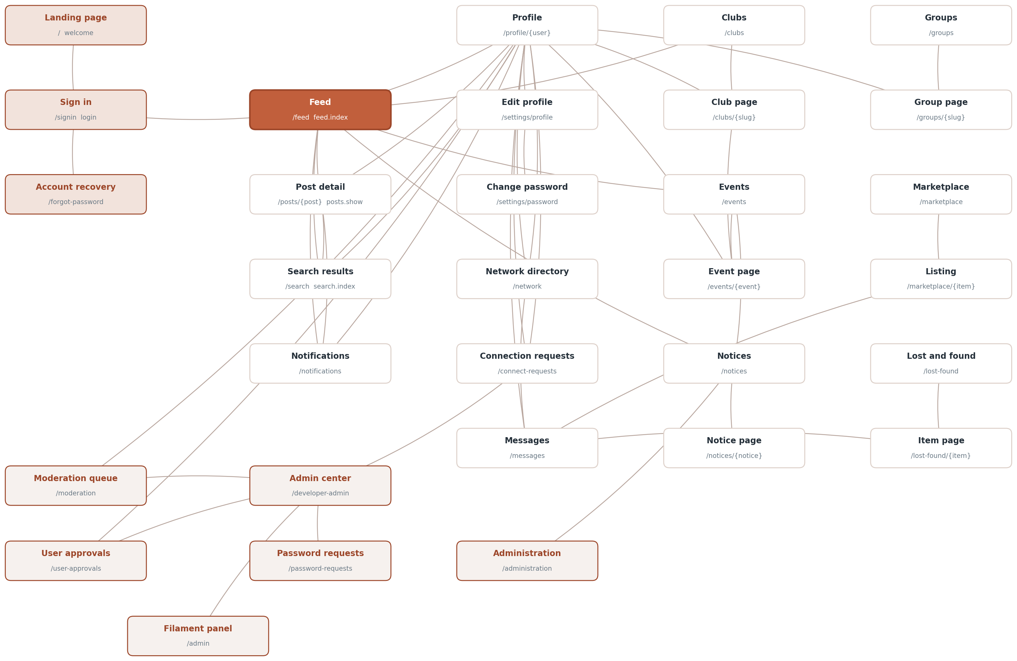
Figure 1. The pages of the application and the links between them.

7. Database design
The schema holds 53 tables. Five of those belong to the framework and store cache entries, queued jobs and job batches; the remaining 48 hold application data. Figure 2 groups them by module, and Figures 3 to 8 give the columns and relationships of each group in turn.

7.1 Users, profiles and the social graph
users holds identity, role and account state. Everything that describes a person but is not needed on every query lives in user_profiles, which uses user_id as its primary key rather than a surrogate identifier.
Relationships between people are stored in four separate tables because they mean four different things. friendships is a mutual link with a status and one row per pair. user_follows is one-directional and needs no status. user_blocks hides content in both directions and is checked on almost every query. user_mutes hides an author temporarily and carries an expires_at that may be null for a permanent mute. connection_applications records the student request that an administrator must approve before a student and a faculty member can be connected. See Figure 3.

7.2 Posts and engagement
posts is the centre of the feed. A post can carry several attachments, so post_media holds one row per file with a position column that preserves the order they were uploaded in. The older media_type and media_path columns on posts itself mirror the first attachment.
Every kind of engagement has its own table. The ones that can happen only once per person per post, which is reactions, saves, hides and views, use a composite primary key of the two identifiers instead of an auto-incrementing one, so the database itself enforces the rule. Polls are two tables: poll_options for the choices and poll_votes for the answers, with a unique constraint that gives each voter one vote per post. See Figure 4.

7.3 Clubs, events and notices
Clubs and events are linked in two directions: an event may belong to a club through events.club_id, and a post may belong to a club through posts.club_id. Membership is a pivot table that carries a can_post_events flag, which is what allows an ordinary member to publish on the club's behalf without changing their role anywhere else.
Events have three separate participation tables rather than one with a status column, because registering, marking interest and checking in are independent of each other: a person may be interested without registering, and may check in whether or not they registered. Notices carry their own attachments table and a set of targeting columns, audience, department, batch and semester, which decide who is notified when one is published. See Figure 5.

7.4 Groups, marketplace and lost property
These three boards are the simplest part of the schema. Each has an items table owned by a user, and where a response is possible there is one child table for it: community_group_files for uploads to a group, and lost_found_claims for someone saying they have found or lost an item. Groups and clubs both use a slug column for their URLs rather than the numeric identifier.
lost_found_items carries two columns about how a case ended. resolved_at is when it was marked reunited and resolved_by is who marked it, which is either the person who posted it or an administrator acting for them. Keeping the time separately from updated_at is what allows the reunited list to be ordered by when each case was settled rather than by when the row was last touched. See Figure 6.

7.5 Pictures
Events, clubs, notices, marketplace listings and lost property items can all carry more than one picture, and rather than five nearly identical tables they share one. media is polymorphic: mediable_type holds the model class name and mediable_id its primary key, the same convention the mentions table already used. position decides the order, and position zero is the cover the listing pages show.
There is no foreign key on that pair, because a foreign key can only point at one table. The trade-off is that the database cannot delete a picture row automatically when its owner is deleted, so the code that removes an owner removes its media first. Figure 8 shows the table and the five it serves.
Each of those five tables still has the single image column it had before galleries existed, such as events.poster_path. Those columns are read as a fallback when a row has no media rows at all, which is what keeps records created before the change showing their picture. New uploads only ever write media rows.

7.6 Reports, notifications and the audit trail
Reports are kept in three separate tables rather than one polymorphic table, because a report against a post, a comment and a profile each need different columns and are resolved by different actions. All three share the same status vocabulary, so the moderation queue can treat them alike.
notifications is written by one class, app/Support/Notifier.php, and carries a group_count column so that repeated activity on the same item can be folded into a single row rather than filling the list. audit_logs records administrator actions with the actor, the action, and the record affected. See Figure 7.

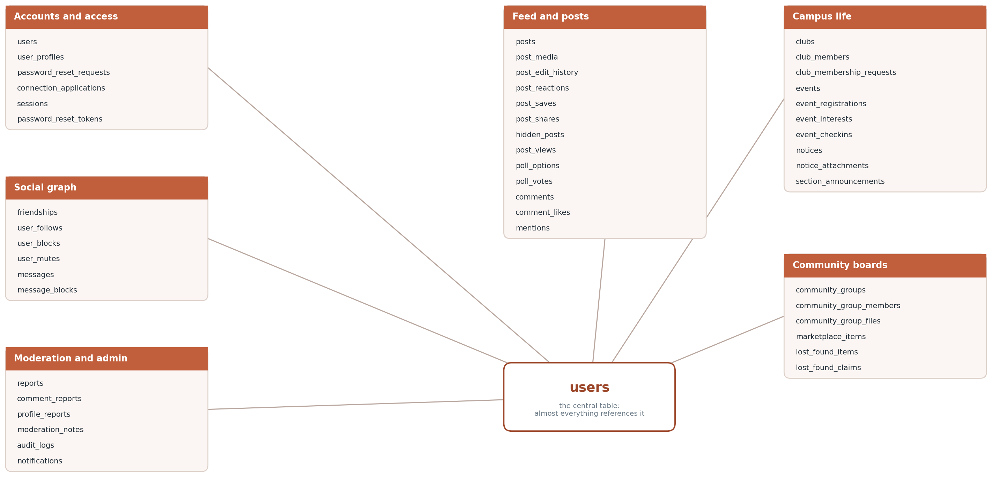
Figure 2. The tables grouped by module.
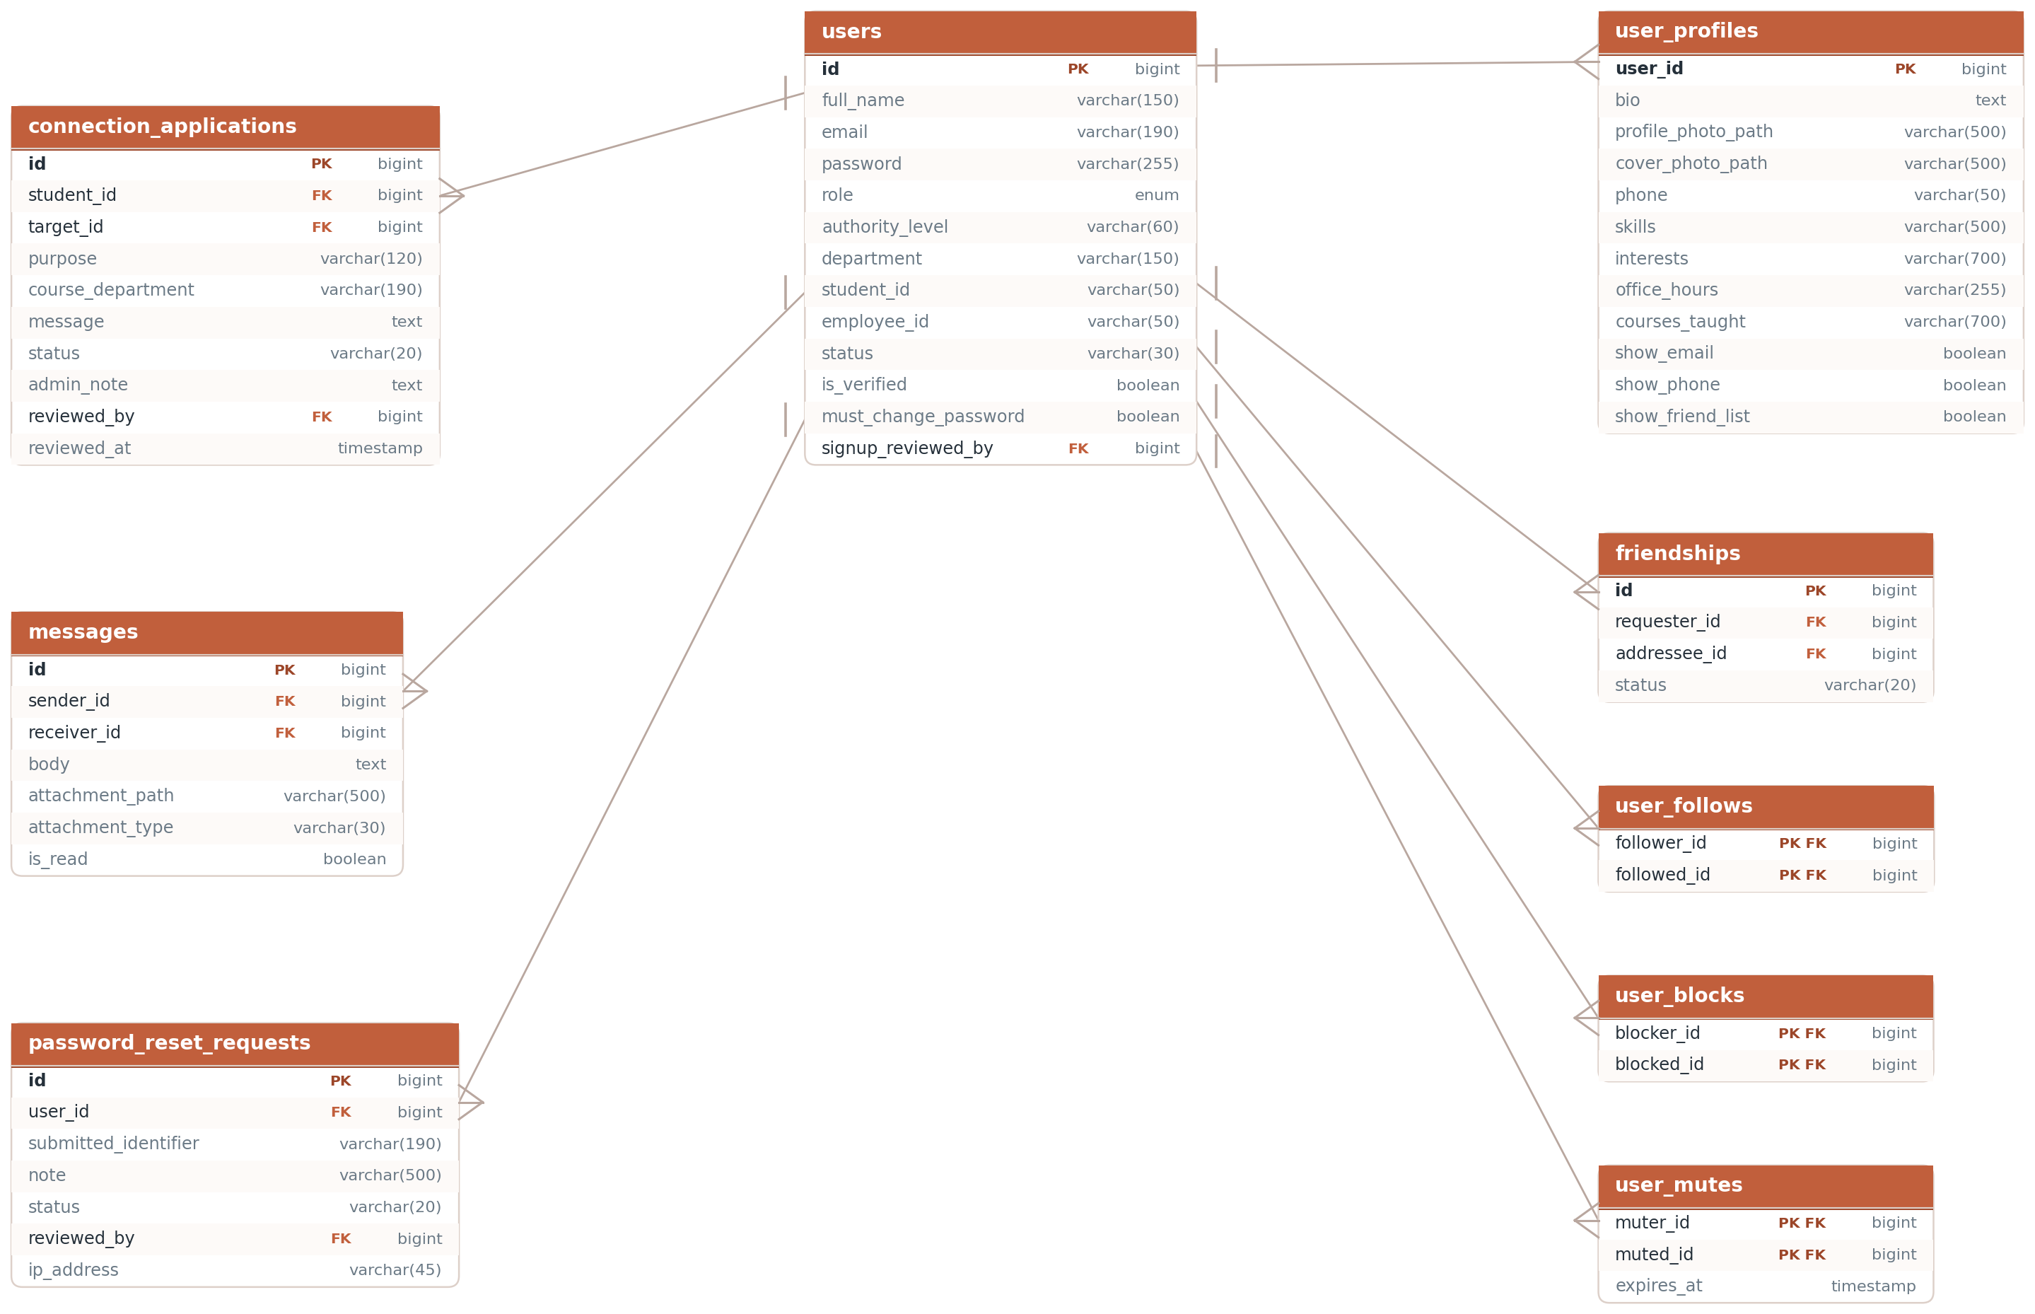
Figure 3. Accounts, profiles, connections and messaging.
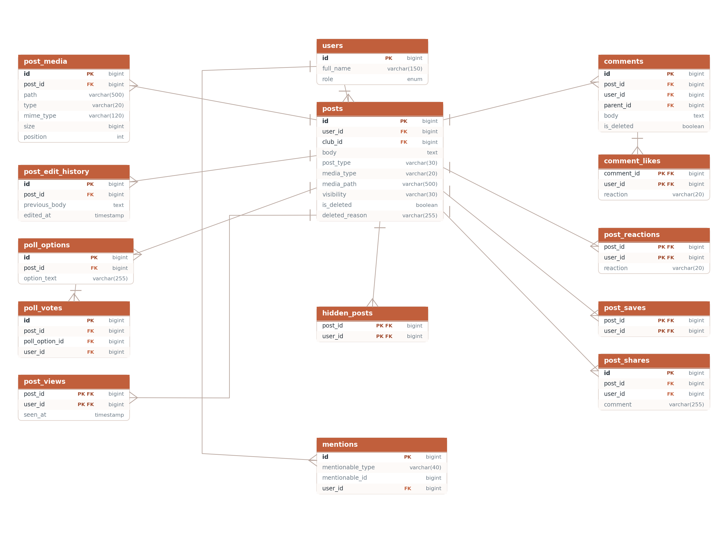
Figure 4. Posts, attachments, polls, comments and reactions.
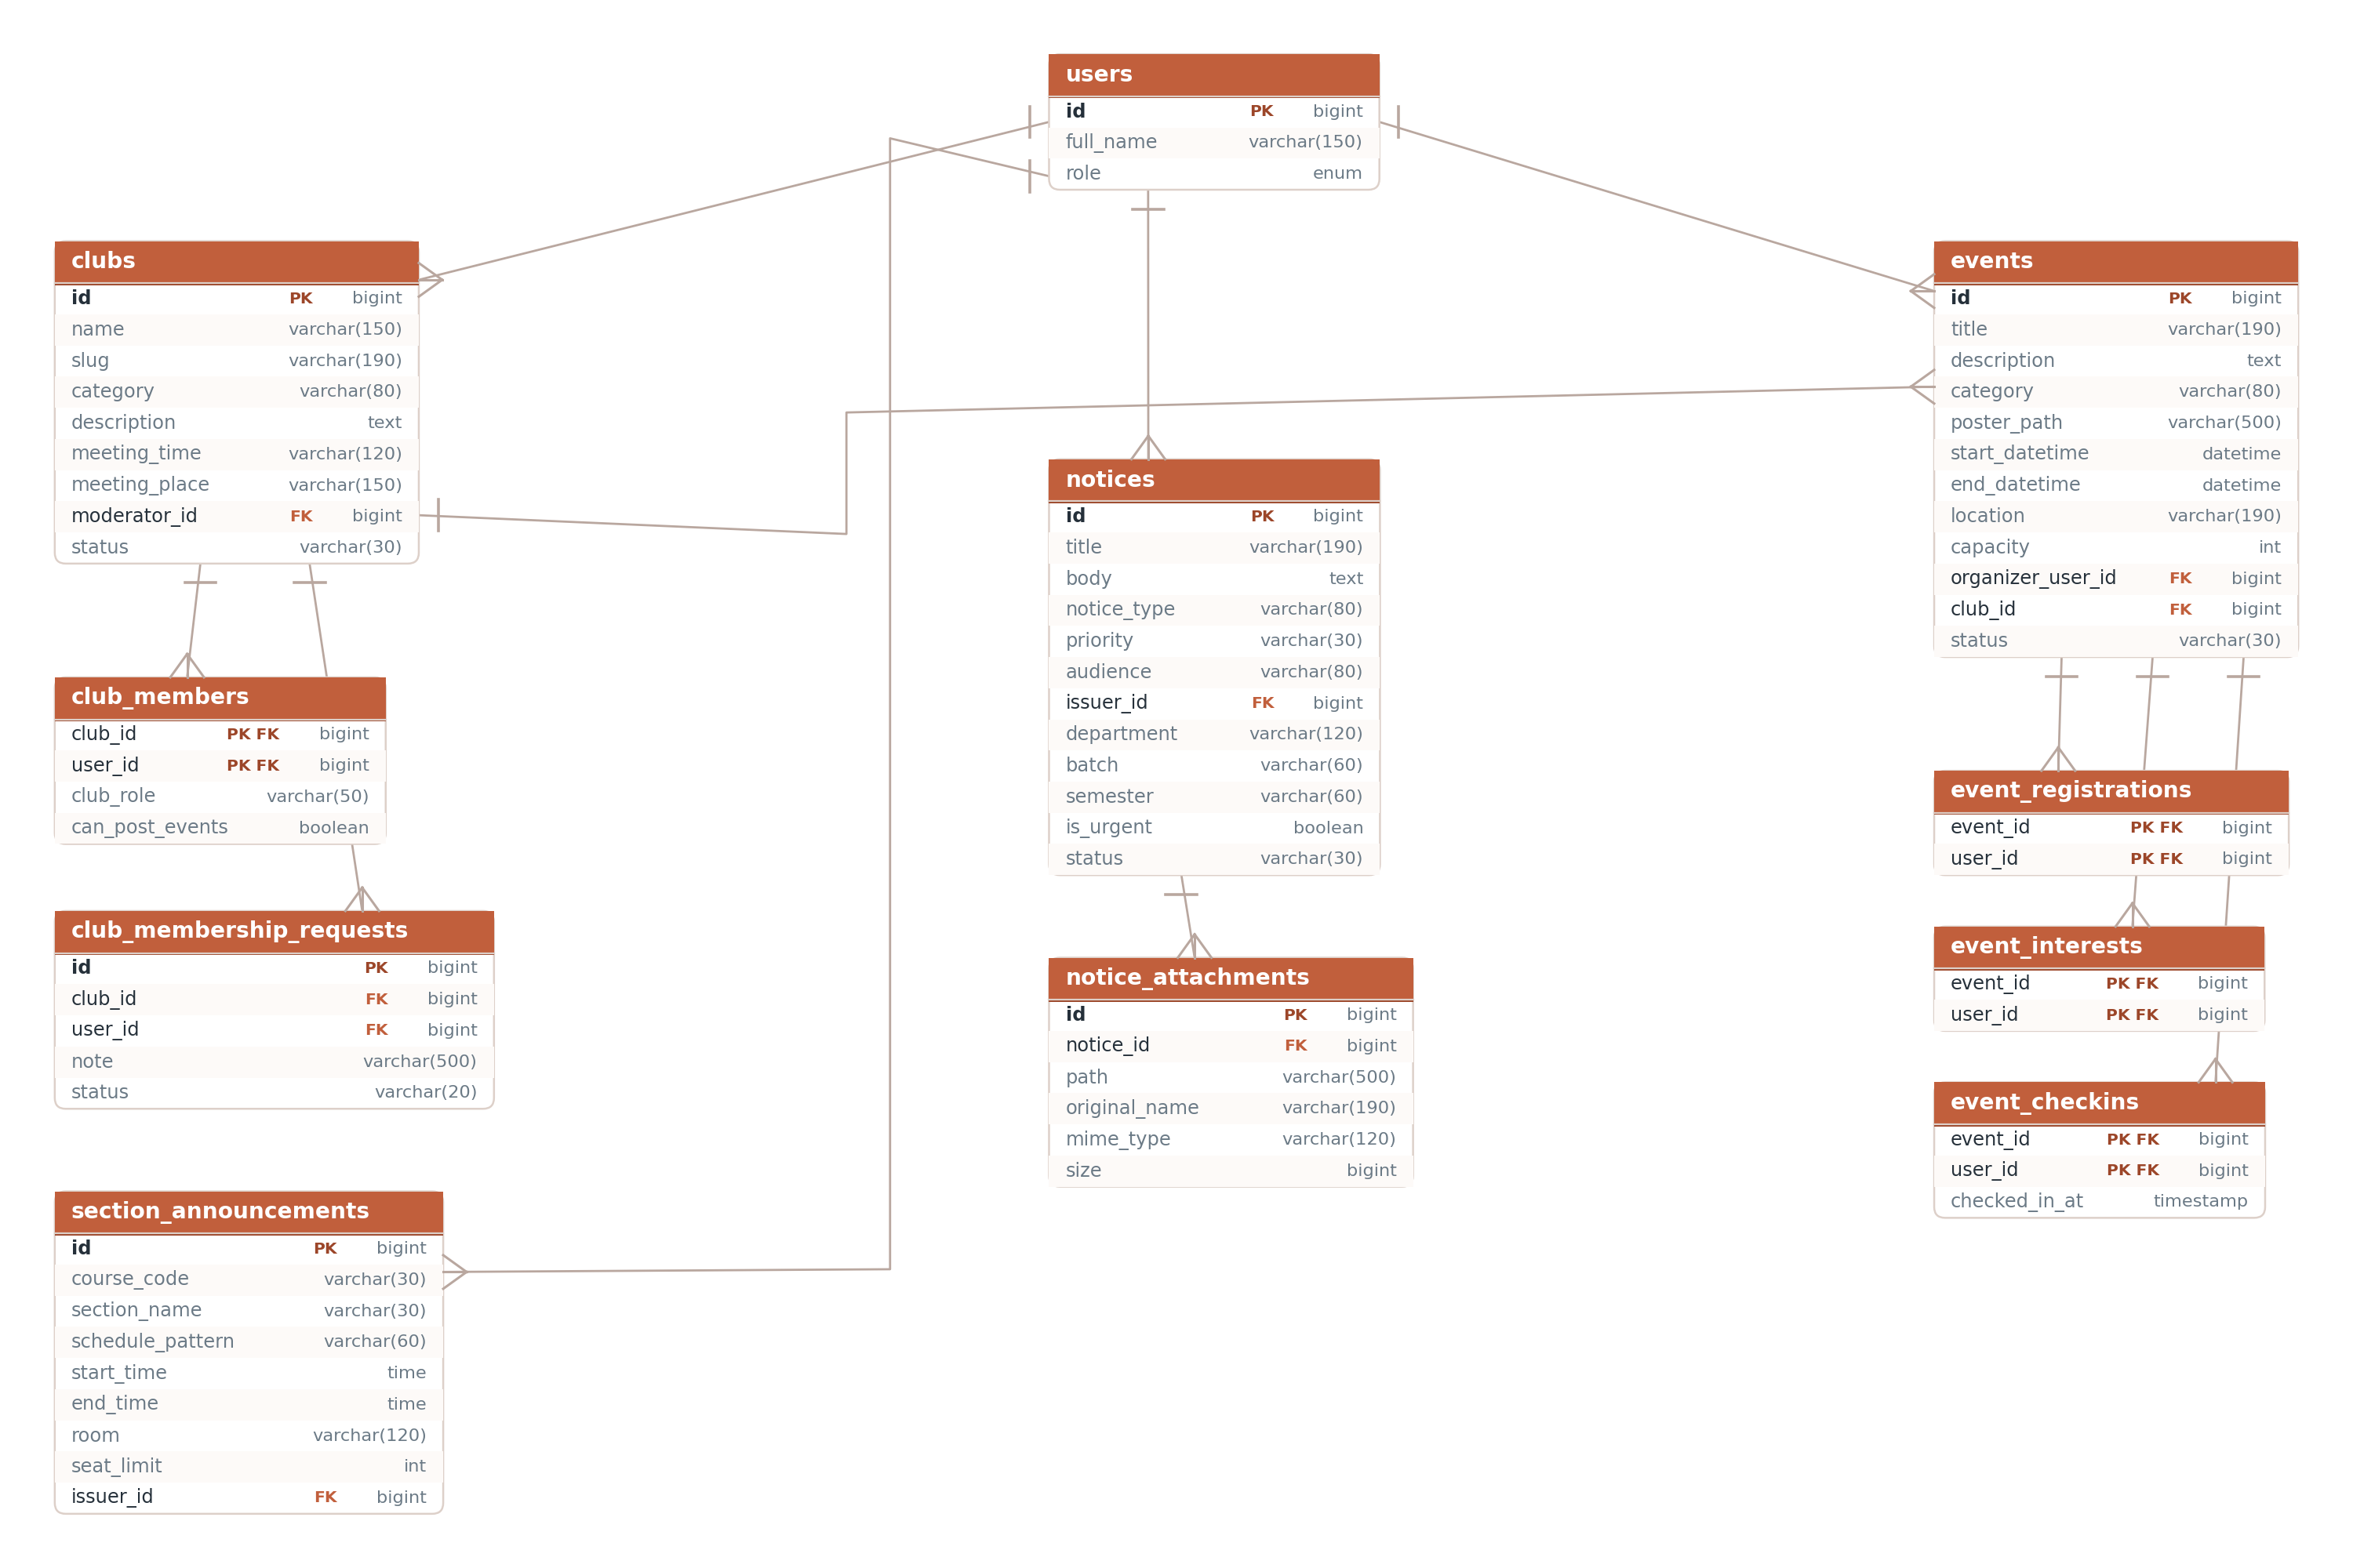
Figure 5. Clubs, events, notices and section announcements.
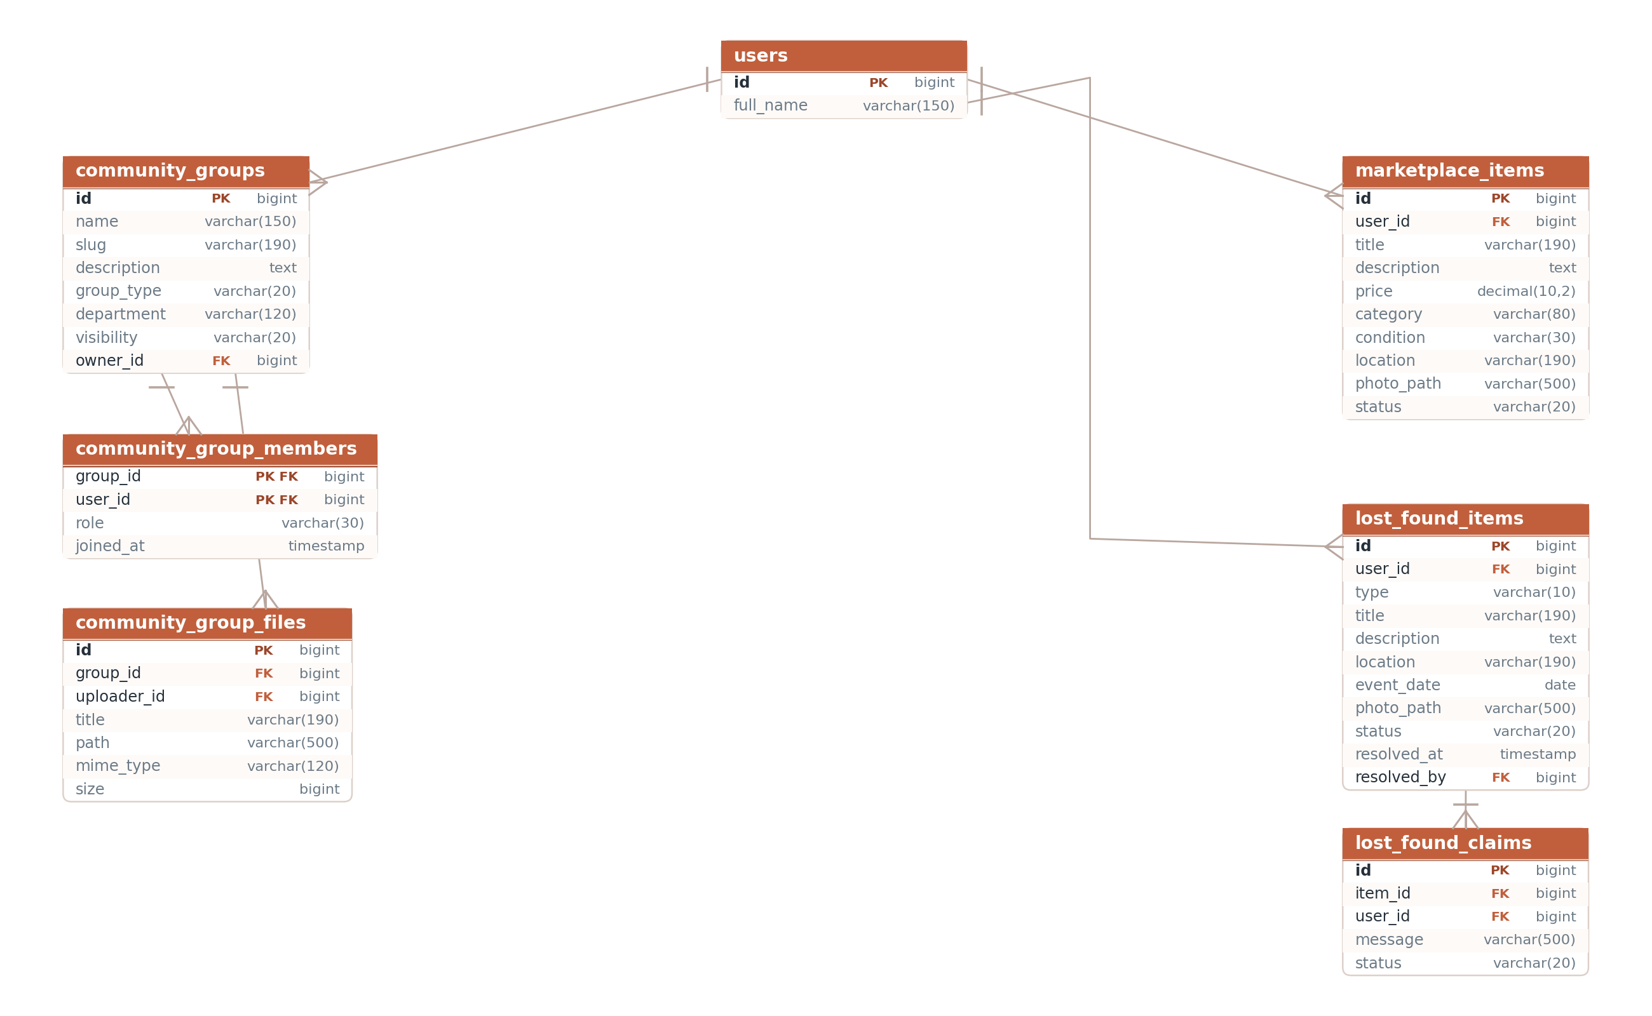
Figure 6. Community groups, marketplace listings and lost property.
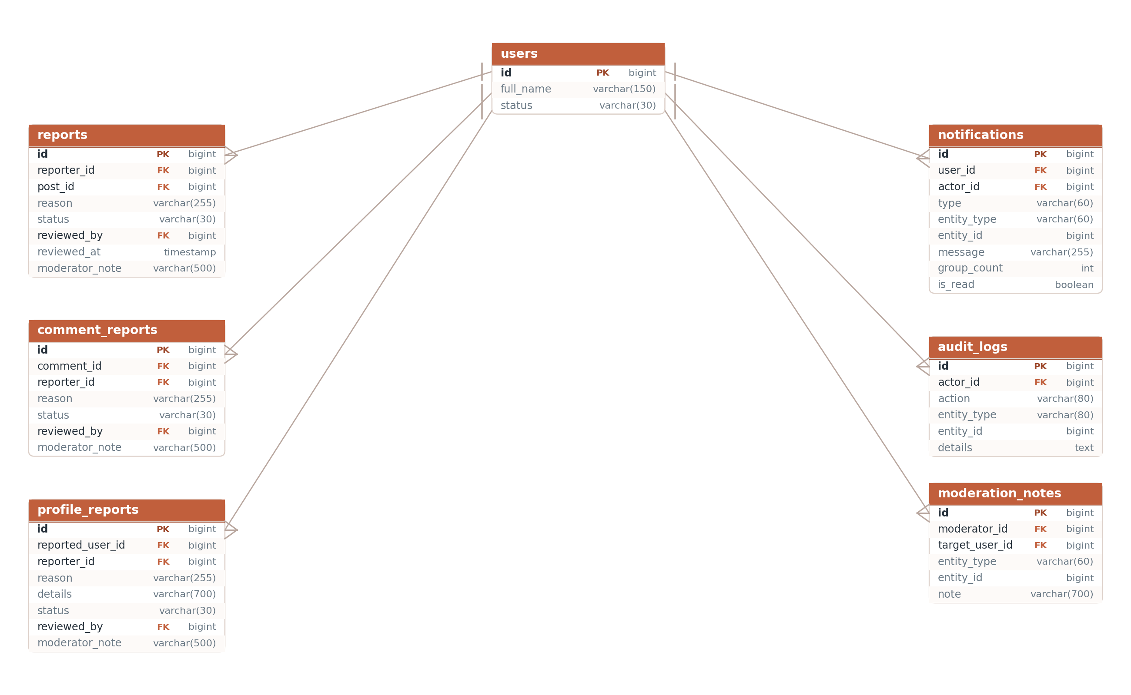
Figure 7. The moderation and notification tables.
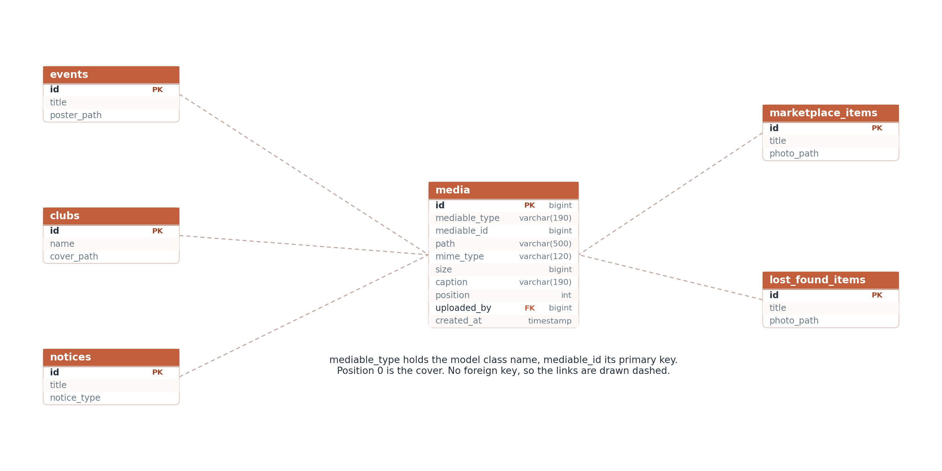
Figure 8. The media table and the five kinds of record it holds pictures for.

7.7 Conventions used throughout the schema
Primary keys. Most tables use an auto-incrementing id. Join tables that record a fact about a pair of records use a composite primary key instead, which makes the "only once" rule a database constraint rather than something the application has to remember. post_reactions, post_saves, post_views, hidden_posts, comment_likes, user_follows, user_blocks, user_mutes, club_members, event_registrations, event_interests, event_checkins and community_group_members all work this way.
Foreign keys. Every foreign key is declared with cascadeOnDelete, so removing a post removes its media, poll options, reactions and comments with it. The few columns that may legitimately be empty, such as posts.club_id and notifications.actor_id, are nullable and use nullOnDelete. The one exception is the media table, whose link to its owner is a class name and an identifier rather than a foreign key, and so has to be cleaned up in code.
Soft deletion. Posts and comments are never removed from the table. They carry is_deleted and deleted_reason, and the visible scope filters them out. This keeps the reply chain intact when a parent comment is removed, and preserves the record of what a moderator acted on.
Status columns. Records that move through a workflow carry a status string rather than a boolean, so a third state can be added without a migration. The values in use are:
Table | Status values
users | active, pending, suspended, rejected
friendships | pending, accepted
connection_applications | pending, reviewing, approved, rejected, cancelled
club_membership_requests | pending, approved, rejected
clubs | active, inactive
events | published, cancelled
notices | published, archived
reports, comment_reports, profile_reports | open, reviewing, resolved, dismissed
marketplace_items | available, sold
lost_found_items | open, resolved
password_reset_requests | pending, approved, rejected

Timestamps. Most tables carry the usual created_at and updated_at pair. Tables that are written once and never modified, such as notifications, mentions, post_media and audit_logs, keep only created_at and set $timestamps = false on their model.
Migration files. Migrations are grouped by feature rather than one file per table. 0001_01_02_000001_create_posts_and_engagement_tables.php, for example, creates posts and every table that hangs off it, so the whole feature can be read in one place. Later additions are separate files with names that state what they add.

8. Feature guide
This chapter is the main reference for finding code. Each feature is described the same way: what a user sees, a table naming every file involved, a numbered trace of one request from the browser to the database and back, the rules the code actually enforces, and the pages it links to.
Route names rather than line numbers are used throughout, because a route name is stable when the file is edited. To find a route, search routes/web.php for its name.

8.1 Authentication and sign-in
What it does. Users sign in at /signin with an email and password. There is no public sign-up form; accounts are created by the university. A sign-in attempt is refused if the account status is not active, with a different message for a pending, suspended or rejected account. Anyone who cannot sign in files a recovery request at /forgot-password, which an administrator reviews and answers by issuing a randomly generated temporary password shown to the administrator once. An account holding a temporary password is redirected to the password screen until it is changed. Administrators approve, reject, suspend and reactivate accounts at /user-approvals.

Where the code is
Layer | File
Routes | login, login.attempt, logout, password.request, password.request.store, password-requests.index, password-requests.review, user-approvals.index, user-approvals.review
Controllers | Auth/LoginController.php (create, store, destroy), PasswordResetRequestController.php (create, store, index, review, temporaryPassword), UserApprovalController.php (index, review)
Models | User.php, PasswordResetRequest.php
Views | auth/login.blade.php, auth/forgot-password.blade.php, admin/password-requests.blade.php, admin/user-approvals.blade.php
Supporting | Http/Middleware/ForcePasswordChange.php, Rules/UiuEmail.php, the login rate limiter in Providers/AppServiceProvider.php
Tables | users, password_reset_requests

How it works
- GET /signin reaches LoginController::create, which returns the auth.login view. The route sits in the guest group, so a signed-in visitor is redirected away.
- POST /signin reaches LoginController::store through the throttle:login middleware. That limiter is defined in AppServiceProvider::boot as eight attempts per fifteen minutes, keyed on the lower-cased email plus the client IP address.
- store validates the email and password, loads the user by lower-cased email, and checks the password with Hash::check. A miss returns the generic message "Those credentials don't match an account."
- If the account status is not active, a match expression picks the message for pending, suspended or rejected and returns it as an error. No session is created.
- On success the controller calls Auth::login, regenerates the session identifier to defeat session fixation, stamps last_login_at, and redirects to the intended URL or to feed.index.
- On the next request ForcePasswordChange runs. If must_change_password is set and the route is not the password screen or sign-out, it redirects to settings.password with a warning.
- For recovery, PasswordResetRequestController::store looks the submitted identifier up against email, student_id and employee_id, and stores a pending row with the request IP address. The confirmation message is the same whether or not a user matched, so the form cannot be used to discover which accounts exist.
- PasswordResetRequestController::review generates a twelve-character password, hashes it, sets must_change_password, marks the request approved, and flashes the plain password once so the administrator can pass it on.

Key rules
- Only active accounts can sign in. The other statuses are pending, suspended and rejected.
- Sign-in is limited to 8 attempts per 15 minutes per email and IP pair. Recovery requests are limited to 6 per minute.
- The temporary password alphabet excludes characters that look alike, and TEMP_LENGTH is 12.
- Only one open recovery request is allowed per account. A request that matched no account is still stored, with a null user_id, and approving it returns an error telling the administrator to reject it instead.
- A request that has already been reviewed cannot be reviewed again.
- Both administrative screens call abort_unless($request->user()->isAdmin(), 403) before doing anything.
- UserApprovalController::review refuses to act on an account whose role is admin. Approval sets the status to active, marks the account verified, and fills authority_level from the role if it is empty.
- Signing out invalidates the session, regenerates the token, and returns to the landing page rather than the sign-in form.

Connected pages
The landing page links to login; login links to password.request. A successful sign-in lands on feed.index. admin-center.index links to password-requests.index and user-approvals.index, and user-approvals.index links out to profile.show.

8.2 Profiles and settings
What it does. Every user has a profile at /profile/{user} with a cover image, avatar, counts for friends, followers, posts and photos, and six tabs: All, About, Friends, Photos, Posts and More. The owner edits their details at /settings/profile, including four privacy toggles and both images; faculty, officials and administrators also get office hours, research interests, courses taught and academic resources. Passwords are changed on a separate screen. The light and dark preference is a cookie written by POST /theme and read back on the server, so the correct theme is present in the first response.

Where the code is
Layer | File
Routes | profile.me, profile.show, profile.edit, profile.update, profile.report, settings.password, settings.password.update, theme.update
Controllers | ProfileController.php (me, show, edit, update, report), SettingsController.php (passwordForm, updatePassword), ThemeController.php
Models | User.php, UserProfile.php, Post.php, ProfileReport.php
Views | profile/show.blade.php, profile/edit.blade.php, settings/password.blade.php
Supporting | Http/Middleware/ShareThemePreference.php, Services/SocialRules.php, the theme helpers in resources/js/app.js, the cookie exclusion in bootstrap/app.php
Tables | users, user_profiles, friendships, user_follows, posts, club_members, clubs, profile_reports

How it works
- GET /profile/{user} resolves the user by route model binding and calls ProfileController::show.
- The method checks the requested tab against a fixed list and runs only the queries that tab needs, so opening the About tab does not fetch photos.
- The friends list is a query against friendships that selects whichever side of the row is not the profile owner, filtered to accepted rows and active accounts.
- Club rows come from club_members joined to active clubs, and the first two roles that are not plain membership are shown as badges.
- The view is given the friendship record, whether a connection may be requested, whether a message may be sent, and whether the viewer follows this person. It uses those four values to decide which buttons to render.
- PUT /settings/profile runs ProfileController::update, which validates eighteen fields, writes name, department and designation onto users, and creates or updates the matching user_profiles row.
- Uploaded avatar and cover images are stored on the public disk under profiles and covers, and their paths are merged into the same update.
- For the theme, the header button writes the cookie in JavaScript and posts to /theme. ThemeController accepts only light or dark and reissues the cookie for one year. On the next request ShareThemePreference reads it and shares the value with every view.

Key rules
- Privacy flags live on user_profiles. show_email, show_student_id and show_friend_list default to true; show_phone defaults to false. The owner always sees their own details.
- Avatar and cover uploads must be images and are capped at 10 MB each.
- The academic block on the edit form renders only for faculty, official and administrator accounts.
- UserProfile uses user_id as its primary key and does not auto-increment.
- Changing a password requires the current password, a confirmation field and a minimum of six characters. Success clears must_change_password and stamps password_changed_at.
- A profile report is stored with updateOrCreate keyed on the reported user, the reporter and the open status, so repeated reports update one row instead of filling the queue.
- The theme cookie is deliberately excluded from Laravel's cookie encryption in bootstrap/app.php, because the browser has to read it before the page paints.

Connected pages
profile.show links to profile.edit, settings.password, clubs.show, messages.index, connect-requests.index, and posts to every network.* action. It is linked from the feed, search, the network directory, connection requests, club and group member lists, and both moderation screens.

8.3 Network and connections
What it does. /network is a searchable, role-filtered directory of active users. Each card offers the action that applies: Connect, Accept, Decline, Unfriend, Message, or a link to apply for permission to connect. Friendships are one row with a status; following, blocking and muting are separate one-way relations. Students cannot befriend faculty or officials directly. Instead they file an application at /connect-requests which only an administrator can approve, and approval creates the accepted friendship.

Where the code is
Layer | File
Routes | network.index, network.request, network.accept, network.decline, network.remove, network.follow, network.block, network.mute, connect-requests.index, connect-requests.apply, connect-requests.review, connect-requests.cancel, connect-requests.suspend-student
Controllers | NetworkController.php (index, request, accept, decline, remove, follow, block, mute), ConnectionRequestController.php (index, apply, review, cancel, suspendStudent)
Models | Friendship.php, UserBlock.php, UserMute.php, ConnectionApplication.php, and the follow relations on User.php
Pages | Pages/Network/Index.jsx, Pages/ConnectRequests/Index.jsx (React)
Supporting | Services/SocialRules.php, Support/Notifier.php, the respond helper in Http/Controllers/Controller.php
Tables | friendships, user_follows, user_blocks, user_mutes, connection_applications, club_members, notifications

How it works
- GET /network runs NetworkController::index, which excludes the viewer, keeps only active accounts, and applies the search term across name, department, designation, email and profile skills.
- Results are ordered faculty, official, student, then by name, and paginated 24 to a page with the query string preserved.
- The view asks SocialRules::friendshipStatus for each card and branches: an accepted row shows Unfriend, a pending row shows either a "Request sent" chip or Accept and Decline, and anything else shows Connect or the application link.
- POST /network/{user}/request re-checks SocialRules::canRequestConnection, then decides whether the new row starts as pending or accepted based on which rule matched.
- A newly created row sends one notification through Notifier::send, using the accepted or the requested wording as appropriate.
- accept updates the row where the other user is the requester; decline deletes it; remove deletes the row in either direction.
- For the student path, ConnectionRequestController::apply refuses anything that is not a student writing to faculty or an official, refuses duplicates, validates the purpose, department and message, and stores a pending application.
- review is administrator only. It maps the chosen action to a status, records the note, reviewer and time, and on approval creates the accepted friendship between the two accounts. That accepted friendship is what later allows messaging.

Key rules
- SocialRules::canRequestConnection applies its checks in order: never your own profile; never an administrator account on either side; a student may only request another student; faculty to faculty and official to official are accepted immediately; any other same-role pair is allowed as a pending request; everything else is refused.
- friendships has a unique index on the requester and addressee pair. The controllers write only pending and accepted, and delete rows rather than storing a rejected state.
- A mute lasts a set number of days, defaulting to 30 and clamped between 1 and 365. Muting again while a mute is live removes it, so the button toggles.
- Blocking creates a single row and there is no unblock route. Post::scopeForViewer filters blocks in both directions, and blocked users are also removed from mention autocomplete.
- Following is a toggle. A notification is sent only when following, never when unfollowing.
- Connection applications move through pending, reviewing, approved, rejected and cancelled. Only the applying student may cancel, and only while the application is still pending or under review.
- The sidebar badge counts applications that are pending or under review, scoped to the viewer's own applications unless they are an administrator.

Connected pages
network.index links to profile.show, the messages page and connect-requests.index. connect-requests.index links to profile.show and the messages page. The post card in the feed posts to network.follow, network.mute and network.block.

8.4 Private messaging
What it does. /messages is a three-column inbox: the thread list, the open conversation and a details rail. Both the list and the history are fetched in the background from the same routes that serve the HTML, so switching conversation or sending a message never reloads the page. A floating button on every signed-in page opens the same thread list as a popup with small chat windows, and checks for new messages every twenty-five seconds. Messages carry text, a file, or both. Administrator accounts see a page explaining that messaging is disabled for them.

Where the code is
Layer | File
Routes | messages.index, messages.show, messages.store
Controller | MessageController.php (index, show, store)
Models | Message.php, and the sent and received relations on User.php
Views | messages/index.blade.php, messages/disabled.blade.php, components/messenger-widget.blade.php
Front end | the ccMessenger and messagesPage Alpine components in resources/js/app.js
Supporting | Services/SocialRules.php (canMessage, isBlocked, unreadMessageCount, forgetCountsFor)
Tables | messages, user_blocks, friendships

How it works
- GET /messages reaches MessageController::index. An administrator asking for HTML gets the disabled page straight away.
- Otherwise the method loads every message the user has sent or received, groups them by the other party, and reduces each group to the other user, the last message and the unread count.
- The same method answers background requests with JSON instead of HTML. Both the inbox page and the floating widget fetch that JSON.
- The inbox boots an Alpine component seeded with the ?with= parameter, so a link from a marketplace listing or a profile opens the right conversation immediately.
- Opening a thread calls GET /messages/{user} in the background. MessageController::show loads the two-way history oldest first, marks the other party's messages as read, clears the cached unread count, and returns the conversation as JSON.
- Sending calls POST /messages/{user}. store first asks SocialRules::canMessage and refuses with a 422 response if the answer is no.
- It then validates the body and the attachment, refuses a message that is empty in both, stores any file on the public disk, and records the client mime type.
- After creating the row it clears the recipient's cached unread count so their badge updates, and returns the new message as JSON for the open thread to append.

Key rules
- canMessage refuses if either party is an administrator, if sender and recipient are the same person, or if a block exists in either direction. Faculty may message anyone past those checks. Everyone else must have an accepted friendship.
- Message bodies are limited to 4000 characters on the server. Attachments are limited to about 35 MB.
- A message with neither text nor a file is rejected.
- Unread counts are cached per user for a short period and cleared whenever a message is sent or a thread is opened.
- Read receipts are one-directional: opening a thread marks the other party's messages as read. Nothing is marked read from the list alone.
- The floating widget polls every 25 seconds and is hidden below the large breakpoint. Its badge shows 9+ above nine.

Connected pages
messages.index is linked from the sidebar with an unread badge, from profile.show when messaging is allowed, from the network directory, from connection requests, and from marketplace listings and lost property items with a ?with= parameter.

8.5 The feed
What it does. Signed-out visitors at / get the landing page; signed-in users are redirected to /feed. The feed has two tabs. "For You" is a ranked mix of campus posts; "Following" is a plain newest-first list from people the viewer follows. Posts load ten at a time and more arrive as the viewer scrolls. A right-hand rail shows the latest notice, the next three events, three clubs the viewer has not joined, upcoming academic deadlines and the next campus shuttle. Posts that scroll past the viewer are recorded as seen and are pushed down the next time the ranking runs.

Where the code is
Layer | File
Routes | welcome, feed.index, feed.more, feed.seen
Controller | FeedController.php (welcome, index, more, markSeen, and the private batch, rankedIds, fetchPosts and cursor helpers)
Models | Post.php (the ranking constants and the visible, forViewer, rankedFor, inRankingWindow and olderThanCursor scopes), PostView.php, Notice.php, Event.php, Club.php
Views | feed/index.blade.php, feed/_posts.blade.php, feed/_post.blade.php, feed/_composer.blade.php, feed/_comment.blade.php
Front end | the ccFeed Alpine component in resources/js/app.js
Tables | posts, post_views, hidden_posts, user_mutes, user_blocks, user_follows, friendships, comments, post_reactions, post_media, poll_options, poll_votes, notices, events, clubs

How it works
- GET /feed reaches FeedController::index. The tab defaults to "For You" and the cursor is read from the query string.
- For the ranked tab, the cursor either matches an existing session token or a fresh one is minted at offset zero.
- The ranked list of post identifiers is cached under that token for ten minutes. On a cache miss the controller ranks the pool afresh and stores the resulting identifiers.
- Ranking is one raw SQL expression built by Post::rankingScoreSql, which combines time decay, the author's relationship to the viewer, engagement counts and a penalty for posts already seen.
- The controller slices ten identifiers out of the cached list and loads those posts with their authors, reactions, saves, poll options, comments and comment authors, restoring the ranked order with MySQL's FIELD function.
- Blade renders the page, and the ccFeed Alpine component is given the endpoints, the tab, the next cursor and whether more posts exist.
- An intersection observer watches a sentinel element 800 pixels below the last post. When it comes into view the component fetches the next batch and appends the returned HTML.
- A second observer watches each post. A post that is sufficiently visible is queued, and the queue is sent to feed.seen after two seconds or once 25 identifiers have gathered. markSeen records them in post_views.

The ranking weights
Every weight is a constant on app/Models/Post.php, so tuning the feed means editing one file. The scale is set by the recency weight: read every other number as "how many hours of freshness this signal is worth".
Constant | Value | What it scores
RECENCY_WEIGHT | 12.0 | Points a post scores at age zero, before decay
RECENCY_HALF_LIFE_HOURS | 12.0 | Hours in which the recency score halves
FRIEND_WEIGHT | 5.0 | The author is an accepted connection
FOLLOWED_WEIGHT | 3.0 | The author is followed but not a connection
AUTHORITY_WEIGHT | 2.5 | The author is faculty, an official, an administrator or verified
COMMENT_WEIGHT | 2.0 | Multiplier on the log of the comment count
REACTION_WEIGHT | 0.4 | Multiplier on the log of the reaction count
CIRCLE_COMMENT_WEIGHT | 3.0 | Multiplier on comments from the viewer's own circle
CIRCLE_REACTION_WEIGHT | 1.6 | Multiplier on reactions from the viewer's own circle
SEEN_PENALTY | 6.0 | Subtracted when the viewer has already scrolled past the post

Key rules
- RANKING_WINDOW_DAYS is 60, RANKING_POOL_LIMIT is 400 posts per ranked session, and CIRCLE_ID_LIMIT is 1000 identifiers.
- The ranking time is pinned once per session so the score does not drift between pages, and posts dated in the future are clamped to age zero.
- scopeForViewer removes posts the viewer hid, authors they have muted while the mute is live, and both directions of a block. scopeVisible removes deleted posts.
- The page size is 10. The Following tab fetches one extra row and uses it to decide whether more exist.
- The ranked snapshot lives for 10 minutes; the latest notice is cached for 60 minutes.
- At most 100 seen identifiers are accepted in one call.
- A post counts as seen at 60 per cent visibility, or less if it is taller than 70 per cent of the viewport. Pending identifiers are also flushed when the tab is hidden.
- Without JavaScript the page still works: a <noscript> "Load more posts" link carries the cursor, turning infinite scroll into ordinary paging.

Connected pages
Reached from the landing page, the sidebar and every profile. Links out to notices, events, clubs, profiles, the post detail page and every post action route.

8.6 Posts
What it does. A user writes a post in the composer dialog, optionally attaching up to ten images or videos, optionally adding a poll of up to six options, and choosing who may see it. Once published, anyone may react, comment, save it, share it, hide it, report it or vote in its poll. The author or an administrator may edit or delete it. Deletion is a soft delete that records a reason, and editing keeps the previous text in an edit-history row.

Where the code is
Layer | File
Routes | posts.store, posts.show, posts.update, posts.destroy, posts.save, posts.hide, posts.share, posts.report, posts.react, posts.vote
Controller | PostController.php (store, collectUploads, show, update, syncMentions, destroy, toggleSave, hide, share, report, vote)
Models | Post.php, PostMedia.php, PostSave.php, PostShare.php, HiddenPost.php, PostEditHistory.php, PollOption.php, PollVote.php, Report.php, AuditLog.php
Views | feed/_composer.blade.php, feed/_post.blade.php, feed/show.blade.php
Front end | the ccComposer Alpine component and the ccPost and ccToast helpers in resources/js/app.js
Supporting | Policies/PostPolicy.php, Support/Mentions.php, Support/Notifier.php, Services/SocialRules.php
Tables | posts, post_media, poll_options, poll_votes, post_saves, post_shares, hidden_posts, post_edit_history, reports, audit_logs, mentions

How it works
- The composer dialog is seeded from Blade with the server's own limits, so the browser and the server agree on what is allowed.
- Files chosen or dropped are checked in the browser for type, size and count, and the file input is rebuilt so the upload order matches what is shown on screen.
- Submitting runs a client-side check and then lets the ordinary multipart form post to posts.store.
- PostController::store normalises a single file into an array, validates the body, visibility, files and poll options, then sniffs each file's real mime type before storing it on the public disk.
- The post row is created, with the type set to poll if any option was filled in and the club identifier kept only if the author is allowed to post for that club.
- Each upload becomes a post_media row carrying its position, and each filled option becomes a poll_option row.
- syncMentions parses the body, stores the mention rows, and sends one notification to each newly named user.
- Back in the feed, save, hide and share go through the background helper. Because those requests announce themselves as background requests, the controller answers with JSON and the page updates in place with a toast.

Key rules
- At most 10 attachments per post, at most 220 MB per file, and at most 5000 characters of text.
- Uploads must be images or videos. The stored type is decided from the sniffed mime type, not the file extension.
- Visibility is one of uiu, department or connections, defaulting to uiu.
- Poll options are filtered for blanks before storage, and the post only becomes a poll if at least one survives. The composer requires at least two before it will submit.
- Editing is restricted to the author by PostPolicy. Deleting is allowed for the author or an administrator.
- Deleting sets is_deleted and a reason rather than removing the row, and an administrator deletion also writes an audit log entry.
- Saving toggles, hiding is idempotent, and sharing always inserts a new row.
- Reporting uses updateOrCreate keyed on reporter, post and open status, so repeat reports do not flood the queue.
- A poll vote is keyed on the post and voter, so a voter holds exactly one vote and may change it.
- The feed shows at most four media tiles, folding any extras into a +N badge on the fourth.

Connected pages
Reached from the feed, search results and notifications. Links to profiles, comment actions, reaction actions and the moderation queue by way of a report.

8.7 Comments and reactions
What it does. Every post has a collapsible comment thread with one level of replies, and comments can be written without leaving the feed. Reactions are a set of four, Like, Love, Helpful and Question, applied by tapping the button or hovering to pick from a flyout. The same four work on posts and on comments. Choosing the reaction already held removes it. Comments can be edited by their author, deleted by their author or an administrator, and reported.

Where the code is
Layer | File
Routes | comments.store, comments.update, comments.destroy, comments.react, comments.report, posts.react
Controllers | CommentController.php (store, notifyForComment, update, destroy, react, report), ReactionController.php (store)
Models | Comment.php, CommentLike.php, PostReaction.php, CommentReport.php
Views | feed/_comment.blade.php, and the reaction bar in feed/_post.blade.php
Front end | the ccReactions and ccMentionField Alpine components in resources/js/app.js
Supporting | Policies/CommentPolicy.php, Support/Notifier.php, Support/Mentions.php
Tables | comments, comment_likes, post_reactions, comment_reports, mentions, notifications

How it works
- Pressing the comment button reveals the thread, which was already loaded with the post.
- Submitting the inline form posts the body in the background to comments.store.
- CommentController::store validates the body and the optional parent identifier, then creates the comment.
- The notification ladder runs, and because the request expects JSON the controller renders the single comment partial to a string.
- The returned HTML is appended to the thread, the comment count is increased, and the input is cleared.
- Reacting posts the chosen key to posts.react. ReactionController::store deletes the row if the same key is sent again, updates it if a different key is sent, and creates it otherwise.
- If a reaction now stands, the post author is notified, with a group count of how many other people have reacted.
- The response carries the active state, the chosen reaction, the new count and the breakdown by type, and the reaction bar redraws itself.

Key rules
- The four reactions are defined once, as a constant on ReactionController, and both the post and comment partials read that constant, so adding a fifth is a one-line change.
- Sending the reaction already held clears it. Sending a different one updates the existing row rather than creating a second.
- Comment bodies are limited to 2000 characters.
- Editing is restricted to the author. Deleting is allowed for the author or an administrator and is a soft delete, so replies underneath survive.
- A deleted comment renders as nothing at all, and its replies still render.
- The notification ladder sends one notification per person, most specific first: people mentioned, then the parent comment's author, then the post author, then everyone else already in the thread, capped at 40. The comment's own author is excluded, so nobody is notified twice and no one notifies themselves.
- Reaction notifications fire only when a reaction stands, never when one is cleared.
- Comment bodies are escaped before mention links are inserted, which is why the view prints them unescaped.
- comment_likes and post_reactions use composite primary keys with no auto-incrementing identifier.

Connected pages
Rendered inside the feed, the post detail page and search results. Every comment carries an anchor identifier, which is what a comment notification jumps to.

8.8 Notifications and mentions
What it does. The bell in the header opens a notification centre listing up to 100 recent notifications, filterable by All, Unread, Mentions, Posts, People or Campus, and grouped into Today, Yesterday, This week and Earlier. Repeated activity on the same item collapses into one row reading "Name and 4 others reacted to your post." Opening a row marks it read and jumps to whatever it refers to. Typing @ in the composer or a comment box opens a people picker, and the people named receive a mention notification.

Where the code is
Layer | File
Routes | notifications.index, notifications.read, notifications.read-all, notifications.go, users.search
Controllers | NotificationController.php (index, markAllRead, read, go), UserSearchController.php
Models | Notification.php, Mention.php
Pages | Pages/Notifications/Index.jsx (React), and the picker markup in the composer and post partials
Front end | the mention half of ccComposer and the ccMentionField component in resources/js/app.js
Supporting | Support/Notifier.php, Support/Mentions.php, the unread count helpers in Services/SocialRules.php
Tables | notifications, mentions, user_blocks, user_mutes

How it works
- Typing @ in a text area matches the text before the caret against a pattern and records where the token starts and ends.
- The lookup is debounced by 200 milliseconds, and a request ticket discards responses that arrive out of order.
- UserSearchController excludes the viewer and both sides of any block, matches names loosely and identifiers by prefix, converts each result to its mention handle, removes duplicates and returns eight.
- Choosing a suggestion splices the handle into the text and restores the caret position.
- When the post or comment is saved, Mentions::sync resolves the tokens to accounts, removes mention rows for handles that an edit took out, inserts the new ones, and returns only the people newly named.
- The caller sends one mention notification to each of them.
- Notifier::send drops self-notifications and anything suppressed by a block or a live mute, then either folds into an existing unread row of the same type and entity or inserts a new one, and clears the cached unread count.
- notifications.go marks the row read and redirects by entity type, adding a comment anchor when the notification was about a comment.

Key rules
- The notification types stored are post reaction, comment reaction, post comment, comment reply, also commented, mention, follow, friend request, friend accept, notice, event and system.
- Only reactions and comment activity collapse. Those match on the entity alone; every other type also matches on the actor.
- When a row collapses, the newest actor takes over the row and the group count is rewritten. The message is built from the actor's name plus the number of others and truncated to fit the column.
- A user is never notified of their own action, and a block in either direction or a live mute suppresses the notification entirely.
- Broadcasts, used for notices and events, insert in chunks of 500 with a guard so that sending twice does not duplicate.
- At most 20 mentions are honoured per post or comment. A handle is the student identifier, else the employee identifier, else the local part of the email address.
- Only exact handle matches are stored, so a loose name match that is not a real handle is discarded.
- The notification list is capped at 100 rows, and both the read and jump routes verify the notification belongs to the requester.

Connected pages
Reached from the bell on every signed-in page. Links out to posts, comments, events, notices, clubs, messages and profiles.

8.9 Search
What it does. The header search box on every signed-in page submits to one global search page covering people, posts, clubs, events, notices, community groups and marketplace items. A dropdown narrows the search to a single category, and a department box further restricts the people results. Each category renders as its own card, and post results are rendered as full feed cards.

Where the code is
Layer | File
Route | search.index
Controller | SearchController.php (index)
Models | User.php, Post.php, Club.php, Event.php, Notice.php, CommunityGroup.php, MarketplaceItem.php
Views | search/index.blade.php, which includes feed/_post.blade.php for post results
Supporting | the header form in components/app-layout.blade.php
Tables | users, posts, clubs, events, notices, community_groups, marketplace_items

How it works
- The header form sends the search term to search.index.
- SearchController::index trims the term, checks the filter against a fixed list and falls back to searching everything.
- All seven result collections start empty, so an empty term short-circuits every query and the page shows its prompt.
- With a term present, one LIKE pattern is built and a closure decides which of the seven blocks to run.
- Each block searches its own columns and is limited to 20 rows.
- All seven collections are handed to the view, which shows a card for each category that produced results.
- Post results are rendered through the feed partial, so a search hit is a fully working post card with reactions and comments.

Key rules
- The categories are people, posts, clubs, events, notices, groups and marketplace. Anything else in the filter falls back to searching everything.
- Every category is capped at 20 results and there is no pagination.
- Matching is a plain LIKE on both sides of the term. There is no full-text index and no relevance ordering.
- Only active users, undeleted posts, active clubs, published events and notices, and available marketplace items are returned.
- The department box applies to the people results only.

Connected pages
Reached from the header of every signed-in page. Links out to profiles, clubs, events, groups and the marketplace.

8.10 Clubs
What it does. Users browse a searchable grid of active clubs, each card showing category, member count, published event count and moderator. Opening a club shows its cover, description, meeting time and place, members, published events, its most recent posts, and a Request to Join button. The club moderator and administrators also see the pending membership queue with Approve and Decline buttons. Members holding posting rights get two inline composers on the club page: one to publish a club event, one to post to the club page.

Where the code is
Layer | File
Routes | clubs.index, clubs.show, clubs.request, clubs.review-request, clubs.leave
Controller | ClubController.php (index, show, requestMembership, reviewRequest, leave)
Models | Club.php, ClubMembershipRequest.php, and the club relations on User.php
Pages | Pages/Clubs/Index.jsx (React), clubs/show.blade.php
Supporting | Services/SocialRules.php (canManageClub, canPostClubEvent)
Tables | clubs, club_members, club_membership_requests, and the club columns on events and posts

How it works
- GET /clubs filters to active clubs, applies the search across name, category and description, and counts members and published events in the same query, so each card can show both without a second query.
- The index renders one card per club, carrying that club's own member and event counts.
- GET /clubs/{slug} binds the club by its slug. The controller loads members with those holding posting rights first, published events by start time, and the eight most recent visible posts.
- It also computes whether the viewer may manage the club, may post for it, is already a member, and has a request outstanding.
- Request to Join posts to clubs.request, which refuses existing members and duplicate requests, validates the note, and stores a pending row.
- Approve posts the decision to clubs.review-request, which aborts unless the viewer may manage this club and the request belongs to it.
- On approval it updates the request and attaches the user to the club with the ordinary member role and no posting rights.
- Leaving detaches the row and answers with the new member count so the page can update in place.

Key rules
- Only clubs with an active status appear anywhere in the interface.
- A club may be managed by an administrator or by its own moderator.
- A club event may be published by an administrator, by a faculty club moderator who is the moderator of that club, or by any member whose membership row carries the posting flag.
- One pending request per person per club, enforced both in the controller and by a unique index.
- Approved members get the plain member role. Posting rights are never granted through this flow; they are set on the membership row directly.
- Membership notes are limited to 500 characters.

Connected pages
Reached from the sidebar and from the admin centre. Links to the club page, and from there to event pages, profiles, the event composer and the post composer.

8.11 Events
What it does. The events page lists published events by start time, with category filter pills built from the categories actually in use. Each card shows a poster, a date block, the host, a capacity bar and Register and Interested buttons. Users allowed to publish get an inline create form that can post either as a university event or on behalf of a club. The event page adds an attendee list, a check-in button and a check-in count.

Where the code is
Layer | File
Routes | events.index, events.show, events.store, events.register, events.interest, events.checkin
Controller | EventController.php (index, show, store, notifyAudience, register, interest, checkin)
Models | Event.php, EventCheckin.php, Club.php
Pages | Pages/Events/Index.jsx (React), events/show.blade.php
Supporting | Services/SocialRules.php (canPostClubEvent), Support/Notifier.php
Tables | events, event_registrations, event_interests, event_checkins, club_members

How it works
- GET /events loads published events with their registration and interest counts, which the capacity bar on each card needs, applies the optional category filter, and gathers the distinct categories for the filter pills.
- The same method decides whether to show the create form: the viewer may publish university events, holds posting rights in some club, or moderates a club.
- Submitting posts to events.store, which validates the title, description, category, start and end times, location, optional registration link, optional capacity, optional club and optional poster image.
- The controller then checks authority: with a club chosen it asks whether the viewer may post for that club, and without one it asks whether they may publish university events.
- A poster is stored on the public disk, and the event is created with the organiser set to the current user and a default capacity if none was given.
- notifyAudience builds the message and broadcasts a notification: to the club's active members for a club event, or to every active account for a university event.
- Register attaches the user without detaching anyone else, so pressing it twice is harmless, and returns the new registrant count.
- Interested toggles its row; check in creates one if it does not exist. Both answer with the updated state.

Key rules
- University events may be published by an administrator, or by faculty whose authority level is Vice Chancellor, Pro Vice Chancellor or Dean.
- Club events may additionally be published by anyone the club posting rule allows.
- Only published events are listed. Draft, cancelled and archived events are skipped when notifications are sent.
- The default capacity is 100. Poster images are limited to 10 MB.
- A club event with no active members sends no notification at all.
- Registration and check-in are idempotent; interest is a toggle.
- Capacity is shown but not enforced: registration does not compare the registrant count against the capacity.

Connected pages
Reached from the sidebar, from the feed rail, from the notices page and from club pages. Links to the event page and to profiles.

8.12 Notices and section announcements
What it does. The notice board lists published notices newest first with important ones pinned above, plus a featured card, three counters, ten type filters, a keyword search, and advanced filters for department, batch, semester and importance. A notice page shows the full text, the issuer, downloadable attachments and up to four related notices. Users with notice authority get a publishing form that accepts several file attachments. The separate Administration page lists course section announcements with course code, section, schedule pattern, times, room and seat limit, and gives the same users a form to publish one.

Where the code is
Layer | File
Routes | notices.index, notices.show, notices.store, administration.index, administration.store
Controllers | NoticeController.php (index, show, store, notifyAudience), SectionAnnouncementController.php (index, store)
Models | Notice.php, NoticeAttachment.php, SectionAnnouncement.php
Pages | Pages/Notices/Index.jsx (React), notices/show.blade.php, administration/index.blade.php
Supporting | Support/Notifier.php (broadcast and audienceQuery), the authority checks on User.php
Tables | notices, notice_attachments, section_announcements

How it works
- GET /notices starts from published notices and clones that query three times to count all, urgent and academic notices without running three separate base queries.
- The featured notice is the most important recent one, and its identifier is excluded from the list below so it is not shown twice.
- Each filter present in the query string is applied, then the search term across title, body and type, and the result is paginated 20 to a page.
- The publishing form renders only when the viewer may issue notices.
- NoticeController::store aborts without that right, then validates the title, body, type, priority, audience, targeting fields and each attachment.
- It removes the attachments from the data before creating the notice, then stores each file on the public disk and records its original name, mime type and size.
- notifyAudience builds the label from the notice's importance, resolves the audience string to a set of accounts, and broadcasts the notification.
- On the Administration side, store checks the same right, validates the seven fields, and derives the title from the course code and section name.

Key rules
- Issuing notices and issuing section announcements both require an official or administrator account whose authority level is Registrar or Developer.
- The ten notice types are exams, class routines, payments, admission, scholarship, transport, department, sections, academic and university.
- A notice counts as important when it is flagged urgent or its priority is urgent or high. Important notices sort first everywhere.
- The audience string maps to a role: students, faculty or officials, with anything else meaning everyone. It always restricts to active accounts and adds a department filter when one is set.
- Notice broadcasts ignore blocks and mutes, because an official announcement should not be suppressible by a personal setting.
- Attachments are limited to 10 MB each and to document and image types.
- The notice list paginates 20 to a page; the related notices on a detail page are limited to four.

Connected pages
Reached from the sidebar and the feed rail. Links to the notice page and to the events page. The Administration link appears in the sidebar only for accounts that may use it.

8.13 Community groups
What it does. Groups are spaces for a course, a batch, a project, a club or a general community. The index is a paginated grid with a keyword search and a type filter, plus a create form open to any signed-in user. A group page shows the owner, description, live member count, its members with their roles, and a shared file list. Members can upload documents; anyone else sees a prompt to join first, and the Join button works without reloading the page.

Where the code is
Layer | File
Routes | groups.index, groups.show, groups.store, groups.join, groups.upload-file
Controller | GroupController.php (index, store, show, join, uploadFile)
Models | CommunityGroup.php, CommunityGroupFile.php
Pages | Pages/Groups/Index.jsx (React), groups/show.blade.php
Tables | community_groups, community_group_members, community_group_files

How it works
- GET /groups applies the search across name, description and department, applies the type filter, counts members and files, and paginates 12 to a page.
- The create form posts to groups.store, which validates the name, type, department and description.
- The controller turns the name into a slug and, while that slug already exists, appends a number until it is free.
- It creates the group with the current user as owner and immediately adds that user to the membership table with the owner role.
- GET /groups/{slug} binds by slug and loads the owner, the 30 most recently joined members and every file with its uploader.
- The Join button posts in the background. The controller attaches the user with the member role and returns the new member count, which the page writes into the heading.
- Uploading posts to groups.upload-file, which aborts with a clear message if the user is not a member.
- It validates the optional title and the file, stores the file on the public disk, and records it with the title falling back to the original file name.

Key rules
- Group types are course, batch, project, club and community.
- Any signed-in user may create a group. There is no role check.
- The creator becomes the owner; anyone joining later becomes a member. Joining is open and needs no approval.
- Only members may upload. Files are limited to 20 MB and to document formats.
- Slugs are unique both by construction and by a unique index, and are what the URL uses.

Connected pages
Reached from the sidebar. Links to the group page and from there to member profiles.

8.14 Marketplace and lost property
What it does. The marketplace lists available items in a paginated grid, filtered by one of seven categories and a keyword search, with an inline posting form and a path to contact the seller by message. A seller can mark their own listing sold, which removes it from the list. Lost and Found has four lists: open items, the reunited record, the viewer's own posts, and, for administrators, everything. Within any of those the items can be narrowed to lost or found. Anyone may post an item with pictures, a location and a date. Someone other than the poster submits a claim message on an open item, and the poster, or an administrator acting for them, sees the claims with a reply link and can mark the item reunited or reopen it.

Where the code is
Layer | File
Routes | marketplace.index, marketplace.show, marketplace.store, marketplace.sold, lost-found.index, lost-found.show, lost-found.store, lost-found.claim, lost-found.resolve, lost-found.reopen
Controllers | MarketplaceController.php (index, show, store, markSold), LostFoundController.php (index, show, store, claim, resolve, reopen)
Models | MarketplaceItem.php, LostFoundItem.php, LostFoundClaim.php
Pages | Pages/Marketplace/Index.jsx, Pages/LostFound/Index.jsx (React), marketplace/show.blade.php, lost-found/show.blade.php
Tables | marketplace_items, lost_found_items, lost_found_claims

How it works
- GET /marketplace builds a query for available items, clones it once for the total counter, then applies the category and search filters and paginates 16 to a page.
- The posting form validates the title, description, optional price, category, optional location and optional photo, stores the photo, and creates the item owned by the current user.
- The item page loads the seller and three other available items in the same category.
- Mark Sold aborts unless the caller owns the listing, then sets the status to sold, which drops it out of the listing.
- GET /lost-found reads which of the four lists was asked for, falls back to the open list when the viewer may not use that one, and applies the lost or found filter and the search on top.
- The reunited list is ordered by resolved_at rather than by creation date, because it reads as a record of when each case ended.
- Posting validates the type, title, description, location, optional date and pictures, creates the item, then attaches each picture.
- The item page shows claims to the poster and to administrators. Everyone else sees only whether they have already claimed, which is read from the database rather than remembered in the browser.
- Resolve and reopen both abort unless the caller is the poster or an administrator. Resolve records the time and who did it; reopen clears both.

Key rules
- Marketplace items are available or sold, and only available items are listed or suggested.
- The seven marketplace categories are used books, calculator, laptop, cycle and bike accessories, roommate, tuition and other.
- Only the seller may mark a listing sold. There is no edit or delete route and no administrator override.
- Lost and found items are lost or found, and open or resolved. The poster or an administrator may resolve one, and either may reopen it if it was marked by mistake.
- The reunited list is visible to everyone; the "everything" list is administrator only.
- Any signed-in user may post to either board.
- Pictures are limited to 10 MB each and ten per item on both boards; claim messages to 500 characters.
- A marketplace listing posted with no price is shown as negotiable rather than as zero.
- Both lists paginate 16 to a page.

Connected pages
Reached from the sidebar. Both item pages link to the poster's profile and into the messages page with the conversation preselected.

8.15 Moderation and the admin centre
What it does. /developer-admin is the administrative home page: eight counters, links into the other administrative tools, a recent-accounts list and a summary. /moderation is the review queue for the three kinds of report, with tabs for Open, Posts, Comments, Profiles and Resolved. Each open report offers a moderator note and two buttons: take action, which removes the post, deletes the comment or suspends the reported account, or dismiss. Both pages are administrator only.

Where the code is
Layer | File
Routes | admin-center.index, moderation.index, moderation.posts.review, moderation.comments.review, moderation.profiles.review
Controllers | AdminCenterController.php (index), ModerationController.php (index, reviewPost, reviewComment, reviewProfile, and the shared private reviewReport)
Models | Report.php, CommentReport.php, ProfileReport.php, AuditLog.php
Views | admin/center.blade.php, admin/moderation.blade.php
Supporting | the administrator gate and policy registration in Providers/AppServiceProvider.php
Tables | reports, comment_reports, profile_reports, audit_logs, posts, comments, users

How it works
- Both pages start with an administrator check that aborts with 403 for anyone else.
- The admin centre sums the open counts of all three report tables, then builds its statistics: pending, active and suspended accounts, pending applications, open reports, active clubs, published events and published notices.
- /moderation reads the requested tab from a fixed list, defaulting to Open.
- It loads the latest 100 rows of each report type with their related records, computes the three counters, then blanks the collections the chosen tab does not need.
- The view renders one card per report showing the reporter, the reason and a preview of the reported content, with a form for any report still open.
- All three review routes funnel into one private method, which re-checks the administrator right and validates the decision and note.
- Taking action runs the type-specific step: a post is soft-deleted with a moderator reason, a comment is removed, or the reported account is suspended with the note recorded against it.
- Either way the report is updated with its new status, the reviewer, the time and the note, and the page redirects back with a confirmation.

Key rules
- Both pages require the administrator role. There is no separate moderator role.
- A report is open while its status is open, pending or under review, and afterwards is resolved or dismissed.
- The single-type tabs show every status for that type; the Open and Resolved tabs filter across all three.
- Each report type is capped at the latest 100 rows on this page.
- Acting on a post soft-deletes it, acting on a comment removes it, and acting on a profile report suspends the account.
- The administrator gate in AppServiceProvider grants every policy check, so the policies only have to describe the owner's rights.
- The admin centre excludes administrator accounts from all of its account counters.
- The audit log is written in exactly one place: when an administrator deletes a post.

Connected pages
Reached from the sidebar, which shows these links only to administrators. The admin centre links to the moderation queue, user approvals, password requests, connection applications, clubs, events, notices and the Filament panel.

8.16 The Filament admin panel
What it does. A second administrative interface at /admin with its own sign-in screen, matching the site's colours and typography and supporting dark mode. It provides record tables and forms for users, clubs, events and notices, a report queue, a read-only audit log, and a statistics widget on its dashboard. Only active administrator accounts may open it.

Where the code is
Layer | File
Routes | Registered by the panel itself, not in routes/web.php
Panel | app/Providers/Filament/AdminPanelProvider.php
Resources | app/Filament/Resources/ with one folder of pages each
Widget | app/Filament/Widgets/PlatformStatsWidget.php
Access rule | canAccessPanel on app/Models/User.php
Tables | users, clubs, events, notices, reports, audit_logs

What each resource manages
Resource | Manages | Pages
UserResource | Accounts: name, email, role, authority level, status, verified and forced-password flags. Filters by role and status | List, edit
ClubResource | Clubs, with the slug filled in automatically from the name | List, create, edit
EventResource | Events: title, description, category, location, times, capacity and status | List, edit
NoticeResource | Notices: title, body, type, priority, audience and status. Stamps the issuer on create | List, create, edit
ReportResource | Post reports: status and moderator note. Stamps the reviewer and time on save | List, edit
AuditLogResource | The audit trail, read only. Creation is disabled and there are no row actions | List
PlatformStatsWidget | Dashboard tiles: total users, active users, visible posts and open reports, cached for five minutes | Dashboard

Key rules
- Access requires both the administrator role and an active status.
- Resources are discovered automatically from the folder, so adding a resource class is enough to add a section to the panel.
- Creating a notice here stamps the issuer but does not broadcast notifications and cannot attach files, because that logic lives in NoticeController. Notices meant to reach people should be published from /notices.
- Comment reports and profile reports have no Filament resource; they are handled at /moderation.

Connected pages
Reached from the sidebar link that appears only for administrators, and from the admin centre. The panel does not link back into the main application.

8.17 The feed sidebar cards
What it does. Two cards in the feed's right rail. "Upcoming deadlines" lists up to four academic milestones that have not finished yet, each with a type icon, its date or date range and a relative label such as "Today", "Tomorrow", "In 5 days" or "In progress", with the trimester name in the header. "Next shuttle" shows a route dropdown, direction filter pills, a countdown to the next departure with its start and end stops, the later departures, and the route's stops. A route marked provisional carries a warning that the times are unofficial.

Where the code is
Layer | File
Routes | None. Both cards are rendered inside the feed page
Views | components/deadlines-card.blade.php, components/shuttle-card.blade.php
Supporting | app/Support/AcademicCalendar.php, app/Support/ShuttleSchedule.php
Configuration | config/academic.php, config/shuttle.php
Tables | None. Both read configuration only

How it works
- The feed page renders both components inside its sticky right rail, which is hidden on small screens.
- The deadlines card asks AcademicCalendar::upcoming for four milestones and AcademicCalendar::trimester for the heading.
- upcoming walks the configured milestones, parses each date and optional end date, and skips anything that has already finished.
- For each remaining milestone it records whether it is a range, whether it is currently running, and how many days away it is, then sorts and takes the requested number.
- The card chooses an icon and colour from the milestone type and marks anything running or within three days as urgent.
- The shuttle card asks ShuttleSchedule::allRoutes, which returns each route with its stops and its next departures.
- upcoming walks today and the next two days, skips departures that have already gone, labels each as towards or away from campus, sorts by time and slices.
- The card hands that timetable to a small Alpine component, so switching route, filtering by direction and counting down all happen in the browser without further requests.

Key rules
- Both helpers read only from configuration files. Changing the trimester dates or the shuttle timetable means editing config/academic.php or config/shuttle.php, not the database.
- A multi-day milestone stays listed until its end date has passed, not its start date.
- The relative label is "In progress" for a running range, "Today", "Tomorrow", "In N days" below a week, "Next week" below a fortnight, and a day count beyond that.
- The shuttle card looks two days ahead, so it still shows something after the last departure of the day.
- A route flagged provisional shows the unofficial-times warning.
- If nothing is configured, both cards render their empty states rather than failing.

Connected pages
Rendered only inside the feed. Neither card links anywhere.

8.18 Pictures and galleries
What it does. Events, clubs, notices, marketplace listings and lost property items can carry up to ten pictures each. A listing page shows the first one as a cover, with a count badge when there are more. A detail page shows the cover full width with arrows, a thumbnail strip and a click-to-zoom viewer that also answers the arrow keys and Escape. Whoever posted the item, and any administrator, gets an Edit pictures panel for uploading more, removing one, or promoting one to the cover. An item with no picture of its own is not left blank: a cover is drawn for it.

Where the code is
Layer | File
Routes | media.store, media.destroy, media.cover
Controller | MediaController.php (store, destroy, cover)
Model | Media.php
Shared behaviour | app/Models/Concerns/HasGallery.php
Rules and storage | app/Support/Gallery.php
Generated covers | app/Support/CoverImage.php
View | components/media-gallery.blade.php
Table | media

How it works
- HasGallery is used by the five models that can hold pictures. It gives each one a media relation, a coverUrl() and a gallery() list.
- coverUrl() returns the first media row, or the model's older single-image column if it has no media rows, or a generated cover if it has neither. It therefore always returns something drawable.
- CoverImage::dataUri() builds that generated cover as an inline SVG: a gradient from one of six palettes built around the site's terracotta, faint circles, and up to two initials taken from the title. The palette is chosen from a hash of the class name and the record's identifier, so one record always draws the same picture, and renaming it does not change the colour. Nothing is written to disk.
- Uploading posts to media.store with the kind of record and its identifier in the path. Gallery::canEdit allows the record's owner or an administrator; the owner is defined per model by galleryOwnerId().
- The controller trims the upload to whatever room is left below the limit of ten, stores each file on the public disk in a folder named for the kind of record, and appends a media row.
- Promoting a picture to cover renumbers the others and sets the chosen one to position zero.
- Removing a picture deletes the file as well as the row.

Key rules
- Ten pictures per record, 10 MB each, images only.
- Position zero is the cover. It is the only position with a meaning.
- The owner of a record is its poster, except for a club, where it is the moderator. Administrators may edit any gallery.
- The older single-image columns are still read, so records created before galleries existed keep their picture. Nothing writes to them any more.
- Deleting a record does not delete its media rows automatically, because the link is not a foreign key. Code that deletes owners must delete their media first.

Connected pages
Used by the club, event, notice, marketplace and lost property pages. The listing pages use only the cover; the detail pages use the whole gallery.

9. The landing page
The public home page at / is a three-dimensional model of the UIU campus rendered with Three.js. It is the first thing a visitor sees and the page a user returns to after signing out. It is described separately here because it does not follow the pattern of the rest of the application: it has no database access, no controller logic and no forms.

9.1 What is in the scene
The model is built from the university's own geometry: three connected buildings of eleven storeys joined by two recessed link sections, with the open first and second floors of the centre, the external stair on the right flank of the left building, the frontal stair up to the terrace, the bike garage, the two courtyard gardens with their ponds, and the roof with its solar panels, satellite dishes, water tanks and planters. Around it are the football field, the boundary railing and gate, the brick footways, the dual carriageway with moving traffic, the canal with its bridge, and the apartment blocks on the far bank.
The scene has a day state and a night state. At night the sky darkens, stars appear, the windows light up individually, the street and courtyard lamps come on, and fireflies drift over the grass.

9.2 How it is put together
File | Owns
resources/js/landing.js | The entry point, which loads the scene only if the browser can run it
resources/js/landing/scene.js | Renderer, camera, lights, the animation loop and the quality tiers
resources/js/landing/palette.js | Every colour and light value, once for day and once for night
resources/js/landing/sky.js | The sky gradient, clouds, sun, moon and stars
resources/js/landing/campus.js | The buildings, garage, courtyards and roof
resources/js/landing/world.js | Ground, field, grass, roads, traffic, canal, bridge and trees
resources/js/landing/neighbourhood.js | The apartment blocks across the canal
resources/js/landing/facade.js | The window textures and their lighting maps
resources/js/landing/night.js | The fireflies

The building is generated from a table of zones rather than modelled by hand. Each zone records its width in window modules, how far forward it sits, and whether its lower floors are open. Every wall, window, pillar, parapet and roof fitting is derived from that table, so correcting a proportion is a single number rather than a set of coordinates.

9.3 Two techniques worth knowing
Day and night are one number. The theme change is a single value moving from zero to one over just over two seconds. A palette function blends the day and night colour sets into one reused object, and every module has a method that applies the blended palette to its materials. Nothing is rebuilt and no shader is recompiled, so the transition costs almost nothing.
Every texture is drawn in code. There are no image files in the scene at all. The window grids, brickwork, leaves and water are all painted onto canvas elements at start-up and used as textures. This keeps the page to a single JavaScript download and avoids dozens of extra requests.

9.4 Performance
The scene detects the device's capability at start-up and picks one of three quality tiers, which control the number of grass blades, trees, buildings and fireflies, the shadow map size and the pixel ratio ceiling. The animation loop pauses when the tab is hidden or the canvas scrolls out of view. A visitor whose system asks for reduced motion gets a single still frame.
Three.js is a separate build entry that is loaded only by this page, so it never enters the JavaScript that signed-in pages download. If the browser has no WebGL support, or the script fails to load, the page falls back to a plain gradient and the rest of the landing page still works.

10. Security

10.1 What is protected and how
Passwords are never stored in readable form. They are hashed with PHP's password_hash through Laravel's Hash facade, and checked with Hash::check. Changing a password requires the current one.
Sign-in is rate limited to eight attempts per fifteen minutes for each combination of email address and IP address, so a password cannot be guessed by repetition. The session identifier is regenerated on a successful sign-in, which defeats session fixation. Failed attempts return one generic message, so the form cannot be used to discover which addresses have accounts. The recovery form behaves the same way.
SQL injection is prevented by the query builder. Every value that reaches the database goes through a bound parameter. Where a raw expression is unavoidable, as in the feed ranking, the numbers inlined into it are integers taken from the database rather than from the request.
Cross-site scripting is prevented by Blade, which escapes everything printed with {{ }}. The few places that print unescaped HTML, notably comment and post bodies with mention links, escape the user's text first and only then insert the markup, so the order of operations is what makes it safe.
Cross-site request forgery is prevented by Laravel's token, which is required on every form and is sent automatically with background requests.
Uploads are validated on the type as well as the size. Images and videos are checked against their sniffed mime type rather than the file extension, and documents are restricted to a fixed list of formats. Files are stored under the public disk with generated names, not the names they arrived with.
Authorisation is checked on the server for every action, not only hidden in the interface. A button the user should not see is not rendered, and the controller behind it refuses the request anyway.

10.2 Configuration to check before deployment
- Set APP_DEBUG=false and APP_ENV=production. The example environment file already ships with debug off.
- Change every seeded password. The demonstration accounts all share one password.
- Set SESSION_SECURE_COOKIE=true, which requires the site to be served over HTTPS.
- Point CACHE_STORE at Redis if the deployment has it, since the default database cache does more work per request.
- Keep the .env file out of version control and out of the web root.

11. Known limitations and future work
These are recorded honestly so that anyone reading the code is not surprised by them, and so that the next piece of work has somewhere obvious to start.

11.1 Rules that are shown but not enforced
- Post visibility. A post stores a visibility of university, department or connections, but the feed query does not yet filter on it. Every visible post is shown to every signed-in user.
- Search results. The search page does not apply the viewer filter that the feed applies, so a post by a blocked or muted author can still appear in search results.

11.2 Tables and classes that are not used
- message_blocks and its model exist but nothing reads or writes them. Blocking for messaging is enforced through user_blocks.
- moderation_notes and its model exist, but moderator notes are written onto the report rows instead.
- app/Rules/UiuEmail.php validates that an address belongs to the university, but no route uses it, because there is no public sign-up form.
- The privacy_level column on user_profiles and the visibility column on community_groups are stored but never read.
- lost_found_claims.status defaults to pending and is never updated; there is no accept or reject action for a claim.
- media.caption is stored and read but there is no interface for setting it.

11.3 Missing actions
- There is no route to unblock a user once blocked, and no route to leave a community group.
- The audit log is written in only one situation, when an administrator deletes a post. Other administrative actions are not recorded.
- Creating a notice from the Filament panel stamps the issuer but does not send notifications and cannot attach files, because that work lives in the notice controller. Notices intended to reach people should be published from the notices page.
- resources/views/messages/show.blade.php cannot be reached: the controller redirects every ordinary request for that route into the inbox.

11.4 Things worth building next
- Enforce post visibility in the feed query, which is the largest gap between what the interface promises and what the code does.
- Offer a waiting list once an event is full, now that registration stops at the capacity.
- Apply the viewer filter to search results so blocks and mutes hold everywhere.
- Add an unblock action and a leave-group action.
- Extend the audit log to cover approvals, suspensions and notice publication.
- Replace the messenger's timed check for new messages with a push mechanism, which would cut most of the background requests the application makes.
- Finish the move to React. The feed, private messages, search, settings and the profile pages are still Blade. The feed is the largest of these and should be taken last, because it is the composer, infinite scroll, reactions and comments at once.
- Resize uploaded pictures. A gallery accepts ten images of up to 10 MB each and serves them at full size, which is the heaviest thing the application does to a slow connection.
- Add automated tests. The project has PHPUnit available but no test suite; the permission rules in SocialRules would be the most valuable place to start, because they are pure functions with clear expected answers.

Appendix A. Route reference
Every URL in the application, in the order it appears in routes/web.php. The Filament panel registers its own routes under /admin and is not listed here.
Method | URL | Route name | Handler
GET | / | welcome | FeedController@welcome
POST | /theme | theme.update | ThemeController@__invoke
GET | /signin | login | LoginController@create
POST | /signin | login.attempt | LoginController@store
GET | /forgot-password | password.request | PasswordResetRequestController@create
POST | /forgot-password | password.request.store | PasswordResetRequestController@store
POST | /logout | logout | LoginController@destroy
GET | /feed | feed.index | FeedController@index
GET | /feed/more | feed.more | FeedController@more
POST | /feed/seen | feed.seen | FeedController@markSeen
POST | /posts | posts.store | PostController@store
GET | /posts/{post} | posts.show | PostController@show
PUT | /posts/{post} | posts.update | PostController@update
DELETE | /posts/{post} | posts.destroy | PostController@destroy
POST | /posts/{post}/save | posts.save | PostController@toggleSave
POST | /posts/{post}/hide | posts.hide | PostController@hide
POST | /posts/{post}/share | posts.share | PostController@share
POST | /posts/{post}/report | posts.report | PostController@report
POST | /posts/{post}/react | posts.react | ReactionController@store
POST | /posts/{post}/vote | posts.vote | PostController@vote
POST | /posts/{post}/comments | comments.store | CommentController@store
PUT | /comments/{comment} | comments.update | CommentController@update
DELETE | /comments/{comment} | comments.destroy | CommentController@destroy
POST | /comments/{comment}/react | comments.react | CommentController@react
POST | /comments/{comment}/report | comments.report | CommentController@report
GET | /me | profile.me | ProfileController@me
GET | /profile/{user} | profile.show | ProfileController@show
GET | /settings/profile | profile.edit | ProfileController@edit
PUT | /settings/profile | profile.update | ProfileController@update
POST | /profile/{user}/report | profile.report | ProfileController@report
GET | /settings/password | settings.password | SettingsController@passwordForm
PUT | /settings/password | settings.password.update | SettingsController@updatePassword
GET | /network | network.index | NetworkController@index
POST | /network/{user}/request | network.request | NetworkController@request
POST | /network/{user}/accept | network.accept | NetworkController@accept
POST | /network/{user}/decline | network.decline | NetworkController@decline
POST | /network/{user}/remove | network.remove | NetworkController@remove
POST | /network/{user}/follow | network.follow | NetworkController@follow
POST | /network/{user}/block | network.block | NetworkController@block
POST | /network/{user}/mute | network.mute | NetworkController@mute
GET | /connect-requests | connect-requests.index | ConnectionRequestController@index
POST | /connect-requests/{user} | connect-requests.apply | ConnectionRequestController@apply
POST | /connect-requests/{application}/review | connect-requests.review | ConnectionRequestController@review
POST | /connect-requests/{application}/cancel | connect-requests.cancel | ConnectionRequestController@cancel
POST | /connect-requests/{application}/suspend-student | connect-requests.suspend-student | ConnectionRequestController@suspendStudent
GET | /messages | messages.index | MessageController@index
GET | /messages/{user} | messages.show | MessageController@show
POST | /messages/{user} | messages.store | MessageController@store
GET | /clubs | clubs.index | ClubController@index
GET | /clubs/{club:slug} | clubs.show | ClubController@show
POST | /clubs/{club}/request | clubs.request | ClubController@requestMembership
POST | /clubs/{club}/requests/{membershipRequest}/review | clubs.review-request | ClubController@reviewRequest
POST | /clubs/{club}/leave | clubs.leave | ClubController@leave
GET | /events | events.index | EventController@index
GET | /events/{event} | events.show | EventController@show
POST | /events | events.store | EventController@store
POST | /events/{event}/register | events.register | EventController@register
POST | /events/{event}/unregister | events.unregister | EventController@unregister
POST | /events/{event}/interest | events.interest | EventController@interest
POST | /events/{event}/checkin | events.checkin | EventController@checkin
GET | /notices | notices.index | NoticeController@index
POST | /notices | notices.store | NoticeController@store
GET | /notices/{notice} | notices.show | NoticeController@show
GET | /administration | administration.index | SectionAnnouncementController@index
POST | /administration | administration.store | SectionAnnouncementController@store
GET | /developer-admin | admin-center.index | AdminCenterController@index
GET | /password-requests | password-requests.index | PasswordResetRequestController@index
POST | /password-requests/{passwordRequest}/review | password-requests.review | PasswordResetRequestController@review
GET | /user-approvals | user-approvals.index | UserApprovalController@index
POST | /user-approvals/{target}/review | user-approvals.review | UserApprovalController@review
GET | /moderation | moderation.index | ModerationController@index
POST | /moderation/posts/{report}/review | moderation.posts.review | ModerationController@reviewPost
POST | /moderation/comments/{commentReport}/review | moderation.comments.review | ModerationController@reviewComment
POST | /moderation/profiles/{profileReport}/review | moderation.profiles.review | ModerationController@reviewProfile
GET | /groups | groups.index | GroupController@index
POST | /groups | groups.store | GroupController@store
GET | /groups/{group:slug} | groups.show | GroupController@show
POST | /groups/{group}/join | groups.join | GroupController@join
POST | /groups/{group}/files | groups.upload-file | GroupController@uploadFile
GET | /marketplace | marketplace.index | MarketplaceController@index
POST | /marketplace | marketplace.store | MarketplaceController@store
GET | /marketplace/{item} | marketplace.show | MarketplaceController@show
POST | /marketplace/{item}/sold | marketplace.sold | MarketplaceController@markSold
GET | /lost-found | lost-found.index | LostFoundController@index
POST | /lost-found | lost-found.store | LostFoundController@store
GET | /lost-found/{item} | lost-found.show | LostFoundController@show
POST | /lost-found/{item}/claim | lost-found.claim | LostFoundController@claim
POST | /lost-found/{item}/resolve | lost-found.resolve | LostFoundController@resolve
POST | /lost-found/{item}/reopen | lost-found.reopen | LostFoundController@reopen
POST | /media/{media}/cover | media.cover | MediaController@cover
DELETE | /media/{media} | media.destroy | MediaController@destroy
POST | /media/{type}/{id} | media.store | MediaController@store
GET | /search | search.index | SearchController@index
GET | /users/search | users.search | UserSearchController@__invoke
GET | /notifications | notifications.index | NotificationController@index
POST | /notifications/read-all | notifications.read-all | NotificationController@markAllRead
POST | /notifications/{notification}/read | notifications.read | NotificationController@read
GET | /notifications/{notification}/go | notifications.go | NotificationController@go

Appendix B. Where to find things

B.1 By question
If you want to change | Open
A URL, or add a page | routes/web.php
What the feed shows, and in what order | app/Http/Controllers/FeedController.php and the constants at the top of app/Models/Post.php
Who may connect with, or message, whom | app/Services/SocialRules.php
Who may publish notices or university events | app/Models/User.php, the canIssue and canPost methods
Who may edit or delete a post or comment | app/Policies/PostPolicy.php, app/Policies/CommentPolicy.php
The wording or grouping of notifications | app/Support/Notifier.php
How @mentions are parsed and linked | app/Support/Mentions.php
Upload size and type limits | The constants at the top of the relevant controller
The sidebar, header, or navigation | resources/views/components/app-layout.blade.php for Blade pages, resources/js/Layouts/AppLayout.jsx for React ones
Which pages are React | INERTIA_ROUTES at the top of resources/js/Layouts/AppLayout.jsx
Pictures, covers and galleries | app/Support/Gallery.php, app/Support/CoverImage.php, app/Models/Concerns/HasGallery.php
Colours, spacing, buttons, cards | resources/css/app.css
Anything interactive on a Blade page | resources/js/app.js
A React page | The matching file under resources/js/Pages
The landing page scene | resources/js/landing/
A database column | The matching file in database/migrations, then the model's $fillable
Demonstration content | app/Console/Commands/SeedDemoContent.php
Trimester dates or the shuttle timetable | config/academic.php, config/shuttle.php
The admin panel's tables and forms | app/Filament/Resources/

B.2 Controllers
Controller | Feature
Auth/LoginController | Sign in and sign out
PasswordResetRequestController | Account recovery, and the administrator review of it
UserApprovalController | Approving, rejecting and suspending accounts
FeedController | The feed, its ranking and its infinite scroll
PostController | Creating, editing, deleting, saving, hiding, sharing, reporting and voting
CommentController | Comments, comment reactions and comment reports
ReactionController | Post reactions
ProfileController | Viewing and editing profiles, and profile reports
SettingsController | Password changes
ThemeController | The light and dark preference cookie
NetworkController | The people directory, connections, following, blocking, muting
ConnectionRequestController | Student applications to connect with staff
MessageController | The inbox, conversations and sending
UserSearchController | The people lookup behind mention autocomplete
SearchController | Global search
NotificationController | The notification centre
ClubController | Club directory, club pages and membership
EventController | Events, registration, interest and check-in
NoticeController | University notices
SectionAnnouncementController | Course section announcements
GroupController | Community groups and their files
MarketplaceController | Marketplace listings
LostFoundController | Lost and found items and claims
AdminCenterController | The administrative home page
ModerationController | The report review queue

B.3 Models by table group
Group | Models
Accounts | User, UserProfile, PasswordResetRequest, ConnectionApplication
Social graph | Friendship, UserBlock, UserMute, Message, MessageBlock
Posts | Post, PostMedia, PostEditHistory, PostReaction, PostSave, PostShare, HiddenPost, PostView, PollOption, PollVote, Mention
Comments | Comment, CommentLike
Clubs and events | Club, ClubMembershipRequest, Event, EventCheckin
Notices | Notice, NoticeAttachment, SectionAnnouncement
Groups and boards | CommunityGroup, CommunityGroupFile, MarketplaceItem, LostFoundItem, LostFoundClaim
Moderation | Report, CommentReport, ProfileReport, ModerationNote, AuditLog, Notification

B.4 Blade views
Folder | Pages
auth | Sign in, account recovery
feed | The feed, a single post, and the composer, post and comment partials
profile | Profile page, edit profile
settings | Change password
messages | Inbox, conversation, disabled notice
clubs | Club page
events | Event page
notices | Notice page
administration | Section announcements
groups | Group page
marketplace | Single listing
lost-found | Single item
search | Search results
admin | Admin centre, moderation queue, user approvals, password requests
components | The page layout, icons, gallery, messenger widget, deadlines card, shuttle card

B.5 React pages
Every file below is under resources/js. A page is resolved by the name the controller passes to Inertia::render.
File | Screen
Pages/Network/Index.jsx | People directory
Pages/ConnectRequests/Index.jsx | Connection applications
Pages/Clubs/Index.jsx | Club directory
Pages/Events/Index.jsx | Event list
Pages/Groups/Index.jsx | Group directory
Pages/Notices/Index.jsx | Notice board
Pages/Notifications/Index.jsx | Notification centre
Pages/Marketplace/Index.jsx | Marketplace listings
Pages/LostFound/Index.jsx | Lost and found board
Layouts/AppLayout.jsx | Sidebar, header, flash banner, mobile bar
Components/Icon.jsx | The same icon set the Blade pages use
Components/UserAvatar.jsx | Photo or initials chip
Components/Pagination.jsx | Pager matching the Blade one
Components/icons.js | The icon path data
inertia.jsx | Entry point that mounts the pages

B.6 Console commands
Command | Purpose
uiu:wipe-demo | Empty the content tables, keeping the administrator
uiu:import-faculty | Create accounts from the faculty CSV
uiu:demo-content | Create or remove sample content for testing

