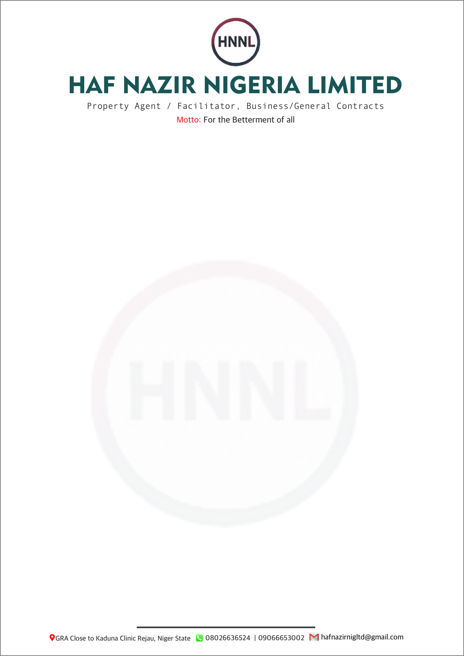

12 January 2026
The Managing Director
Bulletine Construction Company Ltd
Through:
The Financial Controller,
Bulletine Construction Company Ltd,
7A, B Close, Omenailtto Street
Kado Estate, Abuja
Through:
The Accountant,
Bulletine Construction Company Ltd,
Along Abaji – Lokoja Route,
Abaji, FCT, Abuja.

Dear Sir,
OFFER LETTER FOR THE PURCHASE OF SCRAP MATERIALS
We, HAF NAZIR Nigeria Limited of GRA, Close to Kauna Clinic, Rijau, Niger State, on behalf of Matakwa Integrated Service, of No. 7, Ebele Street, Isolo, Lagos, Nigeria, hereby formally submit this offer for the purchase of construction company scrap metal materials and other scrap belonging to Bulletin Construction Company Ltd, located at your Abaji (FCT Abuja) and Toto (Nasarawa State) sites.
This offer is made following the physical inspection and verification of the scrap materials available at both locations, and is facilitated by HAF NAZIR Nigeria Limited.
1. Offer Price
The total offer price for the scrap materials is:
₦1,100,000,000.00 (One Billion, One Hundred Million Naira Only).
2. Scope of Scrap Materials
This offer covers all agreed construction scrap metal materials and other scrap available at:
- Abaji Site – FCT Abuja
- Toto Site – Nasarawa State

3. Method of Payment
Payment shall be made on a Block Funding – Pay-to-Drop basis as follows:
- ₦100,000,000.00 (One Hundred Million Naira Only) every five (5) working days, tied strictly to the evacuation of scrap materials from your sites.
- In a situation where the buyer is able to move all the Scrap materials in less than 10 weeks, then all the remaining balance payment will be paid in BULK.
4. Financial Institution
Both parties agree that United Bank for Africa (UBA) shall serve as the designated financial institution for all transactions relating to this transaction.
5. Facilitation / Agency Fee
Both parties acknowledge the role of HAF NAZIR Nigeria Limited as the facilitator of this transaction and agree as follows:
- Bulletin Construction Company Ltd shall pay 5% of the total transaction value.
- Matakwa Integrated Service shall pay 5% of the total transaction value.
- The total facilitation / Agency fee is therefore 10% of ₦1,100,000,000.00, amounting to ₦110,000,000.00 (One Hundred and Ten Million Naira Only).
- This facilitation fee shall become payable immediately upon commencement of the first block funding instalment payment.
6. Validity of Offer
This offer remains valid subject to acceptance and execution of a formal Sales Agreement by both parties.
We trust that the above terms are acceptable. Kindly indicate your acceptance by acknowledging this offer in writing, so that we may proceed with documentation and implementation without delay.
Once this offer is accepted, we would expect a copy of the full inventory list of the available scraps in both sites to be attached to the letter of acceptance.
Please accept the assurances of our highest consideration.
Yours faithfully,

For: Matakwa Integrated Service

Authorized Signatory
Name: Alhaji Usman Musa Ushe
Designation: Facilitator
Date: 12 January 2026

