AlexNet

1. Introduction

AlexNet deepens the network structure and learns richer and higher-dimensional image features on the basis of LeNet. We select AlexNet for this project, because it is the most widely researched CNN and is a proper trade-off between speed and accuracy.

In contrast to other respondents using standard characteristics and classifier training techniques, AlexNet [1] used neural networks, particularly convolution neural networks. The model comprises of 3 fully connected layers and 5 convolutional layers. The first layer of AlexNet is used for input of a filtered image with a dimension of 227 × 227 × 3 respectively for width, height, and depth (red, green, blue). The last fully connected layer connects 1000 connected layers and the rest of the layers’ work as a feature extractor. For each input image, AlexNet can produce a 4096-dimensional feature vector that includes the hidden layer activations instantly before the output layer. AlexNet itself is a huge structure containing 650,000 neurons and 60 million parameters. Fig. 1 illustrates the architecture of AlexNet [2].

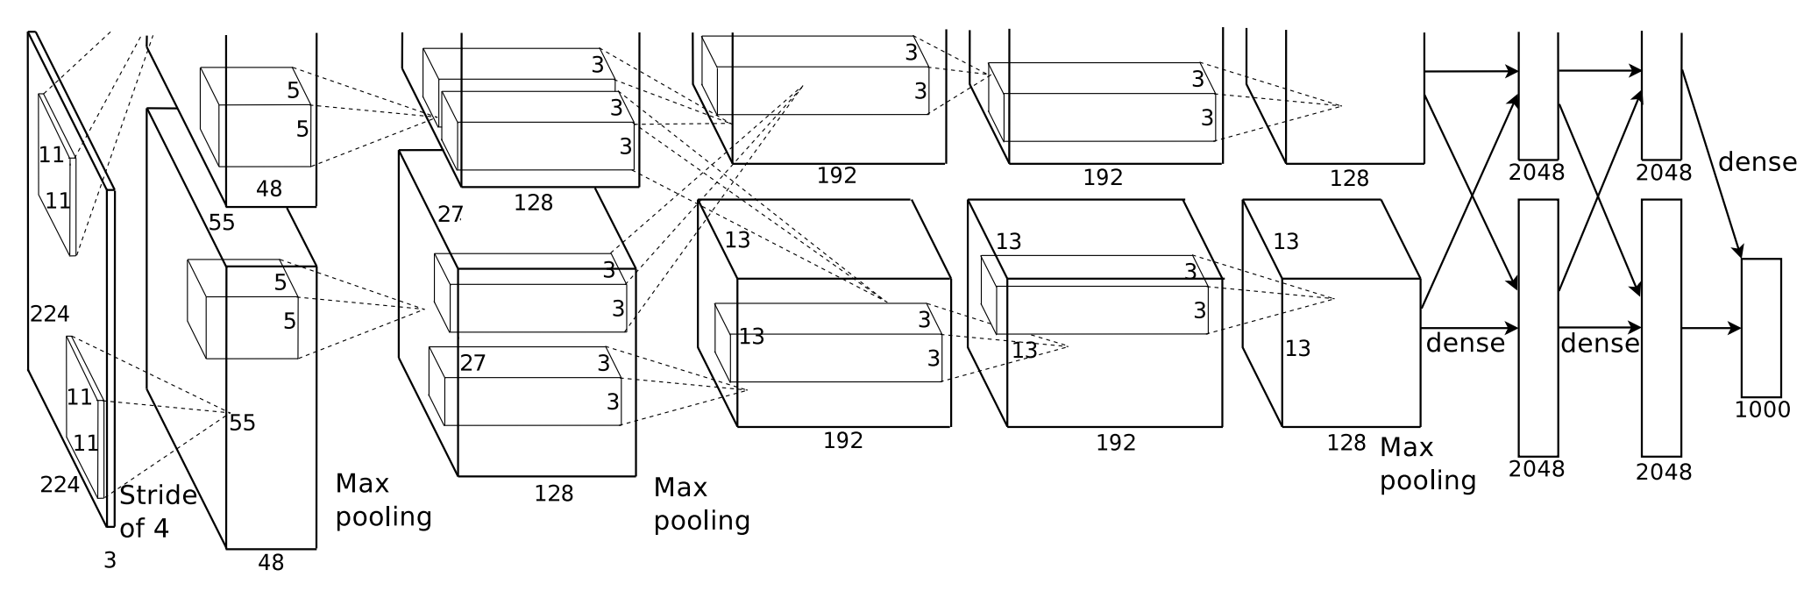

Fig. 1. The architecture of AlexNet

The model was trained on approximately 1.2 million training pictures and performed testing on 150,000 ImageNet data sets test pictures [3]. This model is very efficient for reducing the overfitting problem with the help of maintaining dropout and data augmentation.

1. Result
   1. Result in Dataset MNIST

The results of training the MNIST dataset and the curves of Train Loss and Train Accuracy with AlexNet model are shown in Fig. 2 and Fig. 3.

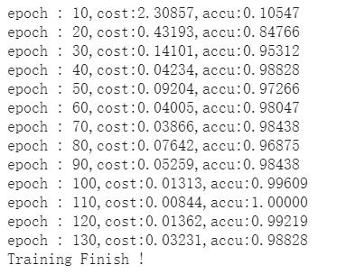

Fig. 2. Accuracy in MNIST with AlexNet

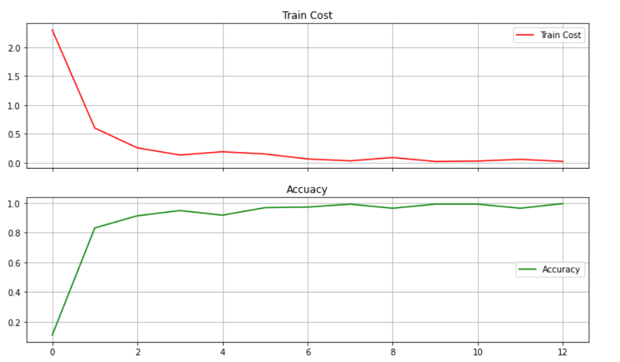

Fig. 3. Train Cost and Accuracy in MNIST with AlexNet

* 1. Result in Dataset CIFAR-10

The results of training the CIFAR-10 dataset with AlexNet model are as follows. As shown in Fig. 4, the accuracy is 76.190%. Besides, the curves of Train Loss and Train Accuracy are shown in Fig. 5.

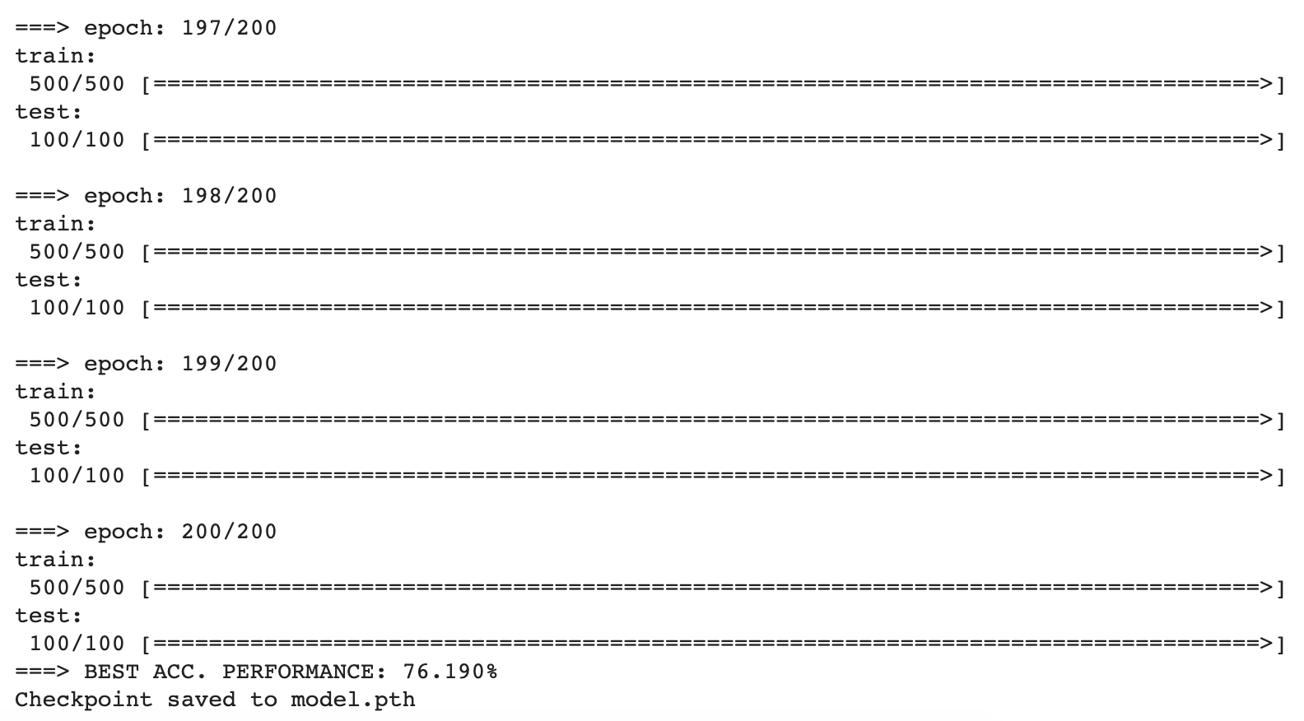

Fig. 4. Accuracy in CIFAR-10 with AlexNet

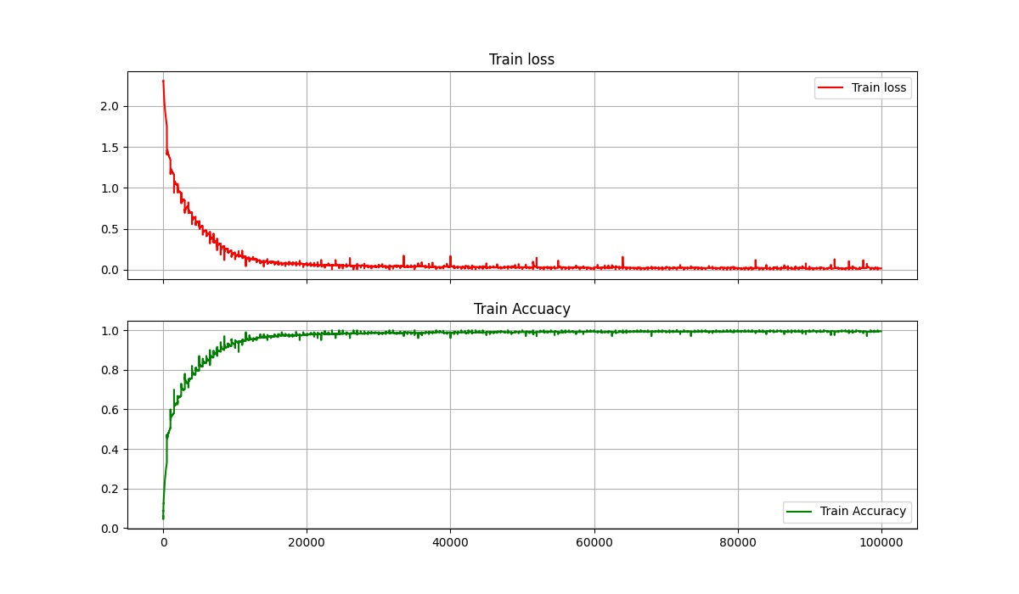

Fig. 5. Train Loss and Train Accuracy in CIFAR-10 with AlexNet

Reference

[1] Fazla Rabbi Mashrur, Amit Dutta Roy, Dabasish Kumar Saha, “Automatic Identification of Arrhythmia from ECG Using AlexNet Convolutional Neural Network”, 2019 4th International Conference on Electrical Information and Communication Technology (EICT), 20-22 Dec. 2019.

[2] A. Krizhevsky, I. Sutskever, G. E. Hinton, “ImageNet Classification with Deep Convolutional Neural Networks”, International Conference on Neural Information Processing Systems, vol. 2, pp. 1097-1105, 2012.

[3] S. Gu, L. Ding, Y. Yang, X. Chen, “A new deep learning method based on AlexNet model and SSD model for tennis ball recognition”, 2017 IEEE 10th International Workshop on Computational Intelligence and Applications (IWCIA), 11-12 Nov. 2017.